**Unit 4 Body Language-Using Language**

Reading for writing**教学设计**

临安中学 余智良

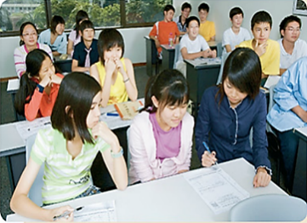 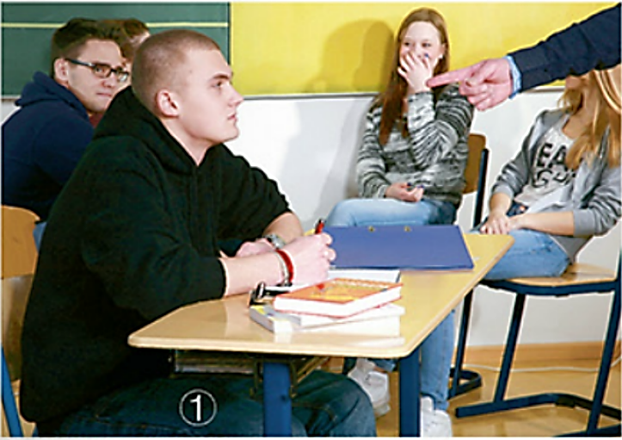

**教学目标与核心素养：**

知识目标：

1. To read a passage about how a teacher knows her/ his students by body language.
2. To learn how to describe the different body language and the message it conveys

能力目标：

To learn to write a passage to describe the body language of a person.

情感目标：

To learn to show or describe emotions or feelings indirectly.

**教学重难点:**

教学重点：

1. To practice some of students’ reading skills, like summarizing, guessing the meaning of difficult words.
2. To learn to write a passage to describe the body language of a person.

**教学难点：**

1. To learn to write a passage to describe the body language of a person.
2. **引导学生仔细阅读并模仿使用肢体语言的表达法。**

**课前准备：多媒体，黑板，粉笔**

**Teaching procedure：**

**一、Pre-reading**

1. pre-reading: talk about the function of body language and describe different body language in class.

教师活动：present a passage, and ask students to point out the description of body language and what messages does each body language convey.

学生活动：read the passage, point out the descriptions and tell their functions

教师活动：(Actually, body language can reveal a lot about your feelings and your intentions. Do you know that in every class, you will show teachers a lot of different、vivid body language with yourself not realizing it.) ask students to describe different classroom body language.

   



学生活动：describe the body language shown in each picture and tell what their body language implies

教师活动：ask students a question: How do teachers tell their students’ performance in class?

学生活动：by looking at/reading students’ classroom body language

教师活动：ask students a question: Why do the teachers think students’ classroom body language is important?

学生活动：answer the question. If not, they can find it out in the reading passage.

**二、While- reading**

Task 1: 学生活动：Read the text on page 44、divide the passage into three parts and conclude the main idea of each part.

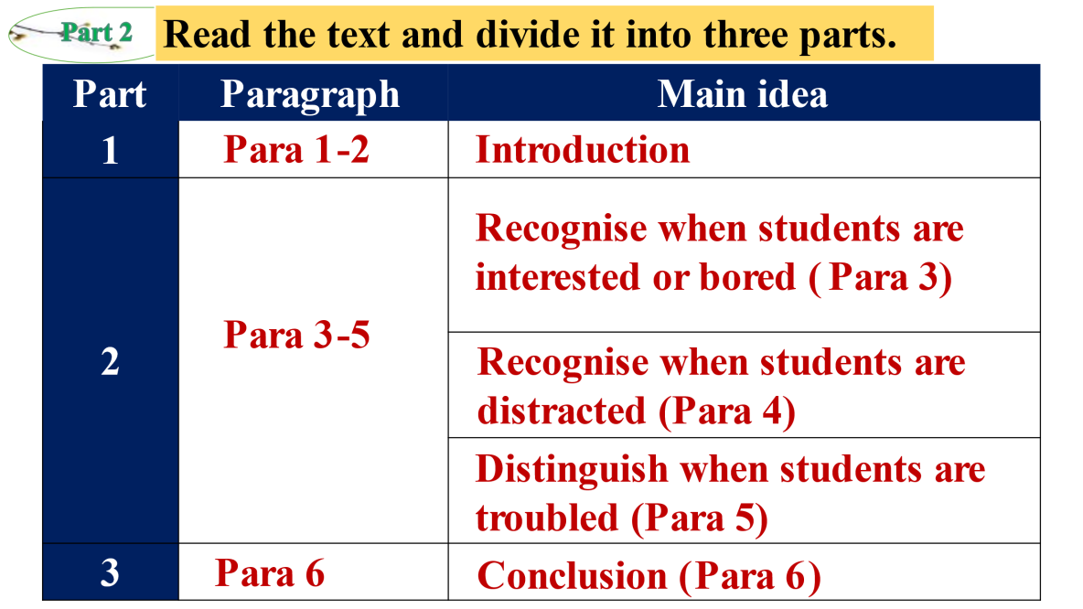

Task 2: 学生活动：read Para 3-5 together and match the body language with the meanings.

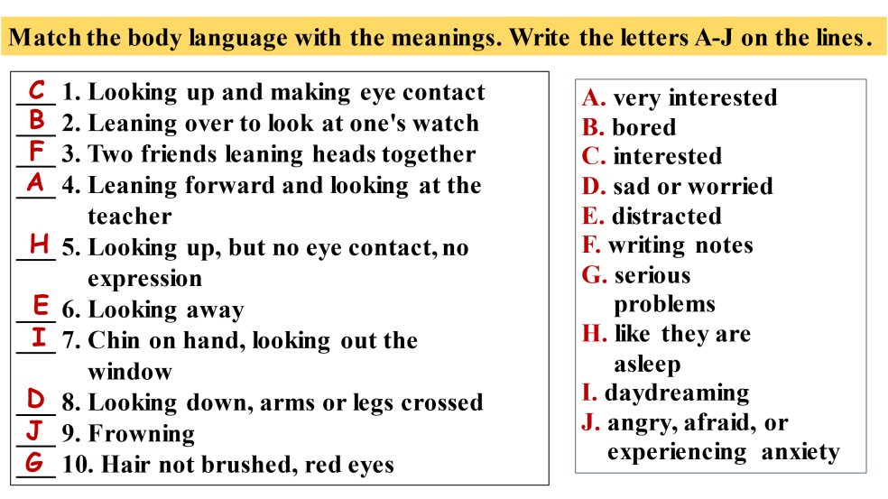

Task 3: 学生活动：Read Para 3-5 again and answer the following questions.

Q: How many feelings are mentioned in this part? What are they?

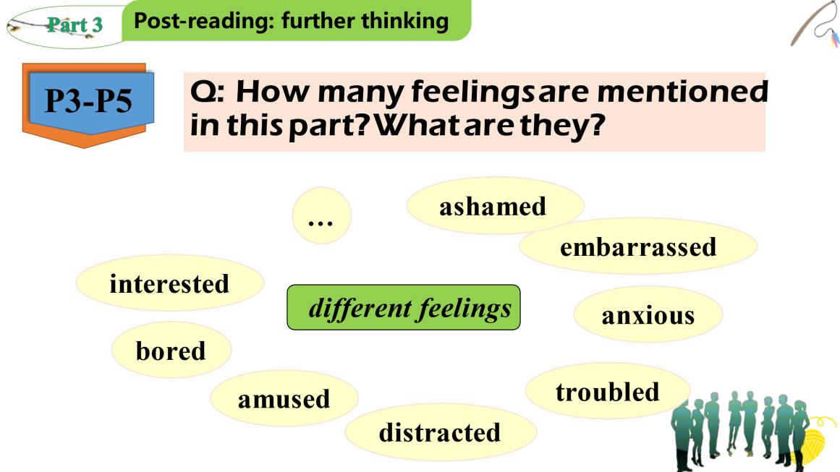

Q: What different verbs does the teacher use to mean he/she notices and judges students’ body language?

**know, recognize, perceive, distinguish, infer, inquire, assess**

教师活动：help students deal with difficult words

**三、post- reading: writing task**



教师活动：assign students the writing task and make the requirements clear

**Requirements:**

1. **You are the teacher who is scolding;**
2. **Make full use of the information you can get from the picture;**
3. **Design a plot for the picture and make up a logical story;**
4. **Use as many as the expressions learnt in this lesson;**
5. **Work with your partner and finish the story of 80 words in 5 mins.**

学生活动：Students have 5 mins to work with partners and write a short passage focusing on designing the plot and the description of body language.

学生活动: share their work with others

教师活动: 1.comment on students’ works and show them a sample

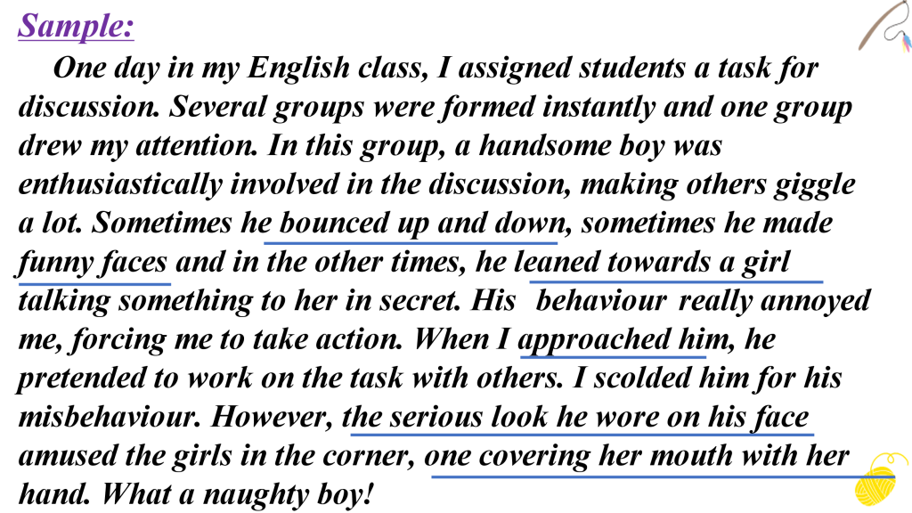

学生活动：point out the description of body language

**Homework:** Revise their work and copy it down on their exercise books