选择性必修二Unit4 Write about a rail journey across Canada学案

**Task1 Complete the blanks about the detailed information of their experiences in different places.**

**Jasper**



**Lake Louise**

**Vancouver**





**took the train;**

**___________________ looked massive;**

**__________ took their breath away**

**took a __________ out into the bay;**

**visited __________;**

**took a hike in a______**

**took a ______ through the Canadian Rockies;**

**spectacular __________________;**

**creatures**

**The Prairie**

**Winnipeg**





**Edmonton**

**center of Canada’s ______________ drilling industry;**

**____________ in winter;**

**large ________________**

**amazed by the open country;**

**went through two _____________ provinces;**

**a bunch of __________**

**an _________ area**



**Montreal**

**Toronto**

**Ontario**





**signs and ads in ____________;**

**people speak English with ________;**

**visited lovely shops;**

**visited _______________________ along St Paul Street;**

**met Jean Philippe in a restaurant alongside _____________________; unique _____________ culture and traditions**

**The__________________ city in Canada;**

**went up the_____________;**

**saw misty clouds rising from ___________________;**

**__________ of glass and steel; ___________________ cars;**

**met Lin Fei in ___________.**

**a land of forests and _____; rolling _________;**

**bushes and ____________;**

**the wide stretch of Lake Huron**

**Task 2 Complete the mindmap about Canada.**

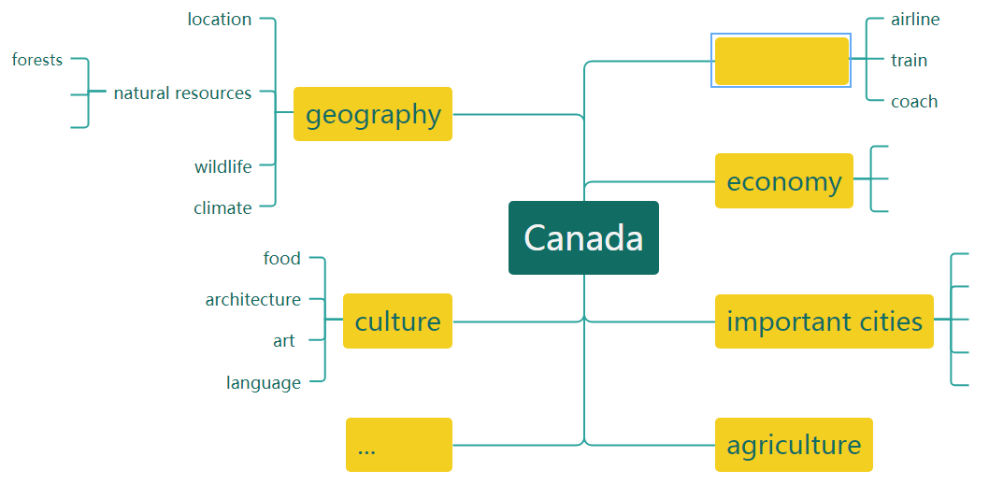

**Task 3 Writing**

**Dear Mum and Dad,**

**______________________________________________________________________________.**

**We started in Vancouver, _______________________________________________. Then,_________________________________________________________________________.**

**From there, we_________________________________________________________________.**

**_____________________________. Then after we__________________________, we went on to ____________________________________________________________________________.**

**Finally,________________________________________________________________________.**

**Love,**

**Daiyu**