Chapter 1 Historical Background
- Discuss the Question
- Have you ever heard “Art comes from life and goes beyond it”? How do you understand it?
- What do you know about Charles Dickens?

- Read by Yourself

¹monarch /ˈmɒnək/ n.
君主；帝王

²representation
/ˌreprɪzenˈteɪʃən/ n.
描绘；表现

³contemporary
/kənˈtempərəri/ adj.
当代的

⁴comic /ˈkɔmɪk/ adj.
滑稽的；使人发笑的

⁵correspond to
与……相符；契合

⁶revolt /rɪˈvəult/ n.
反抗；反叛

⁷prosperity /prɔˈsperɪti/
n. 反抗；反叛

◇◇ What’s Realism?◇◇
The 19th century is the century of greatest change in the history of Western civilization. The French revolution broke up the older of Europe. Almost all over Europe, the middle class established their effective rule, with monarchs¹ having less power. The great political events caused great social and economic changes.
The great social chaos and urban poverty brought about by the social and economic changes created severe problems to which the political leaders reacted in many ways. They called for voting rights, freedom of speech, wanted independent countries and so on.
During 1830s and 1840s, the reformers led several revolutions, but all failed. Thus followed a time of loss of hope, and brought about revulsion against Romanticism. The need was felt for a return to what was plain and real.
After the great wave of the international romantic movement had spent its force in the fourth decade of the 19th century, Europe literature moved in the direction of realism.
The realists wanted a truthful representation² in their works of contemporary³ life. They thought of their method as observational and objective. “A novel is a mirror walking along the road,” said one writer.
If romanticism allows full play to the imagination and stress love of beauty and interest in the past, the realists focus on the real and plain life. Its language is usually simple, clear and direct, while the tone was often comic⁴, frequently satiric.
The period of realism in English literature corresponds⁵ roughly to the latter half of the reign of Queen Victoria (1837-1900). This is the period when England was at the peak of its power, rapidly growing into a strong, industrialized nation.
In spite of its stable government and greatly increased population, the country suffered severe economic depression. A revolt⁶ began against optimism that had characterized the early days of the Victorian rule. Both the prosperity⁷ and the social troubles like unemployment left marks on the literature of the period.

¹monarch /ˈmɒnək/ n.
君主；帝王

²representation
/ˌreprɪzenˈteɪʃən/ n.
描绘；表现

³contemporary
/kənˈtempərəri/ adj.
当代的

⁴comic /ˈkɔmɪk/ adj.
滑稽的；使人发笑的

⁵correspond to
与……相符；契合

⁶revolt /rɪˈvəult/ n.
反抗；反叛

⁷prosperity /prɔˈsperɪti/
n. 反抗；反叛

◇◇Who is Charles Dickens◇◇
Charles Dickens was born on February 7, 1812, the son of a clerk at the Navy Pay Office. His father, John Dickens, continually living beyond his means, was imprisoned for debt in the Marshalsea in 1824. 12-year-old Charles was removed from school and sent to work at a boot-blacking factory earning six shillings⁸ a week to help support the family. This dark experience cast a shadow over the clever, sensitive boy that became a defining experience in his life, he would later write that he wondered “how I could have been so easily cast away at such an age.”
This childhood poverty and feelings of being abandoned, although unknown to his readers until after his death, would be a heavy influence on Dickens’ later views on social reform and the world he would create through his fiction.
Dickens would go on to write 15 major novels including, Oliver Twist, Bleak House, Great Expectations, A Tale of Two Cities, and his personal favorite, David Copperfield. He will forever be associated with the celebration of Christmas due to his Christmas Books, the most popular being A Christmas Carol. Dickens also edited, and contributed to, weekly journals Household Words and All the Year Round. Near the end of his life he traveled throughout Britain and America giving public readings of his work.
Charles Dickens died an old man of 57, worn out with work and travel, on June 9, 1870. He wished to be buried, without ceremony⁹, in a small cemetery⁹ in Rochester, Kent, but the Nation would not allow it. He was laid to rest in Poet’s Corner, Westminster Abbey, the flowers from thousands of mourners overflowing the open grave. Among the more beautiful bouquets were many simple clusters of wildflowers, wrapped in rags.
Charles Dickens’ best book is David Copperfield, a kind of autobiographical romance, in which his power over our everyday emotion is unrivalled¹⁰. Within one page he can make the reader burst with laughter and soon wet the book with honest tears. But whatever he wrote he has some basis on his own experience. In his youth he had been familiar with the most humble surroundings and the most poverty-stricken districts. As a novelist of genius, he has created a whole world of beings mirroring the movement of life, with unforgettable scenes and full of good humor, tender emotions and loving-kindness.

⁸shilling /ˈʃɪlɪŋ/ n.
先令(英国1971年以前货币单位，一先令值12旧便士，20先令合一英镑)

⁹cemetery /ˈsemɪtri/ n.
墓地；坟墓

¹⁰unrivalled /ʌnˈraɪvld/ adj. 无与伦比的

- Check Your Understanding
- What’s the difference between romanticism and realism?
/ | Realism | Romanticism
Content
Language
Representative writers
Works
- The following are Charles Dicken’s life events. Please reorder them.
(1). He was born as a son of an impoverished government clerk.
(2). He received little schooling.
(3). He inherited money from his uncle.
(4). He paid off his father’s debt.
(5). He learned shorthand and becoming a reporter.
(6). He began to work in a blacking factory at 12.
(7). His father put into prison for debt.
(8). He started writing fiction in his spare time.
★Right order:
3. How would you describe Charles Dickens’s childhood? Try to come up with several adjectives.

4. Why were many beautiful bouquets wrapped in rags sent to Charles Dickens when he was
dead?

- Share Your Opinion
…Of all my books, I like this the best…But, like many fond parents I have in my heart of hearts a favorite child. And his name is DAVID COPPERFIELD.
—Charles Dickens
Discuss with your partners why Charles Dickens regarded David Copperfield as his favorite child among all works.

Chapter 2 A Bad Child
- Discuss the Question
- Can you recall some happy events during your childhood? Share with your classmates.
- How would you describe your childhood?

- Read by Yourself

¹slam /slæm/ v.
(使…) 砰地关上

²waddle /ˈwɒdl/ v.
(鸭子似地) 摇摆地行走

³barge /bɑ:dʒ/ n.
驳船(运河、河流上运载客货的大型平底船)

⁴orphan /ˈɔ:fn]/ n.
孤儿

My life has been full of ups and downs, and during my childhood the downs seemed to rain on me like a never-ending storm. When I look back on those years, I can’t believe that any grown-up would behave in that way to a child. But they did.
My story starts in Suffolk with the first noise I ever heard—the slamming¹ of our front door.
My great-aunt, Betsey Trotwood, had been quite sure I was going to be a girl. When she was told I was a boy, she got up in a rage and stormed out. My poor mother! She was all alone in the world, except for me and our housekeeper, Peggotty. My father had died six months before I was born.
My early childhood was very happy. I remember watching geese waddle² around our back yard and reading picture books with Peggotty. Peggotty was not pretty, like my mother, Clara, but she was kind and loving, and I adored her as much as I adored my mother.
Then one evening at a friend’s house, my mother met Mr Murdstone. He had black hair and a hard, cold, handsome face. My mother seemed to light up in his company, but even though I was very young, I could tell Mr Murdstone didn't like me at all. And I didn’t like him. Before long, this unpleasant man began to visit our house more and more often.
So I was very happy when Peggotty took me on a holiday to the seaside where her brother, Dan Peggotty, lived. I fell in love with his house, which was in an upside-down boat—a large black barge³, with an iron funnel blowing out chimney smoke. I also fell in love with his little orphaned⁴ niece, Emily, who lived with him. She was bold and pretty with a wildness that completely captured my heart.
I often think that if I hadn’t met Emily, some of the terrible things that happened to her in later life may never have taken place. But you can’t know these things at the time.
Dan Peggotty also looked after an orphaned nephew named Ham, a tall boy with a wide smile, who was several years older than I was.

After Mr Murdstone’s coldness, the friendliness of Dan’s family made me very happy. Best of all, I loved playing on the beach with little Emily. I had a very heavy heart when Peggotty and I had to leave them all and return home. But nothing could have prepared me for the awful news that was waiting for me.
While I’d been away, my mother had married Mr Murdstone. From now on he was going to live with us. I felt as if the air had been strangled⁵ out of me. Mr Murdstone was the kind of man that smothers all hope and happiness.
Now that they were married, he ordered my mother around and bullied her until I couldn’t bear to watch. If she showed me kindness, he’d say, “Don’t be so weak, Clara. You must be frm with the boy.” He said I was a bad child and that he was determined to crush me.
“David,” he said one day, beckoning⁷ me over to him, “what do you think I do if I have a dog or a horse that doesn't do what I tell them?”
“I don’t know,” I whispered nervously.
“I beat it,” he replied, with an evil glint⁸ in his eyes.
I shivered⁹ with fear, knowing that if I gave him the slightest excuse, he would beat me.
Peggotty was very upset about Mr Murdstone, and she tried talking to my mother. But my mother was too afraid of her new husband to do anything that might make him angry—she was totally in his power. I could never get my mother on her own any more—Mr Murdstone was always there.
Things got worse when Mr Murdstone’s sister came to live with us. Miss Murdstone looked just like her brother. Her face was full of gloom¹⁰ and cruelty. “I don't like boys” were the first words she spoke to me, and it seemed that whatever I said or did was wrong in her eyes.
If it were possible, she was even harsher towards my mother than her brother. My poor mother now had two jailers¹¹ instead of one. `The Murdstones scolded her day and night. I never saw my mother speak her mind again, unless she had first checked with those two that they agreed.
I was not allowed to play with other children, because the Murdstones thought all children were vipers¹². The only escape I had was to lose myself in the small collection of books my father had left us. As I read, I imagined myself as the hero of each story and the Murdstones as the evil characters, always getting into trouble.

⁵strangle /ˈstræŋɡl]/ v.
扼死; 勒死

⁶smother /ˈsmʌðə(r)/ v.
使窒息而死; 闷死

⁷beckon /ˈbekən/ v.
招手示意; 举手召唤

⁸glint /ɡlɪnt/ n.
闪光；闪亮

⁹shiver /ˈʃɪvə(r)/ n.
颤抖，哆嗦

¹⁰gloom /glu:m/ n.
忧郁; 愁闷

¹¹jailer /ˈdʒeɪlə(r)/ n.
监狱看守; 狱卒

¹²viper /ˈvaɪpə(r)/ n.
蝰蛇(一种小毒蛇)

Mr Murdstone insisted I did lessons with my mother, but he and Miss Murdstone would stand over me, frowning¹³ and telling my mother to be firmer. Every day I found it harder to work, with these two evil people watching my every pencil stroke¹⁴. And every day they would punish me for being “stupid”.
One morning, Mr Murdstone looked even sterner¹⁵ than usual and I saw he was gripping¹⁶ a thin cane in one hand. “You must be extra careful today,” he warned me, pointing the cane at me.
That day, I made mistake after mistake. My body was shaking with fear. Before long, Mr Murdstone jumped up, shouting, “We can’t expect Clara to put up with the worry David is causing her today!”
My mother started crying and reached out towards me.
“Stop it at once, Clara!” ordered Miss Murdstone.
My mother fell silent as Mr Murdstone turned his steely¹⁷ gaze on me. “You and I will go upstairs now, David,” he said.
I walked up the stairs with my knees trembling. Mr Murdstone’s heavy footsteps followed right behind me. As soon as we entered my bedroom he shut the door.
“Why are you doing so badly in your lessons?” he demanded.
I shook with terror. I had to give an answer, but the only one I could think of was the true one and I knew it would end in disaster.
“I...I...can’t do my work,” I spluttered¹⁸, “when...when you and Miss Murdstone are there.”
No sooner had these words left my mouth than he grabbed hold of my head and began slapping me. I had to fight back—I had to. All those weeks of bullying and loneliness exploded in me.
I sank my teeth deep into his right hand—the one holding my neck—and tasted the salty and sour texture¹⁹ of his skin. He yelled in pain and sprang backwards, letting go of my head in shock. He stared down in horror at the deep bite marks on his hand.
The next instant, he rushed at me, hitting me with both hands on my head, on my back, on my chest. I held my arms over my face, dizzy with pain and shock. I was only ten years old, and I couldn’t defend myself against a fully-grown man.
I heard my mother and Peggotty screaming on the stairs outside my room, begging Mr Murdstone to stop. But he took no notice. How long the attack lasted, I don’t know, but by the time he finished, I collapsed²⁰ in a heap²¹ on my bedroom floor.

¹³frown /fraʊn/ v.
皱眉; 蹙额

¹⁴stroke /strəʊk/ n.
(打、击等的) 一下

¹⁵stern /stɜ:n/ adj.
严厉的; 苛刻的

¹⁶grip /ɡrɪp/ v.
紧握; 紧抓

¹⁷steely /ˈsti:li/ adj.
强硬的; 冷冰冰的

¹⁸splutter /ˈsplʌtə(r)/
v. 气急败坏地说

¹⁹texture /ˈtekstʃə(r)/
n. 质地; 手感

²⁰collapse /kəˈlæps/
v. 突然) 倒塌，坍塌

²¹in a heap
颓然（倒下）; 重重地（倒下）

For five days I was kept a prisoner in my room, with Miss Murdstone acting as jailer.
On the fifth night, I heard Peggotty outside my room. “They’re sending you away to a boarding school in London,” she whispered through my door.
“When am I going?” I asked.
“Tomorrow,” she answered, “first thing in the morning.”

- Check Your Understanding
- How do you understand “ups and downs” in Paragraph 1?

2. Can you figure out who they are according to the descriptions in the story.
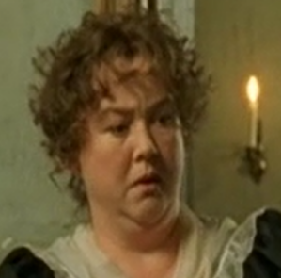 | 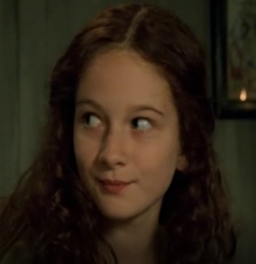 | 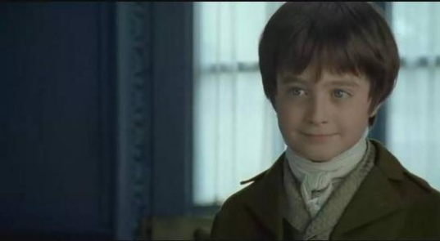 | 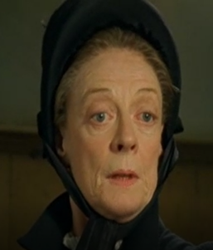
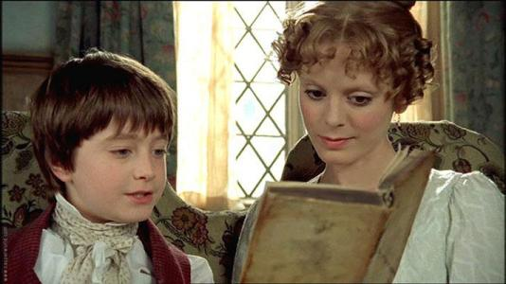 | 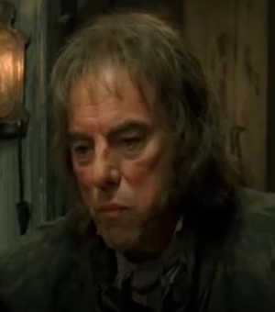 | 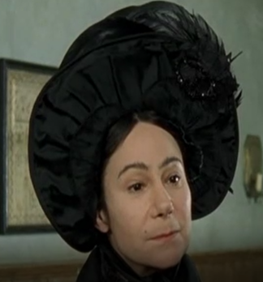 | 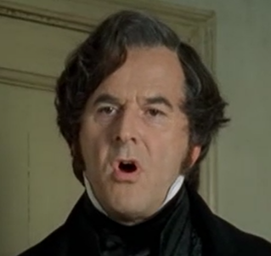
- What does David think of his childhood?

- Why was David’s early childhood happy?

- Why was David’s childhood become unhappy?

6. How does the writer describe Mr Murdstone and Miss Murdstone?
Name | Appearance | Character
Mr. Murdstone
Miss. Murdstone

- How was David’s feeling toward Mr. Murdstone? How does the writer describe it?

8. Try to find the sentence describing the following feelings: “happy”, “unhappy”, “angry”,
“desperate”, and “frightened”.

- Share Your Opinion
- The title of Chapter 2 is “A Bad Child”. Do you think David Copper is a bad child according to
how he behaved in the story? Give your reasons.

