选择性必修二Unit 4 Using Language (2) Reading for writing教学设计
浙江省龙游县第二高级中学 邱筠
浙江省衢州第三中学 邱赛仙
文本分析：
该部分的阅读语篇是Reading and Thinking板块LiDaiyu、Liu Qian两姐妹乘坐火车横跨加拿大旅行游记的续篇，文章以Seeing the True North via Rail:Toronto and Montreal为题，记述了两姐妹从多伦多到蒙特利尔这段旅途中的所见所闻，尤其谈到在多伦多中国城与Li Daiyu妈妈的老同学Lin Fei会面，以及在蒙特利尔与当地小伙子Jean-Philippe的交流，体现了加拿大多元文化的特色，有利于学生进行文化对比，培养跨文化交流与沟通的意识。该语篇以时间的推移和地点的转换为线索，用优美、流畅的语言描绘出一幅具有加拿大特色的多彩画卷，包括当地的自然美景、城市风貌、文化传统、艺术生活筹，为学生接下来完成写作任务提供了重要的信息和鲜活的语言素材。同时，作者的遣词造句体现人物情感，两个语篇用了大量表达人物主观感受的词汇，如pleased, took their breath away, truly amazed, astonished, surprised等，以及对环境正面评价的词汇，如a pleasant hike, exceptional beauty, beautiful scenery, the most awesome journey, spectacular mountain peaks and forests, wonderful sights and sounds, fantastic restaurants and clubs等。以上词汇说明人物欣赏环境，心情愉悦。作为家长，Li Daiyu和Liu Qian父母首先希望孩子旅途安全，其次也希望她们享受旅行，从旅行中学会东西。这也为后面的写作作了铺垫，即写一封得体的邮件须考虑收件人的身份和感受。
学习目标：
通过本课的学习，学生能够：
- 了解加拿大重要城市的主要文化；
- 感受游记的独特语言，通过语言体会人物情绪；
- 理清游记的旅行线路，角色转换，给文中女孩的父母写一封得体的家信（电子邮件）。
学习重难点
Key points:
- Understand the text and know about the culture of Canadian major cities.
- Use the map to draw routes and write an email about the rail travel accordingly.
Difficult point:
Appreciate the language and understand the girls’ emotions.
教学过程
Step l:Revision
The teacher starts the lesson by review the previous text “Seeing the true north via rail:Vancouver and the heart of Canada” and asks:
T:Which places did Li Daiyu and Liu Qian visit in the previous journey? Circle them on the map.
S:Vancouver,Lake Louise,Jasper Edmonton,the Prairie winnipeg .
T: Today,we,re going to learn another text with the title “Seeing the true north via rail:Toronto and Montreal” Can you predict what the passage will probably talk about?
Ss: It will probably talk about the second part of their trip.
T: Yes. We have another word for “one part of a journey or race”, that is “leg”.
[设计意图]：通过复习上一篇游记引出本文题目，并预测内容，同时猜测leg的意思。
Step2:Reading and understanding
Task1:Go through the text, and circle on the map which cities they visited and plan to visit.
Possible answer:Toronto,Montreal,Halifax.
Task2:Can you divide the passage into three parts and conclude the main idea of each part?
Paras1~4:Li Daiyu and Liu Qian,s experience in Toronto.
Paras5~9:Li Daiyu and Liu Qian,s experience in Montreal.
Paras10:Their time spent on the train towards Halifax.
[设计意图]：理清旅行路线，并根据各部分路线给课文内容分段，概括大意。
Task3:Read for details
- What did the girls see and do in Toronto.
△ the largest and wealthiest city in Canada;
△ went up the CN Tower;
△ saw misty clouds rising from the Niagra Falls;
△ skyscrapes of glass and steel;
△ old-fashioned cars;;
△ met Lin Fei in chinatown.
More questions:1. What did the girls see when they went up the CN Tower?
2. Why was it possible to get all kinds of good Chinese food in Toronto?
Watch a video and say whether you have seen what is mentioned in the text.

- What did the girls see and do in Montreal.
△ signs and ads in French;
△ people speak English with an accent;
△ visited lovely shops;
△ visited artists in their workplaces along St.Paul Street;
△ met Jean Philippe in a restaurant alongside the St.Lawrence River;
△ Unique Quebec culture and traditions.
Watch a video and feel the culture in Montreal.
[设计意图]：理解语篇内容，找出两人在Toronto和 Montreal所见所闻所做，之后观看视频，对两个城市文化有更直观的感受。
Step3:Reading for writing
Q1:The girls experience in each place is significantly different. Can you figure out their route and what they experienced at each place?
Vancouver→ Lake Louise → Jasper → Edmonton → The prairie → Winnipeg → Ontario → Toronto → Montreal → Halifax
[设计意图]：理清两人的总旅行路线及经历的主要细节，为写作做内容上的铺垫。
Q2:What do you know about Canada from their travel experience? Complete the mindmap.
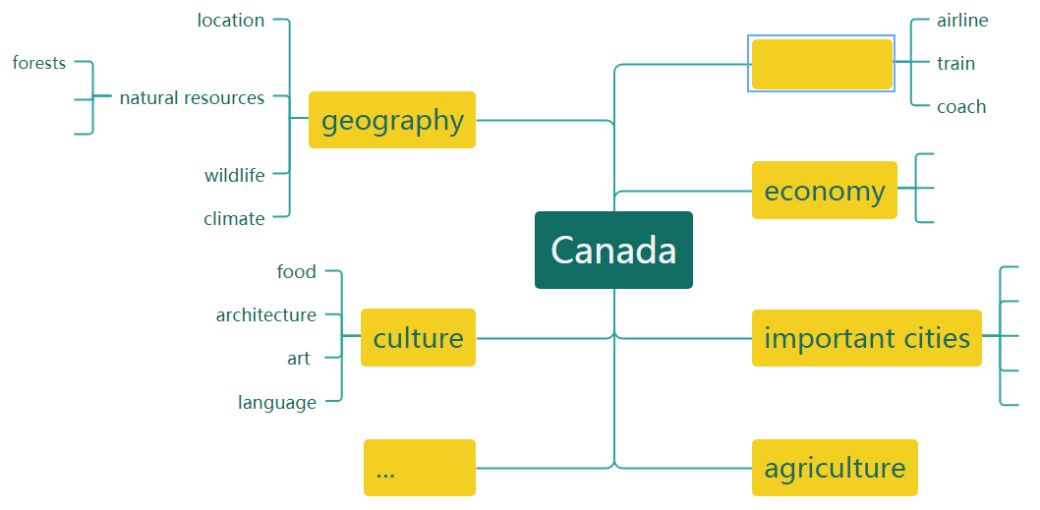
[设计意图]：帮助学生构建加拿大的知识结构图，并谈谈学生对加拿大印象深刻的地方，从知识学习到知识构建的过程。
Q3:Did the girls enjoy the journey? Can you find some sentences that show their emotions?
*The next day was clear and mild, and they were pleased to see the beautiful mountains looking out over the city. Later, they took a pleasant hike in a forest just a short distance away.
*...where the blue water literally took their breath away with its exceptional beauty.
*Looking at the beautiful scenery, they both agreed that it was the most awesome journey they had ever taken. In addition to seeing spectacular mountain peaks...
*However, they did not anticipate seeing such an open country, and were truly amazed.
*Standing in the distance, they were astonished to see misty clouds rising from the great Niagara Falls,...
*They were surprised to see that all the signs and advertisements were in French and...
*Overall, Montreal is a city with wonderful sights and sounds.
*There are fantastic restaurants and clubs around, too.
...
Q4:What type of writing is it?How do you know?
A travel journal.
→the title
→who,when,where,what,how
→developed in chronological and spatial order
→vivid descriptions
[设计意图]：文体特征讨论及语言赏析，为学生写作提供语言素材及组织方式。
Step4:Writing
Discussion: If you were the girls, parents,what would you most care about when your girls are travelling in Canada?
·safety
·Do they enjoy the trip?
·when will they come back?
Now,imagine that you,re Li DaiYu.Use the map on P45 and your notes,write an email to your parents telling them about the trip.
Remember to tell them what they are concerned about.
[设计意图]：换位思考，让学生体会父母对身在异国他乡旅行的孩子最关心的事来构思写作内容，读者思维，让语言更得体。
Step5: Evaluating
Use the checklist to help you assess your partner's draft.Then take your draft back and revise it according to your partner's comments.
- Does the writer start the email with an appropriate greeting?
 ② Is the email well-organized and coherent?
③ Does the writer make use of discourse markers to express different relationships between ideas?
 ④ Are the descriptions of people and places interesting?
 ⑤ Does the writer end the email in a natural way?
[设计意图]：生生互评，对标评价标准检测学生是否达成本课写作目标。
Homework:
Explore more about Canada and compare Chinese and Canadian culture.

