**Worksheet**

1. **Analyze para.3-7 and answer the following two questions. Then work in groups of four and finish the mind map.**

* What new things does the author discover? （how? → descriptive words）
* What activities does the author do to explore? （how? → verb phrases）

Sentence pattern: Following in the footsteps of Xu Xiake enables us to explore/discover _____(what new things). ________(details)

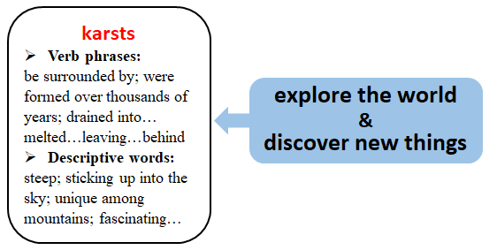

1. **Homework: Your American friend Peter is planning to visit China for sightseeing. Please write a letter to recommend Guilin to him. __________________________________________________________________________________________________________________________________________________________________________________________________________________________________________________________________________________________________________________________________________________________________________________________________________________________________________________________________________________________________________________________________________________________________________________________________________________________________________________________________________**