**学生课堂导学案 [潘宇佳老师原创]**

**Chapter 8 The Big Race —— *the Ultimate Trainer* [节选]**

The four of them hurried outside. It was almost time for the big race. There were people everywhere, and there was a buzz of excitement in the air. Proud mums and dads were picking out the best places to watch the race. Runners were warming up, pinning their numbers onto their vests, taking last minute advice. It wasn't hard to spot Kevin Beadle - he was the one with the smug look on his face. Jake could see why - he was wearing the trainers!

   “Are you going to go and take them off him?” Anna asked. Mariah nodded, but it was clear that Luther had another idea. There was twinkle in his eyes.  “I was just thinking these trainers have never been tested in a race yet. It would be interesting to see how they do.” Luther suggested.

Mariah thought it over, then at last she agreed.  “You mean you’re going to let him run in them?” Jack looked puzzled. Luther nodded. For a second, Jake felt a sharp stab of jealousy. Beadle was bound to win easily with those trainers. Then he remembered his own kit. It was almost time for the race to begin! With so much going on, he had forgotten to get changed.

   “I’ll be back in a minute.” Jack exclaimed.  After he had changed, Jake was only just in time for the start of the race. The race organizer called the runners to the starting line.

   Jake could see Kevin in the middle of the pack. A smirk played on the tall boy's face. Jake told himself to ignore it.

    The whistle blew and the race began. Five laps of the school playing fields. Right away, Kevin Beadle sprinted to the front of the pack. The trainers were doing their stuff.

    But Jake told himself just to concentrate on his own running. It was tough -he had spent so long running in the amazing trainers that real running was hard work.

After the first lap, he was near the back, and his legs ached. He spotted Anna in the crowd. The two strange adults were still with her. Anna shouted to him, “Come on, Jake! You can do it!” That made him feel better. He forced himself to go faster. Beadle, of course, was far ahead of all the other runners.

After the third lap, Jake was around the middle of the pack. His side was starting to hurt and his breath burned in his lungs, but he would not let himself slow down. There was something good about the way it felt. Whatever happened, it was up to him, not the trainers.

    Beadle increased his lead.

    The fourth lap was the hardest yet. It was the time when runners began to puff and pant, and a lot slowed down. But Jake gritted his teeth and pushed on. He overtook a few runners. He didn't even look up to see how far ahead Kevin Beadle was.

     And then he was passing Anna for the last time - it was the last lap. Even Luther and Mariah looked excited now. Luther was jumping up and down and yelling at the top of his voice, “Go on!” “You are doing brilliantly, Jake!” Anna screamed.

   The last lap was a blur. Jake’s whole body ached, not just his legs. But on he ran!

   Just when he thought he couldn't run another step, he heard a cheer from up ahead. Kevin Beadle had crossed the finishing line. The tall boy was holding up his arms.

   That gave Jake an extra burst of energy. He dug deep into himself, and ran on for the finishing line. Other runners jostled elbows against him as they made their final charge for the finish as well. At last Jake crossed the line. He was tenth - much better than he had expected!

     He bent over and tried to catch his breath. He was exhausted, but he felt pleased with himself as well. He looked over at the winner, who was standing with a group of admirers. Of course, Kevin Beadle looked as fresh as he had at the start of the race.

   But Jake didn't even care anymore. He knew that Beadle had not really won at all. The trainers had won for him.

Anna rushed over and gave Jake a great big hug, “You were great!”

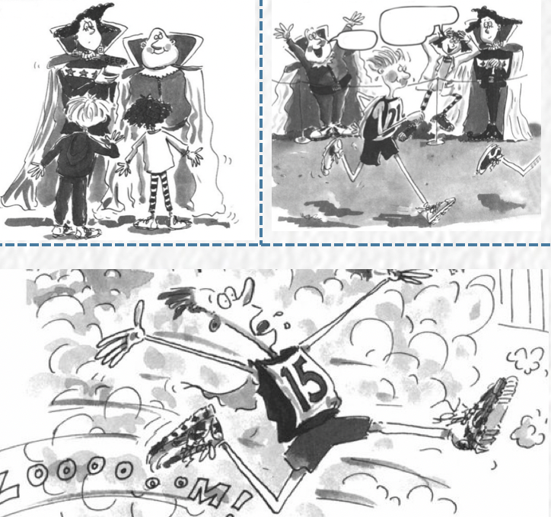

1.Lead in – A video clip of Kindler program from BBC

Before the race: _________________; _______________________________; ___________________________________;

During the race: _________________________________________; __________________________________________;

After the race: ___________________________________________________________________;

2.Read for the structure

Q1. What was the genre of the passage?  A. Narration  B. Exposition  C. Argumentation D. biography

Q2. Content should be contained.

Before the race, we need to describe___________________________________________________________________.

During the race, the description of ____________________; ___________________;_____________ should be included.

After the race, describing _________________________ is a must.

Q3. The passage is organized in ___________________ order/sequence.

3.Read for Setting

|  |  |  |
| --- | --- | --- |
| Setting | When |  |
| Characters |  |
| What |  |

4.Read for the plot : *(how to make advanced sentences step by step with guidance? )*

Before the Big Race

Q1. What did audience do? 他们挑选了最佳的位置观看比赛.They _________________________________________.

Q2. How about their feelings? 空气中弥漫着兴奋的嗡嗡声. ______________________________________(there be句型)

Q3. What were athletes doing?

Athletes were __________________________ ,__________________________and ________________________. (三连动词)

Q4. Where were they? Q5. What were they waiting for?

They were _______________________________________,_________________________________.(doing形式做伴随状语)

Q6. How did Kevin feel? Q7. Why did he felt in that way?

______________________________________, (doing形式做原因状语) he was _____________________________________with______________________________________________(with的伴随状语)

Q8. Did author show the feelings of other athletes in the first part?

________________________________________________________________________________, (doing形式做原因状语),

Jack felt ___________________________________________________________________________________(非谓语结构) =___________________________________________________________________________________________(无灵主语)

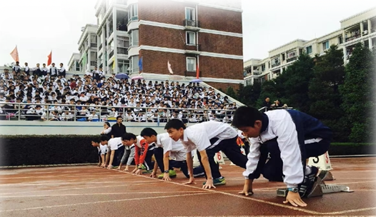

***Physical action***

***Pose***

***Try to make more versions on your own.***

______________________________,(独立主格) Jake and other athletes _______________________on the starting line,  ______________________ and _____________________(三连动词)with ____________________( with的伴随状语)

Q9. Who else? As the owner of the magic trainers, they didn’t take them back in order to ____________________________.

Q10.Why they didn’t take back? _______________________________________________________ (doing形式做原因状语), they __________________________________________________________________________ test in the race. (非谓语结构)

***Words bank for describing “anxiety”***

**be restless**

**be worried sick**

**the worry in his eyes**

**with growing uneasiness**

**Tension took hold of her/ flooded over sb.**

**His heart almost leaped from his body.**

**There was a touch of nervousness ….**

**face whitened**

**glanced at him anxiously**

**throat tight and mouth dry**

**heart beat wildly and legs trembled**

**with butterflies in the stomach**

**palms sweating and hands shaking**

**anxiously backed away**

During the Big Race

***The whistle blew***

Q1. Kevin’s performance? With the help of the magic trainer, Kevin ______________________________________________.

Q2. How about Jack’s performance? _______________as the race was,(倒装句) he _________________________________.

= In spite of/ Despite _____________________________(让步状语), he _________________________________.

=___________________________________________________,(让步状语从句) he _________________________________.

***At first lap***

Q3.How about Jack’s performance? Though his legs __________________________ and _________________,with _____________________,(audience performance) Jake still _____________________________________________________.

Q4. Kevin’s performance? Kevin ___________________________________________________________________________.

***After the third lap first lap***

In the middle of the pack/runners, though ________________and _______________________never letting himself down /giving up.

***Jacks’ Physical act***

***the fourth lap first lap***

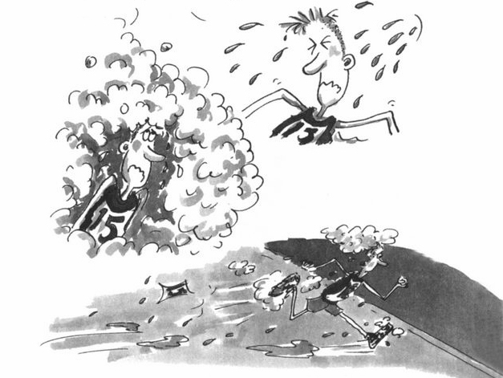

_________________________it was time when he began to _____________but still_____________

Q2.How about feelings of Luther and Mariah?

________________________, (形容词做状语) Luther was ________________________, and ___________________________.

***Came to the last lap***

Q1.How about Jack’s performance? He was ______________________________, but __________________________.(并列句)

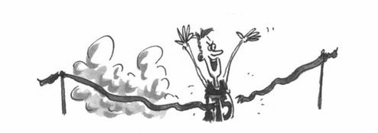

While Jake was dashing towards the finishing line, Kevin_______________,with_________________________. (with复合结构)

= While Jake was dashing towards the finishing line, Kevin_______________, _________________________________.(非谓语)

Q3.How about audience response?____________________________, a pack of admirers ________________________________________________________________________________________________.

Q4. After hearing the cheering, Jake_________________________________.

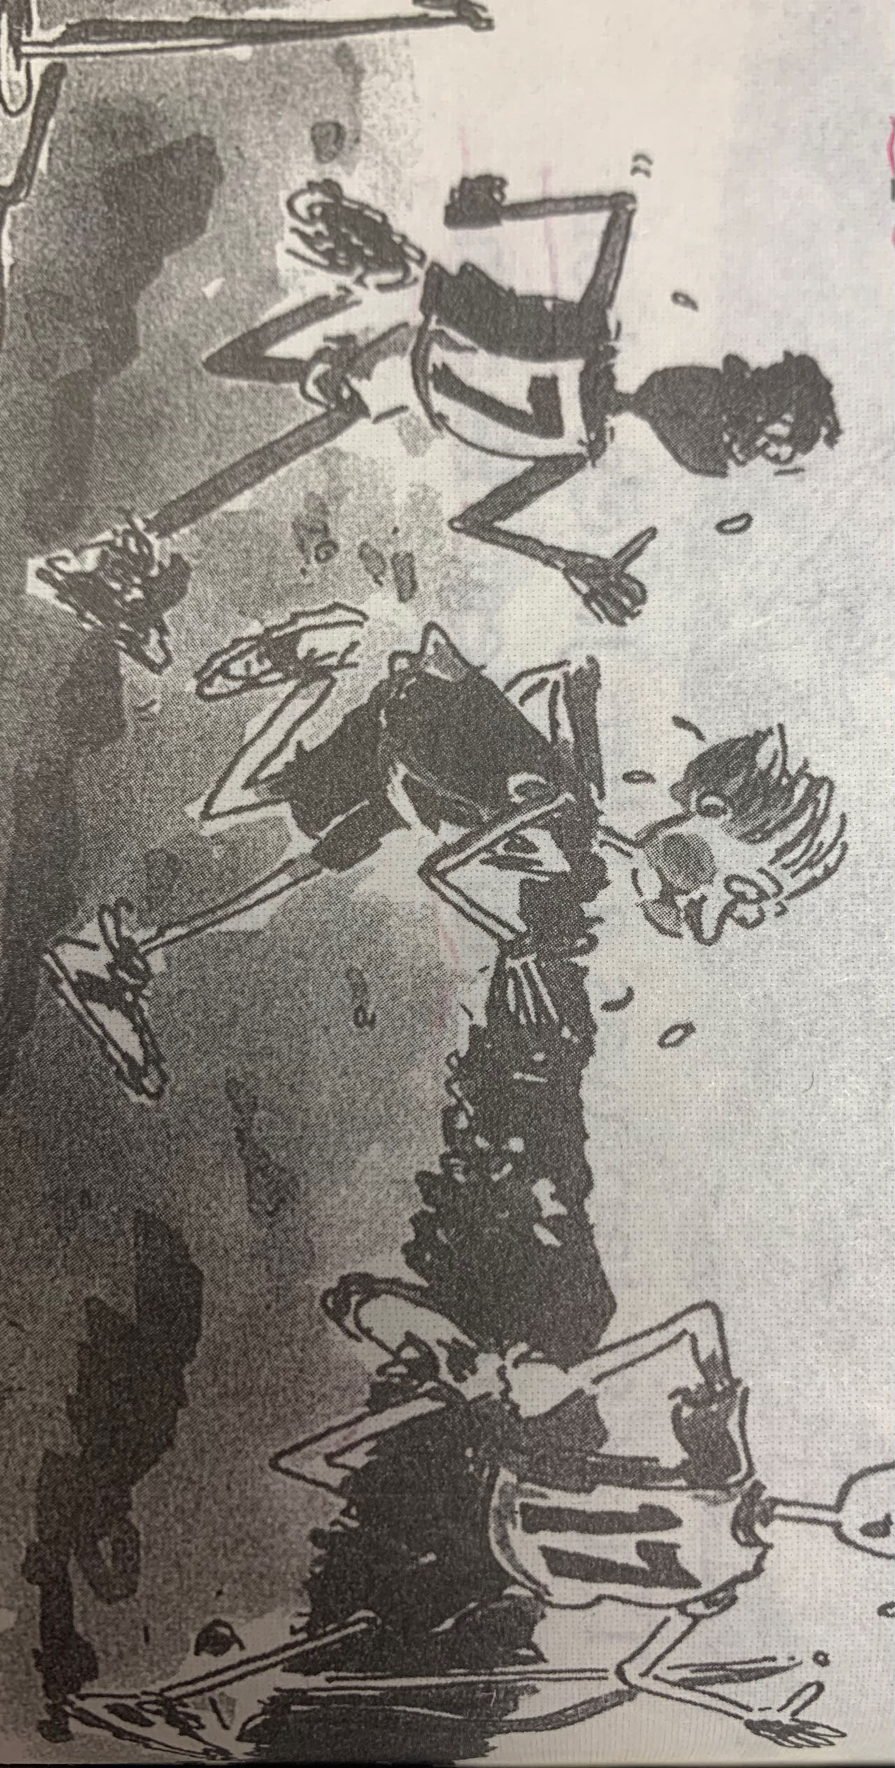

Runners________________________________________ (独立主格) Jake______________________________________,

__________________________________________and___________________________________________. (三连动词)

Afore the Big Race

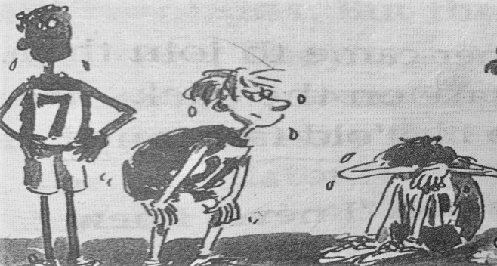

1.Crossing the finishing line, Jake _______________________ ,__________________ and_____________________.

2._________________________as Jake was, (倒装句)he felt nothing else but ___________________ and a sense of_______________________.

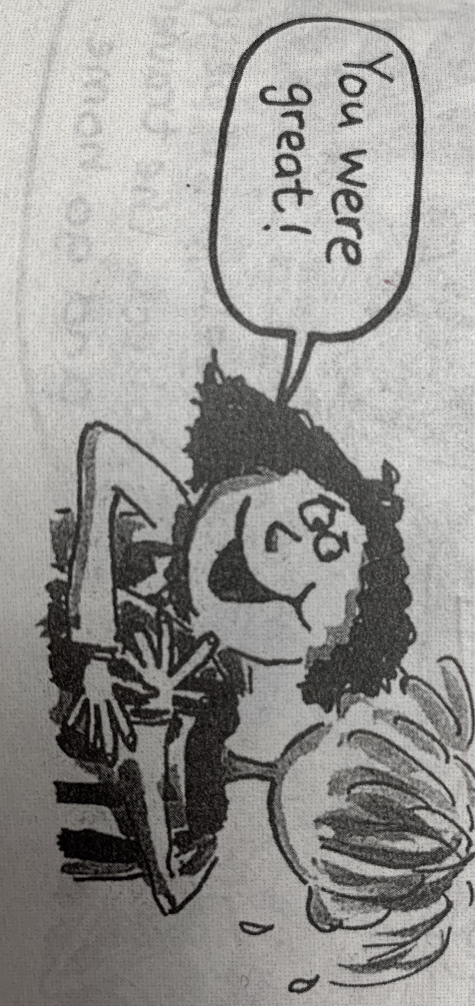

**Deliberate Practice 1 2022年6月普通高等学校招生全国统一考试（新高考Ⅰ卷）**

It was the day of the big cross-country run. Students from seven different primary schools in and around the small town were warming up and walking the route（路线）through thick evergreen forest.

I looked around and finally spotted David, who was standing by himself off to the side by a fence. He was small for ten years old. His usual big toothy smile was absent today. I walked over and asked him why he wasn't with the other children. He hesitated and then said he had decided not to run. What was wrong? He had worked so hard for this event!

I quickly searched the crowd for the school's coach and asked him what had happened. "I was afraid that kids from other schools would laugh at him," he explained uncomfortably. "I gave him the choice to run or not, and let him decide."

I bit back my frustration（懊恼）. I knew the coach meant well — he thought he was doing the right thing. After making sure that David could run if he wanted, I turned to find him coming towards me, his small body rocking from side to side as he swung his feet forward.

David had a brain disease which prevented him from walking or running like other children, but at school his classmates thought of him as a regular kid. He always participated to the best of his ability in whatever they were doing. That was why none of the children thought it unusual that David had decided to join the cross-country team. It just took him longer — that’s all. David had not missed a single practice, and although he always finished his run long after the other children, he did always finish. As a special education teacher at the school, I was familiar with the challenges David faced and was proud of his strong determination.

*Para1.We sat down next to each other, but David wouldn't look at me.*

*Para2.I watched as David moved up to the starting line with the other runners.*

***Para2.I watched as David moved up to the starting line with the other runners.***

______________________________________________________________________________________________________________________________________________________________________________________________________________________________________________________________________________________________________________________________________________________________________________________________________________________________________________________________________________________________________________________________________________________________________________________________________________________________________________________________________________________________________________________________________________________________________________________________________________________________________________________________________________________________________________________________________________________

**Deliberate Practice 2 2023年3月宁波十校高三联盟考读后续写**

“Number 7, Jobie Nymble, takes the lead,” cried the announcer. “Just one more hurdle (跨栏) and—” Cheers erupted. “Jobie Nymble from Riverside Middle School takes first place in the girls’ 100-meter hurdles!” The crowd went wild as Jobie’s teammates screamed and yelled.

Determined to go all the way to County Championships, Jobie patted her worn neon-green track spikes (钉鞋). They were bursting at the seams (接缝处), but she didn’t care. They were her lucky shoes and she loved them. “Next Saturday, we’re taking home the gold,” Jobie whispered to her spikes, excitedly retying them. “Don’t forget, guys,” said one of her teammates cheerfully. “My birthday party is next Friday at Hidden Park.” “Beep. Party recorded in calendar,” joked Jobie in her best robot voice.

Jobie brimmed with excitement all week long. At track practice, she leaped over those hurdles faster than she’d ever leaped before. The day of Marisol’s party, Jobie put on her favorite outfit: her fancy blue shorts, an old track T-shirt from her dad, and her lucky spikes.

The party was in full swing when Jobie arrived at Hidden Park. Music and the smell of grilled food filled the air. Two of Jobie’s teammates rushed toward her, breathless and barefoot, asking her to try the slide. Jobie’s eyes darted toward the party area. Suddenly, she saw it. The BIGGEST inflatable (充气的) slide she had ever seen was on the far side of the park. Smiling kids zoomed down the slide at unspeakable speeds.

Without thinking twice, Jobie took off her spikes and rushed toward the slide. Its ladder stretched to the sky like Jack’s magical beanstalk, but she reached the top in no time. She sat down, slipped to the edge, and closed her eyes as she let go. Jobie couldn’t get enough, conquering the slide over and over again. When it was finally time to go home, she reluctantly made her way back to the track where she’d left her shoes.

*Para 1. As she eyed the area from a distance, panic set in.*

*Para2. The next day, without her lucky spikes, Jobie was among the best track teams gathering for the championships.*

***Para2. The next day, without her lucky spikes, Jobie was among the best track teams gathering for the championships.*** ________________________________________________________________________________________________________________________________________________________________________________________________________________________________________________________________________________________________________________________________________________________________________________________________________________________________________________________________________________________________________________________________________________________________________________________________________________________________________________________________________________________________________________________________________________________________________________________________________________________________________________