## Unit 2 Bridging Cultures

## Welcome, Xie Lei

## Business Student Building Bridges

**Textbook Analysis:**

This reading text shows an exchanged student named XieLei, who went to the UK for a year-long exchange programme. At first, it is difficult for her to adapt to the life in the completely new surroundings, by studying on her own and seeking help from her tutor, she adapted to the life in the UK gradually, both in daily life and academic requirement. In this process, she embraced British culture and actively spread Chinese culture, building a bridge for Chinese-British cultural exchanges.

**Learning objectives:**

## By the end of the class, students will

## 1. get to know Xie Lei’s challenges and solutions in the UK;

## 2. trace the changes of Xie Lei’s feelings;

## 3. introduce the four stages that Xie Lei experienced.

Teaching procedures:

Step1: Lead-in

1. present a diagram of the increase in the number of Chinese students studying abroad from 2002 to 2022.
2. Question: Have you ever wondered what challenges you will encounter when you come to a completely new country ?

Step2: Detailed exploration

Activity 1: Listening

Task: Draw the words or expressions that describe time in the text.

, , , , ,

Conclusion: written in order of

Activity 2: Pay attention to the title,subtitle, picture, and the last para

Where do you think the text is from?

1. a science magazine B. a school newspaper
2. A travel journal D. an advertisement brochure

answer:

Activity 3: para1--2: Honeymoon stage 留学蜜月期

Find the following elements：

when:

who:

what:

how:

Conclusion: an experience

Q: Is it easy for XieLei to adapt to the lives in the UK?

Activity4: para 3 and para 5: Discomfort stage 留学不适期

Activity5: para 4 and para 6: Recovery stage 留学恢复期

to be an a learner

P15 exercise 4

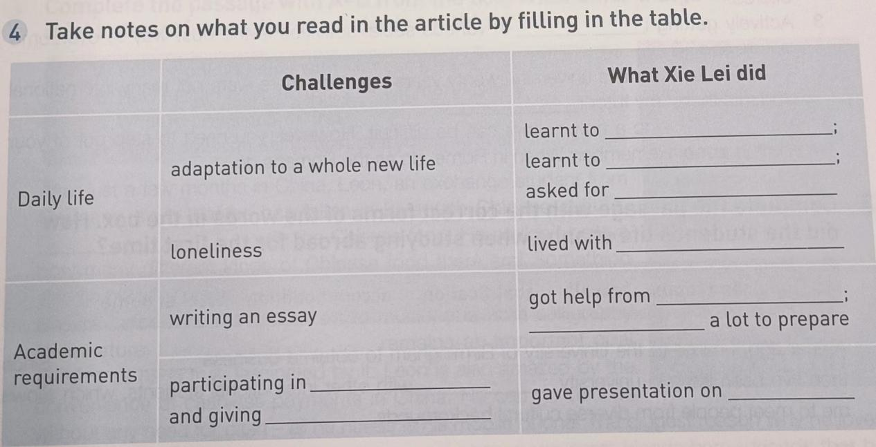

Critical thinking, logical thinking

Success factors:

external factors:

1.

2.

internal factors:

Para2: “My ambition is to set up a business in China after graduation” she explained.

Para3: At first, XieLei had to adapt to life in a different country. “You have to get used to a whole new life,” she said.

Para3: “ I had to learn how to use public transport and ......,I ask them to repeat themselves a lot!”

Para4: We take turns to cook each evening. They really love my stir-fried tomatoes and eggs!

Para6: What surprised her was that she found herself speaking up in class after just a few weeks.

Para6: “My presentation on traditional Chinese art was a great success, which boosted my confidence,” she said.

Para7: “As well as studying hard, I’ve been involved in social activities.

Question: which is more important? external factors or internal factors?

Activity6: para7: Adaptation stage 留学适应期

Step4: Scan and circle the words to trace the changes of Xie Lei’s feelings.

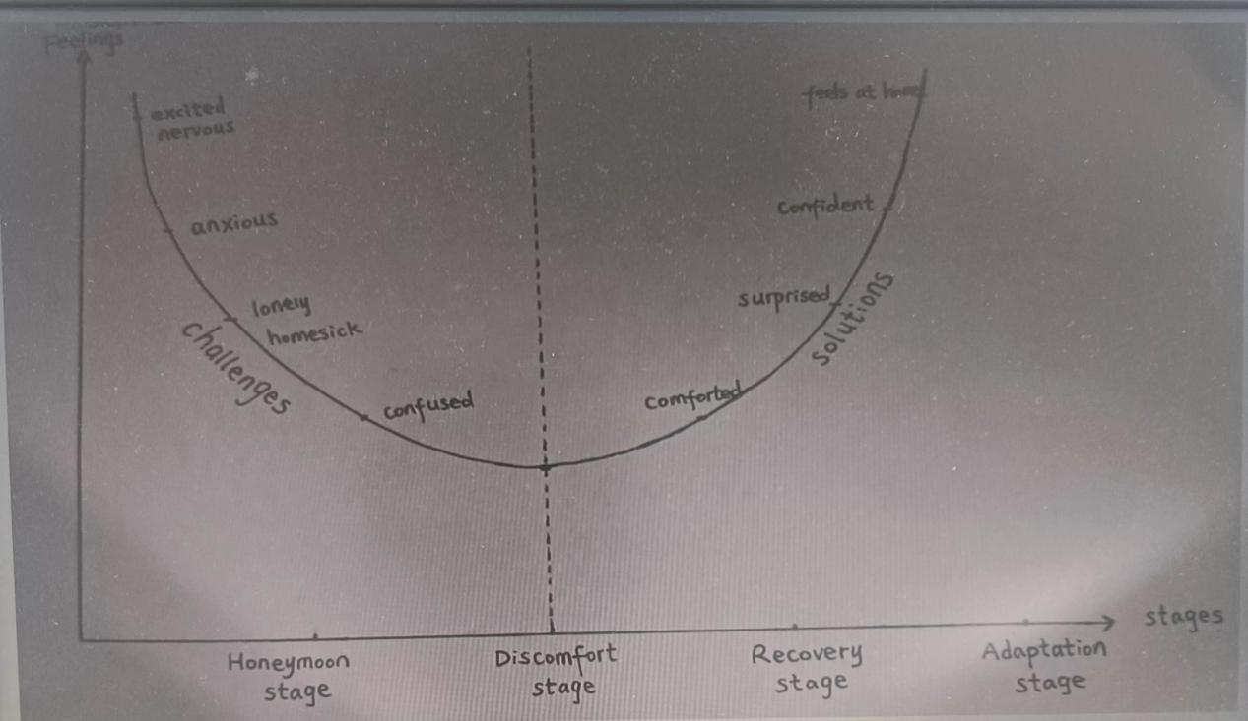

Question: why did XieLei experience discomfort stage?

Step5: Title

What bridges?

Step6: deep thinking

XieLei experienced the four stages of studying abroad. When you go from middle school to senior school, do you have similiar experiences?Please make a dialogue with your partner based on the four stages ,you can refer to the expressions in BOOK 1 Welcome unit.

Step7: conclusion

Step8: Homework