**B1U4 Listening & Speaking 教学设计 by 尚洁**

**Teaching Aims：**

By the end of this lesson, students will be able to

1. **Listen to get main ideas and detailed information** from natural disasters news reports *(Learning&Understanding)*
2. **Summarize key factors and features** of news reports and **imitate** reporters to present reports *(Applying & Practicing)*
3. **Work in groups to report different natural disasters** *(Transfer & Innovation)*

**Teaching Procedures:**

**Step1: Warming up（Opening Page）**

Show the picture on P47 to the class, and ask

**Q1: What’s going on in this photo?**

**Q2: What kind of natural disasters can you think of?**

（分小组讨论，选取多个小组代表进行回答问题1。同时引导学生回答出rescue/ survivor/ ruins/collapsed等关键词，在此情境中引导学生学习自然灾害相关的生词，为之后的听力扫清词汇障碍；借助问题2过渡到下一个环节，学习各种“自然灾害”的英语表达）

**Step2: Pre Listening**

**Activity1: Vocabulary Learning**

Q1: Look & Give the name o the natural disasters

Show pictures of different natural disasters to students and ask them to answer together.

Q2: To give more details about natural disasters to the public, we do we need?

Elicit “News reports” from the class. Then show a video clip to students:

*Watch & Think: How to report natural disasters?*

**Activity2: Fill in the KWL form**

Q: How to **report** natural disasters? Discuss in pairs & Fill in the KWL form

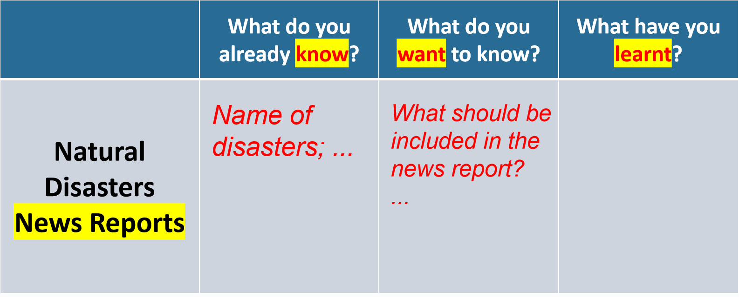

（活动1借助图片激活学生词汇学习，初步了解自然灾害的英文名称。之后展示真实的新闻报道视频，让学生初步感知“新闻报道”。活动2延续观看视频前提出的问题：如何报道自然灾害？自行填写KWL表格第一栏，回忆有关“报道自然灾害”的背景知识。同桌互相讨论，填写KWL表格第二栏，思考如何用英语进行自然灾害报道，明确个人学习目标。）

**Step3: While Listening**

**Activity1: Listen for gist**

Set up P48 Ex2: Listen to the news report and tick the disasters that you hear

Elicit answers from the class.

Then ask the question:

What important **factors** are included in these reports?

**Activity2: Listen for details**

Listen again and fill in the form.

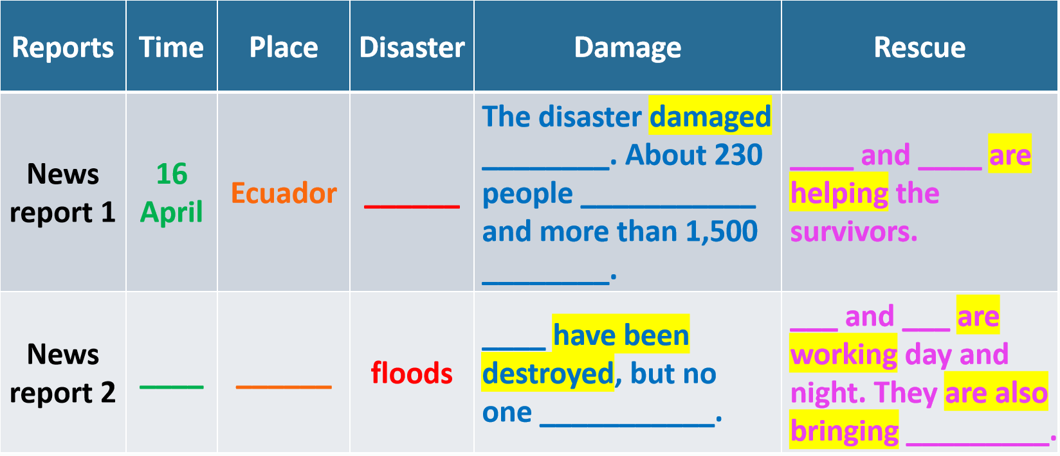

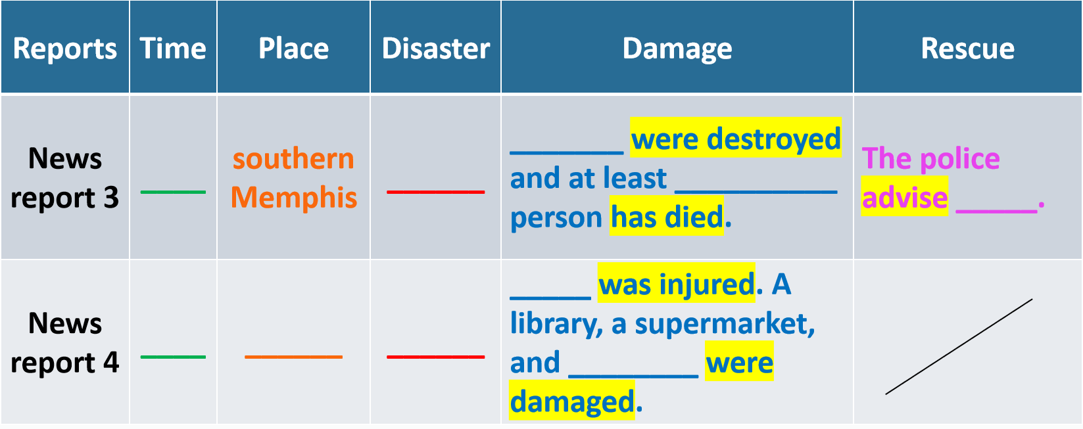

（听第一遍，明确各报道涉及的具体灾害名称，同时提出问题，引导学生总结出自然灾害新闻报道中涉及的重要因素：time/place/disaster/damage/rescue;

听第二遍前，提示学生关注新闻报道中的时态；听第二遍，获取报道中的细节信息）

**Step4: Post Reading**

**Activity1: Read like news reporters**

Ask students to work in groups to discuss detailed information in each report. Ask each group read the news report based on their answers respectively. Students should read like real news reporters.

**Brief Summary:** How to **report** natural disasters?

Ask students to work in groups and find out key features of natural disasters news reports. Remind them to think from “Content”, “Tense” and “Other features”. Elicit from the class.

**Activity2: Report natural disasters**

Set up Ex 4 on P49. Ask students to work in groups to prepare a short news report based on what they have learnt in this lesson. Display the marking criteria in advance.

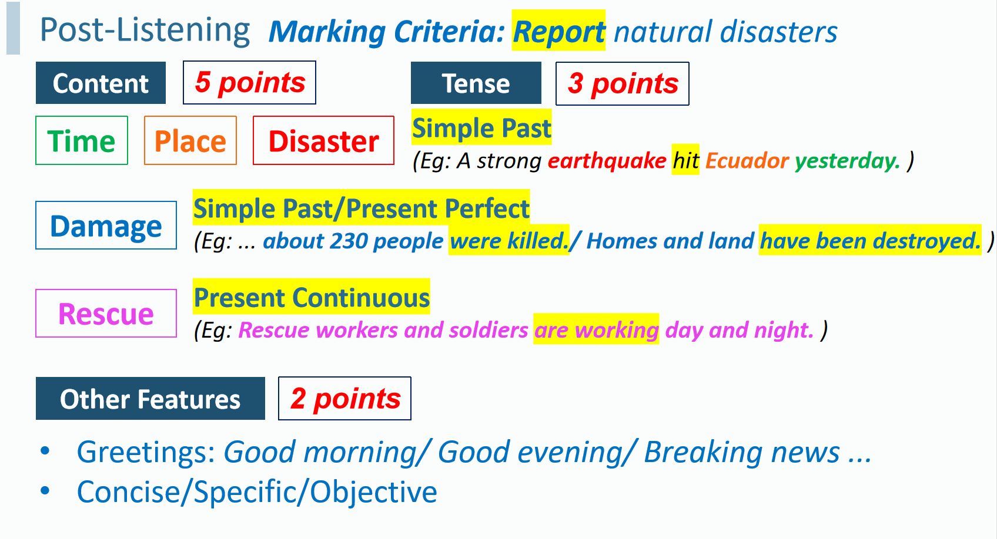Then ask group members to report natural disasters respectively and give marks based on the criteria.

（活动1：学生以小组为单位核对答案，提升学生参与度；各小组模仿听力播报新闻，提示学生关注新闻中的时态、常用语言表达、语音语调、语速等；核对答案之后，根据听力材料进行小结，总结出自然灾害新闻报道的内容、时态等特征，为之后的独立播报新闻作铺垫。

活动2：学生以小组为单位，选取某一个具体的自然灾害信息，结合听力所学，整理完成新的新闻报道。教师应提前给出评分标准，提示学生根据评分标准进行准备；小组展示时邀请其他同学根据评分标准给出即时评分。）

**Step5: Homework & Summary**

**Homework:**

* Work in pairs & finish the KWL form
* Read the article from China Daily & Make a short news report

*Typhoon damages crops in Guangdong https://www.chinadaily.com.cn/a/202207/04/WS62c2aa16a310fd2b29e6a443.html*

**Summary：**

Live to Tell:

Raising Awareness, Reducing Mortality.

---- United Nations International Strategy for Disaster Reduction (2016)

（作业：1.完成KWL最后一栏表格，自我检测本课学习效果；2.补充阅读一篇：*Typhoon damages crops in Guangdong*，让学生根据长篇报道提炼关键信息，整理完成一篇短篇口头新闻播报，以实现对本节课所学知识的迁移创新。

小结：以opening page中的引言作为结语，呼吁学生们应重视对自然灾害的学习与了解，而新闻正是了解自然灾害的渠道之一。同时提醒学生们应做好应对自然灾害的准备，为之后listening&talking版块的学习做铺垫。）