Book3 Unit4 Space exploration

Reading and thinking

1. 教材分析：

该板块活动主题是“了解太空探索的发展历程”。主要让学生阅读语篇的基础上，了解人类探索太空的发展历程，帮助学生了解人类在太空探索方面做出的努力和牺牲，也旨在渗透我国科学家在近些年太空探索领域作出的卓越成就，从而探究科学家们的精神品质，坚定文化自信，增强爱国情怀，引导学生树立远大志向。

1. 教学思路和设计理念：

综合视野下的阅读教学以文本解读为起点，以目标定位为标杆，以教学设计为依托，以阅读体验为载体，以语言学习为根本，以综合学习为视野。基于这个理念，本次课的教学思路是：围绕太空探索这一话题，立足于历史发展线索，了解历史事实，探究人物品质，树立人物精神，坚定远大理想。

1. 教学目标：

1. To enable the students to summarize the main idea of each paragraph.

2. To guide the students to be aware of qualities of scientists and astronauts in space exploration.

3. To help the students raise the awareness of determination and persistence in order to achieve their life goal.

1. 教学过程：

Lead in: video (We are explorers)

T: Looking up at the stars, what are you thinking about? (show a picture )

The vast space is waiting for humans’ exploration.

Q：How can we go to space?

Ss: By space vehicles.

Q: Can you list some space vehicles you know?

S: Satellites; spacecraft…

Q: Some spacecraft can carry people to space, what are they called?

S: Manned spacecraft.

T: The brave people such as Yang Liwei have been carried to space in the spacecraft, they are…

S: Astronauts.

Q: How can the spacecraft be sent or launched to space?

S: By rocket.

T: After they are launched into space, along what will they move?

S: orbit.

T: Around what will they orbit?

S: The earth.

With the help of _____________, such as _______, __________, mankind is exploring space. Some spacecraft are _________, which have carried _________ into space. They will be ________ by rockets, after which they will ________around the earth along the _________.

设计意图：本文以space exploration作为导入，实现启动学生的已有认知,激发学生话题兴趣。导入的问题利用学生已知，引出文本关键词汇，并及时加以操练，做到温故知新，帮助学生更快更好地进入后续文本阅读。

Reading

Q: Read the passage for the type of it. ----it is a popular science article.

Para 1: curiosity

Q: What is the attitude of people to space?

S: be curious about…

curiosity

Q: What does the curiosity lead to?

S: Scientists make vehicles to carry brave people into space.

Q: What else? (fill in the gap)

S: they also…

Inspiration：

It is the curiosity about space that …

Para 2: achievements

Q: What is the first step for scientists to explore space?

S: escaping the gravity.

Q: After escaping the gravity, there was a competition between two countries.

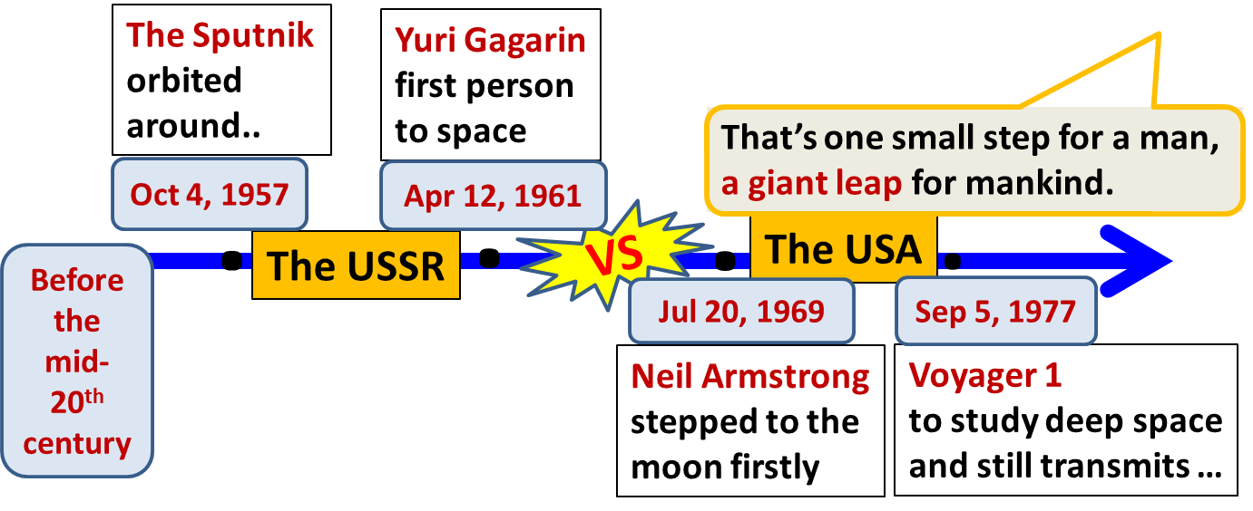

Q: What turned the impossible dream into a reality?

S: determination, efforts from scientists…

Para 3: desire

T: Space exploration is not an easy job, what happened later was tragic.

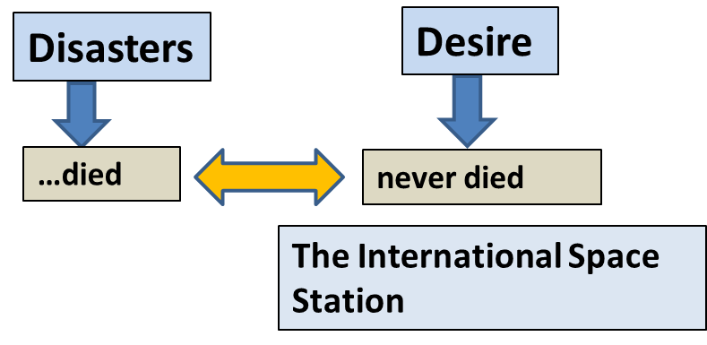

Inspiration:

Despite the …, humans’ …for space exploration never died. For example, …. Thus, greater achievements are made.

Para 4: China’s progress

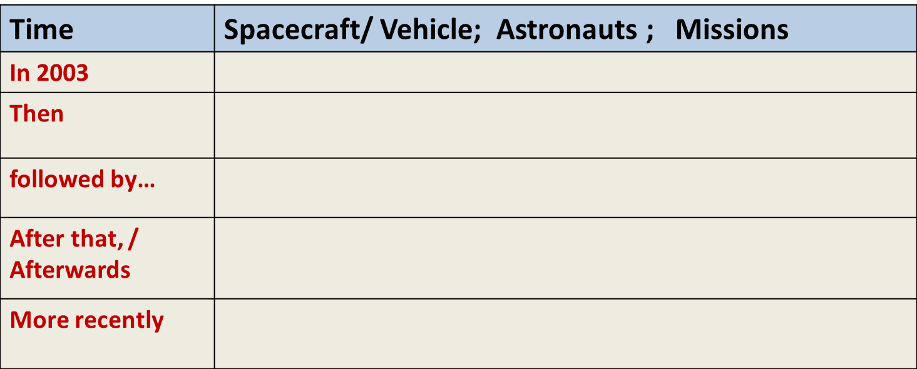

Q: What contributed to the remarkable achievements?

S: support from government; great efforts; experience; persistence…

Para 5: future

Q: What is the future of space exploration?

S: It remains bright.

Q: What are the scientists’ hope? and your hope?

设计意图：引导学生理解文本，解读文本，提升学生阅读素养。

Critical thinking:

Title: Space: the final frontier

Q: Is space the “final” frontier?

What other frontiers will be explored?

(underground; the deep sea; the Arctic; new life forms; new civilizations)

Frontier is limited, while _____________ is limitless;

Books are limited, while _____________ is limitless;

_______ is limited, while ____________ is limitless;

…

Q: As a student in Senior Two, what are you eager to explore?

What qualities can help us to explore the limitless with the limited?

设计意图：本环节在理解文本结构和内容基础上，解读文本标题，并提升文本内涵，太空不一定是人类最后的探索边疆，引导学生与自身实际相结合，树立远大的目标，采取切实的行动，去积极探索更多未知领域。

Assignment:

Write down your detailed plans of your limitless exploration.

The following should be included: you ambition; qualities needed; actions to take.

设计意图：在课堂学习和操练的基础上，利用读写结合，将所学、所思、所想“落地”，写成文本，操练语言，提升思维品质。