选择性必修二 Unit 5 Using language 2

Share your story about providing first aid 教学设计

1. **文本分析**

该板块的活动主题是“分享你实施急救的故事”(share your story about providing first aid)。该阅读语篇讲述了一名叫Chen Wei的高中生运用海姆利希式急救法救人的事迹。文章不仅叙述了Chen Wei救助窒息病人的过程，还介绍了海姆利希式急救法的历史和操作方法。该语篇结构清晰，第一部分叙述Chen Wei救人的过程，第二部分介绍海姆利希式急救法的历史和操作要领，第三部分评价Chen Wei救人的事迹。其中第一部分和第三部分是记叙文的典型写法。而文章的第二部分更接近说明文的写法，在叙述海姆利希式急救法的操作方法时使用了不少祈使句，简洁明了地说明步骤和要领，便于读者理解操作，减少失误概率。

1. **学习目标**

通过本堂课的学习，学生能够：

1.在理解文章内容的基础上分析语篇结构，把握记叙文的写作特点，体会段落之间的衔接与过渡。

2.掌握海姆利希式急救法的操作步骤，了解其历史以及注意事项。

3.探究文章的主题意义，学习Chen Wei的精神品质。

4.按照记叙文的要求，仿照阅读语篇写自己的急救故事。

1. **教学过程**

**Activity 1: Watch the video**

Q：What is young Sheldon suffering?

How does he feel?

If your friend is choking on something, what would you do?

What do you want to know about the Heimlich manoeuvre?

设计意图：

通过视频导入急救这一话题，引起学生兴趣。同时鼓励学生提出一些关于海姆利希式急救法的问题。

**Activity 2: Read and complete**

Read the article and then put A--E in the correct places in the text. And state your reasons.

Q：What functions do these first sentences in the article serve? Make a choice.

设计意图：

阅读全文并匹配正确选项，关注语篇衔接词，体会段落之间的衔接与过渡，发展学习策略。

**Activity 3: Read for the structure**

Read the passage, divide it into three parts and summarize the main ideas.

Part 1(Para.1-Para2): the story of a choking incident

Part 2(Para.3-Para5): the introduction of the Heimlich manoeuvre

Part 3(Para.6): comments on the choking incident

设计意图：

通过分段和概括大意，厘清文本结构。在理解文章内容的基础上分析语篇结构，为下文分析文本细节做好铺垫。

**Activity 4: Read for details**

(1) Read part 1 and finish the mind-map in a group of four.

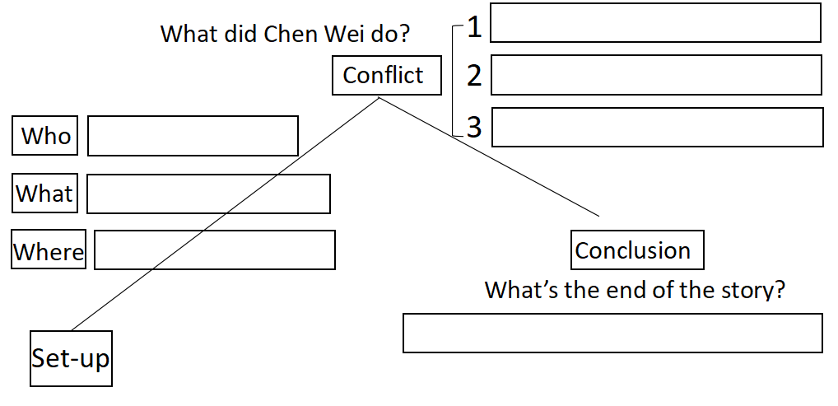

1. Read part 2 and number the following steps in the correct order.

______ Make a fist with one hand

______ Stand behind him

______ Place the fist in the upper part of his stomach

______ Push up and into his stomach in one motion

______ Grab your fist with the other hand tightly

______ Wrap your arms around his waist

Answer the questions raised in the beginning of the class.

1. Read part 2 and answer the question.

Q: What purpose does the quote serve?

设计意图：

一方面厘清故事的结构，把握记叙文的写作特点，为下文写作做好框架上的铺垫。另一方面，通过请学生合作演示海姆利希式急救法的具体步骤，加深印象，帮助学生掌握急救知识，了解海姆利希式急救法历史以及注意事项。

**Activity 5: Read for language**

Q: How can we describe an urgent situation vividly?

设计意图：

学习原文的语言特征，为写作搭建语言框架。

**Activity 6: Writing**

1. Brainstorm useful expressions for first aid for burns by hot water.

假设你和你班同学Mike正在教室做作业，突然Mike的杯子摔倒在地上，开水烫伤了他的脚，于是你对此实施了必要的急救。

Characteristics of burns: __________________________________________________________

Descriptions of feelings

To show one’s pain: ______________________________________________________________

To show one’s worries: ___________________________________________________________

First aid treatment for burns: ① ____________________________________________________

② ____________________________________________________

③ ____________________________________________________

1. Write a narrative essay.

假如你是李华，给校英文报专栏投稿，记述上周你对班级同学Mike实施烫伤急救的经历，并简单谈谈你的感受。

注意：1.词数80字左右（开头已给出，不计入总词数）；

2. 合理增加细节，使行文连贯；

Accidents always happen suddenly. The other day, Mike had his glass knocked over, thus spilling the hot water on his right leg.

Immediately, I arose from my seat and ran to his table at once.________________________ _______________________________________________________________________________

_________________________________________________________________________________________________________________________________________________________________________________________________________________________________________________________________________________________________________________________________________________________________________________________________________________________________________________________________________________________________________________________________________________________________________

_______________________________________________________________________________

_______________________________________________________________________________

设计意图：

按照记叙文的要求，仿照阅读语篇写自己的急救故事。

**Homework**

完成写作任务。

1. **教学反思**

一节课的时间比较紧张，学生很难在课堂上完成写作任务，输出语篇。可以考虑第二节课再加以补充，同时分享学生的习作。