衢州高中高三英语衢丽湖联考试卷二次开发（2025.4.10）
出题人：李小珍 审核：高三英语备课组
一、词汇积累

overlook ______________
trail __________
壮观的 _____________
slippery ____________
许可证 ______________
disoriented _____________
因…而闻名 ______________
票房大片_____________
intense succuss _____________

inclination ____________
script ________
autobiography ________
传播；循环 ____________
domestic animals _____________
爆发 ___________
imprecise ______________
关键步骤 _________________
限制 _______________
获得资金 _________________
carry through ______________
flawless performance _______________

二、词汇运用
1. Leave a trip plan with a friend _____________________. 提前给你的朋友留下旅行计划。
2. She also expresses her sadness about the ___________________(隐私的丧失) during her teenage years.
3. Premature fame is not ______________(necessary) a good thing. 过早出名未必是一件好事。
4. Vets are on the _______________ (在前线) of the outbreak.
5. _____________ and crowded areas make it easier to lose objects.
6. Everyone misplaces things _________________________(偶尔).
7. Most of the team members __________(专攻) drone technology, while others are enthusiasts ___________(招募) by the company.

三、句子翻译
1. Park visitors interested in sightseeing or recreating in the Controlled Recreation Area managed by Mt Seymour must purchase a pass.
________________________________________________________________________________________
________________________________________________________________________________________

2. Seema Lakdawala, a virologist at Emory University in Atlanta, who was not involved in the research, said she was surprised that only 2% of the vets surveyed tested positive for the antibodies, considering another CDC study showed that 17% of dairy workers sampled had been infected.
________________________________________________________________________________________
________________________________________________________________________________________
________________________________________________________________________________________

3. OpenAI, the company behind the artificial intelligence tool ChatGPT, has set out restructuring plans to make it easier for it to raise money and remove restrictions made by its non-profit parent (母公司).
________________________________________________________________________________________________________________________________________________________________________________

应用文
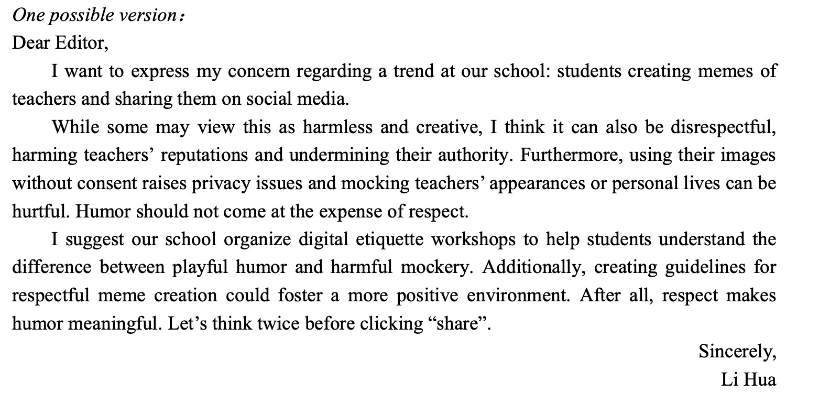

读后续写
