**2025届高考备考冲刺：读后续写极简构思**

**以2025年温州市普通高中高三第二次适应性考试读后续写为例**

**一、语篇分析**

本文主题为人与社会，主要涉及家人亲情层面。

主人公“我”因自己强壮的身材自小被赋予看照顾瘦弱哥哥Brian的责任。在一次南瓜雕刻比赛中，两人合作的作品并未如愿获得一等奖，但为了实现自己购买游戏的私心，“我”偷拿了全部奖金，并隐瞒了获得二等奖的事实。多年后，在帮哥哥整理行李时，“我”偶然翻到了一本相册及里面的照片……

**二、存在的问题**

1. 主题定位不准确
2. 情节过渡、衔接不自然
3. 人物设置、人物心理刻画不到位
4. 大篇幅对话

**三、续写备考的小技巧**

**1. “思维可视化”阅读工具**

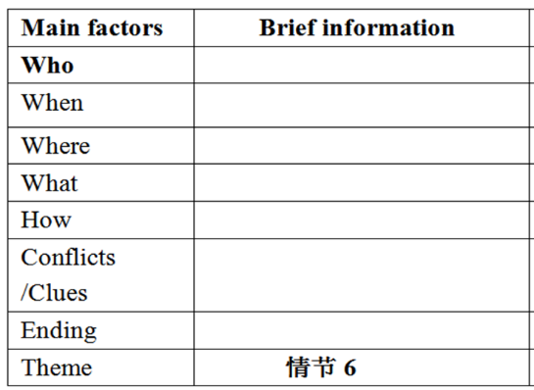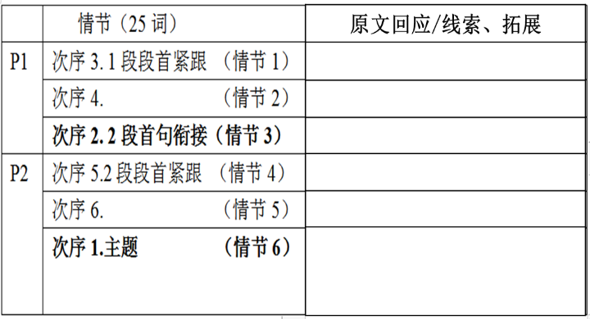

**2. 与原文交互、就地取材**

原文中常含有很多的线索或暗示，学生可在细读文本时，锁定线索、明确可回应点，就地取材，使自己所写的文章与原文在内容和语言上实现协同一致。

* **本文可回应的细节：**
* “I’d always been told to take care of my older brother, Brian, who was born weak and small.” … “saw my larger size and strong body as a sign that I was to be a kind of guardian angel for Brian.” “However, that was not the case.”
* “Unexpectedly, he asked for a cut.”
* “…I came across an old album filled with photos he had taken as the school photographer.”

**四、场景拓展：丰内容美语言**

读后续写的最后一步是根据梳理的情节脉络，拓写内容、丰富语言表达。

1. **常见语言结构（三元素法）**

前缀+主句+后缀

1. **优秀句式表达**

1）非谓语结构、with结构、独立主格结构

2）倒装、强调、虚拟语气、无灵主语

3）动作链、真实对话

1. **常见描写方式**

1）动作描写

2）心理描写（想法、回忆）

3）表情外貌描写（情感、情绪）

**4. 原文就地取材**

1）内容类：

* I was to be a kind of guardian angel 🡪 ________ can be my guardian angel?
* afraid to look into his eyes 🡪 look into his eyes with _______?
* Brian was weak and small 🡪 Brain was ____?

2）语言类：

* When…, it dawned on me that….
* If he really wanted to win, he would have been here today, I thought to myself, justifying stealing the cash from under poor Brian’s runny nose.

**5. 分步骤练习**

**Step1 要素抓取：锁定文本大意**

|  |  |
| --- | --- |
| **Who** |  |
| **When/ Where** |  |
| **What** |  |
| **How** |  |

**Step2 脉络梳理：确定主题升华**

|  |  |
| --- | --- |
| **Theme** |  |
| **Conflict** |  |
| **Ending** |  |

**Step3 情节构思：连贯文本主线**

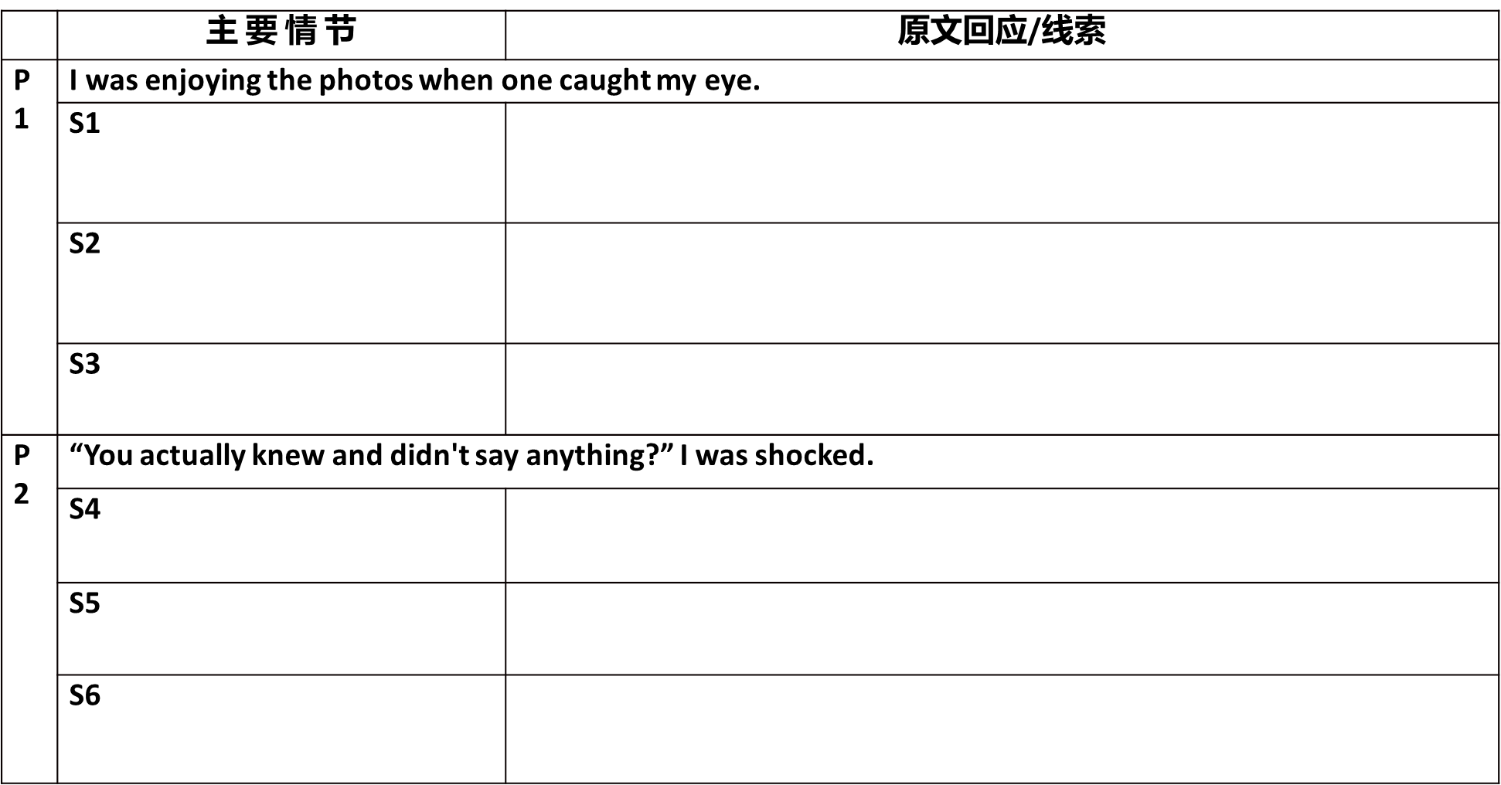

**Step4 场景拓展：丰内容美语言**

***Paragraph 1: I was enjoying the photos when one caught my eye.***

**S1 Describe the photo + feelings (所见所感结合写)**

A1.在照片中，我站在舞台上，手里拿着(紧紧攥着)奖品信封，我们雕刻的南瓜(骄傲地摆)在身旁，校长面带微笑。（倒装句+独立主后缀）

_______________________________________________________________________________

_______________________________________________________________________________

A2.我皱着眉头，把照片翻了过来，在那儿，整齐地印着 “照片由Brian，官方摄影师拍摄”。

_______________________________________________________________________________

**S2 My feelings （感受）**

A3. a) 盯着这张照片，我的心狂跳不止，手指紧张地颤抖，呼吸在喉咙处猛地一滞。（前缀+主句+后缀）他是不是一直都知道，却只是选择了沉默？

_______________________________________________________________________________

_______________________________________________________________________________

A3. b)我刚看了一眼，一股难以置信和羞愧的情绪/震惊和愧疚(以排山倒海之势)就将我淹没了/在我心中涌起/涌上心头（一..就）

_______________________________________________________________________________

_______________________________________________________________________________

A4. a) 要不是这张照片，我还会一直以为我的秘密被妥善地掩埋着。但真相就摆在那里，用Brian那清晰可辨的字迹回望着我。（虚拟）

_______________________________________________________________________________

_______________________________________________________________________________

A4. b) 要不是这张照片，我还会一直误以为Brian当时不在场。但其实他一直都在，捕捉着每一个我以为他错过的瞬间。（虚拟）

_______________________________________________________________________________

_______________________________________________________________________________

A4. c) 不是因为感冒在家，也没有错过那个时刻，而是他就在现场，捕捉着每一个我曾发誓他没看到的瞬间。（陈述）

_______________________________________________________________________________

_______________________________________________________________________________

**S3 (衔接) confronting Brian I couldn’t help asking Brian about the photo.**

A5. a) 我的手颤抖着，转过身面向他，声音几乎低得像耳语。

_______________________________________________________________________________

A5. b) 我转向他时，双手颤抖，声音几乎无法保持平稳。

_______________________________________________________________________________

* **(s2,s3中间可增加环境描写对比）**

阳光透过布满灰尘的窗户洒进来，照亮了这张照片，仿佛在嘲讽我的无知。

_______________________________________________________________________________

***Para.2 “You actually knew and didn't say anything?” I was shocked.***

**S4. Brian’s explanation Brian took over the photo and explained to me.**

B1. a) Brian只是对我笑了笑，点了点头，“因为这从来不是钱的问题。我要一半只是为了证明我能像你一样有用。更重要的是，我们一起创造了美好的东西，这就足够了。”他的声音很低，但每一个字都像锤子一样敲打着我。

_______________________________________________________________________________

_______________________________________________________________________________

B1. b) Brian看着我，唇角泛起一丝淡淡的微笑。“我看得出你有多渴望那场比赛，” 他轻声说道。“我不能把它从你身边夺走”。他的话久久回荡在我耳畔。

_______________________________________________________________________________

_______________________________________________________________________________

B1. c) Brian站在他的行李箱旁（照应pack），午后的阳光在他脸上投下柔和的阴影，他的眼中满是戏谑而非责备。他轻声笑了笑，轻轻合上相册，然后说道：“你向来都不是个很会说谎的人，知道吗。”

_______________________________________________________________________________

_______________________________________________________________________________

**S5 My feelings Guilt and regret gave way to deep relief and appreciation.**

B2. a) 我的心仿佛被一只看不见的手紧紧地攥着。我从没想过Brian其实需要我的支持和肯定。曾经吞噬我的贪婪现在看起来如此荒谬——真正重要的是我的哥哥，那个一直爱我、容忍我的人。

_______________________________________________________________________________

_______________________________________________________________________________

B2. b) 在那一刻，我突然明白，这些年来我一直被愧疚所累，而Brian早已选择让它淡去。多年来，我一直认为自己是他的守护者，但实际上是Brian，他默默地扛起了我秘密的重担，用我不配得到的宽容保护着我。

_______________________________________________________________________________

_______________________________________________________________________________

B3. 要是我早点看出他的慷慨大度/告诉他事实就好了！之前的愧疚感渐渐消散，取而代之的是深深的感激，钦佩和理解。

_______________________________________________________________________________

_______________________________________________________________________________

**S6 Brian’s love relieved my guilt 学习续写故事结尾+主旨提炼**

* **主旨提炼1 ：兄弟情的真正意义在于互相理解、照顾与宽容**

B4. a) 这些年来，我一直以为自己是那个扮演保护者角色的人。我压根没想到，那个曾经被我认为弱小的Brian，一直在默默地守护着我。

_______________________________________________________________________________

_______________________________________________________________________________

B4. b) 这段经历在我的生命中留下了不可磨灭的印记，让我懂得兄弟情与个子大小，力量强弱无关，而关乎互相理解、照顾与宽容。

_______________________________________________________________________________

_______________________________________________________________________________

* **主旨提炼2：自然点题**

B5. a) 倘若未曾发现这张照片，我永远不会意识到看似柔弱的Brian，用他的方式默默地守护着我，成为我真正的守护者。自那以后，我们兄弟俩分享秘密，互相守护，彼此越来越合拍（默契）了（grow in tune with each other)。

_______________________________________________________________________________

_______________________________________________________________________________

B5. b)我深吸一口气，凝视着他的眼睛(与前文不敢直视呼应)，终于鼓起勇气说：“对不起，Brian。我欠你一个第一名。对我来说，你永远是最好的哥哥。”

_______________________________________________________________________________

_______________________________________________________________________________

* **主旨提炼3：画面定格**

B6. a) 我一言不发，把相册放到一边，走上前去，紧紧地拥抱了他，发誓从今往后要做一个更好的兄弟。

_______________________________________________________________________________

B6. b) 我凝视着他，渐弱的阳光在他苍白的脸上洒下柔和的光，让他看起来更小了，却又不知为何，显得更强大了。

_______________________________________________________________________________