**BBC Trending**

**Why would anyone take the A4 skinny waist challenge?**

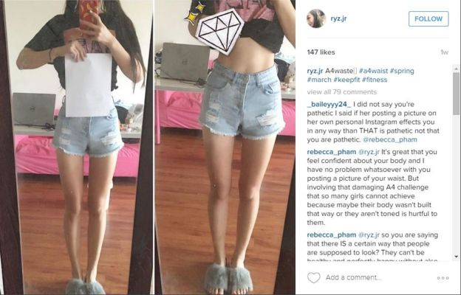

The #A4waist challenge# - in which women compare the size of their waists to the width of a standard A4 sheet of paper - started in China and prompted a huge online **backlash(强烈反对)**. But what do some of the women who participated in the trend say - why did they take part?

It's been criticized as irresponsible and potentially unhealthy. The latest craze from China involves mostly women holding up sheets of paper and taking selfies(自拍) - they "win" if the paper entirely covers their waist. It's called the "A4 challenge" after the standard paper size that's just 21cm across.

Critics say the challenge, like other similar trends before it, could promote eating disorders and body shaming.

So why would a healthy person take part?

Azura Ge is a Chinese student in Boston. She told BBC Trending that she was proud to show off the progress she had made in the gym.

Another Chinese student told BBC Trending that she posted a challenge picture in order to show off her recent weight loss.

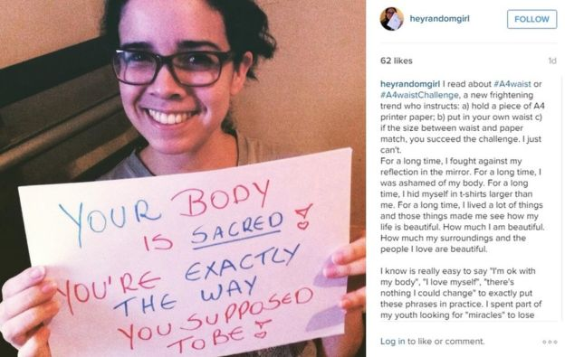

But others **took issue with(向…提出异议)** the challenge. Angela Hui is a writer in London. She was born in Wales to Chinese parents and she talked to BBC Trending radio about the pressures she faced to be thin growing up in an Asian family.

"I was brought up with tough love. Asian families just aren't afraid to tell you what they're thinking. You have that fear of **being ridiculed(嘲笑，奚落)** and you grow up with a really prejudiced(有偏见的) body image," she says.

"Especially at Chinese New Year, when a lot of families get together, before they say anything they judge you, they're **poking(戳)** you saying 'you've put on weight' or 'you need to eat less.' I'm not confident, I've jumped on many quick-fix diets. That's not healthy."

And Hui was certainly not a lone voice online, as many posted images mocking(嘲笑) or criticizing the challenge.

Weibo has started a number of challenges linked to body mass, including the "belly button challenge" - which saw people trying to reach around their back to touch their belly button - and the "collarbone challenge", which saw women compete to balance rows of coins on their collarbones.

*Blog by Emma Wilson*

*Additional reporting by Kerry Allen, BBC Monitoring*

**补充练习：**

**1.Opinions from both sides:**

(1) Those who say YES to the challenge:

__________________________________________________________________________________________________________

__________________________________________________________________________________________________________(2) Those who say NO to the Challenge:

__________________________________________________________________________________________________________

__________________________________________________________________________________________________________

**2. Your opinion:**

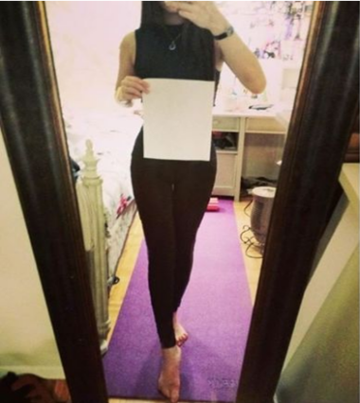

Opinions about the challenge:

________________________________________________________________________

________________________________________________________________________

________________________________________________________________________

________________________________________________________________________