选择性必修二Unit 5 Reading and thinking First Aid For Burns

文本简述
该板块的主题为“学习烧/烫/灼伤的急救措施”，该板块旨在为学生呈现正确的急救方法。从文本结构和写作特征上看，该语篇为说明文，具体来说是医院宣传单上的一篇文章，其目的是向人们宣传正确的烧/烫/灼伤的急救方法。该语篇按照事理逻辑次序安排信息，通过小标题清晰呈现各部分内容，准确描述烧/烫/灼伤的成因、类型、特征以及急救措施，部分段落使用主题句概括大意，层次明晰，其中配有插图辅助，便于学生快速、准确的理解信息。
教学目标
By the end of the class, students will
1. sort out the information about first aid for burns (causes, types, characteristics of burns and first aid treatment);
2. describe the characteristics & treatment for different kinds of burns;
3. summarize the stylistic features of hospital leaflet;
4. brainstorm the possible occasions to get burnt and occasions to offer first aid.

- 教学设计
Step 1: Lead-in
Using four pictures to describe a situation that occurred in our class.
- What happened to the boy?
- What should be done to the boy?
- What is first aid?
First aid is the kind of help given to someone who suddenly _____________or __________before a doctor comes.

Step 2: Pre-reading
- According to the discussion, what should be done when someone suffers a burn?
- Read the title and make predictions.
Q1: Where is the text most probably from?
Q2: What is the main idea of the text?

Step 3: While-reading
Activity 1 Read to check your predictions
Q1: Where is the text most probably from?
____ advertisement ____ blog post
____ hospital leaflet ____ email
____ newspaper article ____ short story
Q2: What is the main idea of the text?
The text mainly introduces ______ types of burns and their characteristics as
well as how to give _________________ when burns happen.

Activity 2 Read for detailed information
- Scan Part.1 carefully. Q: What are the functions of the skin?
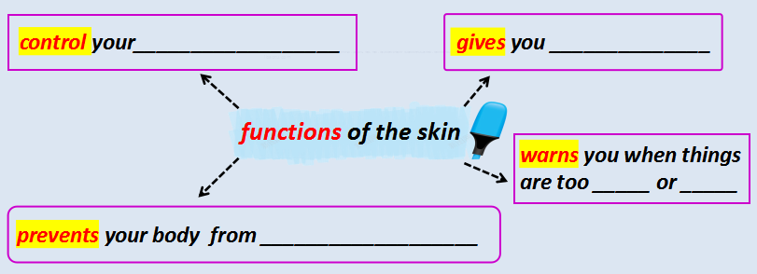
- Scan Part.2 carefully. Q: What are the causes of burns?
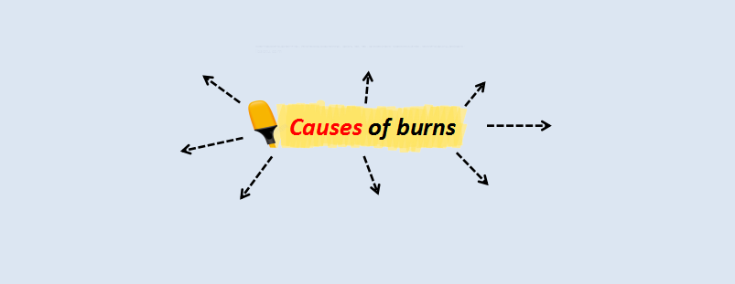
- Scan Part.3 & 4 carefully.
Q: Which type of burns does the following pictures belong to?
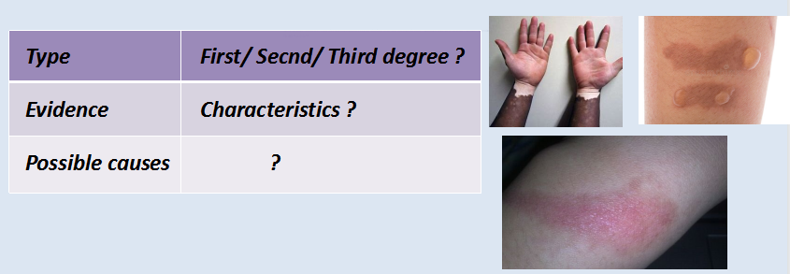
- Scan Part.5 carefully. Q: Put the treatment process in correct order.
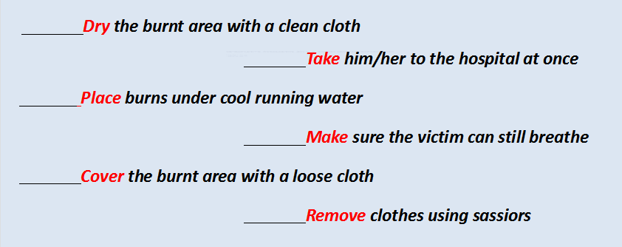
- Summary
Complete the table to summarise the information.
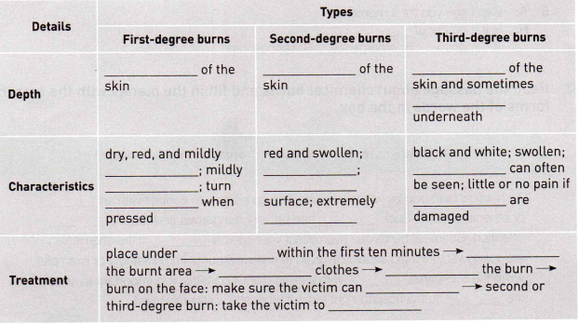
Activity 3 Role play
Perform and desribe the proper first aid by using learned steps.

Activity 4 Read for textual features
- What is the genre of the text? Is it a narration, a description, an argumentation or an

2: How does the author make the text objective and factual?

Activity 5: Group Discussion
Brainstorm the following question or refer to the hint.
- What are the possible occasions when you are likely to get burnt at school or at home?
- What other advice do you know of about first aid for burns? Is it good advice or bad advice? Why?
- What are the possible occasions when people need first aid?

