**2024七选五临门一脚**

**Lead-in: 解读考试大纲要求**

**了解三类选项：**

**1. topic sentence**

**2.coherent sentence（如小标题，段落衔接句）**

**3. detailed sentence （侧重上下文逻辑意义）**

**Step1: analyse the structure of the passage**

**一、有大标题：**

**首段会体现主题词汇 ，观察选项有没有主题词，明确首段挖空处备选选项**

**无大标题：**

**二、七选五文本的几种文本类型：**

**1. 总分**

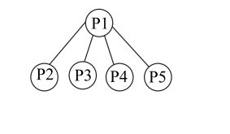 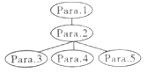 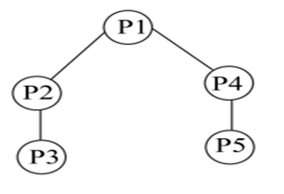

**2. 总分总： 首尾呼应，尾段若有设空，会与首段的主题回扣，注意选项中出现的主题词汇**

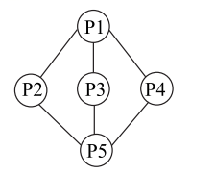

**Step 2: 关注设空位置；优先做段首题，其次段尾题， 容易做的题先做。**

**Step 3：关注选项特点，重点关注核心词汇: 名词，形容词，动词，逻辑词，连词，代词**

**1. 正确选项的特点：与主题内容贴合， 与段落内容贴合度高，通常有表示逻辑的副词，表示指代的代词， 表示语义前后粘连的词汇；**

**Step4: 正确选项的词汇特点：**

**1. 同词/近义词/同根词/ 同畴词（上下义词）复现**

**2. 逻辑词（选项中的逻辑词或空格后的句子有逻辑词）或考生利用上中下三个句子的关系，推断句间逻辑关系**

**A: 并列关系： and, or, neither…nor…, either…or…, likewise, similarly, equally, in the same way, meanwhile, not …but…; Some…, others; For one thing, for another ; In the first place, in the second place 等。**

**B: 递进关系：also, too, as well, besides, even, moreover, on top of that …, apart from …, in addition , beyond… not only…but(also)…**

**C: 转折对比关系：while, whereas, though, although, despite… / in spite of …; but, however, nevertheless otherwise (否则), on the contrary, by contrast, on the other hand （可是）, unfortunately/ unluckily, unlike…, rather than…, instead of…, compared with/ to…**

**(前面否定句. Instead…)**

**D: 因果关系：because, for, since, as, consequently, therefore, thus, so, as a result, That’s why…;**

**thanks to/ because of/ due to, for this reason , after all (毕竟) 等。**

**E: 解释关系：in fact, actually, for example, for instance, in other words, as a matter of fact, that is to say… Rather, (尤指修正上文时) 更确切地说; It turns out that … (用以回答上文的疑惑)**

**F: 顺序关系：at first, at last, finally, eventually, at last; in the end ; at length; ultimately,; firstly, to start with, next, second, secondly, then，later, afterwards, subsequently 等**

**3. 代词**

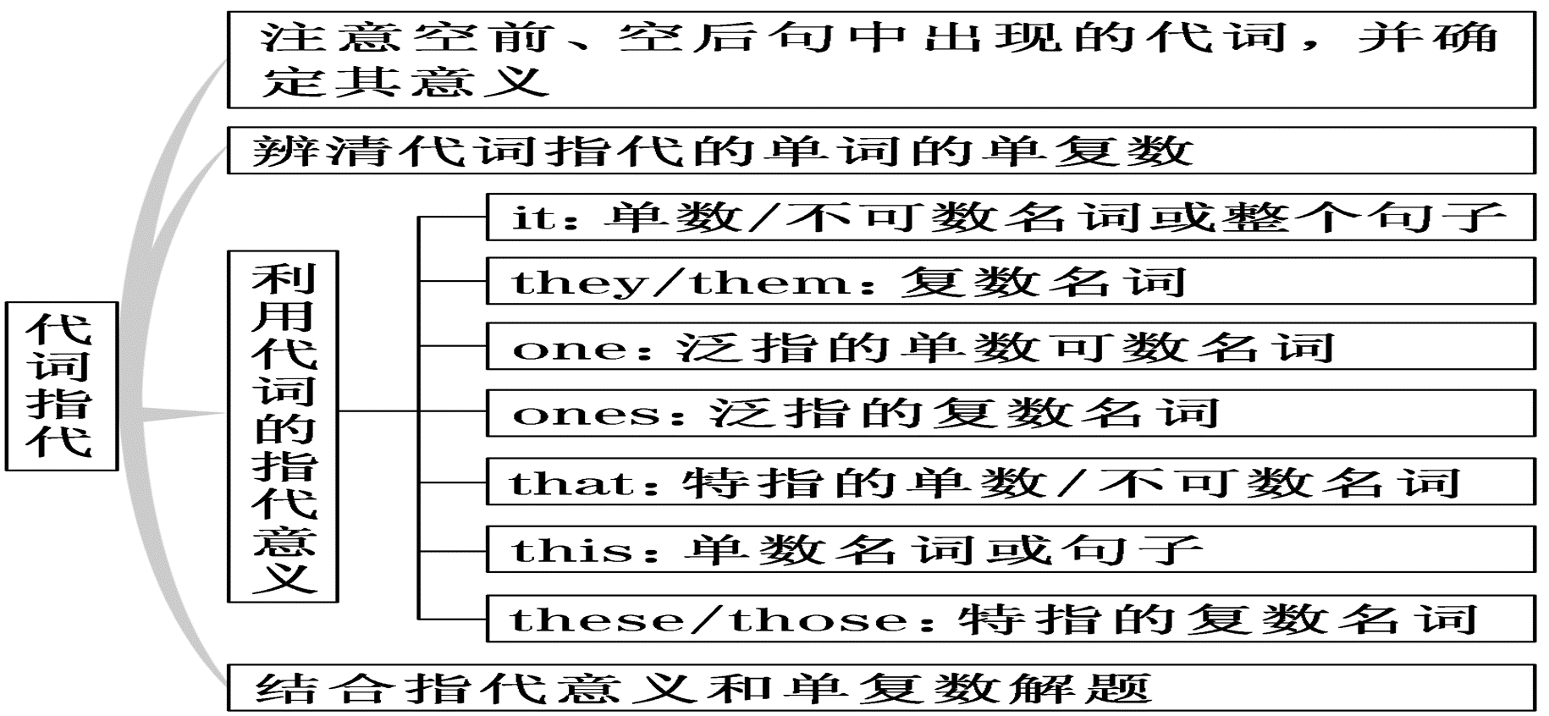

**① 选项中出现代词 （主语或宾语或介宾）**

**② 原文空格后出现代词 （意味着选项中需要有指代的名词出现，结合上下句来锁定正确选项）**

**特别注意：It 有可能是形式主语，代替to do sth; doing sth ;that 主语从句等，请注意甄别。此时，看句子与上下文之间的逻辑意义以及是否有相关词汇复现。**

**注意1：正确选项可能为： ①逻辑词+词汇复现 ②逻辑词+代词**

**注意2： 正确选项代入原文后，上下句的协同性可以通过词汇复现来体现，使上下句出现某一意义的重叠。**

**Step5：冗余选项如何排除**

**冗余选项特点:**

**1. 有两个相似的句式 （祈使句有出现多个的情况） （可能产生冗余选项）**

**2. 有两个选项出现相同的名词，形容词或动词等 （可能产生冗余选项）**

**3. 选项没有特别鲜明的特征，该句子仍然会出现的核心词汇，但有可能核心词汇与空格所在段落无关或者语义与原文相悖或截然相反。（要准确理解选项句意）**

**(大部分的真题中冗余选项的语义与原文主题或原文某个段落语义相反或无关)**

**利用冗余选项的特点，来对以下的习题进行冗余选项的初步排除：**

1. In the past few years, **online learning has become a significant part of the university and college experience.** 36. But are all online courses created equal? How can you be sure that **digital learning** is right for you? 37. We interviewed students and professors to get their advice about **online courses. （2024-1首考）**

C. Do you know that online courses are also part of your education?

E. The chief complaint about online courses is that they lack human interaction.

F. If you take an online course, what can you do to ensure the best possible grade?

G. A survey found that 29 percent of college students registered for online courses.

**两个或多个选项句式相似或一致，会产生冗余选项**

**2.**  34

You would think learning takes more time from you, but actually there are always new ways of doing things that can save you time on daily tasks, freeing you up for the most important. Always be looking for a new way to gain back an hour here or there.

**Lighten up.**

The world won’t come to an end in most cases just because you left a few things undone. Celebrate progress and keep refining(改进) toward a happy productive existence. 35 . Every completion is a small victory that adds up in a big way. **（2022-1浙江首考）**

A. Speed up.

B. Be an active learner

C. Stop trying to balance time between them all.

D. Make choices about what is meaningful in your life.

**3. Personal Forgiveness**

Taking responsibility for **mistakes** is a positive step, but don’t beat yourself up about them. To err (犯错) is human. ____36____ You can use the following writing exercise to help you do this. **（2023-6全国卷I）**

A. A little self-forgiveness also goes a long way.

D. It’s just as important to show yourself some forgiveness.

4. The most obvious advantages of online learning is that you can study anywhere and anytime. 38. “I think a point that many people lose sight of is how easy it can be to fall behind schedule,” says graduate student Amanda Bindman. Before choosing to study online, consider whether you’re a self-motivated learner and if the material seems interesting enough to keep you going.

…

40. A social connection is often a big part of learning. There are things you can do to ease this problem. Jessica Pink, an undergraduate student, suggests taking online courses with a friend, so you can motivate each other to stay on track. You can also find students on the class discussion board to organize a study group, or schedule in-person meetings with your professor to discuss course concepts. （2024-1 浙江省首考）

A. But that doesn’t mean there aren’t deadlines.

B. Your **motivation** should be your main concern.

真题实操：见学案：