**A Lesson Design of “Zero Hunger”**

**I. An analysis of teaching material:**

This text is an extraction from World Food Program official website. It consists of two parts: “Zero Hunger” and “Our vision: five steps to Zero Hunger”. The first part depicts the phenomenon of challenges of hunger and malnutrition; their consequences; World Food Program’s efforts; its progress as well as more lasting solutions needed. The second part of reading is five steps to achieve zero hunger. The theme of the text is familiar to students and it can arouse their sympathy, activate their creative as well as critical thinking abilities to come up with practical solutions to achieve a “zero hunger” world.

**II. Teaching objectives:**

|  |
| --- |
| * Knowledge objective: familiarize students with hunger and malnutrition issues around the world; build students’ vocabulary on this theme; * Ability objective: train students to develop their ability of information extraction, phrase inference, summarize, creative thinking, critical thinking and imitation writing; |

**III. Teaching important points:**

|  |
| --- |
| * Clarify the key word of each paragraph in the first part of reading * Summarize the subtitle for step 2&3 in the second part of reading * Comprehension of the logical structure and coherence of the passage; * Raise students’ awareness of the importance to achieve a “zero hunger” world. |

**IV. Teaching procedures:**

**Step 1: Warming up & lead-in: greeting about what students have for breakfast and introducing the proverb about food; leading in with new words (nutritious; malnutrition) and showing the video of severe situation malnutrition in the Guatemala**

|  |
| --- |
| * Ask students what did they have for breakfast and introduce the new word “nutritious”. * Ask students to translate the proverb “food is the paramount necessity of the people” to Chinese and stress the importance of food. * Introduce the severe condition of hunger and malnutrition in the world by watching a short video clip about “malnutrition in Guatemala”; introduce the new word “malnutrition” by pictures and a sentence. * Ask students to share their feelings after watching the video. |
| **Questions**:   * What did you have for breakfast today? * What is the Chinese version of this proverb? “Food is the paramount necessity of the people”. * How do you feel after watching the video? Do you want to help them? |

**Step 2: Part 1 (para1-3) reading, summarizing & thinking**

|  |
| --- |
| * Scan: read paragraph 1 quickly and find out how many people suffer from hunger and malnutrition and appreciate the effect of numbers in exposition writing. * Read in detail: read paragraph 1 carefully and find the results of hunger and malnutrition. * Summarize: find the word which signals that it is not easy to get rid of hunger and malnutrition completely. * Scan: read paragraph 2 quickly and find out what World Food Program did to deal with challenges. * Summarize: come up with a word to summarize what WFP did. * Scan: read the first sentence of paragraph 3 together and find out the key word. * Read in detail: read paragraph 3 carefully and find out what else need to be done to achieve zero hunger. * Think: What solutions are available to address hunger and malnutrition. |
|  |
| **Tasks & Questions**:   * **Find out** how many people suffer from hunger and malnutrition; * What is the function of numbers here? * **Find out** what results do hunger and malnutrition lead to. * Is it easy to get rid of hunger and malnutrition completely? Which word tells you it is not easy? * **Find out** what did global community do in 2015? What does “zero hunger” aim to do? * Which organization brought up with “zero hunger”? What else has it done? * Is it enough to provide nutritious food for those in need? What result will it lead to? What else need to be done? * **Summarize** what WFP did by using one word. |

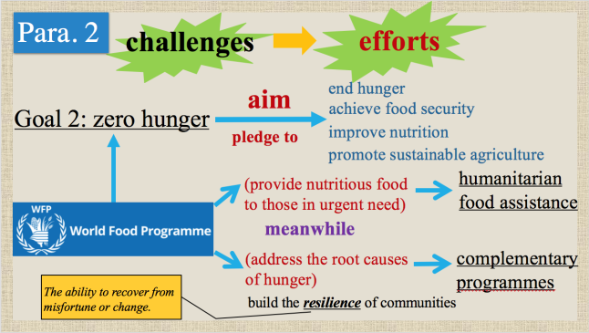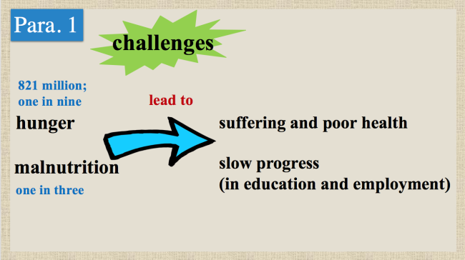

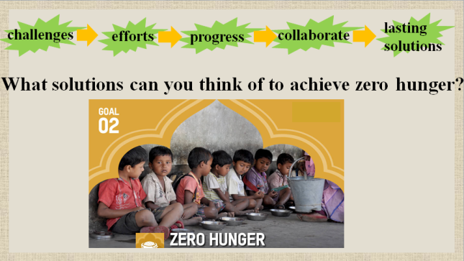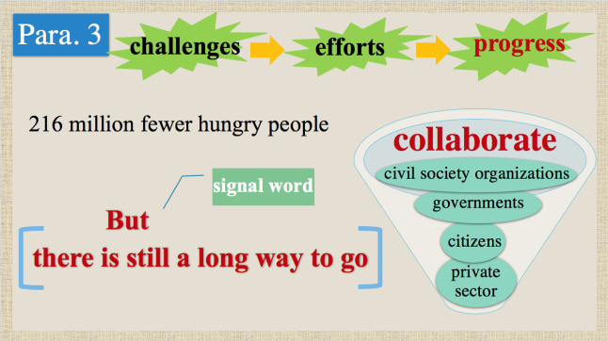

**Step 3: Part 2 (step 1-5) reading, summarizing & thinking**

|  |
| --- |
| * Describe and think: describe the pictures and think what “furthest behind” refers to. * Read in detail: read step 1 carefully and fill in the cycle diagram. * Critical think: paraphrase the subtitle. * Summarize: which group of people does step 1 target at? * Critical think: is it easy for the most vulnerable to make a better life only with farm produce? * Scan: read step 2 quickly and complete different stages of supply chains. * Summarize: make up a suitable subtitle for step 2 in accordance with the picture and content. * Summarize: summarize the key words in step 2. * Scan: read step 3 quickly and find out different situations about food waste in developing and developing countries. * Summarize: make up a suitable subtitle for step 3. * Summarize: summarize what aspect of food is covered in step 3. * Scan: read step 4 and step 5 quickly and answer three questions. * Summarize: summarize which group of people and what aspect of food are covered in step 4 &5. |
| **Tasks & Questions**:   * **Describe** the pictures**.** What kind of people are they? What life do they live? * **Explain** “furthest behind” refer to the most vulnerable in remote places. * Why did such a poor village change so much? * **Explain** the subtitle in your own words. * Is it easy for the most vulnerable to make a better life only with farm produce? What else need to be done? * **Explain** the food supply chains by visual aids pictures. * **Summarize** the content and make up a subtitle for step 2. * What if the food supply chain is broken and food cannot be delivered to the market? * What happened to the crops in developing countries? Why is that? * What about food waste in developing countries? * **Summarize** a subtitle for step 3. * **Find out** (1) what do eat for staple food; (2) what if the climate doesn’t allow the growing of those crops any longer; (3) How can we ensure a child’s healthy development and when is the key period. * **Think** critically aboutthe mind map which contains five steps above and the connection between them. |

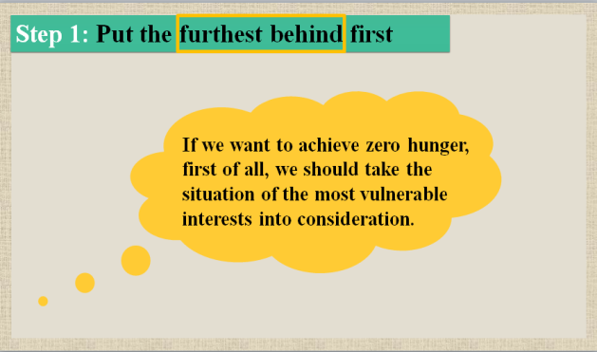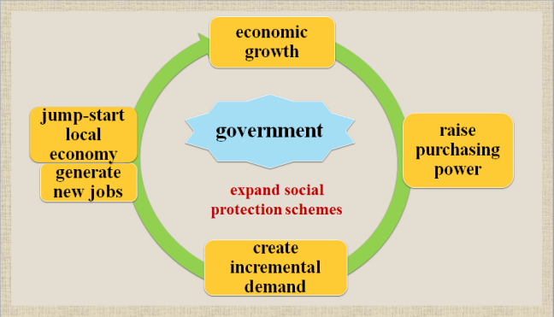

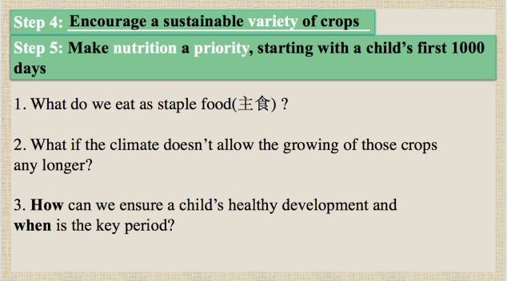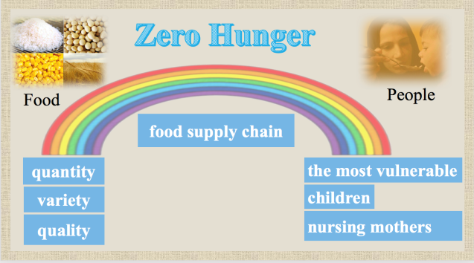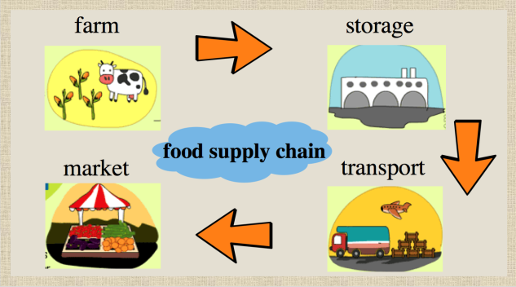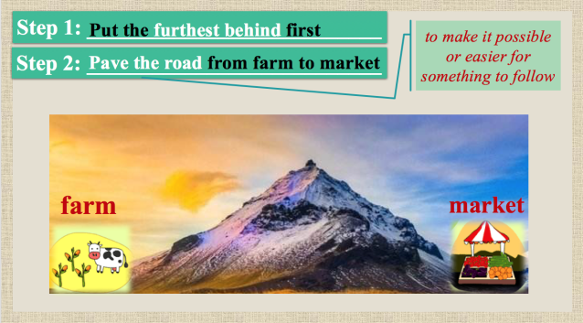

**Step 4: Imitation writing**

|  |
| --- |
| * Discuss in group of 4 to choose a solution on the blackboard or come up with a new one. * Imitate the writing in step 1-5 and write a short paragraph by using newly-learnt words and expressions in the passage. * Share the group writing with the whole class. * Read and appreciate one example together. |

**Step 4: Assignment**

|  |
| --- |
| * ***Polish your paragraph, share the paragraph with others.*** |