背景介绍：
本次课为月考作文讲解课，高一新教材Unit 1 reading for writing 关注建议信的写法，学生已经对建议信的写法有一定的概念，并积累了一些的提建议的句式，完成了建议信备考的思维导图。但学生对本次题目的主要内容理解有偏差，直接导致主要内容不得体，学生把注意事项当中的背景信息当成主要内容，或写how to learn Chinese 或写 Chinese Confucius Institute，所以课堂主要的重难点就是如何规范审题以及如何提合适的建议。

原题呈现：
假定你是李华，你的英国朋友Peter来信就下周三要参加孔子学院（the Confucius Institute）的面试征询你的意见。请你写封回信，内容包括：
1. 写信目的；
2. 提出建议（至少两条）；
3. 表示祝愿。
注意：1. 词数100左右；
2. 可适当增加细节，以使行文连贯
3. 孔子学院是中外合作建立的非营利性机构，致力于增进世界各国人民对中国语言文化的了解，加强中国与世界各国教育文化交流合作。

教学设计：
☆Teaching objectives：
*To learn about the structure and content of letters;
*To recognize what a good suggestion letter is like;
*To write appropriate suggestion letters, especially pay attention to the tone and language.
☆Teaching important points and difficult points：
* How to read the requirement properly
* How to distinguish the background information from the key contents
* How to give proper suggestions in advanced sentence patterns
☆Teaching methods：
Group discussion, live presentation, pair work and individual task
☆Teaching aids：
hand-made mind-maps, handout learning material, PPT and the other normal teaching tools
☆Teaching procedures：
Step 1： Lead in
Task 1: Show a short video about the excellent mind-maps on “how to write a suggestion letter” .
部分学生作业展示：
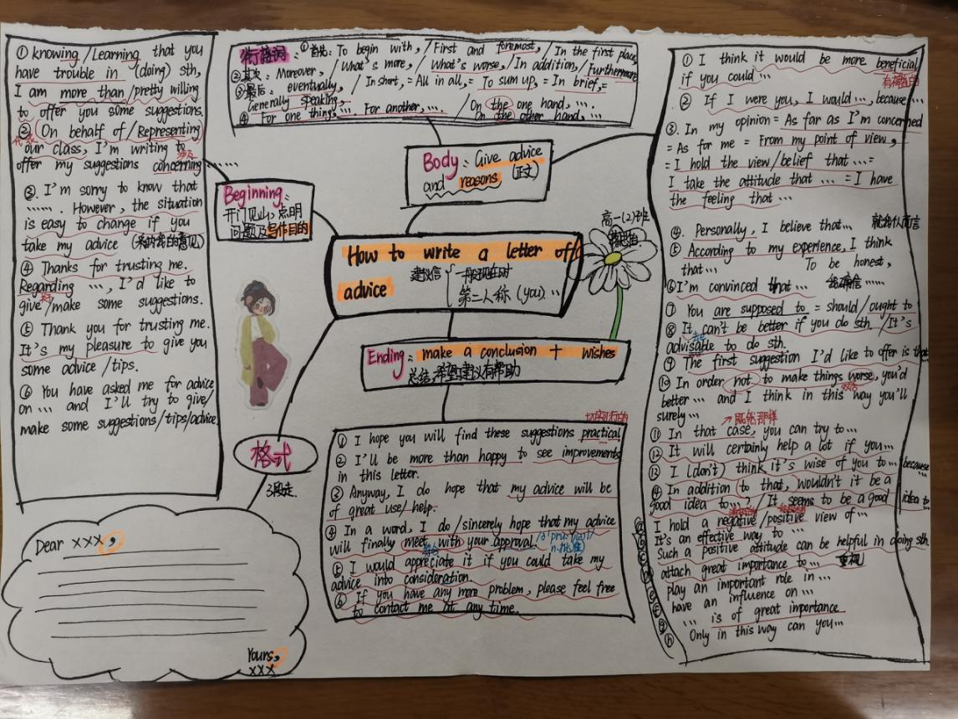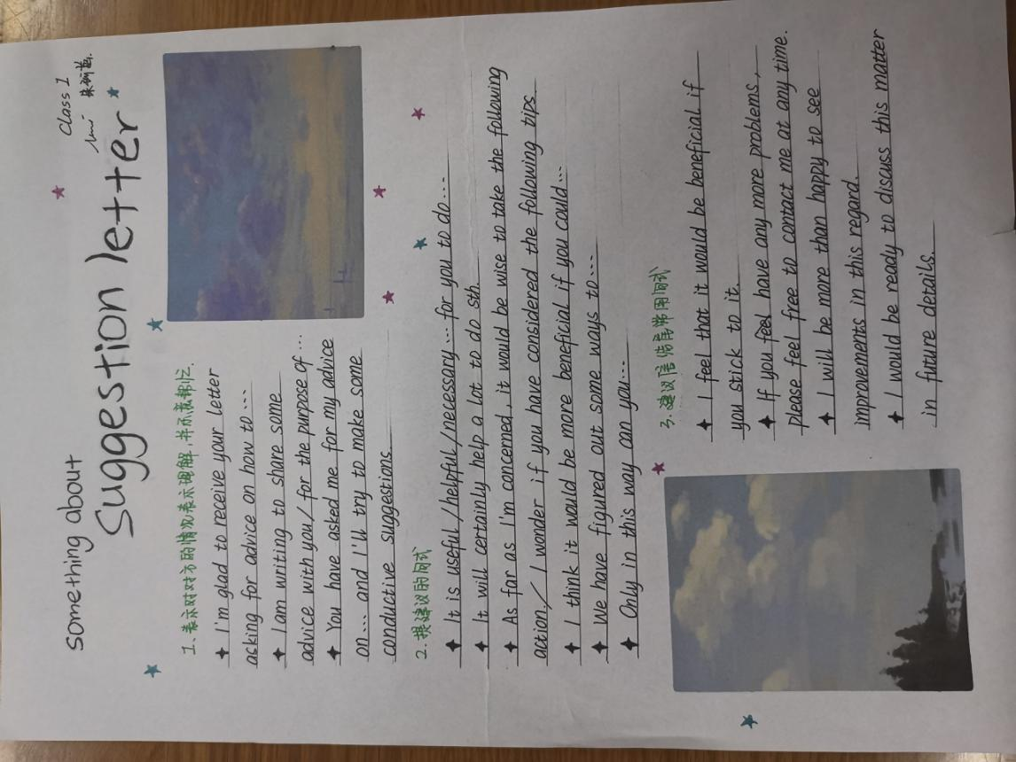

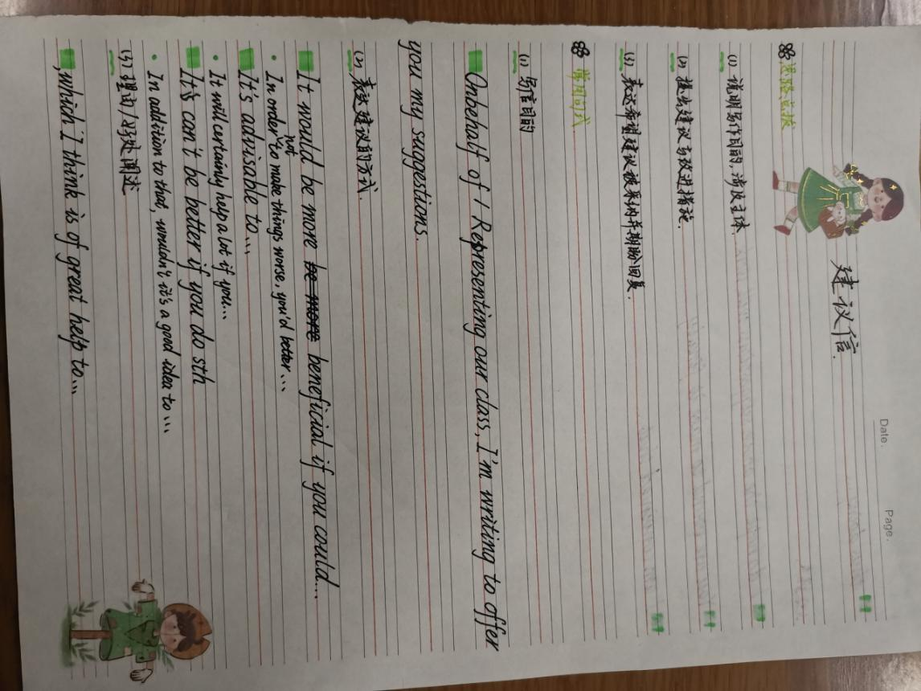

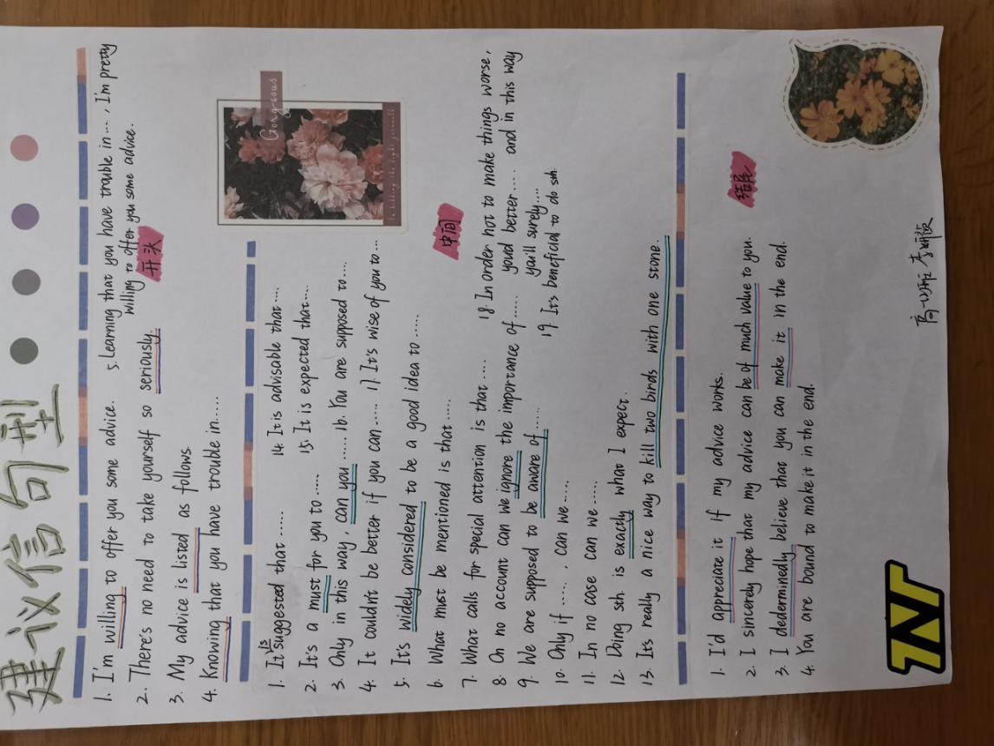

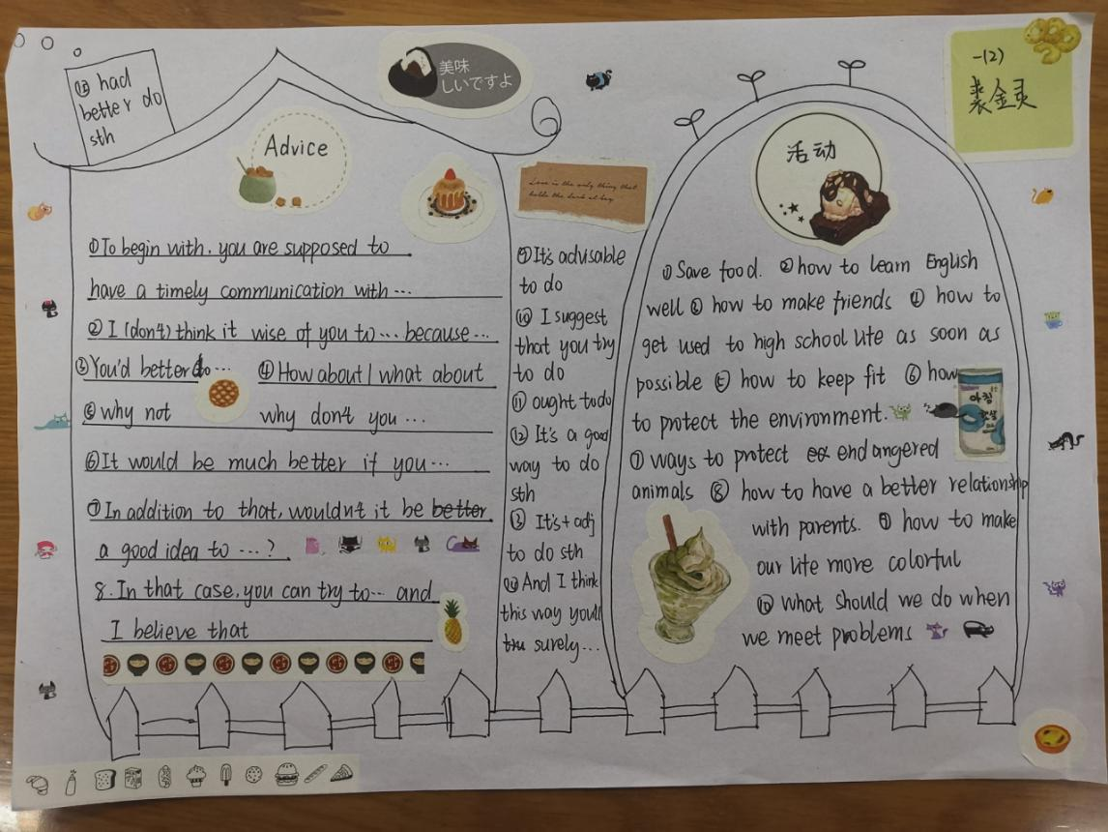

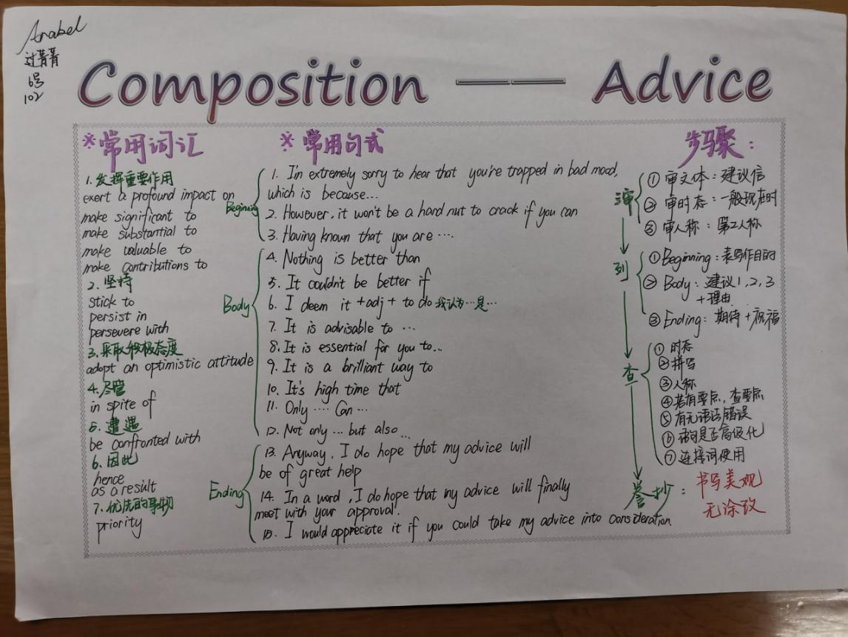

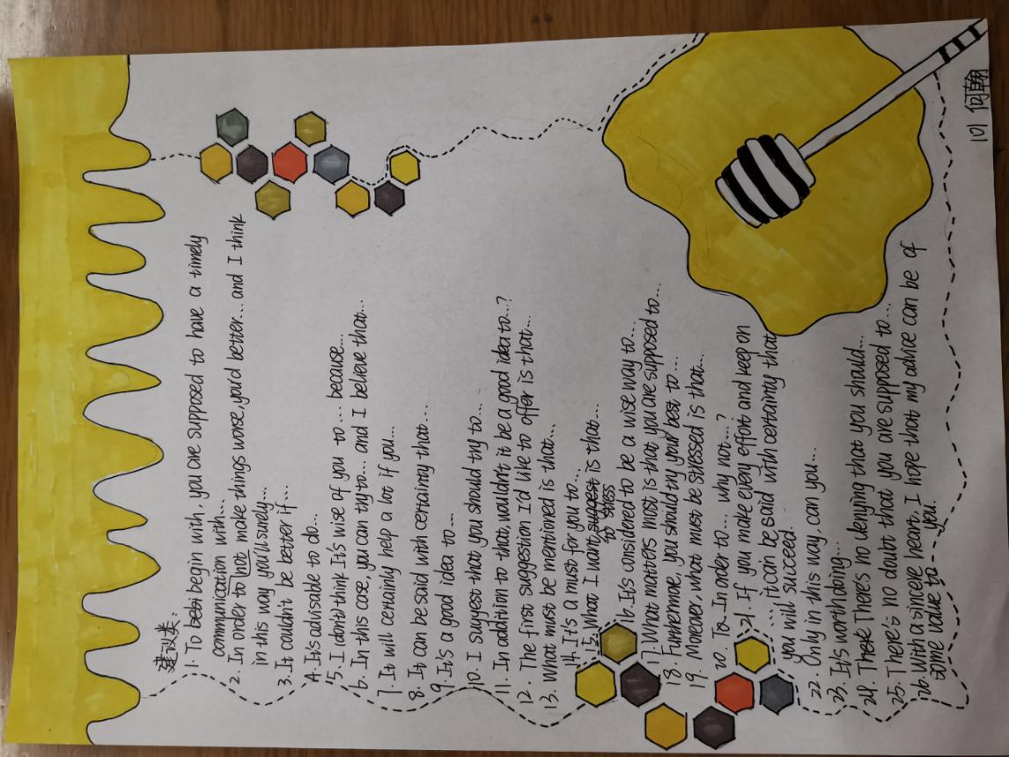

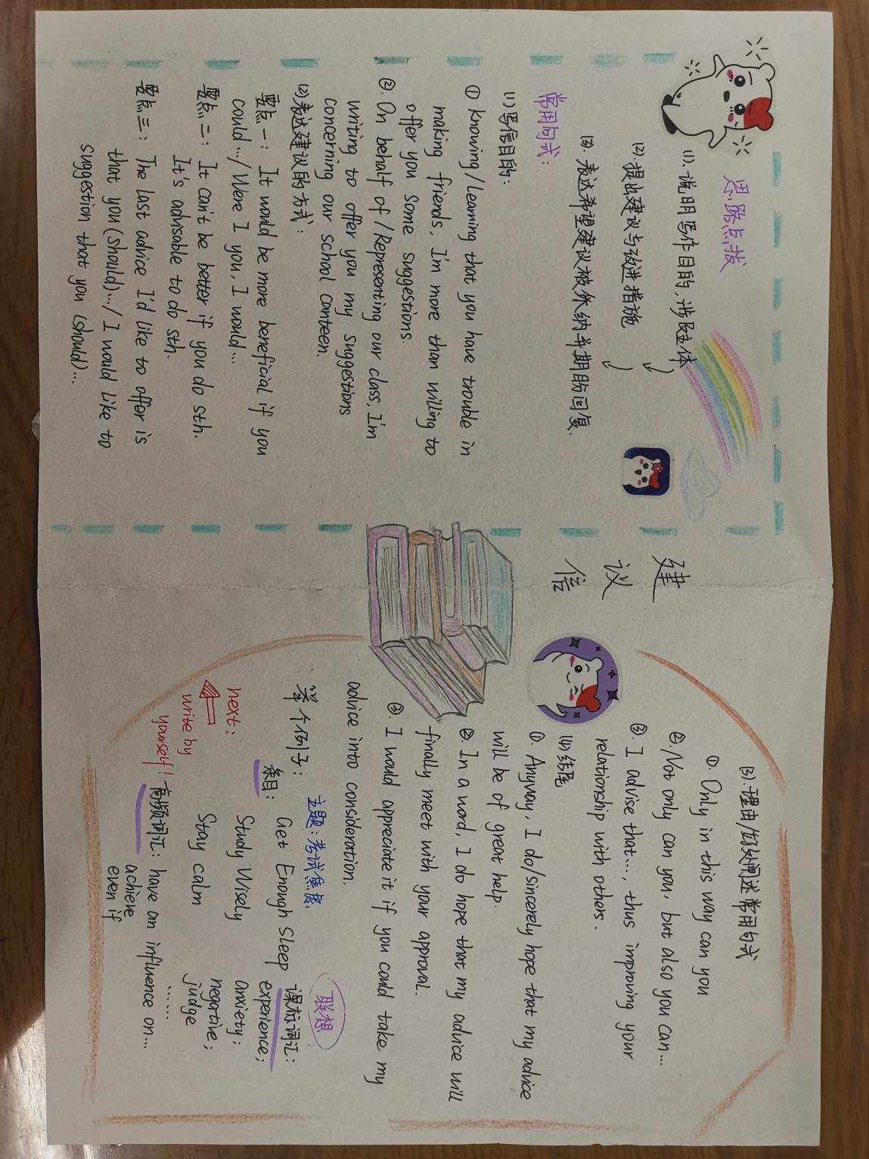
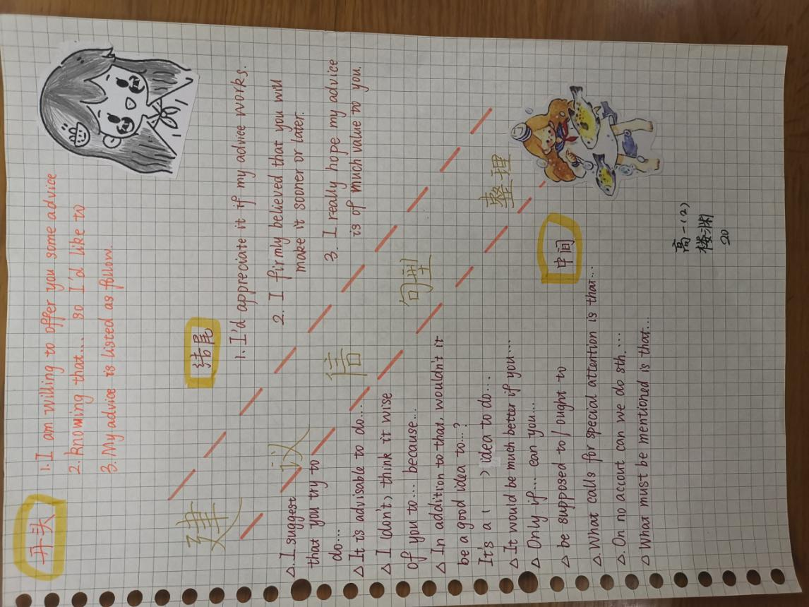
Intention: 教师自制优秀学生作业展示视频，该作业是关于“如何写好建议信”的备考思维导图，以此进行学生情感过渡，点燃学生情绪，让学生有课堂参与感，并引入本课话题“建议信”。
Task 2: How can we get suggestions when we need help?
Intention: 建议信是一种书面的表达方式，要注意语言使用和行文逻辑，让学生意识到提建议方式的区别。
Step 2：Read the requirement
A good understanding of the requirements is half done.
Task 1: Please circle out the key information of the requirement.
Task 2:Think about the relationship between the main points.
1)What’s the writing purpose?
2)What topic should the suggestions and wishes about?
Task 3: Tell the function of the last sentence.
“孔子学院是中外合作建立的非营利性机构，致力于增进世界各国人民对中国语言文化的了解，加强中国与世界各国教育文化交流合作。”
Key：The information here is listed to help you know what kind of suggestions you can make.
Intention: 让学生学会正确规范审题，抓住题目中关键信息并学会多信息处理，锻炼学生总结、概括能力。解决本课难点之一，背景信息不等同于重点信息。
Step3: Ask students to share the correct format as well as the clear structure.
Dear Peter,
Para. 1 -----background information+ purpose
Para. 2------------suggestions (> 2)
Para. 3---------conclusion + wishes
Yours, Li Hua
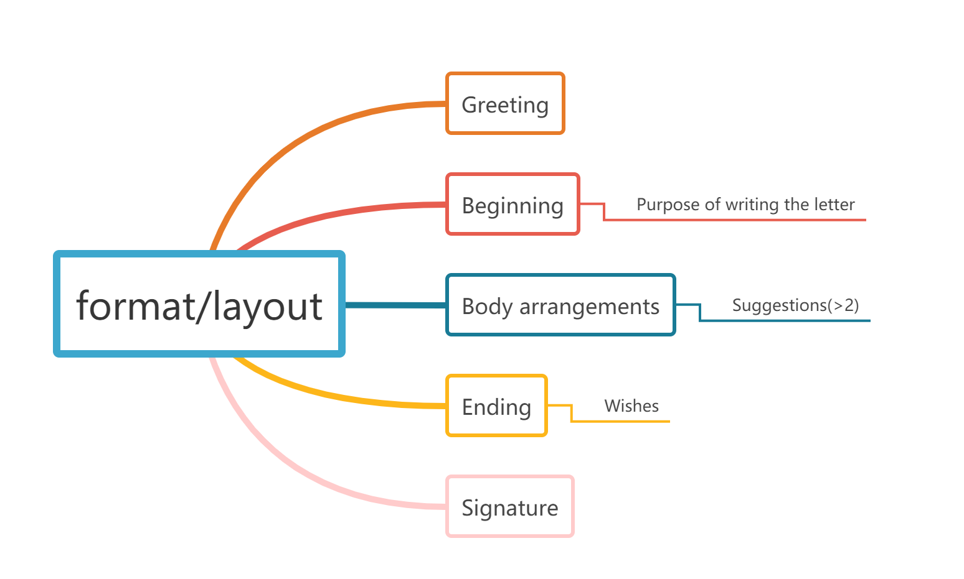
Intention: 从大局上着眼文章结构，从细节上关注文章格式及标点符号。
Step4：Rewrite Para.1
A good beginning is half done.
Task: To rewrite the example of Para. 1 to make it better.
Example:
Learning that you will have an interview for the Confucius Institute which is to be held next Wednesday, I’m writing to give you some suggestions.
Better version:
Glad to receive your letter asking me for some advice on the interview for the Confucius Institute scheduled for this coming Wednesday. I’m writing to remind you of what to prepare for it.
Intention：让学生通过范文改写的方式，学会语言的提升，从而培养学生学习并使用语言的能力。
Step5: Discuss with your partners to give more suggestions.
Proper suggestions lead to an excellent version.
Task 1: What suggestions can we give?
Proper suggestions:
●learn a few Chinese greetings
●wear Han-style clothing
●learn Chinese history and culture
●read some books about Confucius
●learn some Chinese manners
◎arrive on time
◎leave a good impression
◎keep smiling
◎be confident, polite and calm
◎good communication skills
◎dress properly
◎be well prepared
◎sleep well
Useful sentence patterns:
Why not ...;
It's important to do...;
If I were you, I would...;
I would like to suggest you should do...;
It is advisable to ...;
It is a brilliant way to ...;
It is essential for you to ...
It couldn't be better than...;
It should be a good idea to do...;
It will certainly help a lot if you ...;
It would be beneficial if you could ...;
It never fails to be a wise choice to do ...
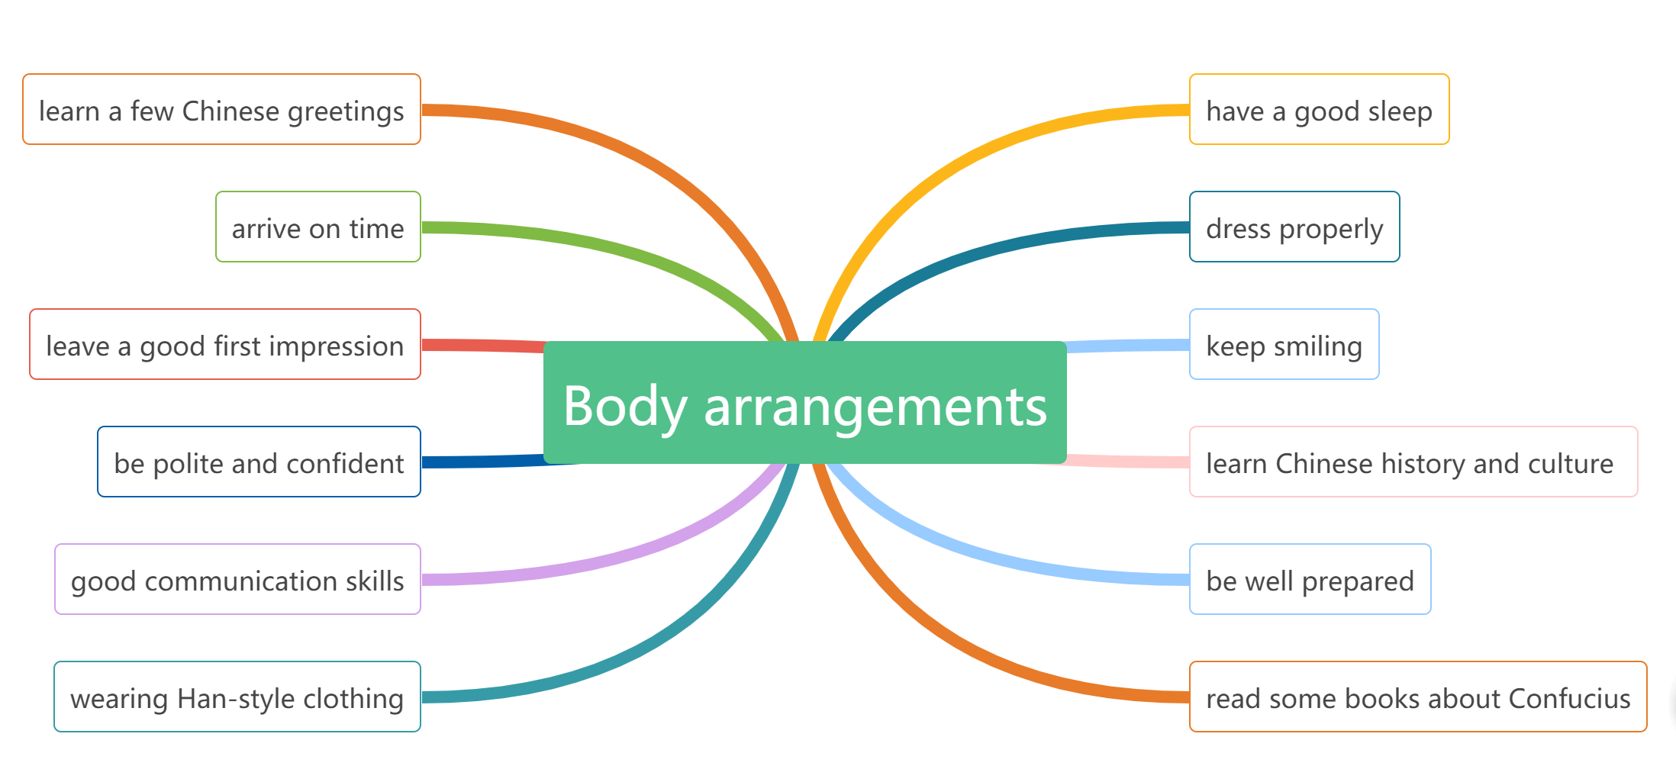
Intention: 让学生通过同伴自主解决问题，判断合理的建议，并学会使用话题高级句型进行成句输出。
Task 2: Read the handout learning material, and tell which one is good and tell the reasons.
学生习作 1:
Firstly, the confucius Institute is a significant symbol of Chinese without which hardly can the foreigners know about the ancient Chinese culture. Not only will you learn to speak Chinese but also you will learn more about confucius. Moreover, you will learn to write some Chinese words. Last but not least, it's not built for making money, the purpose of the Institute is that we want more friends from all around to learn about our culture. Just show your interest about Chinese culture when you are tested.
学生习作 2:
The first suggestion I would like to offer is that you should learn about some Chinese language culture, which I think is of great help to understand the meaning of some questions. Additionally, it is advisable to take part in Chinese clubs to improve your Chinese skills. Finally, it couldn't be better if you could read some great books in Chinese. Not only can it make yourself wiser, but also it can improve your understanding in Chinese, thus letting the teacher know you are a good Chinese teacher.
学生习作 3:
First and foremost, don't be worried and don't be afraid of anyone. It is very important for you to leave them a good impression. It may help you to pass it. Next, you ought to start off your first day of it with a good sleep. Being well rested will help you remove any nervousness you may be feeling. Last but not least, you need to get ready for it before next Wednesday. Because it can help you pass it more easily.
学生习作 4:
First, you are advisable to calm yourself down. The confucius Institute was designed to help foreign guests know Chinese culture better. So be convinced that you are capable of it. Furthermore, I can't emphasize the significance of smiling. It can't be better if a smile is always on your face which will bring others warmth. In addition, preparing well is also a good way to help you stand out in the group. Last but not least, rest well before the interview, which will offer you a clear mind in the interview.
☆Comments on the four versions:
I think example ________________ is __________________ (good/bad), because ____________________________________.
Intention: 让学生通过比较，同伴探讨的方式，对文章内容得体的把握进行再次强调，让学生写文章要紧扣话题。同时，强调写作不能照抄试卷内容，让学生熟悉改卷规则。
Step 6: Share the good ending with classmates.
A good ending makes the composition completed.
Para3:
- I hope my suggestions will be beneficial. Good luck to you!
- Anyway, I do/sincerely hope that my advice will be of great use/help. I'm convinced that you will make it!
- With a sincere heart, I hope that my advice can be of some value to you. You are bound to (一定) make it finally.
- I hope my advice can make a big difference. And I'm looking forward to hearing your good news.
Intention: 让同学学会分享，增加语言输入，并进行语言呈现。
Step 7: Appreciation
Task 1: Appreciate the sample writing.
Dear Peter,
Glad to receive your letter asking me for some advice on the interview for the Confucius Institute scheduled for this coming Wednesday. I’m writing to remind you of what to prepare for it.
It would be wise of you to read some books about Confucius, which helps to better understand traditional Chinese cultures. It would also be beneficial to learn a few Chinese greetings. Additionally, wearing Han-style clothing will make you stand out among the candidates and impress the interviewers greatly.
I do hope my proposal could be practical. Wish you good luck!
Yours sincerely, Li Hua
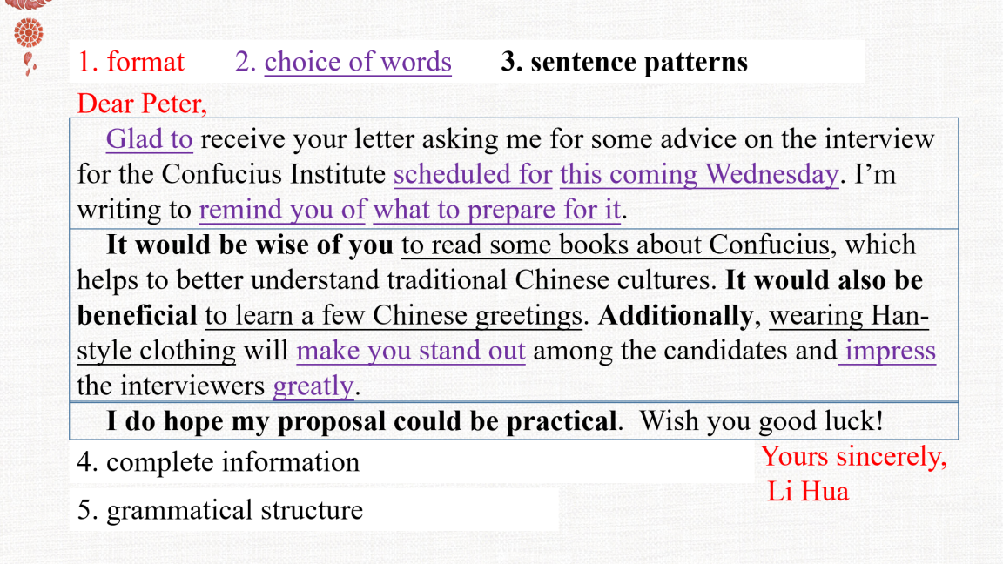
Intention：让学生总总体上学会欣赏整篇文章，关注语言、逻辑和内容。
Task 2: Evaluate your partner’s writing and give three sentences of comments on it.
- format
- handwriting
- choice of words
- sentence patterns
- complete information
- grammatical structure
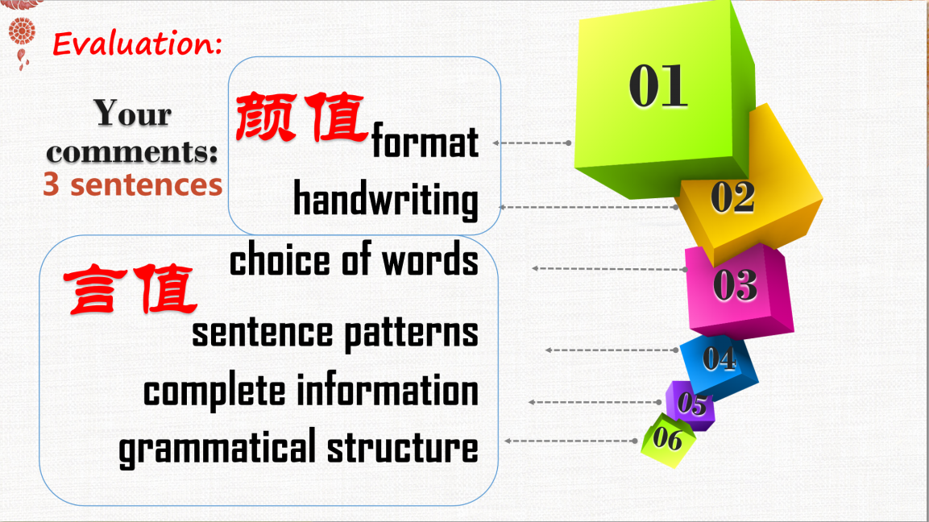
Intention：让学生学会同伴批改，关注细节，学习积累语言，巩固加强课堂所学。
Step 8：Homework
Improve your passage and rewrite your composition.

