教学课题 | Book 7 Unit 5 Reading
课程类型 | Reading& writing | 授课地点 | 录播教室
学情分析 | 1.情感和认知方面：学生对国外的学习生活情况了解是很感兴趣的，在以往的学习阅读中对国外的生活学习也有所了解，但不是很具体。这篇关于中国女孩在伦敦学习和生活情况的介绍和他们的生活比较贴近，在在预读，学习，讨论时会觉得比较亲近熟悉。  2.语言技能方面：本班多数学生的英语语言能力处于年级的中等水平，具备较高的独立思维能力，通过老师的引导和提示，一般能够文本阅读中获取主要信息和重点内容，能根据阅读目的运用适当的阅读策略完成阅读任务。但是他们还欠缺分析和处理深层文本信息的能力以及有效归纳总结文本信息的能力。因此，教师应该充分考虑到本节课教学设计中的任务探究是否能为学生搭好梯子，是否形成合适的认知梯度，是否开展鼓励学生参与的小组活动和个体探究任务，是否完成本节课的教学内容和达成本节课的教学目标。
教材分析 | 本节课以Studying abroad为主要话题，旨在通过文本阅读教学，使学生通过实例（中国女孩谢蕾在伦敦的学习生活情况）对比国内外学习生活的不同，使学生了解在国外学习时收获的益处和可能遇到的一些问题，并学会怎样解决问题和避免这些问题的发生，学会分析、归纳、总结、表达个人观点，能用所学的有关studying abroad的词汇描述在国外学习、生活的益处、困难、对策，从而培养他们的国际视眼。为此，本人根据主要话题、次要话题和支撑性细节将文本进行二次整合，引导学生树立文本信息的脉络，为书信写作做好准备。
教学内容 | - 文本Keep it up, Xie Lei的阅读理解  2. 关于海外留学的益处和建议的书信写作
教学目标 | - 知识目标：通过阅读文本，学会、掌握有关studying abroad的词汇和表达；在文本阅读中体验定语从句的语法功能  - 能力目标：通过阅读文本，分析、归纳国内外学习生活的异同，还要困难和益处，并能在书信的交际情境中表达，实现读写结合，以读促写。  - 学习策略目标：通过设置任务探究和开展课堂交际活动，培养学生的合作学习策略和探究意识，增强团队精神  4. 情感目标：通过阅读文本，引导学生树立理性的海外留学的预期，学会对未来生活变数进行积极地应对
教学重、难点 | - 引导学生分析、归纳海外留学的困难和好处  - 指导学生通过小组合作策略完成海外留学的书信写作
教学方法和策略 | - 任务教学法  - 交际教学法  - 小组合作策略
Teaching Procedures
教学过程设计
Step1 Lead-in
T: Good afternoon, everybody!
Ss: Good afternoon, Ms Yao.
T: Have you ever travelled abroad?
Ss: No.
T: No one? It is a great pity. Do you think travelling abroad is much fun?
Ss: Yeah!
T: Why?
S1: Because we can learn about foreign culture.
S2: We can learn some foreign language.
S3: We can admire beautiful scenery.
T: Great! Travelling abroad is a really wonderful experience, for we can be exposed to foreign art and culture, rewarded with amazing scenery and can have great fun taking part in interesting activities.
T: How about studying abroad? Is it as much fun as traveling abroad?
Ss: No!
T: What do you think of it?
S4: It may be difficult.
T: Bingo! Studying abroad can be much fun and great challenge, as well.
设计说明：通过travelling abroad 到studying abroad的问题链，引导学生根据已有的信息储备预设海外留学的可能的困难，为后续的reading环节铺垫。
Step2 Prediction
T: We are going to read a passage about a Chinese student studying abroad. Let’s read the title “keep it up, Xie Lei Chinese student fitting in well”. When you read the title, what questions come into mind?
Ss: … (Questions vary)
T: You asked quite good questions. But the three questions of yours are the most important:
Who is Xie Lei?
What did she experience, fun or difficulty?
How is she getting on now? How did she make it?
设计说明：通过课文标题引导学生思考提问和预测文本的主题，提升学生的主题意识， 为理清文本“经脉”作准备。
Step3 Reading
T: Let’s read Para. 1 and answer the questions: Who is Xie Lei? How did she feel shortly after she arrived in London?
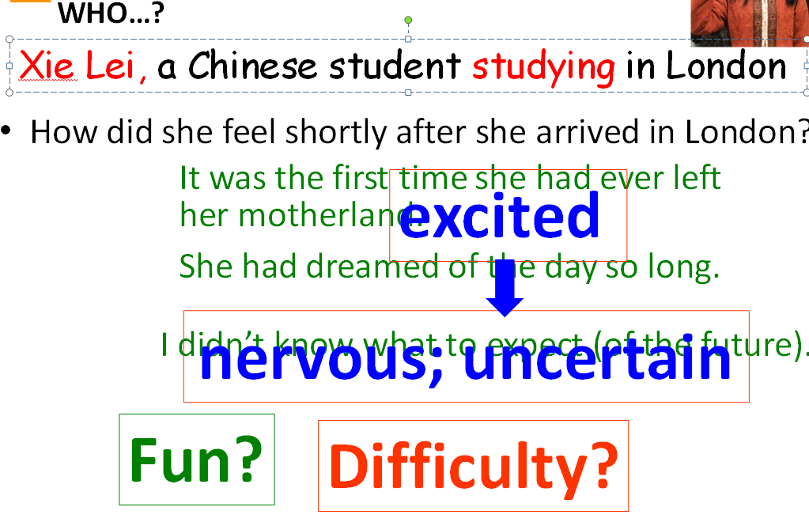
T: Did she experience more fun or more difficulty?
S7: There seemed more difficulty.
T: Bingo! Let’s go on to read about what difficulty she had studying in London.
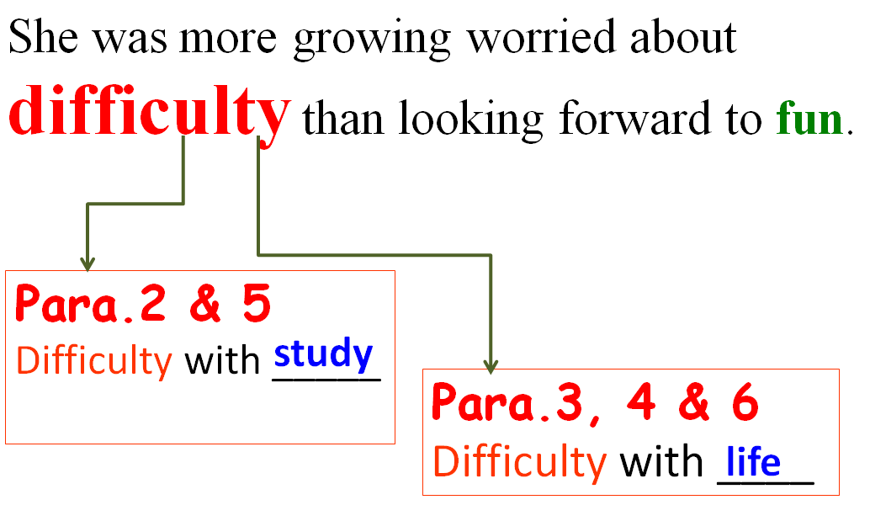
设计说明：问题设计旨在引导学生分析谢蕾初到伦敦前后的情绪变化，通过子问题将学生的思路自然过渡到对主人公所遇困难的有效预测，为接下来的读后归纳作准备。
T: You are supposed to read Paragraphs 2 and 5, finding out what difficulty she had.
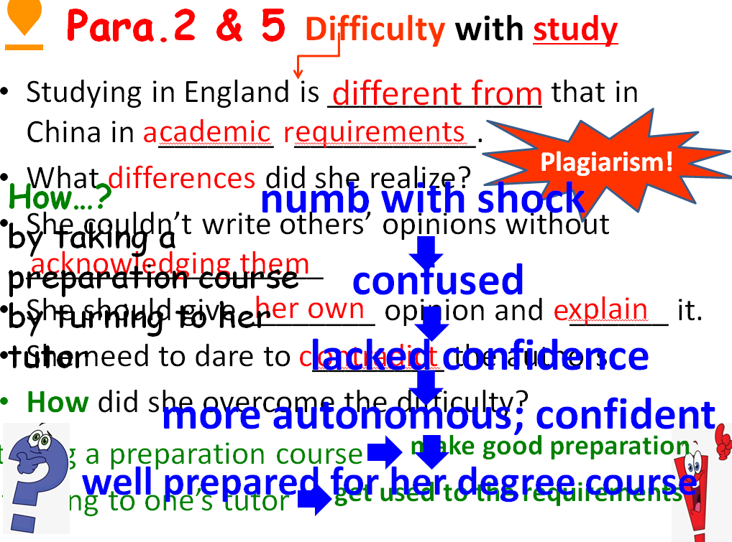
设计说明：通过思维导图引导学生在阅读中关注并分类主话题信息和次级话题信息，通过问题链帮助学生梳理谢蕾在学习中遇到困难、解决问题、实现蜕变，并最终适应国外求学的心路历程，从而使学生根据文本信息的铺陈整理出有逻辑的线性信息，为后续的写作构思作准备。
T: It’s not just study that is hard. Please read Paragraphs 3,4 and 6 and find out how Xie Lei fitted in in the beginning.
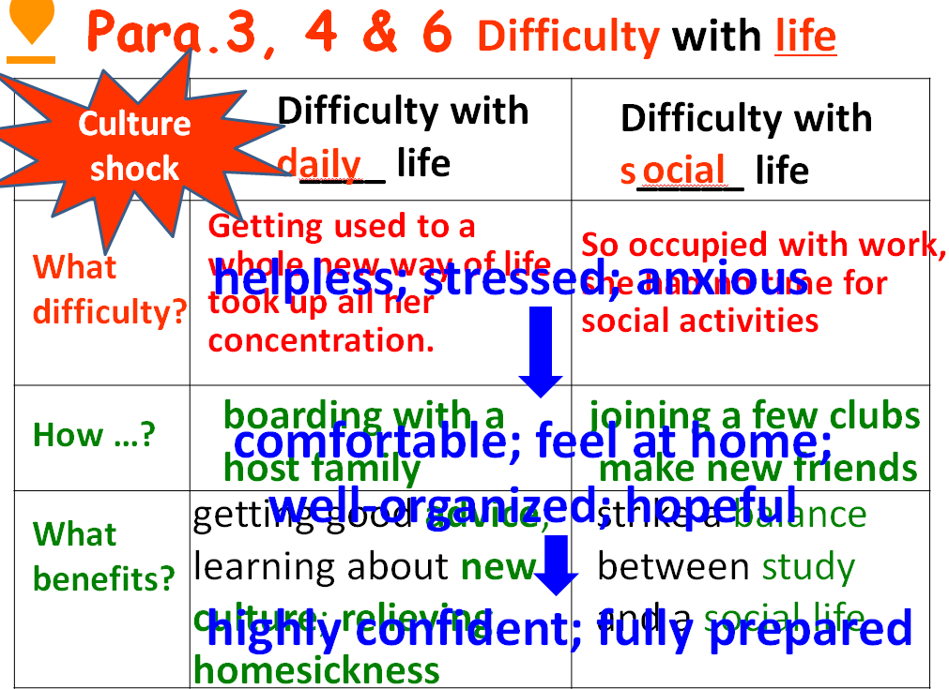
设计说明：通过图表形式引导学生在阅读中关注并分类主话题信息和次级话题信息，通过问题链帮助学生理出谢蕾在伦敦生活期间遇到困难、解决困难并最终克服culture shock，从而使学生根据文本信息的铺陈整理出有逻辑的线性信息，为后续的写作构思作准备。
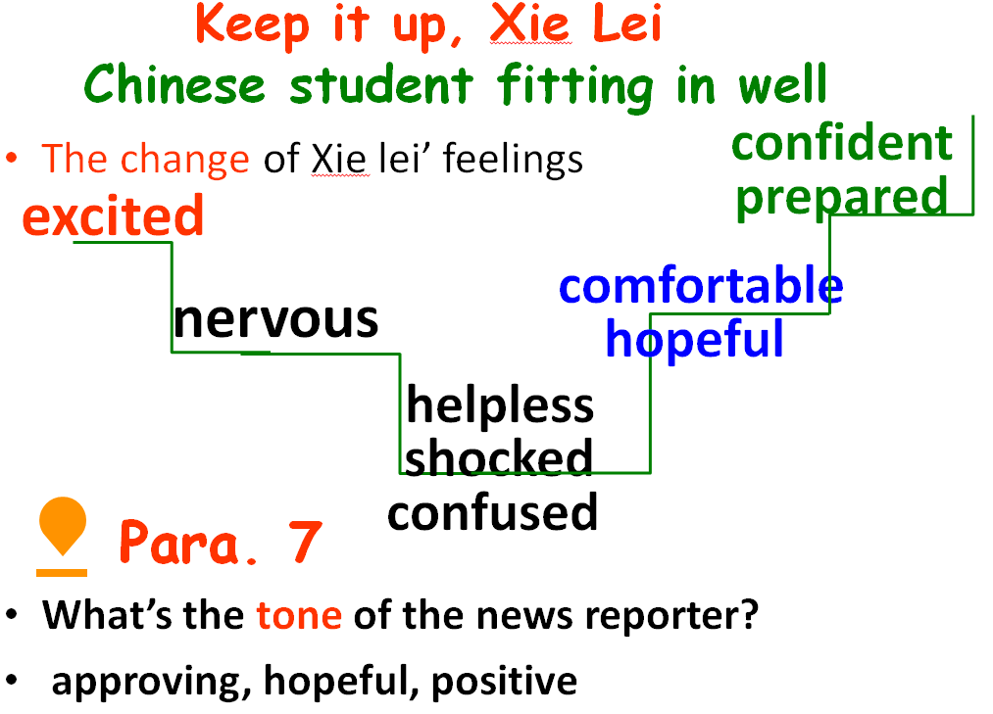
T: We’re glad that Xie Lei has successfully fitted in.
设计说明：指导学生在文本阅读后，再次从解读标题的角度梳理谢蕾在遭遇海外学习生活的困难并成功克服后的现状、未来规划过程中的情感变化，理性客观地看待主人公克服困难后蜕变。
Step 4 Writing
T: Having read the passage, we can learn that there is much difficulty with study and life abroad, but we can manage to overcome it. More importantly, we will enjoy many benefits while studying abroad.
T: You are supposed to write a letter to one of your friends, Li Hua, as instructed.
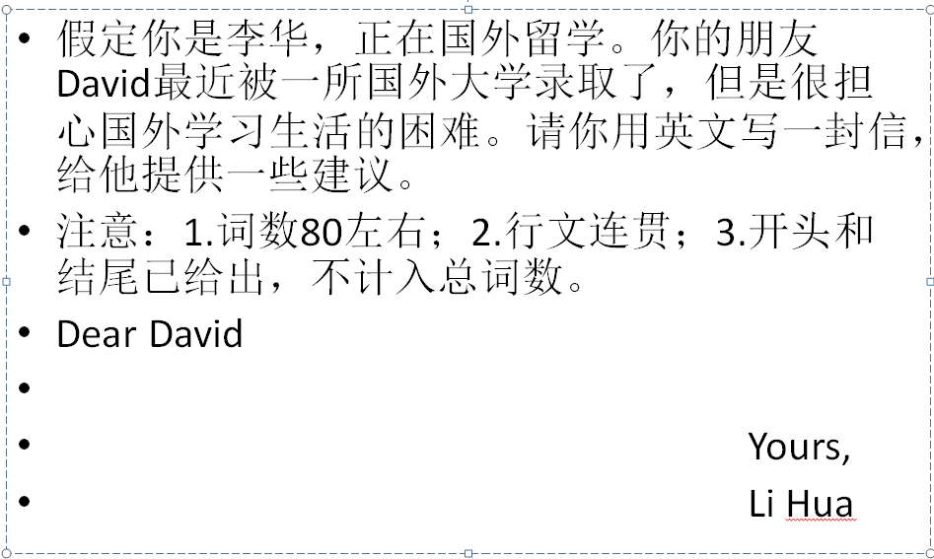
Group work1
T: Please make a group of four or six students to discuss the difficulty and benefits when someone studies abroad, based on the text and the question for writing.
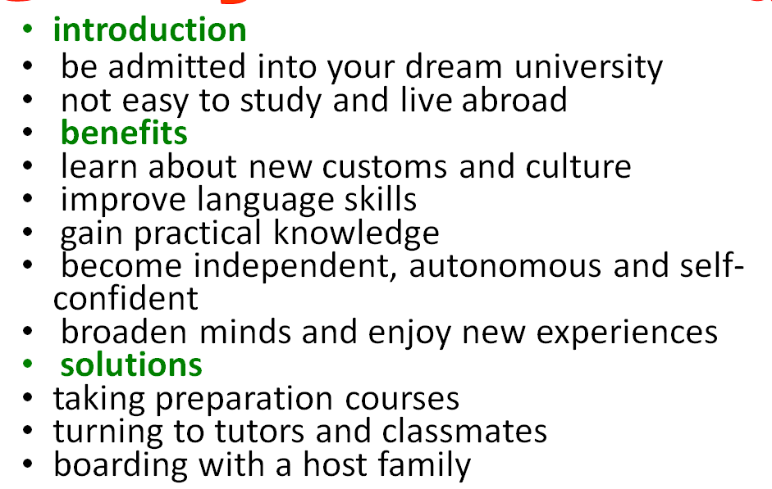
设计说明：这个讨论环节是学生由读到写的过渡。学生通过发挥小组合作的学习优势，集思广益，有层次、有逻辑的整理出书信写作中需要的子话题，根据文本信息罗列出有效词句，为后续的小组写作做好充分的准备。
Group work 2
T: It’s time that we teamed up to complete a piece of writing.
Step 5 Presentation
S：Present their writing work
设计说明：用小组合作的形式完成写作任务，使学生们体会协作的成果，可以有效地降低学生对写作的畏难情绪，进而体验成功的快乐！
Step6 Assignment
Complete and polish your writing after class.
设计说明：有了课堂阅读指导和小组合作写作的成功体验，学生课后独立完成自己书信写作，他们会觉得有底气，也会对个人作品有更高的期待值。
