**Practical Writing**

**How to write about activities effectively**

**Learning Objectives:**

1. Analyze the common mistakes in recent practical writing
2. Grasp the basic elements of writing an event and write correct sentences with these elements
3. Create a piece of practical writing

**Activity1: Let’s share some useful expressions**

1. **在具体某一天、持续几天、从...到...**

在9月18日

在这/上/下周五下午三点钟

持续到11月25日(选必三P8)

持续大约三小时，从上午8:30到11点

1. **计划、举/主办、组织、(报名)参加...**

**Activity2****: Brainstorm expressions about theme and purpose**

**Theme Purpose**

**Practice: Write complete sentences covering the following points**

1.昨天我去参观学校举办的学生国画作品展2.展览目的、时间、地点。

__________________________________________________________________________________________________________________________________________________________

_____________________________________________________________________________

**Activity3: Fill in the form**

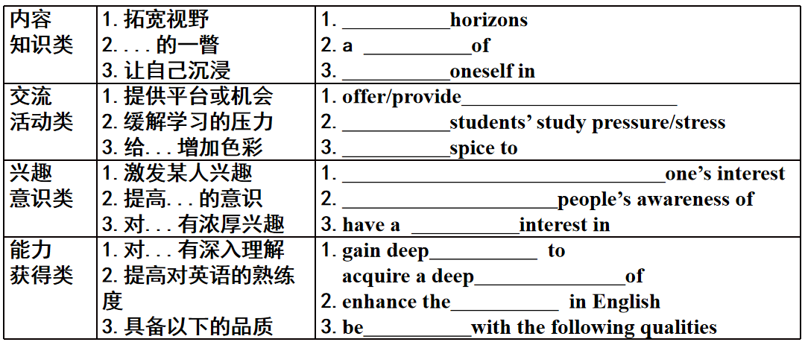

**Activity4: Create your own writing (可参考选必三P8)**

（2021.6浙江）昨天你参观了学校举办的学生国画作品展。请你给校英文报写一篇宣传稿，内容包括：1.展览时间、地点；2.观展感受；3.推荐观展

注意：1. 词数80左右；2. 可以适当增加细节，以使行文连贯。

__________________________________________________________________________________________________________________________________________________________

__________________________________________________________________________________________________________________________________________________________

__________________________________________________________________________________________________________________________________________________________

__________________________________________________________________________________________________________________________________________________________

_____________________________________________________________________________

_____________________________________________________________________________

_____________________________________________________________________________

选必三Unit 1 Art P8 ANCIENT CHINESE ART ON SHOW

The Richfield Museum of Fine Art **is proud to present our new exhibition**, "From Shang to Qing: Chinese Art Through the Ages." Join us as we explore more than 3,000 years of wonderful art from the Middle Kingdom. From bronze bowls to ceramic vases, and jade sculptures to ink wash paintings, **our goal is to display the Chinese artistic genius from ancient times.**

**The highlight of this exhibition is** the painting *Clearing After Snow* *on a Mountain Pass*, one of the great works of Tang Yin (1470-1524). Born during the Ming Dynasty, Tang sought and failed to gain entry into the civil service, so he turned to painting instead. In time, **he gained recognition as** one of the greatest artists China has ever known. This painting, **showing** high mountains, trees, and houses covered in snow, was made **with extraordinary skill**. Though it is over 500 years old, **it looks as fresh and full of life as the day it was created**.

Also of primary note is a collection of nearly 100 bronze objects from the Shang Dynasty (1600 BCE-1046 BCE). While the artists who made these great works are not known, they showed great skill in creating these beautiful pieces. **Some of the items on display** are thought to have come from the collection of Emperor Qianlong(1711-1799), a great admirer of Shang Dynasty bronze.

Finally, we have many fine examples of Tang Dynasty (618-907) sculptures. Most of these are of Buddhist **origin**. Even though Buddhism entered China much earlier, it did not really begin to show expansion until the seventh century. During this same period, trade along the Silk Road also boomed. Chinese sculpture thus found itself **highly influenced by** Buddhist art brought from India and Central Asia through the Silk Road. **These works were intended to** spread Buddhism and they are of exceptional beauty and quality. Looking at the faces of the figures in these sculptures, one sees the faces of the past. **History is brought to life.**

This is just **a small taste of** what is **in store** for you in this exhibition. We **guarantee that** "From Shang to Qing: Chinese Art Through the Ages" will transport you to another time with its amazing collection of works.

"From Shang to Qing: Chinese Art Through the Ages" will **run until November 25**.

Opening hours are from 9:00 a.m.to 5:00 p.m., from Tuesday to Sunday (the museum is closed on Mondays). No one will **be admitted into** the exhibition after 4:30 p.m.

**Admission**: $10 for adults; $8 for students; $5 for children under 12; free for children under 5.

No photos or food and drink are allowed in the museum.