**M2U2 The Internet**

**Reading and Thinking**

**温溪高级中学 普高英语组 郑丹丹**

**Teaching Objectives：**

At the end of the class, students will be able to

1. master the following new words and phrases: convenient, convenience, updated, database, benefit from, be beneficial to, now that, so… that…, have access to, be accessible to…

2. know the structure and the benefits the internet brings to us

3. learn to make good use of the internet with the example of Joan

**Teaching Important and Difficult Points：**

1. How to make students make clear the structure and the main idea of the passage.
2. How to make students work out Joan’s attitude to the internet, and learn from her experience.

**Teaching Procedures:**

**hundred**

**thousand**

**million**

**____________关于**

**Step 1: Free talk**

Students will be asked to say something about the benefits they have gotten from the internet with the following sentence pattern:

**With the app,xxx, it is more convenient for me to...**

The teacher comments on students sharing——**How we have been changed by the internet!**

**Step 2: Prediction**

Students will be asked to look at the title to predict today’s lesson:

1. What is the difference between the two titles?
2. How does the author connect the two titles together?
3. Can you make a prediction of the main idea of the passage?
4. What kind of passage it may be?
5. How does the author feel about the internet according to the title?

**Step 3: Read for structure**

1. Students will be asked to look through the passage quickly and complete the main idea of each para:

Para1: Benefits of the internet to our life

Para2: The difficulty Joan met and solved

Para3: Joan started an IT club to help others

Para4: Joan's next goal

Para5: Joan's life has been greatly improved

2. Students will be asked to divide the passage into three parts according to the main ideas, and work out the functions of each part

**Step 3: Read for Details**

**Task1: Read for the benefits**

Students will be asked to read para1 to answer the following questions:

**Result**

1. What are the benefits?
2. How does the author put forward the benefits?
3. What are the author's comments on the internet?

The teacher comments on the benefits——General benefits

**Task2: Read for specific benefits**

Students will be asked to read para2-4 to answer the following questions:

**Result**

1. Revise structure of the example——Joan’s life have been changed

**Cause**

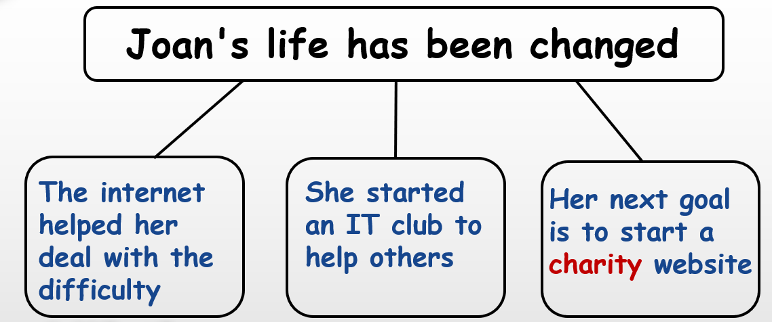

For para2:

1. What is the difficulty? And why?
2. How did Joan deal with the difficulty?
3. What did Joan learn from the difficulty? (Students will be asked to analyze the structure of the long sentence)

For para3:

1. Why did Joan start the IT club? (Students will be asked to analyze the structure of the long sentence)
2. Any examples?

For para4:

1. What does “charity” mean?
2. What stir up Joan to start a charity website to…? (Students will be asked to analyze the structure of the long sentence)
3. Who does “everyone” specifically refer to?
4. What does “digital divide” mean?
5. From here, what kind of person is Joan？
6. What can we learn from Joan’s experience?

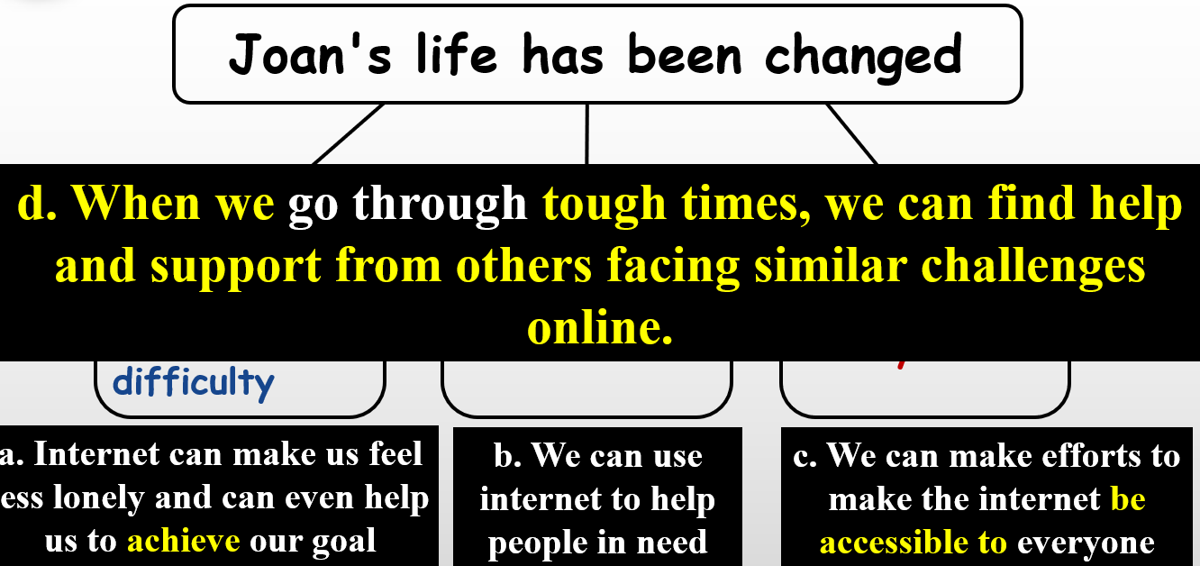

**Step 4: Read for revision**

Students will be asked to look through the passage again and revise the structure and main idea of the passage, and the writing skill the author used.

**Step 5: Summary**

Jan Tchamani，an English teacher in Birmingham，UK，suddenly developed a serious illness. She found herself out of work and 1. (stick) at home. After a while，she discovered that 2. (surf) the Internet could help her feel less lonely and bored. She could do all kinds of things online. She also joined 3. online group where she could talk about her problems and get support and advice 4. others. She realized that one of the greatest 5. (benefit) of the Internet was its ability to remove the distance 6. usually exists between people.7. (inspire) by the people online，she decided to start an IT club and taught older people how to use the Internet. She and her friends organize events and collect money 8. (pay) for private teachers. Jan has started taking online classes to learn more about how to use the Internet to make society 9.______(good)．Jan’s life has been 10. (great) improved by the Internet!