**2024年2月新阵地应用文教学设计**

设计理念：

通过本节课的教学，了解倡议信的写作步骤及基本框架，通过审题、谋篇布局、Q&A问题链、范文赏析等步骤，提高学生对应用文写作的基本认知。同时，通过多道相关话题的串联，让学生对报道句式更为熟悉，形成自己的语料库，以应对相关话题的考察。

教学目标：

1. 学生能够自主对应用文进行审题；

2. 学生能够了解倡议信类应用文的写作结构框架；

3. 学生对要点进行发散性思考；

4. 学生能够学会去乐于助人、参与志愿服务。

Step 1：审题

Lead-in：Preparation for writing：

审题：明确一篇应用文题目的六大要素

体裁、时态、人称、语气、交际对象、主题语境。

Step 2：谋篇布局；

明确三段要写的具体内容：

Paragraph1: 背景介绍+发出活动倡议

Paragraph2: 具体介绍活动内容+意义

Paragraph3: 再次发出活动倡议

Step 3：语言操练

对每个要点进行Q&A模式思考，并给出每部分的词块与句式，让学生有足够的积累

Q1:如何阐释背景？

Q2:号召某人做某事怎么表达？

Q3: What？哪些活动？

Q4: How？如何衔接？

Q5:可以采用哪些句式发出号召？

Step 4：范文呈现

Dear teachers and schoolmates,

With the International Volunteer Day in full swing, I am thrilled to appeal to you to participate in volunteer activities with the theme of mutual assistance and care organized by our school, which celebrate and embody humanistic principles.

The relevant activities commence with beautifying campus activities. Varieties of activities will be organized, including planting trees together, and decorating the initially dull walls, from which we can fully realize the importance of mutual assistance. What follows next is working for the nursing home. During the stay, we are designed to engage them in several interactive games, which involves assisting the elderly in handling daily chores and teaching them to obtain basic computer skills. Subsequent to it, concerning the assistance for disaster-stricken areas, a series of charity contributions are scheduled by our school, such as contributing second-hand reference books and high-quality stationery. What we are supposed to do is cleaning and packing the donations for the people in need. It is worth mentioning that we can exert enough attention to the left-behind children in our daily activities. Personally, all the above volunteer activities are bound to render us rewarding experiences.

It is every bit of what you do that truly counts/matters. Let us work together to make a positive difference to those around us and contribute to a better world for all.

The Students’ Union

Step 5：学生习作呈现，亮点与不足；范文赏析，补齐学生不足

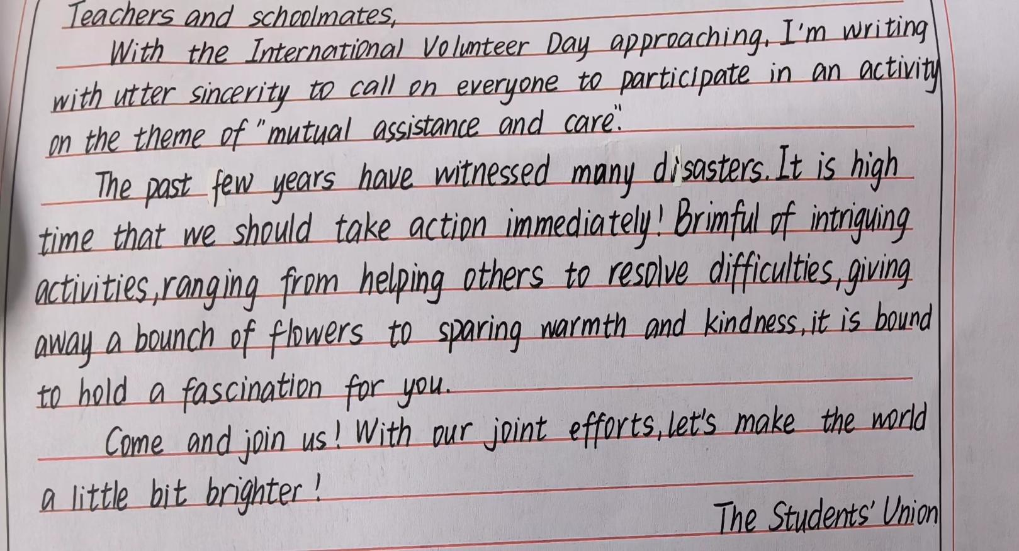内容：

结构：

语言：

不足：

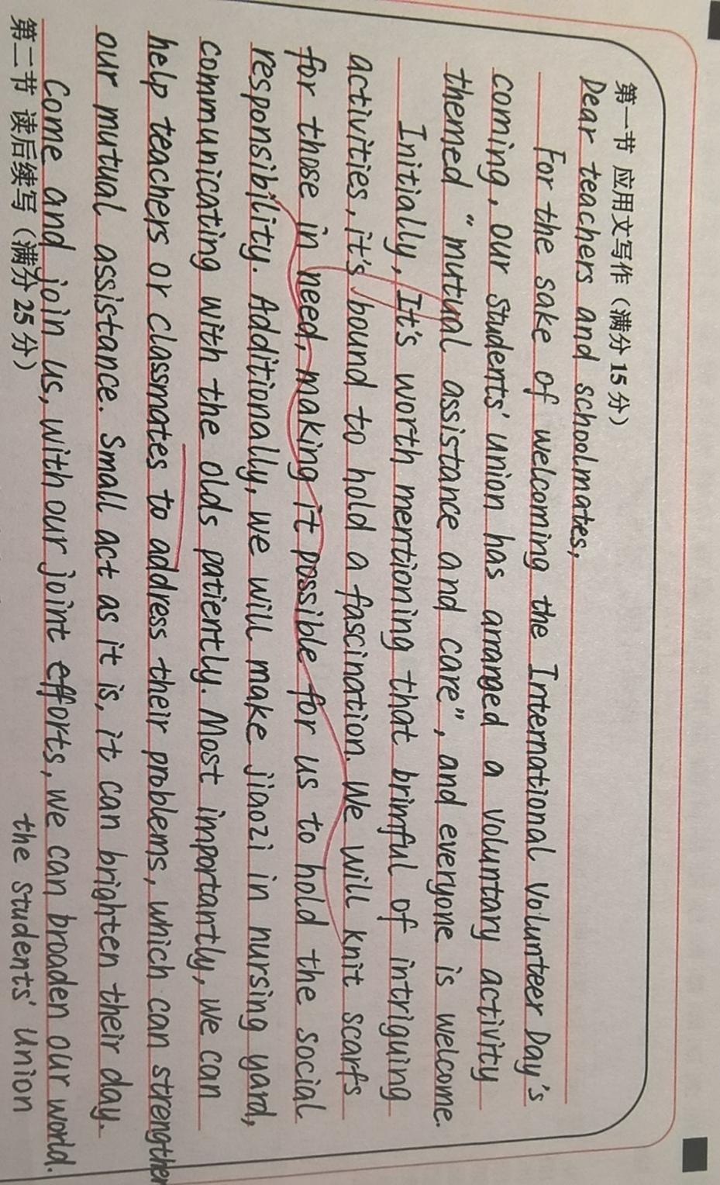

内容：

结构：

语言：

不足：

Step 6：相关话题应用文以及参考范文的赏析

（2023.3 福建模拟）假定你是李华，上周日你校举办了以“The Power of Voluntary Work”为主题的演讲比赛。请你为校英文报写一篇报道，内容包括：1.参加人员；2.比赛过程；3.活动反响。

The Power of Voluntary Work

Targeted at provoking students’ awareness of dedication to assisting others, a speech competition with the title of “the power of voluntary work” was held as scheduled in our school last Sunday.

After several rounds of fierce competition, 10 finalists gained access to the final. At the very start, the opening speech was delivered by the principal, who laid emphasis on the core value of volunteer work. Subsequent to it, each contestant was required to deliver a pertinent speech within 5 minutes, embodying the essence of volunteer work. Eventually, centered on their immediate performance and the content, 3 students were awarded certifications in recognition of their distinguished performance.

Thunderous applause marked the end of the competition. Not only could it ignite students’ zest for volunteering, but it could shed light on the significance of individual’s deeds, which would contribute to the improvement of the society.

Step 7：总结

先给出相关词块，让学生进行摘录，方便后续对倡议信这一信体进行进一步总结。