**基于微写作提升语言技能的读后续写讲评**

**（以Z20读后续写---寻找彩虹源头的女孩为例）**

杭州二中树兰高级中学 郭合英

2021年8月Z20开学考读后续写：

One summer afternoon, when I was about eight years of age, I was looking at a beautiful rainbow that, bending from the sky, seemed to be losing itself in a thick wood about a quarter of a mile distant.

“Do you know, Gracie,” said my brother, who was just recovering from a severe illness, weak and tired, "that if you should go to the end of the rainbow, you would find there precious treasures?”

“Is it truly so?” I asked.

“Truly so,” answered my brother, with a smile but a very serious face.

Now, I was a simple-hearted child who believed everything that was told to me; so, without another word, I rushed out toward the wood. My brother called after me as loudly as he was able to, but I did not take any notice of him.

I cared nothing for the wet grass, on and on I ran. I was so sure that I knew just where that rainbow ended. But when I reached the cedars (雪松林）, the end of the rainbow was not there! Abruptly I saw it shining down among the trees a little farther off; so on and on I struggled, through the thick bushes, till I came within the sound of a stream. I reached the bank of the stream, and I could see it a little way off on the other side. I crossed the stream on a fallen tree, and still ran on, though my muscles were aching and my knees shaking.

Suddenly I met in my way a large porcupine (豪猪）. I ran away from him as fast as my tired feet would carry me. In my fright and hurry I forgot to keep my eyes on the rainbow, and when, at last, I remembered and looked for it, it was nowhere in sight!

When I saw that it was indeed gone, I burst into tears, for I had lost all my treasures, and had nothing but muddy feet and a wet and torn dress. So I set out for home.

注意：

1. 所续写短文的词数应为150左右；

2. 至少使用5个短文中标有下划线的关键词语；

3. 续写部分分为两段，每段的开头语已为你写好；

4. 续写完成后，请用下划线标出你所使用的关键词语。

Paragraph 1:

But I soon found that my troubles had only begun.

、

Paragraph 2:

At last I heard my own name called.

**Teaching contents:**

1.Understand the story and define the theme 读懂故事，确定主题

2.Use the given sentences and keywords to refine the plot 利用给出句和关键词，完善情节

3.Analyze the features of language and make use of micro-writing to rich expression.

剖析语言，巧用微写作，丰富表达

4.Use the micro-writing to perfect the situation 巧用微写作，完善情境

5. Model essay 范文

**Teaching goals：**

Based on mic-writing, the teachers help the students improve the language ability to write continuous writing. After teaching this lesson, you will

1. Analyze the language features of the passage.

2. Based on the language features , make use of the mic-writing to make sentences.

3. Make use of the mic-writing to create a situation with a variety of description,such as action description, psychological description.

**Teaching highlights:**

1. Based on the language features , make use of the mic-writing to make sentences.
2. Make use of the mic-writing to create a situation with a variety of description,such as action description, psychological description.

**Teaching difficulties:**

Make use of the mic-writing to create a situation with a variety of description,such as action description, psychological description.

**Teaching steps：**

**Step1：Lead-in：**

To stimulate the students’ interest, the teacher will show a short video “Over the rainbow”.

**Step 2: 文本解读：**

1. Understand the story and define the theme 读懂故事，确定主题

Choose the best answer according to the passage.

1. Why did Gracie’s brother call her when Gracie rushed out toward the wood?

A. Because her brother regretted telling her the thing.

B. Because her brother fear her taking the treasures.

C. Because her brother wanted her sister to take care of him.

D. Because her brother had taken the treasures.

2. Why did Gracie run on end, ignoring the wet grass?

A. Because she was told to do so.

B. Because she was cheated, running for wreaking.

C. Because she was afraid of the porcupine.

D. She believed firmly she could find the rainbow end.

3. What was the feeling when Gracie firstly rushed into the thick wood?

A. pessimistic B. fearless C. timid D. nervous

4. Why did the brother mention the precious treasure to Gracie?

A. Because there was really a lot of treasure at the end of the rainbow.

B. Because he wanted their family be rich.

C. Because it implied the theme of the article .

D. Because he wanted to prove he was healthy.

（2） 理清脉络 5个W 1个H

|  |  |
| --- | --- |
| 5个W  1个H | CONTENTS |
| who |  |
| when |  |
| where |  |
| what |  |
| why |  |
| how |  |

**Step 3:** Use the given sentences and keywords to refine the plot

利用给出句和关键词，完善情节

Paragraph 1:

But I soon found that my troubles had only begun.

|  |
| --- |
|  |

Paragraph 2:

At last I heard my own name called.

|  |
| --- |
|  |

**Step 4：Analyze the features of language and make use of micro-writing to rich expression**

**剖析语言，巧用微写作，丰富表达**

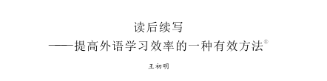

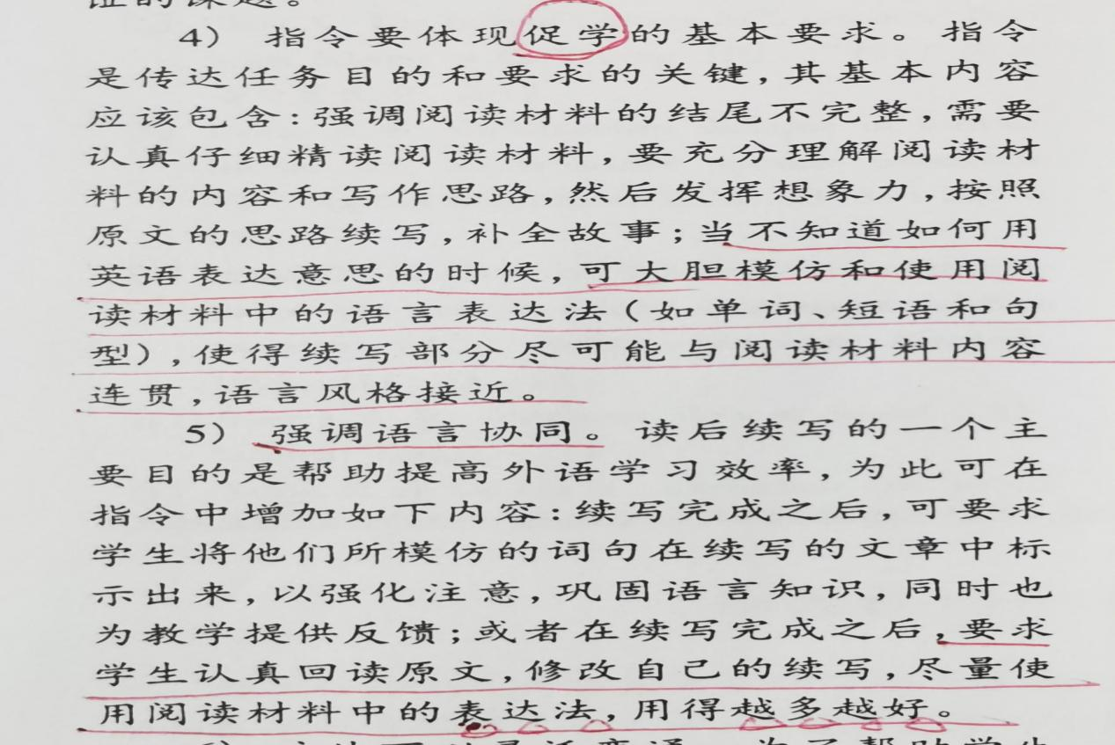



由此可知，续文的语言特点要遵循原文的语言特点，做到语言协同。为此，笔者采用微写作的方式，引导学生创造和模仿原文语言，达到与原文语言风格一致的目的。

【文本句子】One summer afternoon, when I was about eight years of age, I was looking at a beautiful rainbow that, bending from the sky, seemed to be losing itself in a thick wood about a quarter of a mile distant.

【文本句子】Now, I was a simple-hearted child who believed everything that was told to me;

|  |
| --- |
| 【模仿要点】定语从句，现分作定的句式特点。 |

【句子仿写】就在我绝望的时刻，我听到了一个声音，在森林上方萦绕，似乎来自家的方向。

【文本句子】 “Do you know, Gracie,” said my brother, who was just recovering from a severe illness, weak and tired, "that if you should go to the end of the rainbow, you would find there precious treasures?”

【模仿要点】定语从句、宾语从句、虚拟语气和形容词作状语

【句子仿写】丛林中，感到孤独无助的我躺在地上，又饿又累。想像着如果这个时候爸爸、妈妈在就好了。

【文本句子】My brother called after me as loudly as he was able to, but I did not take any notice of him.

【模仿要点】短语：take notice of = notice 注意

【句子仿写】我没有注意到来时的路，结果迷失在森林中。

【文本句子】I cared nothing for the wet grass, on and on I ran. I was so sure that I knew just where that rainbow ended. But when I reached the cedars (雪松林）, the end of the rainbow was not there! Abruptly I saw it shining down among the trees a little farther off; so on and on I struggled, through the thick bushes, till I came within the sound of a stream.

【模仿要点】短语：on and on + 主+ 谓

【句子仿写】我焦急地寻找着回家的路，像个兔子一样在森林中不停地乱跑。

【文本句子】I ran away from him as fast as my tired feet would carry me.

【模仿要点】无灵表达

【句子仿写】在空无一人的森林里，恐惧深深地抓住了我。

【句子仿写】尽管是白天，茂密的森林发出阴冷的光，好像一个巨大的怪物，张开它的血盆大口，好像要把我吃掉。恐惧爬上了我的心头，使我浑身不寒而栗。

【文本句子】In my fright and hurry I forgot to keep my eyes on the rainbow, and when, at last, I remembered and looked for it, it was nowhere in sight!

【模仿要点】keep one’s eye on 注视，监视； in sight 看见

【句子仿写】我靠在树上，抬头注视着天空，努力迫使自己冷静下来：我必须想出一个办法使自己走出森林。

【句子仿写】一看见哥哥，我就像离弦的箭一样朝他飞奔过去，委屈地嚎啕大哭。

【文本句子】When I saw that it was indeed gone, I burst into tears, for I had lost all my treasures, and had nothing but muddy feet and a wet and torn dress. So I set out for home.

【模仿要点】be gone 消失了，不见了； nothing but 只有

【句子仿写】最后，我眯着眼睛凝视着天空，天上除了白云什么都没有。天上的彩虹不见了，这使我伤心极了，心仿佛被撕成了碎片。

**Step5 Use the micro-writing to perfect the situation 巧用微写作，完善情境**

向学生强调细节对情境的重要性，并对细节进行分类，包括语言、心理、动作、表情、场景等。每一种类的细节都有其相应的作用。老师们可以利用微写作，创设相应的情境，赋予故事生命力和鲜活的画面感，让续写内容更加生动、有趣。

【创设情境】虽然是大白天，可是在我心里，白天犹如漆黑的夜。在空无一人的茂密丛林中，我吓得要死，呆在原地放声大哭。

【创设情境】炎热的夏天，丛林里密不透风，这使我满身是汗。找不到回家的路，我害怕地喘不过气来，着急地好像有十个太阳在心里燃烧。我的无助感油然而生，情不自禁地绝望地哭了。

【创设情境】正午的阳光热辣辣地撒向大地，投下的树影像一条条爬来爬去的蛇，吐着长长的舌头朝我扑过来，我害怕极了，大声哭喊，感觉自己的心好像从身体里被撕开了一样。

【创设情境】当哥哥和妈妈突然出现在我眼前的时候，我就像看到了分开十年的亲人，激动的热泪盈眶。我张开双臂，像鸟儿一样朝他们飞奔过去。此时，我感到空气如玫瑰般清新，阳光如少女般温柔，我脸上的笑容像钻石一样闪闪发光。

【创设情境】当听到有人叫我名字的时态，我高兴极了，忘记所有的伤心和疲倦，从地上一跃而起，朝喊我的方向，拼命地挥手，并大声疾呼，“我在这儿。”

【创设情境】当哥哥看到我的时候，一股歉意的微笑挂在他的脸上。 他紧紧地抱着我，说，“世间最最珍贵的珍宝是亲情，不是天上的彩虹。” 我的眼睛湿润了，紧紧地抱着哥哥仿佛想把他的呼吸挤出来。

**Step6** Model essay 范文

Analyze the model essay.(从情节、衔接、语言、描写、修辞等方面去分析)

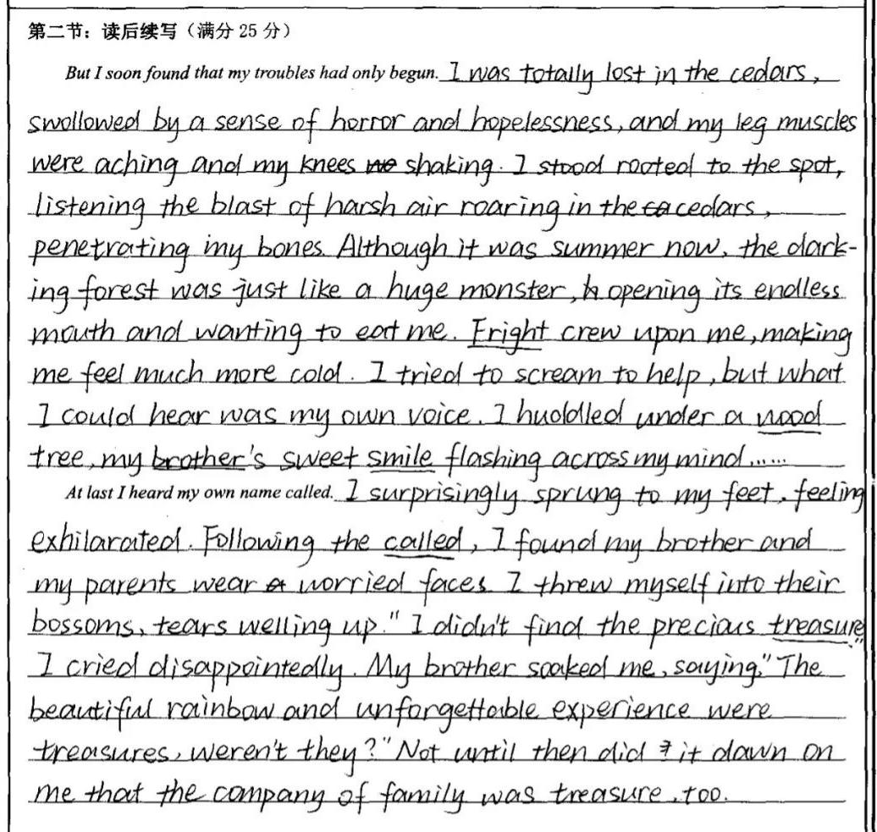

|  |
| --- |
| The features of the passage: |

**A possible answer**

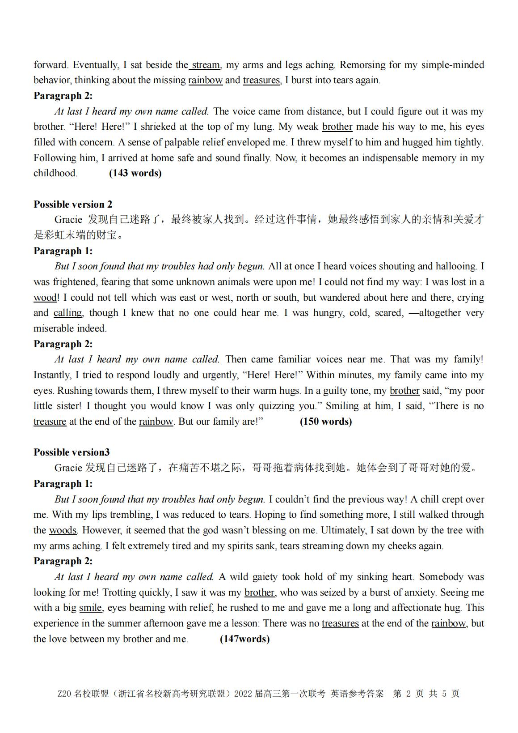

Homework

Apply the micro-writing skill to other continuous writings.