选择性必修第四册
Unit 1 SCIENCE FICTION
Period 1 Reading and thinking
年 级 | Senior Grade 2 | 授 课  教 师 | 郭文昇 | 学 科 | English | 授 课  日 期
课 题 | Satisfaction Guaranteed |  |  | 课时  安排 | 2 | 课 型 | 新授课
文本解读
本单元的主题是“科幻小说”，属于文学体裁。本版板块的阅读文本改编自阿西莫夫的科幻短篇小说《包你满意》，探究人与机器人之间的关系，讲述的是机器人公司员工Larry的妻子Claire与测试版家庭机器人Tony之间发生的故事。故事按照时间顺序自然推进，第一段交代故事背景，余下各段聚焦不同场景和情结。
Ⅰ. Instructional objectives:
At the end of this class, students will be able to:
1. summarize the main idea of this text;
2. infer the changes of Claire’s feelings towards Tony as the story developed;
3. figure out the relationship between the characters mentioned in the story by scanning the passage;
4. learn to describe the similarities and differences;
Ⅱ. Key points:
Infer the changes of Claire’s feelings towards Tony from supporting evidence.
Ⅲ. Teaching procedures:
Step1 Lead-in
The teacher shows some background information of Isaac Asimov. Then, students enjoy some pictures of robots and talk about some related questions.
Q1. What types of robots are the following robots?
Q2. How do robots already help humans today?
Q2. Do you think it is possible for a robot to
think for itself ?
have feelings?
have its own needs and desires?
look and feel like a human being?
Justification: arouse students’ interest and elicit the topic
Step2 Prediction
Students skim the title and pictures to predict the content, and then try to answer the following questions.
Q1. What do you expect to read from the text?
Q2. Whose satisfaction do you think will be guaranteed?
Q3. What does the word “adapted” mean?
Q4. Will there be a robot in this novel? What type of robot will it be?
Justification: prepare for reading
Step3 Skimming and scanning
After prediction, they are asked to skim the text quickly to take notes on who these people (Larry Belmont, Claire, Tony and Gladys Claffern) are and their relationships to each other. Finally, students conclude the main idea of this passage.
Justification: to train students’ ability to summarize the main idea.
Step4. Detailed reading
Students read the story carefully and grasp the keywords to answer the following questions. The most important thing is to explore and infer the changes of Claire’s feelings towards Tony as the story developed.
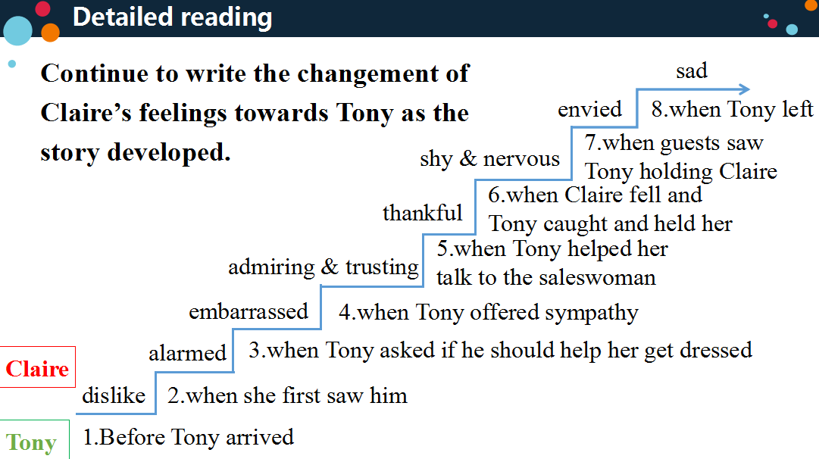
Students work in groups and come up with an ending. Then, they listen to the rest of the story and continue to write the changes of Claire’s feelings towards Tony at the ending. Students try to find the similarities and differences between Tony and a human being.
Justification: Practice reading a passage for details and language features. Help students to fully understand the text to support Step 5.
Step 5. Further thinking
After reading the whole passage several times, the teacher asks the students to discuss the following questions with their partners:
Q1. Whose satisfaction do you think will be guaranteed?
Q2. What does the word “adapted” mean?
Q3. What type of robot will it be?
Q4. Do you think it is possible for a person to love a robot? Why?
Q5. What relationship do you think will develop between humans and robots in the future?
Justification: foster students’ critical thinking.
Ⅳ. Homework
Try to write a summary of the article in about 60 words based on the changes of Claire’s feelings towards Tony.

