**“读后续写”教学设计**

**一、整体设计思路**

1．教材分析与个人思路

这是一个关于一只被遗弃的花猫帮助女主人摆脱危险的故事。女主人搬到德国的一所老房子里，有很多地方都很陈旧，丈夫告诫她不要一个人去探索。有一天，女主人想去探索地下室，但她的丈夫不在家，于是她把这只叫Angelica的猫带上，这只猫一直陪伴着她。女主人不小心从楼梯上摔了下来，手机和眼镜都碎了，她也无法攀爬出去。她想到把手机扔上去让Siri帮忙召唤救援，但是只有Angelica能够帮助她。她把手机扔向天花板，Angelica用爪子打了它一下，让它掉在可以接收信号的地方。女主人通过电话和救援人员联系，请求他们寻找Angelica，这只猫最终引领救援人员找到了她并将她解救。这个故事告诉我们生命是一份礼物，如果我们相信它，生命会用奇迹回报我们。

教师应以文本解读的方式带领学生走进主人公Tasha的心理世界，深入剖析事件的起因经过，引导学生完成结果的输出。在设计思路上，以情节线和情感线并举，从整体阅读到细节阅读，关注伏笔，回应铺垫，完成读后续写的教学任务。

2. 学情分析

本课的授课对象为丽水市龙泉第一中学高三（5）班的学生。他们基础较好，但部分学生在文章的整体性把握以及对某些细节的处理上还有一定难度，因而对学生阅读思维的培养对于教师而言是需要突破的重点和难点。

**二、教学目标**

1. Students will be able to get the theme of the text (angel,perfect companion;

Christmas gift)

1. Students will be able to understand the words and expressions related to the

story and use them to continue the story;

1. Students will be able to learn the techniques about how to continue writing the

story.

**三、教学重难点**

1. Read the lines and read between the lines to fully understand the text;

2. Develop their creative and critical thinking;

3. Apply the techniques to the writing.

**四、教学过程**

Step 1: Lead-in & Analysing

Have a free talk with the students and review the skills they learnt before.

1. What is the writing step of continuation writing?

2. What are the key elements we should focus on while analysing the text?

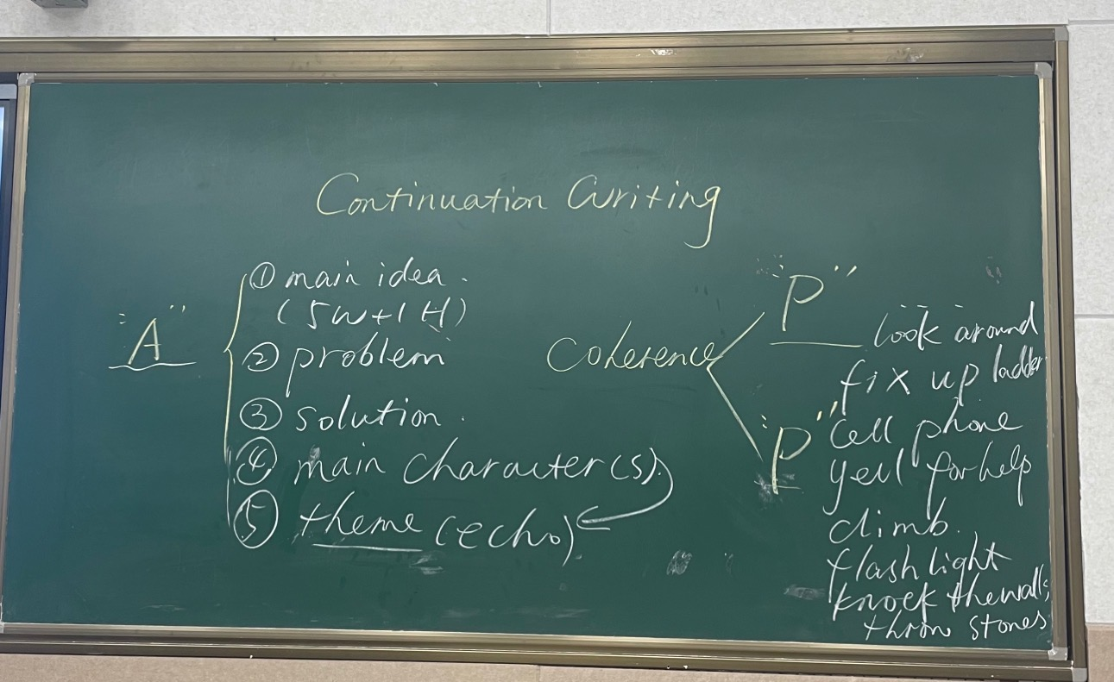

Step 2: Plotting

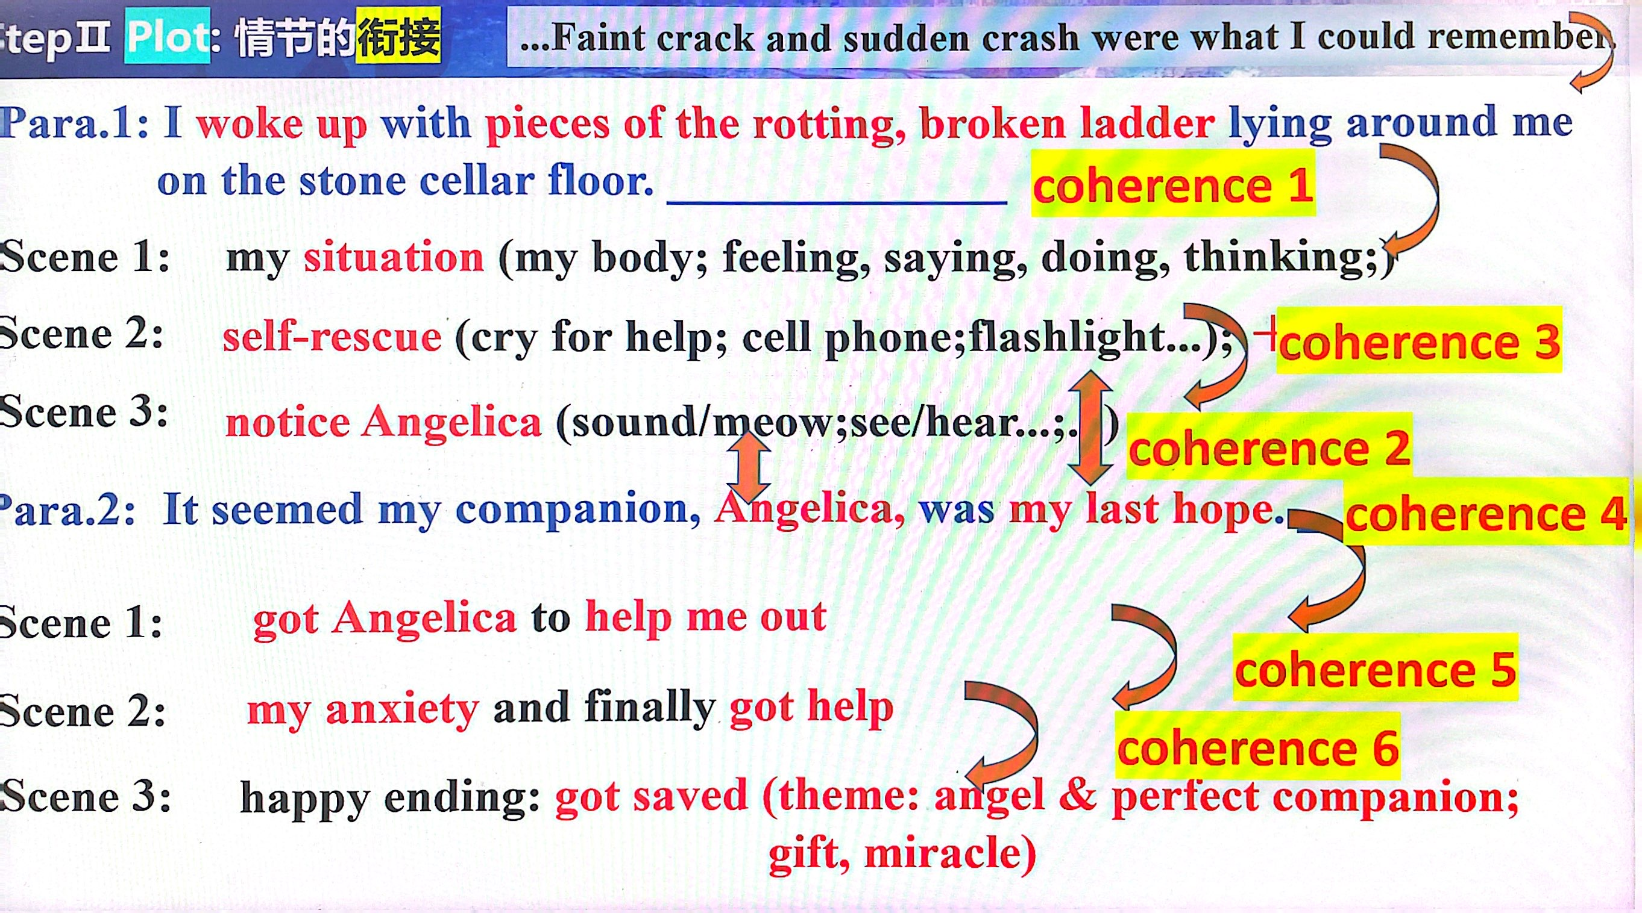

Think about the underground stone cellar with murky depths

Q: What are the possible ways to get out of this pit?

【设计意图】由于第二段提到Angelica, was my last hope.所以逆推到第一段中间必须讲述作者经过多次尝试无果，才有了第二段的最后尝试，所以引导学生脑风暴第一段中各种可能性的尝试很有必要。为下文做铺垫。（见板书）

Step 3:Polishing

1. Read one writing version from one of the students

【设计意图】本篇学生作品主要问题出现在第一段的中间部分的情节，没有提及各种尝试，是情节上的疏忽，让学生口头评价并改写，然后老师给范文。

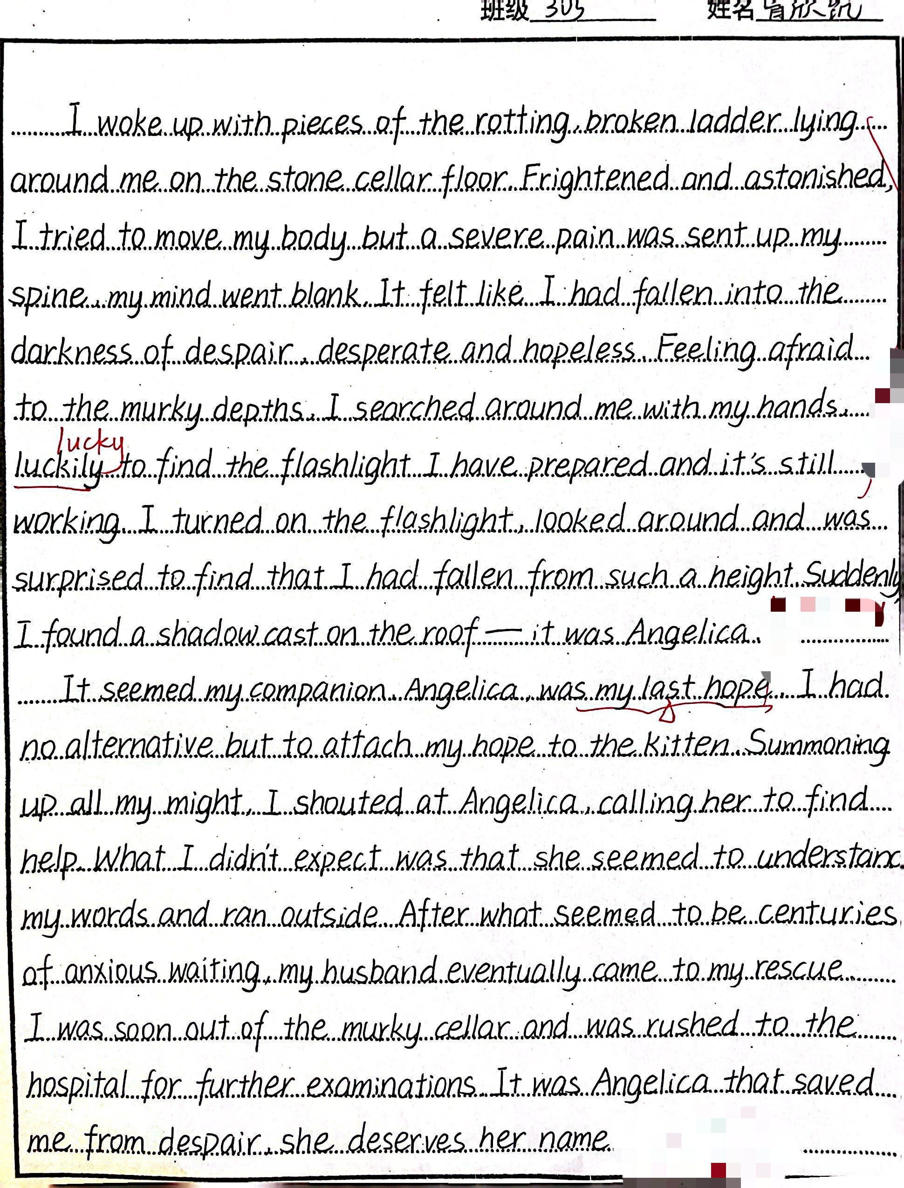

E.g.: ①②...desperate and hopeless.

③Feeling afraid of the murky depths, I plucked up my courage to search around, hoping to find a possible way out, but in vain. ④Later, I was lucky enough to find my flashlight I prepared before, considering it as a good tool to attract the attention of people outside. However, no response/no luck! / this did not work either.

⑤I was getting into an abyss of desperation when suddenly a shadow cast on the wall popped into my eyes — it was Angelica.

补充：书本（选必1U1）对多次失败的表达：

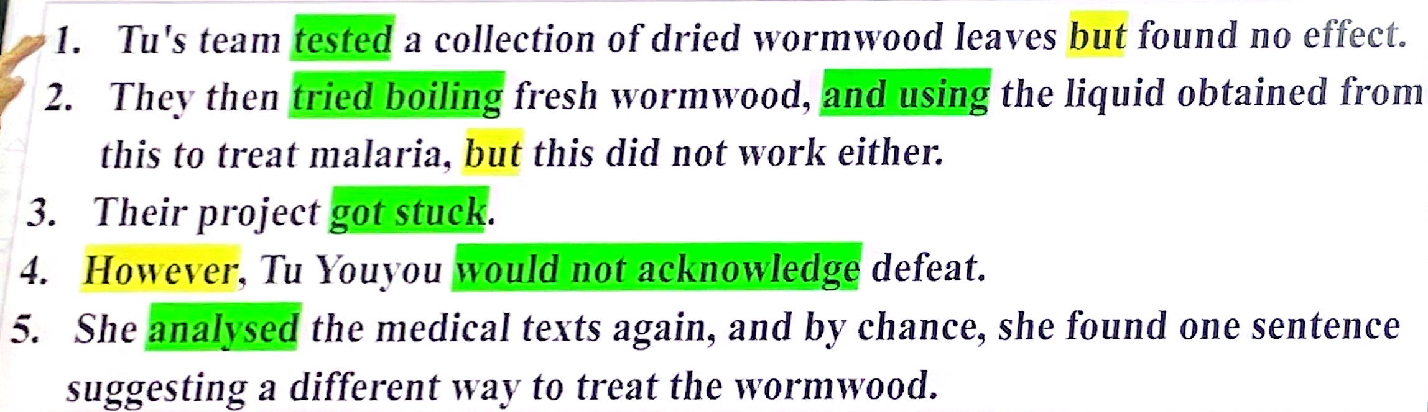

1. 范文学习

*I woke up with pieces of the rotting, broken ladder lying around me on the stone cellar floor.* Aching and confused, I struggled up and wiped the dirt off my clothes, scanning around, only to be greeted with a dreadful darkness. I turned on my flashlight, faint glow dispelling the darkness as well as my fear. Cocooned 包围in the rotten odour / ˈəʊdə(r)/ 臭味, I frowned and covered my mouth, striving to find my way out, but in vain. The freezing air went through my collar and my slight footsteps terrified me again. I had to admit I was not as courageous as Angelica. Searching up and down, I still couldn’t hatch an idea to extricate 使...逃离myself. At this crucial juncture 紧要关头, the constant meows of Angelica caught my attention.

*It seemed my companion, Angelica, was my last hope.* She seemed to sense my dilemma and was anxious to help me out. Angelica circled around nervously as she let out loud meows to arrest passers-by’s attention. No luck! Then she suddenly ran away, leaving me in a desperate situation. “Does she give up on me?”I murmured to myself. It seemed that the last ray of light in my world had dimmed. Maybe I would end up there. Just as I was about to give up, Angelica appeared with one of our neighbors, who helped me out successfully. It turned out that Angelica was running away for someone to come to my rescue. I held Angelica tightly in my arms as I shed grateful tears uncontrolably. I knew deeply in my heart that Angelica was a true angel of our family, also a perfect companion.

**四、课后反思**

本次开课是读后续写的常规教学，延续之前的风格，没有做出太大改变。个人认为整体维稳，没有突破。不足之处有以下几点：

1．课前准备不够充分，课堂各环节的衔接欠严密。

2．文本的逻辑关系梳理不够清晰，缺少深思熟虑，对于脑海中的想法不敢大胆实施。

3．没有领悟到师父的要求，对于关键词的处理没有认真执行，以为有了文本解读的扶持，没有关键词也没关系。但事后发现有关键词更加锦上添花。

4．上课灵活度不够，可能因为心理素质不够扎实，对于个别学生的回答反应不够灵敏，不能很好地满足学生的求知欲和表现欲。

5．解读能力还有待提高，教学经验依旧欠缺。

鉴于以上五个问题，接下去我应潜心教学，心无旁骛，以提高自身水平为念，多取经多实践，争取自我提升。

**附：**

**读后续写题目**

**阅读下面材料，根据其内容和所给段落开头语续写两段，使之构成一篇完整的短文。**

The Christmas holidays were fast approaching, and we had ordered many gifts online. So, when the doorbell rang, I was sure some of the packages had arrived. I ran to the door and swung it open, but no one was there. I sensed something and looked down, only to find a beautiful calico kitten (杂色猫) sitting there, looking up at me with big, intelligent eyes. There was no way that she could have rung the doorbell by herself, was there?

We figured that someone had found the kitten somewhere and left her there, and then rang the doorbell and ran away. They accurately guessed we would welcome an additional family member and take care of her.

My husband called her our little angel, so we named her accordingly. She had a calm aura (气质) about her as she walked straight into our home and hearts, fitting in perfectly. It seemed as if she was always meant to be in this big house with us. She was an old soul and turned out to be the perfect companion. Always by my side, she was more like a puppy than a kitten. Wise beyond her years, she enjoyed wandering through the tunnels and mysterious rooms as much as I did, but with much less fear. Angelica the calico was courageous.

So, I took a page from her book and decided to be brave, too. There was an underground stone cellar (地窖) I had been eager to explore. The only way in was down a rickety (摇晃的) ladder to its murky(阴暗的，难以理解的) depths. I guessed it was an old root cellar, probably twelve feet deep.

I had promised my husband that I wouldn’t explore dangerous areas unless he or someone else was around. Though I knew I was stretching it, I figured that Angelica would count as my companion. I was ready to explore this cellar, and so was she.

I equipped myself with a good flashlight and warm clothes, and carefully started down the rickety ladder while Angelica was looking down at me from above. Faint crack and sudden crash were what I could remember.

注意：

1.续写词数应为 150 个左右；

2.请按如下格式在答题卡的相应位置作答。

*I woke up with pieces of the rotting, broken ladder lying around me on the stone cellar floor.*

*It seemed my companion, Angelica, was my last hope.*