**Unit 5 Book 2 导案**

1. **classical ['klæsɪk(ə)l]adj. 古典的；经典的；一流的n. 古典音乐**

While it is likely that he understood very little of the books, they were his introduction to classical paintings.(2017浙江)虽然他可能对这些书理解不多，但它们是他对古典绘画的入门书籍。

When classical, rather than pop, music was playing, diners spent more. (2018江苏)

当播放古典音乐而不是流行音乐时，用餐者会花更多的钱。

1. **hip-hop [ˈhɪp hɒp]adj.嘻哈文化的n.街舞；嘻哈音乐**

I love jazz and opera. And also hip-hop.我喜欢爵士乐和歌剧，还有嘻哈音乐。

1. **techno [ˈteknəʊ] n.电子音乐；泰克诺音乐**

**词源：来自technology(科技)的逆构词**

1. **energy ['enədʒɪ]n. 能量；精力；活力**

More wind power stations will spring up to meet the demand for clean energy.(2019江苏)

为了满足清洁能源的需求，更多的风力发电站将拔地而起。

No one will ever know what mix of talent, ambition, energy and luck made Dickens such a singular writer.(2018浙江)

没有人知道是什么样的天赋、抱负、精力和运气使狄更斯成为如此非凡的作家。

**energetic [,enə'dʒetɪk] adj. 精力充沛的**

Running is cheap,easy and it’s always energetic.(2018全国I) 跑步既便宜又简单，而且充满活力。

I think it’s really important that the people you’re working with are as committed to the same goal as you are, so you can support each other and keep each other energetic.(2009浙江) 我认为和你一起工作的人都和你一样致力于同一个目标是非常重要的，这样你们就可以互相支持，保持彼此的活力。

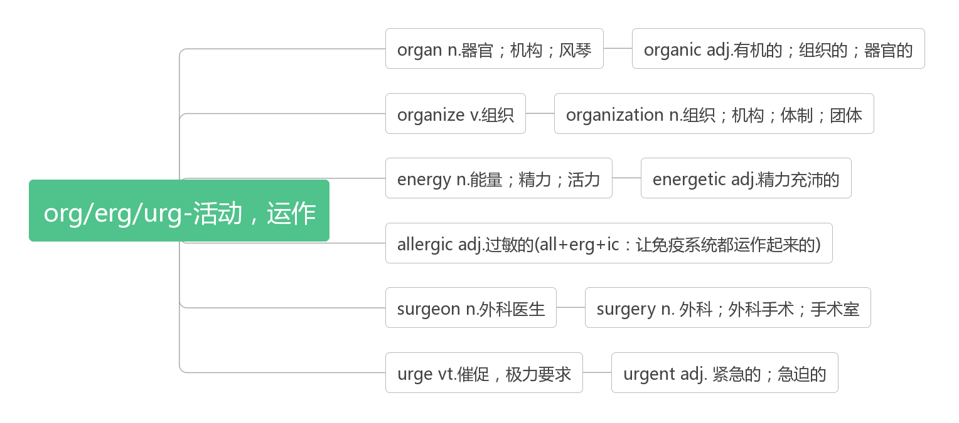

1. **soul [səʊl]n. 灵魂；心灵；精神adj. 心灵的；灵歌的**

**词源：sea——>soul 古日耳曼人认为人的灵魂来自于湖海，最终也归于湖海。**

Age wrinkles the body. Quitting on your dreams wrinkles the soul.

岁月使身体长出了皱纹，而放弃梦想则会使灵魂生出皱纹。

You have to have the courage to examine who you really are, to come to terms with the dark corner of your own soul.

你必须有审视自己的勇气，面对并接受你灵魂中的黑暗角落。

The world has kissed my soul with its pain, asking for its return in songs.——Tagore

世界吻我以痛，而要我报之以歌。——泰戈尔

1. **bagpipe [ˈbæɡpaɪp] n. 风笛**

**合成法：bag(袋子)+pipe(管子)：插在袋子上的管子——风笛**

1. **string [strɪŋ]n. 弦；细绳；一串**

Let’s take string to the boys and watch them fly the kites a minute.(2011浙江)

让我们把线拿给男孩子们，看他们放一会儿风筝。

A string of five rowing boats set out from the opposite bank. 五只划艇排成一排从对岸出发了。

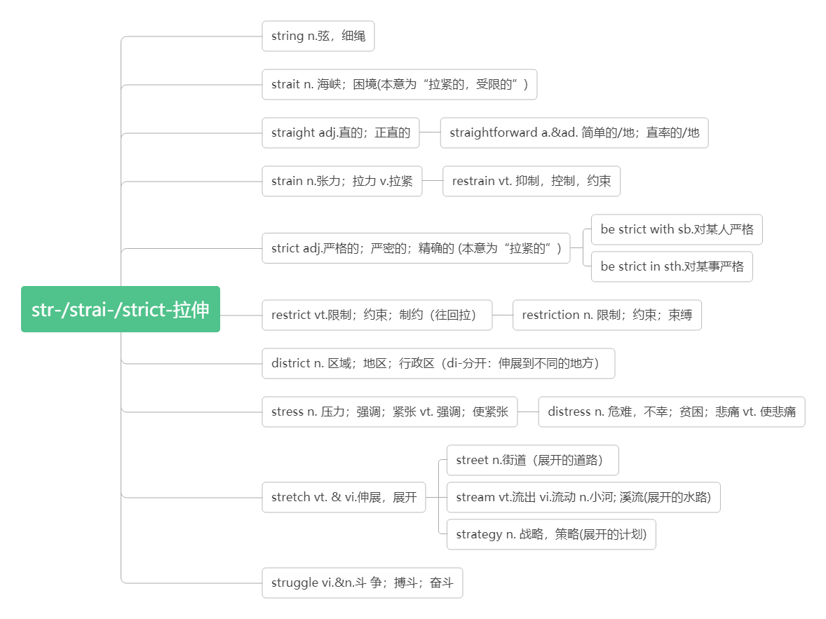

1. **instrument ['ɪnstrʊm(ə)nt]n. 仪器；乐器；器械；**

**词根词缀：in-(内)+stru-(structure结构)+-ment(名词后缀)：有内部结构的器具——仪器，乐器**

But he quickly found that he loved playing this instrument, and was committed to practicing it so that within a couple of months he was playing reasonably well.(2017江苏)

但他很快就发现自己喜欢上了这种乐器，并致力于练习，几个月后，他的演奏就相当不错了。

Originally, just the human voice and maybe some kind of simple instrument, such as a bell, were used to get people’s attention.(2013浙江)最初，人们只是用人声和一些简单的乐器，比如铃铛，来引起人们的注意。

**stringed instrument 弦乐器**

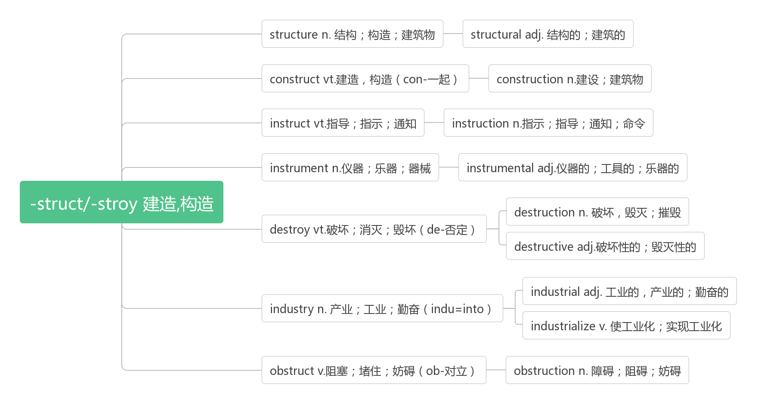

1. **virtual ['vɜːtjʊəl]adj. [计]虚拟的；实质上的，事实上的(未获名义上承认的)**

**词根词缀：virtu-(virtue美德)+-al(形容词后缀)：像美德一样，能感到却摸不到，引申为“虚拟的”。**

BookCrossing is part of a trend among people who want to get back to the “real” and not the virtual.(2016全国II)

图书漂流是一种趋势的一部分，人们希望回到“真实的”而不是虚拟的世界

Low technology is not virtual—so, to take advantage of it, Internet companies have had to get creative.(2014浙江)

低技术不是虚拟技术——所以，为了利用它，互联网公司不得不变得有创意。

1. **choir ['kwaɪə]n.唱诗班；合唱团v. 合唱**

**音意相通：夸 助记：choir本意为教堂的唱诗班，主要任务就是吟唱歌曲夸赞上帝。**

She sings in the school choir. 她是校合唱队的成员。

virtual choir虚拟合唱团

1. **compose [kəm'pəʊz]vt. 构成;创作;作曲**

**词根词缀：com-(一起)+pos-(放置)+e：放到一起——构成**

Cale also uses electronic keyboards to compose. 凯尔也用电子键盘谱曲。

 Ten men compose the committee.委员会由十人组成。

**composition [kɒmpə'zɪʃ(ə)n]n. 作文；作曲；作品；构成；成分**

In fact it was not a new style at all, but a composition of styles from different periods and cultures.(2014江苏)

事实上，它根本不是一种新的风格，而是来自不同时期和文化的风格组合。

Only when Mary read her composition the second time did she notice the spelling mistake.(2012天津)

只有当玛丽第二次读她的作文时，她才注意到拼写错误。

composer [kəm'pəʊzə]n. 作曲家；创作者

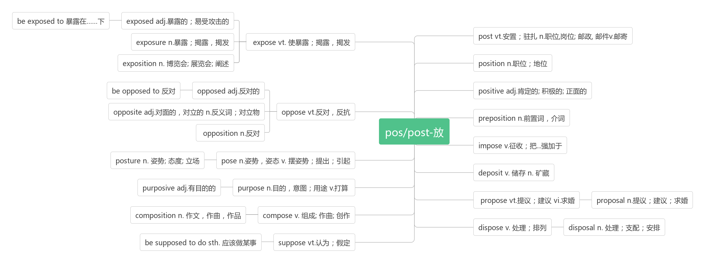

1. **opportunity [ɒpə'tjuːnɪtɪ]n. 时机，机会**

**词根词缀：op-(对着)+port-(港口)+uni-(one)+-ty：正对着港口的一次机会——机会，时机**

Mohammed Rezwan saw opportunity where others saw only disaster. (2017江苏)

默罕默德·雷兹万在别人只看到灾难的地方看到了机会。

Opportunity favors those with a curious mind.(2019天津) 机会总是垂青于有好奇心的人。

Everything negative—pressure, challenges—is all an opportunity for me to rise.([Kobe](E:/Program%20Files%20(x86)/Youdao/Dict/8.9.2.0/resultui/html/index.html" \l "/javascript:;) [Bryant](E:/Program%20Files%20(x86)/Youdao/Dict/8.9.2.0/resultui/html/index.html" \l "/javascript:;))

压力、挑战，这一切消极的东西都是我能够取得成功的催化剂。——科比·布莱恩特

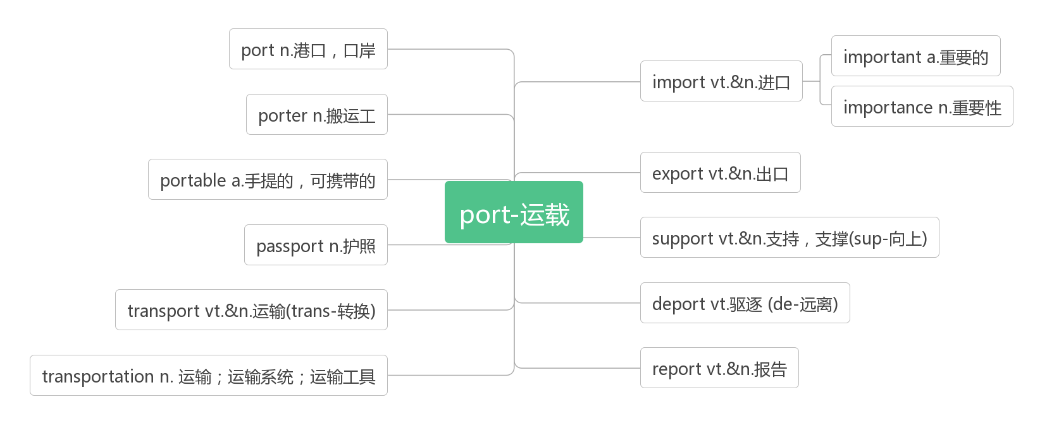

1. **perform [pə'fɔːm]vt. 执行；表演；**

**词根词缀：per-(完全)+-form(形成)：完全把想法形成行动——执行；表演**

They could perform basic addition.(2019全国III) 它们可以进行基本的加法运算。

Freed hands can serve some other purpose and perform complex tasks.(2019江苏)

解放的双手可以用于其他目的并执行复杂的任务。

Modern methods of tracking polar bear populations have been employed only since the mid-1980s, and are expensive to perform.(2019全国I) 追踪北极熊数量的现代方法从20世纪80年代中期才开始使用，而且成本高昂。

**performance [pə'fɔːm(ə)ns]n. 表演；表现；执行**

In baseball, the performance of individual players is less dependent on teammates.(2019北京)

在棒球运动中，个人球员的表现对队友的依赖性较小

Other American studies showed no connections between uniforms and school performance.(2019浙江)

美国的其他研究表明校服和学校表现之间没有联系。

**performer [pə'fɔ;mə(r)]n. 执行者；演奏者**

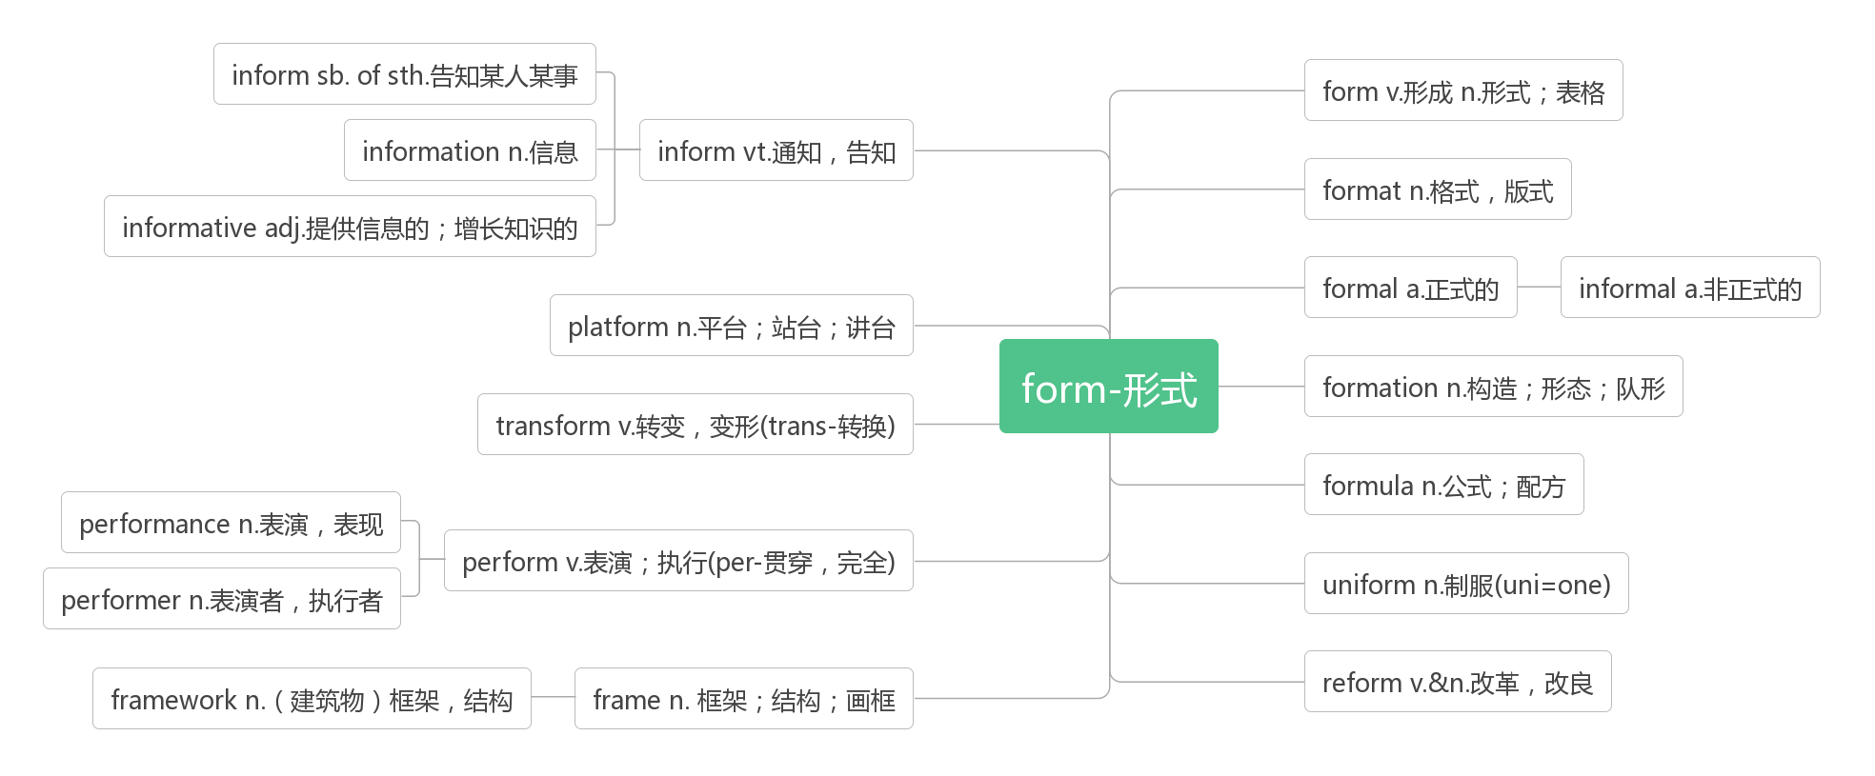

1. **studio ['stju:dɪəʊ]n. 工作室；录音棚；演播室；画室**

**词根词缀：study(学习室，书房)——>studio(工作室，画室)——>studio(录音棚，演播室)**

They performed their first concert in America at CBS television's 53rd street studio.(2019浙江)

他们在哥伦比亚广播公司的第53街演播室举行了他们在美国的首场音乐会。

“I adore dancing,” says Lester Bridges, the owner of a dance studio in Iowa.(2018全国III)

“我喜欢跳舞，”爱荷华州一家舞蹈工作室的老板莱斯特•布里奇斯说。

1. **ordinary ['ɔ:dən(ə)rɪ]adj. 普通的, 平凡的, 平常的**

**词根词缀：ord-(order次序)+in-(里)+-ary(形容词后缀)：在次序中的——普通的，平凡的**

What I want is not just an ordinary cafe but a very special one. (2019全国III)

我想要的不只是一个普通的咖啡馆，而是一个非常特别的咖啡馆。

But doing any ordinary job as well as one can is in itself an admirable commitment.(2019天津)

但是，尽自己所能，做好任何一份普通的工作本身就是一种令人钦佩的承诺。

Ordinary soap, used correctly, can deal with bacteria effectively.(2018北京)

普通的肥皂，正确使用的话，可以有效地对付细菌。

**extraordinary [ɪkˈstrɔ:dnri]adj. 非凡的；卓越的；离奇的**

In Dallas, one dollar invested in arts could harvest an extraordinary return of nearly $300.(2018江苏)

在达拉斯，投资于艺术的1美元可以获得近300美元的非凡回报。

When asked about happiness,we usually think of something extraordinary, an absolute delight,which seems to get rarer the older we get.(2013天津) 当被问及幸福时，我们通常会想到一些不同寻常的事情，一种绝对的喜悦，随着年龄的增长，这种喜悦似乎越来越少。

In spite of the experiments, the idea of an animal compass seemed pretty extraordinary.(2010江苏)

尽管做了这些实验，但动物指南针的想法似乎仍相当超凡脱俗。

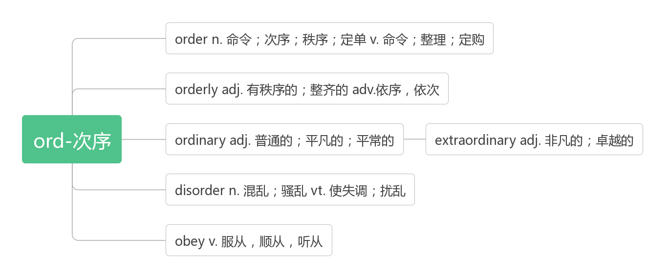**16. 16. enable [ɪn'eɪb(ə)]vt. 使能够**

This enabled Emma to give birth to five baby cranes.(2019江苏)这使得艾玛生下了五只鹤宝宝。

Doing so will help you get into a better university, which will enable you to have a bright future.(2016浙江)

这样做会帮助你进入一个更好的大学，这将使你有一个光明的未来。

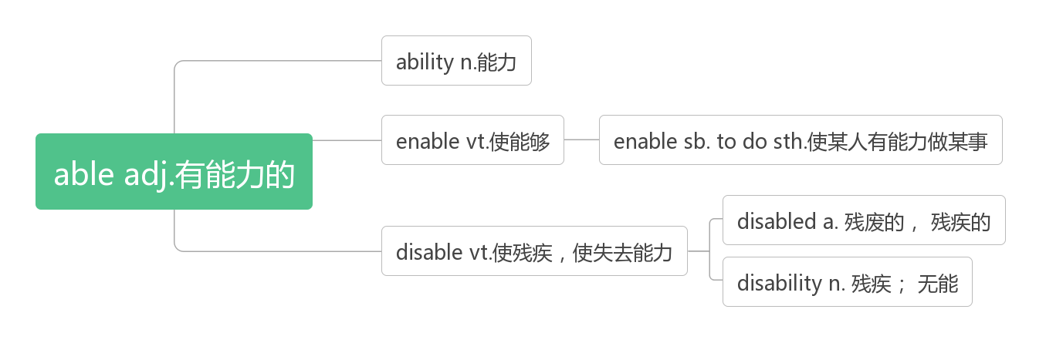**17. 17. prove [pruːv]vt. 证明, 验证link.v.被证明为**

This research also helps to prove that characteristics such as persistence - which can be taught - are key to a child’s life success.(2020浙江一月) 这项研究还有助于证明，毅力等特征——这是可以教会的——是孩子一生成功的关键。

I want to prove that I can teach myself a respectful profession, without going to college, and be just as good as, if not better than, my competitors.(2016北京)

我想证明，我可以不上大学，自学一门受人尊敬的职业，就算不比竞争对手强，至少也和他们一样优秀。

For football and basketball, adding talented players to a team proves a good method.(2019北京)

对于足球和篮球来说，在一个球队中增加有天赋的球员被证明是一个好方法。

His approach to the problem is special and proves good. 他处理这个问题的方法很特别，而且被证明很好。

**proof [pruːf]n. 证明；证据；考验；验证【pl:proofs】**

The case was dismissed in the absence of proof.这个案子由于缺乏证据而被驳回。

Training is worthless unless there is proof that it works.除非能证明训练有效，否则就是白搭。

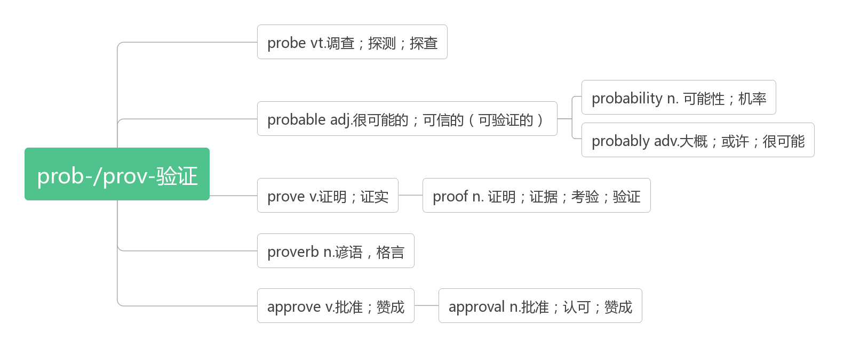

1. **conduct [kən'dʌkt] vt.&vi.传导；引导；实施，执行 n. 行为；实施**

Why did Babbitt's team conduct the research?(2018全国I)

为什么巴比特的团队进行了这项研究?

The easiest way to accomplish this is to make sure you conduct yourself as a good neighbor should. (2018浙江)

要做到这一点，最简单的方法就是确保自己像一个好邻居那样行事。

A fire drill will be conducted in your residence hall every semester.(2018天津)

每学期宿舍楼都会举行一次消防演习。

To return to the problem of water pollution, I'd like you to look at a study conducted in Australia in 2012.(2016浙江)

回到水污染的问题，我想让你看看2012年在澳大利亚进行的一项研究。

**conduction [kən'dʌkʃ(ə)n]n.传导，传输**

Copper is a good medium for the conduction of heat and electricity.铜是热和电的良导体.

**conductor [kən'dʌktə]n. 导体；(公车)售票员；引导者**

My nephew’s fortune came when he bravely helped a conductor brake a tram to stop it from slipping out of the rails.

我外甥的好运来了，他勇敢地帮助售票员刹车，防止电车滑出轨道。

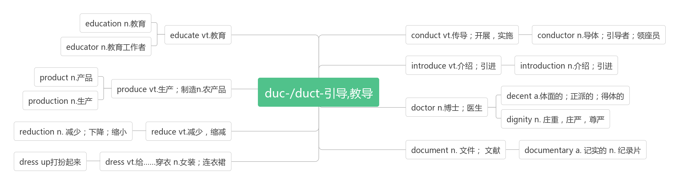

1. **fall in love with 爱上**

I learned that if you fall in love with something and do it all the time, you will get better at it.(2916天津)

我理解到，如果你爱上了某件事，并且一直在做，你就会做得更好

I fell in love with Yosemite National Park the first time I saw it, when I was 13. (2012天津)

当我13岁第一次看到约塞米蒂国家公园时，我就爱上了它。

1. **origin ['ɔrɪdʒɪn]n. 起源；原点；出身；开端**

**破拆法：ori-(原点)+-gin(begin)：开始的原点——起源，开端**

It took many years to become proud of my Asian origin and work up the courage to take back my birth-name.(2014江苏)

我花了很多年才为自己的亚洲血统感到自豪，并鼓起勇气用回自己的出生名。

Legend has it that the origin of the Dragon Boat Festival is to recall the soul of Qu Yuan.(2014江苏)

传说端午节的起源是为了纪念屈原的灵魂。

**original [ə'rɪdʒənl]adj. 最初的；原创的；新颖的n. 原件；原作；原型**

If a predator can move on to another species that is easier to find when a prey species becomes rare，the switch allows the original prey to recover.(2019天津) 如果一个捕食者可以转移到另一个更容易被发现的物种上，那么当一个猎物变得稀有时，这种转换可以让原来的猎物恢复。

It is a logical consequence of the simple fact that the machine cannot achieve its original purpose if it is dead. (2917北京)

这是一个简单事实的逻辑结果：如果机器死了，它就实现不了它原来的目的了。

But some materials slow and scatter(散射) light, bouncing it away from its original path.(2015北京)

但有些材料会使光变慢并散射，使光从原来的路径反弹出来。

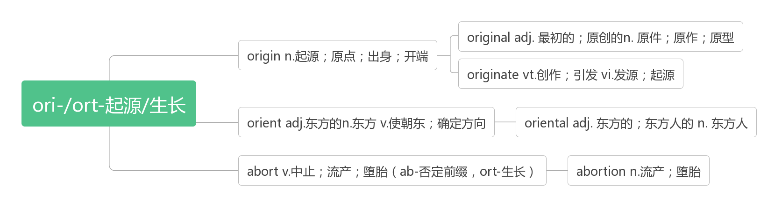

1. **phenomenon [fɪ'nɒmɪnən]n. 现象；奇迹；杰出的人才【pl:phenomena】**

**词根词缀：pheno-(phone声音)+men-(man-做)+-on(名词后缀)：做出来的声势浩大的事。**

At the heart of the phenomenon lie tiny marine microorganisms(海洋微生物)called phytoplankton(浮游植物). (2019北京)

这种现象的核心是微小的海洋微生物，即浮游植物。

What phenomenon is described in the first paragraph?(2018全国II) 第一段描述了什么现象?

And these social phenomena can have very personal consequences.(2010北京)

这些社会现象可能会对个人造成非常严重的后果。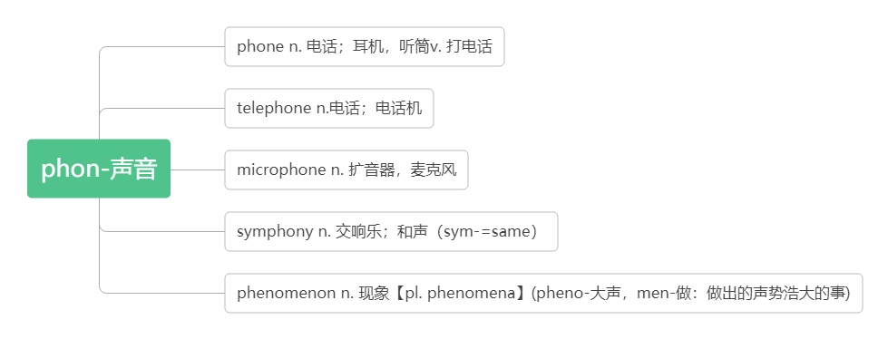

1. **stage [steɪdʒ]n. (发展或进展的)舞台；时期，阶段(stage作先行词时，定语从句引导词通常用where)**

**词根词缀：st-(站)+-age(名词后缀)：所站的地方——舞台；阶段**

Their child is at the stage where she can say individual words but not full sentences.(2019天津)

他们的孩子正处在能说单个单词而不能说完整句子的阶段。

We have come to a stage where we have to rely on our own.我们已经到了必须自力更生的阶段。

You are at a wonderful stage of life.You have many wonderful stages of life yet to come,but they are not without their costs and perils.你正处在人生一个美妙的阶段。还有很多美妙的阶段会来到你面前，但是都不是唾手可得的，你都得付出代价，经历风险。

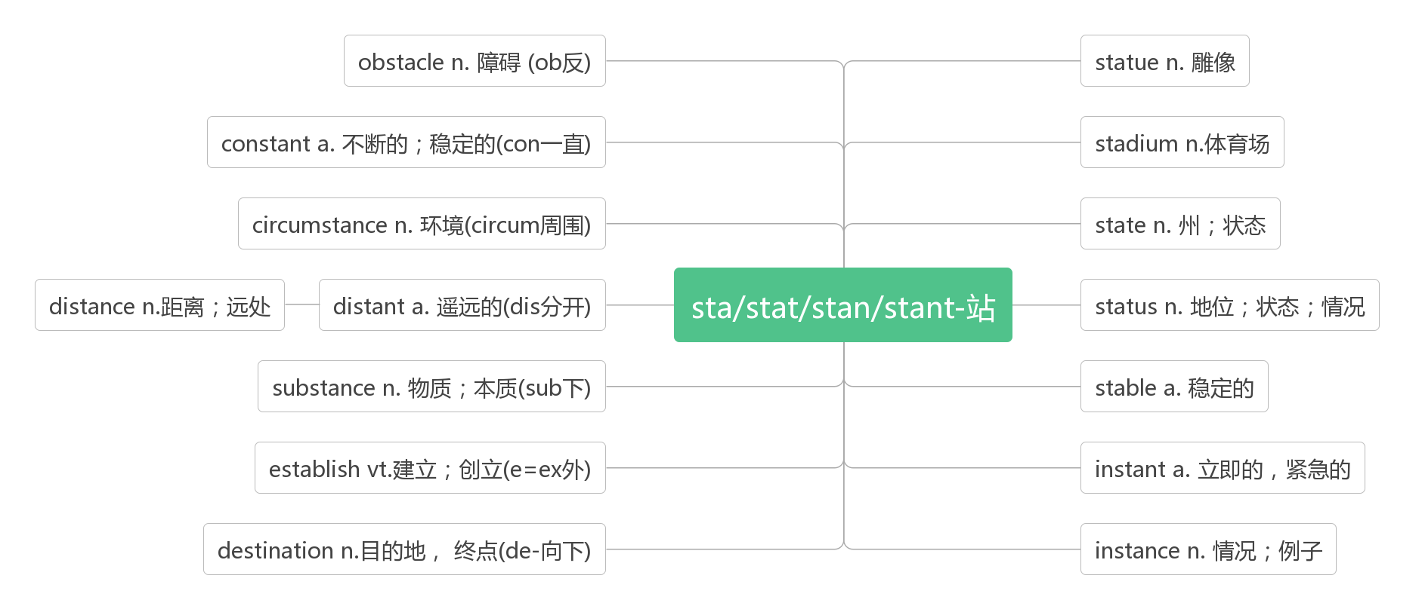

1. **altogether [ɔːltə'geðə]adv. 总共；总而言之；完全地，彻底地**

Altogether there are some ten thousand of these volcanoes on Earth.(2019江苏)

地球上总共有大约一万个这样的火山。

I forgot what he had said to me altogether. (2017全国I) 我完全忘记了他对我说过的话。

At last I ended up hitting the set with my fist, and it stopped working altogether. (2015全国II)

最后，我终于用我的拳头敲打电视机，结果它完全停止了工作。

1. **thus [ðʌs]adv. 如此，因此, 从而, 这样, conj. 因此**

These patterns are unique to each person. Thus, the keyboard can determine people's identities.(2019全国I)

这些模式对每个人来说都是独一无二的。因此，键盘可以确定人们的身份。

The weak links may thus keep species from driving one another to extinction.(2019天津)

这些薄弱的环节可能因此阻止物种间的相互灭绝。

Thus humans who lived a million years ago despite their big brains and sharp stone tools, lived in constant fear of meat-eating animals.(2019江苏)

因此，生活在一百万年前的人类，尽管拥有巨大的大脑和锋利的石器，却一直生活在对食肉动物的恐惧中。

1. **band [bænd]n. 带子; 乐队; 一伙人**

**词源：bind绑——>band(绑在身上的东西)：带子——>band(绑在一起的人)：乐队**

The musician along with his band members has given ten performances in the last three months.(2019江苏)

这位音乐家和他的乐队成员在过去的三个月里演出了十场。

Freddy and his band went nowhere without being followed.

弗莱迪和他的乐队走到哪儿都被人跟踪。

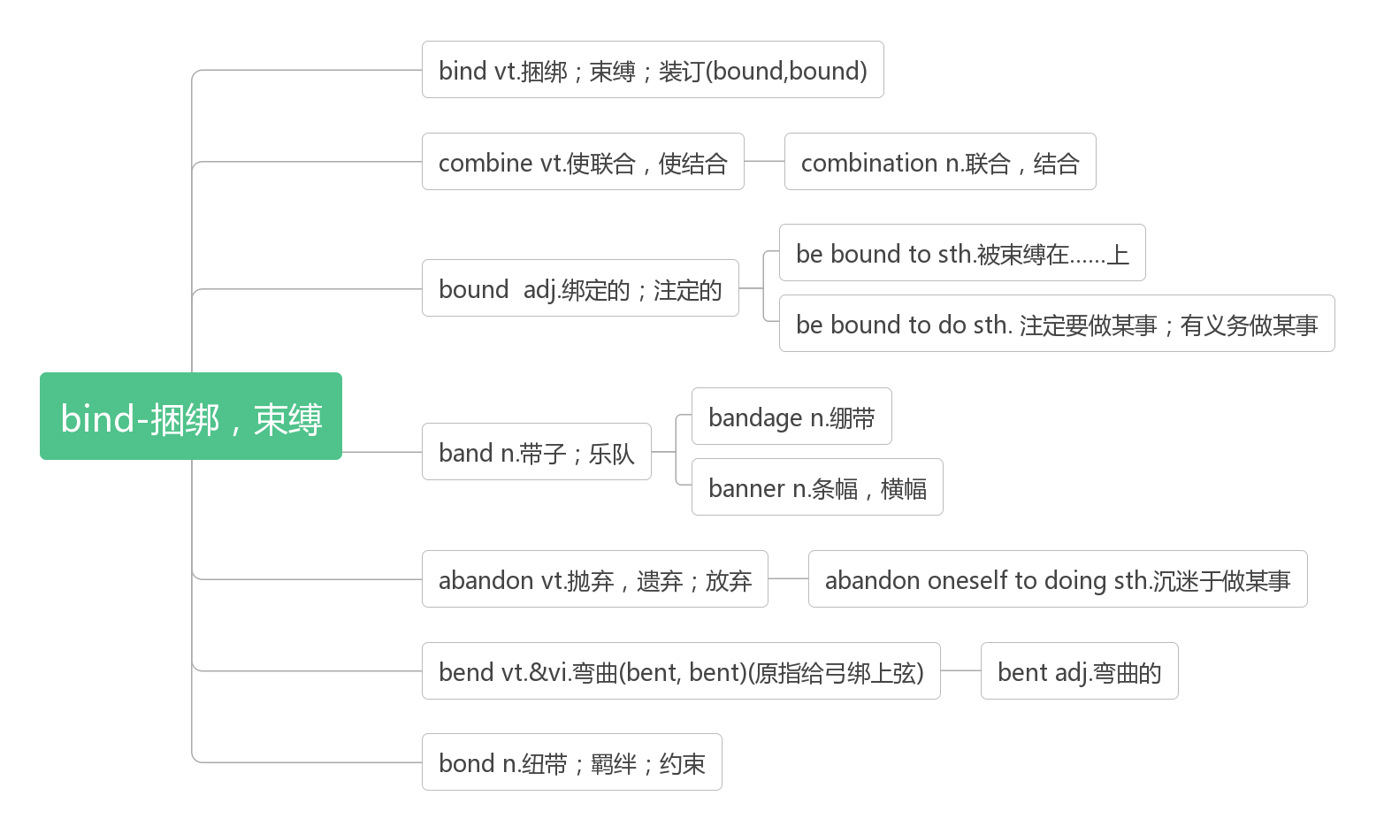

1. **rap [ræp]vt.vi. &n.敲击；说唱**

I like lots of different styles - rock, rap, whatever. 我喜欢各种不同的风格——摇滚、说唱，无论什么。

Country music is very different from pop, rock, rap or other popular music forms.

乡村音乐与流行乐、摇滚、说唱以及其他流派非常不一样。

1. **nowadays ['naʊədeɪz]adv. 如今；目前n. 当今**

Traditional technology still has a place nowadays.(2019江苏)传统技术在今天仍然有一席之地。

Nowadays, cycling, along with jogging and swimming, is regarded as one of the best all-round forms of exercise.(2017天津)

如今，骑自行车和慢跑、游泳一样，被认为是最好的全方位运动方式之一。

1. **gradual ['grædʒʊəl]adj. 逐渐的；循序渐进的**

**词根词缀：grad-(grade级别)+-ual(形容词后缀)：逐级的，逐渐的**

While there are amazing stories of instant transformation, for most of us the changes are gradual and require a lot of effort and work.(2014全国I)

虽然有一些惊人的故事是关于快速转变的，但对我们大多数人来说，改变是渐进的，需要大量的努力和工作

Training for a marathon requires careful preparation and steady, gradual increases in the length of the runs.(2015全国II)

马拉松训练需要仔细的准备和稳定、渐进地增加跑步距离。

**gradually ['grædʒʊlɪ; 'grædjʊəlɪ] adv. 逐步地；渐渐地**

Over 300 years its population grew gradually from 800 people to 8 million.(2018全国III)

300多年来，它的人口从800人逐渐增长到800万。

Gray wolves once were seen here and there in the Yellowstone area and much of the continental United States, but they were gradually displaced by human development.(2017全国III)

灰狼曾经在黄石地区和美国大陆的大部分地区随处可见，但它们逐渐被人类的发展所取代。

Food in small pieces could be eaten easily with twigs which gradually turned into chopsticks.(2016全国III)

小块的食物可以很容易地用小树枝来吃，小树枝逐渐演变成了筷子

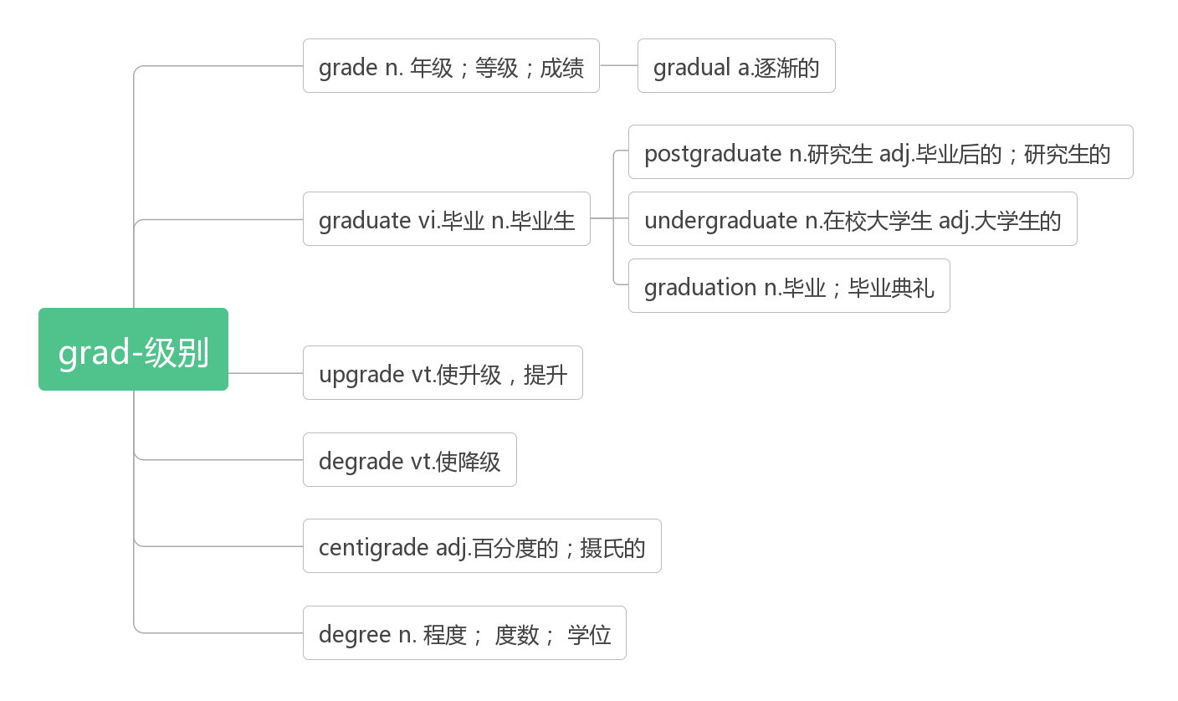

1. **capable ['keɪpəb(ə)l]adj. 能干的，能胜任的，有能力的**

**be capable of有……的能力**

Our robot group, which is made up of four friends, is capable of designing robots as well.(2018天津)

我们的机器人小组，由四个朋友组成，也有能力设计机器人。

They are expected to appear strong and capable.(2011江苏)人们期望他们表现得坚强能干。

**capability [keɪpə'bɪlɪtɪ]n. 才能，能力；性能，容量**

 The country needs a defence capability as insurance against the unexpected.

国家需要有一定的防御能力，以应对不可预知的情况。

No one ever questioned her capability.从来没有人质疑她的能力。

Organizing a whole department is beyond his capability. 组织整个部门是他能力以外的事。

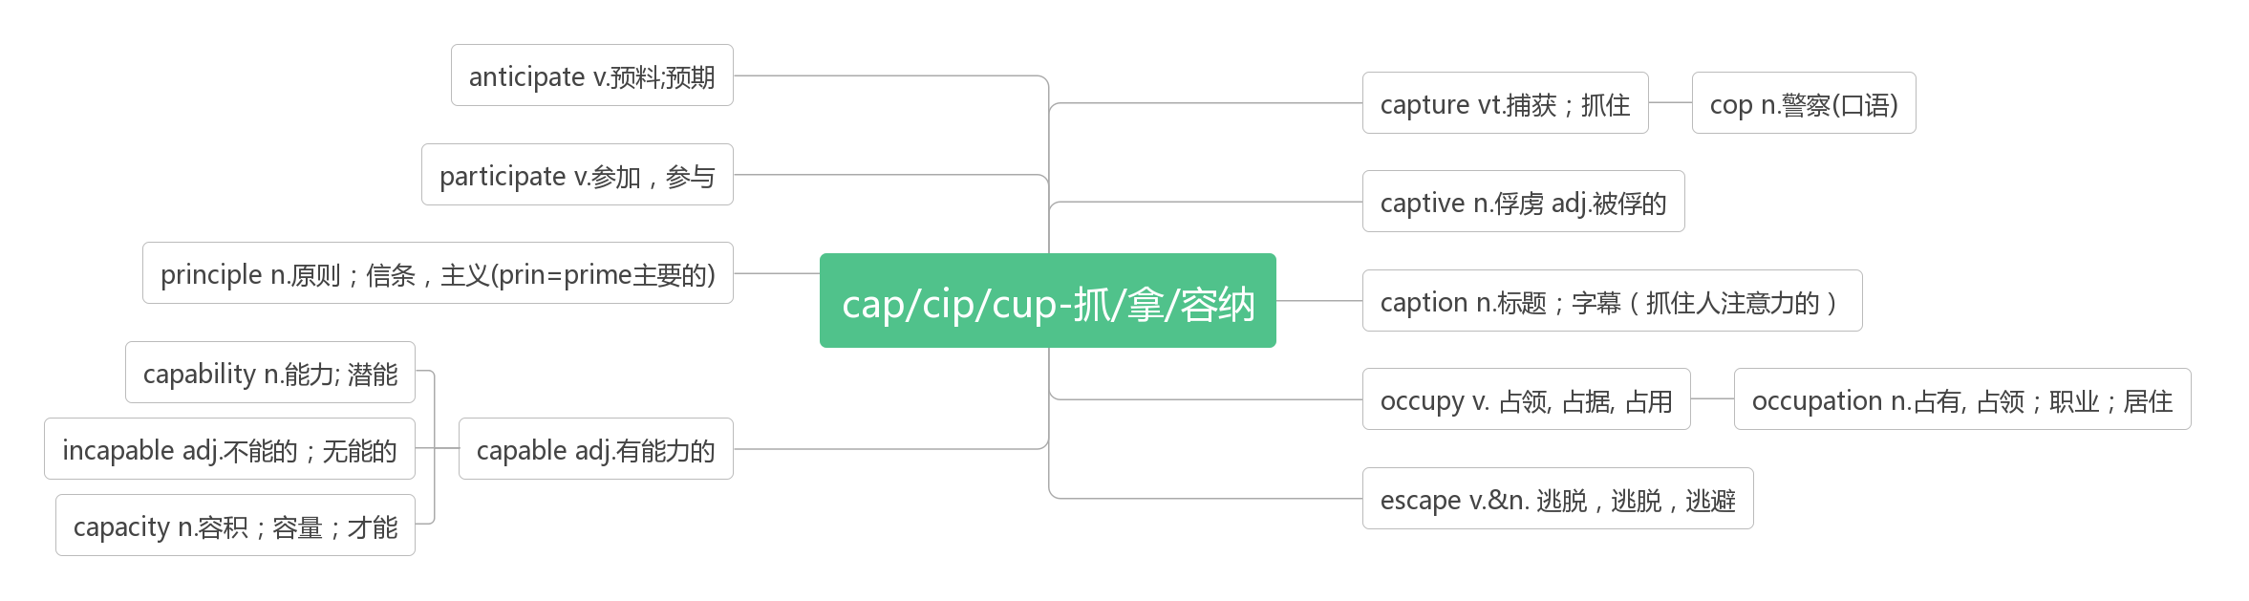

1. **relief [rɪ'liːf] n. 减轻，缓解，解除；救济；安慰**

**词根词缀：re-(强调)+-lief(举起)：抬起压力/痛苦——减轻，缓解，解除**

There was no cure, only pain relief.(2018江苏) 没有治愈方法，只能减轻疼痛。

Still, most of us volunteers breathe a sigh of relief when the season comes to a close.(2019全国II)

尽管如此，当赛季结束时，我们大多数志愿者都松了一口气。

It could be anything—gardening, cooking, music, sports—but whatever it is, make sure it's a relief from daily stress rather than another thing to worry about.(2016全国II) 它可以是任何事情——园艺、烹饪、音乐、运动——但不管它是什么，确保它是对日常压力的一种解脱，而不是另一件需要担心的事情。

**in relief 轻松地，如释重负地**

Not until we succeed in letting wildlife live in peace, can we smile in relief.

直到我们成功地让野生动物和平地生活，我们才能轻松地微笑。

**relieve [rɪ'liːv]vt. 缓解，减轻；使放心**

**妙句助记：I believe my brief words will relieve her grief. 我相信我简短的话会减轻她的悲痛。**

**relieve at 因…感到宽慰**

**relieve sb from/of 使摆脱，解除**

relieve sb from anxiety 消除某人的忧虑

relieve sb of the burden 减轻某人的负担

In 1963 the UN set up the World Food Programme, one of whose purposes is to relieve worldwide starvation.(2017江苏)

1963年，联合国成立了世界粮食计划署，其目的之一是缓解世界范围内的饥饿。

Smiling and laughing has actually been shown to relieve tension and stress.

事实证明，微笑和大笑能够缓解焦虑和压力。

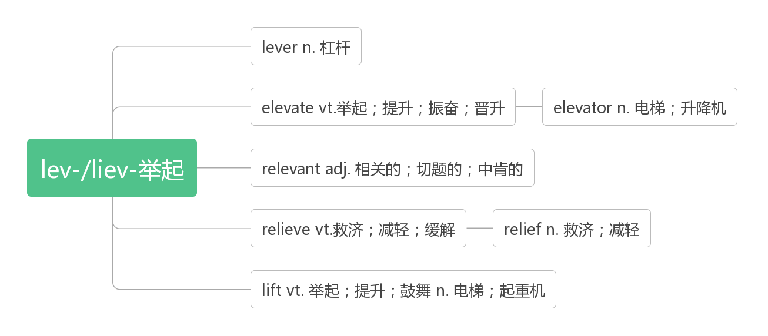

1. **cure [kjʊə; kjɔː]vt.&vi. 治愈; 治疗n.治疗；疗法**

**词源：care(关心)——>cure(治愈)**

**cure sb. of a disease治愈某人某种疾病**

**a cure for a disease 某种疾病的疗法**

This medicine should cure you of your cold.这种药应该能治好你的感冒。

Medical drugs sometimes cause more damage than they cure.(2012江苏)

药物有时造成的损害比它们所能治愈的还要多。

Empathy can be a cure for loneliness, sadness, anxiety, and fear.(2012北京)

共情可以治愈孤独、悲伤、焦虑和恐惧。

Neither its cause nor its cure was understood. 人们既不知道它的起因，也不知道它的疗法。

|  |  |
| --- | --- |
| cure | 强调“治愈”、“使摆脱”，指治愈某种疾病或改正不良习气。 |
| treat | 强调医治的过程，并不涉及治疗的结果 |
| heal | 强调“使伤口愈合”，不能用于治疗感冒或疾病，也可指伤口自身愈合 |
| recover | 强调自身恢复健康，不涉及治疗的过程 |

The doctor cured her of a bad cold.医生治好了她的重感冒。

That will cure him of his bad habits.那将改正他的坏习惯。

There are only two doctors to treat more than 50 patients.只有两名医生来治疗50多个病人。

The wound on my arm has healed.我胳膊上的伤已痊愈了。

He’s now fully recovered from his bad cold.他现在已完全从重感冒中康复了。

1. **absorb [əb'zɔːb; -'sɔːb]vt. 吸收；吸引；承受；理解**

**词根词缀：ab-(强调)+sorb-(拟声词：吸)：吸收**

It takes sunscreen about fifteen minutes to start working, and that's plenty of time for your skin to absorb a day's worth of Vitamin D.(2019全国I)防晒霜开始起作用大约需要15分钟，这段时间足够你的皮肤吸收一天所需的维生素D。

A transparent object doesn't absorb or scatter light, at least not very much. (2015北京)

一个透明的物体不吸收或散射光，至少不是很多。

So many good ideas! It’s too much for me to absorb all at once. 这么多好主意！我很难一下子完全吸收。

**(be) absorbed in 全神贯注于，被……所吸引**

We both became absorbed in the simplicity of playing together.(2018全国III) 我们都沉浸在一起玩耍的简单中。

I don't want to get too absorbed in modeling.(2017全国III) 我不想太沉迷于做模特。

Time passes quickly when you are absorbed in reading a good book. 当你专心读一本好书时，时间就过得飞快。

**absorption [əb'zɔːpʃ(ə)n; -'sɔːp-]n. 吸收；全神贯注，专心致志**

Both scattering and absorption make an object look different from other objects around it, so you can see it easily.(2015北京)

散射和吸收都使一个物体看起来不同于它周围的其他物体，所以你可以很容易地看到它。

He was struck by the artists' total absorption in their work.他被艺术家对创作的全身心投入所打动。

1. **previous ['priːvɪəs]adj. 先前的，之前的**

Later I decided to apply my previous experience to learning how to read and write.(2016天津)

后来我决定用我以前的经验来学习如何读和写。

For previous generations, college was a decisive break from parental control.(2016北京)

对前几代人来说，上大学是摆脱父母控制的决定性突破。

The true nobility is in being superior to your previous self.

真正的高贵在于超越过去的自己。(海明威《真正的高贵》)

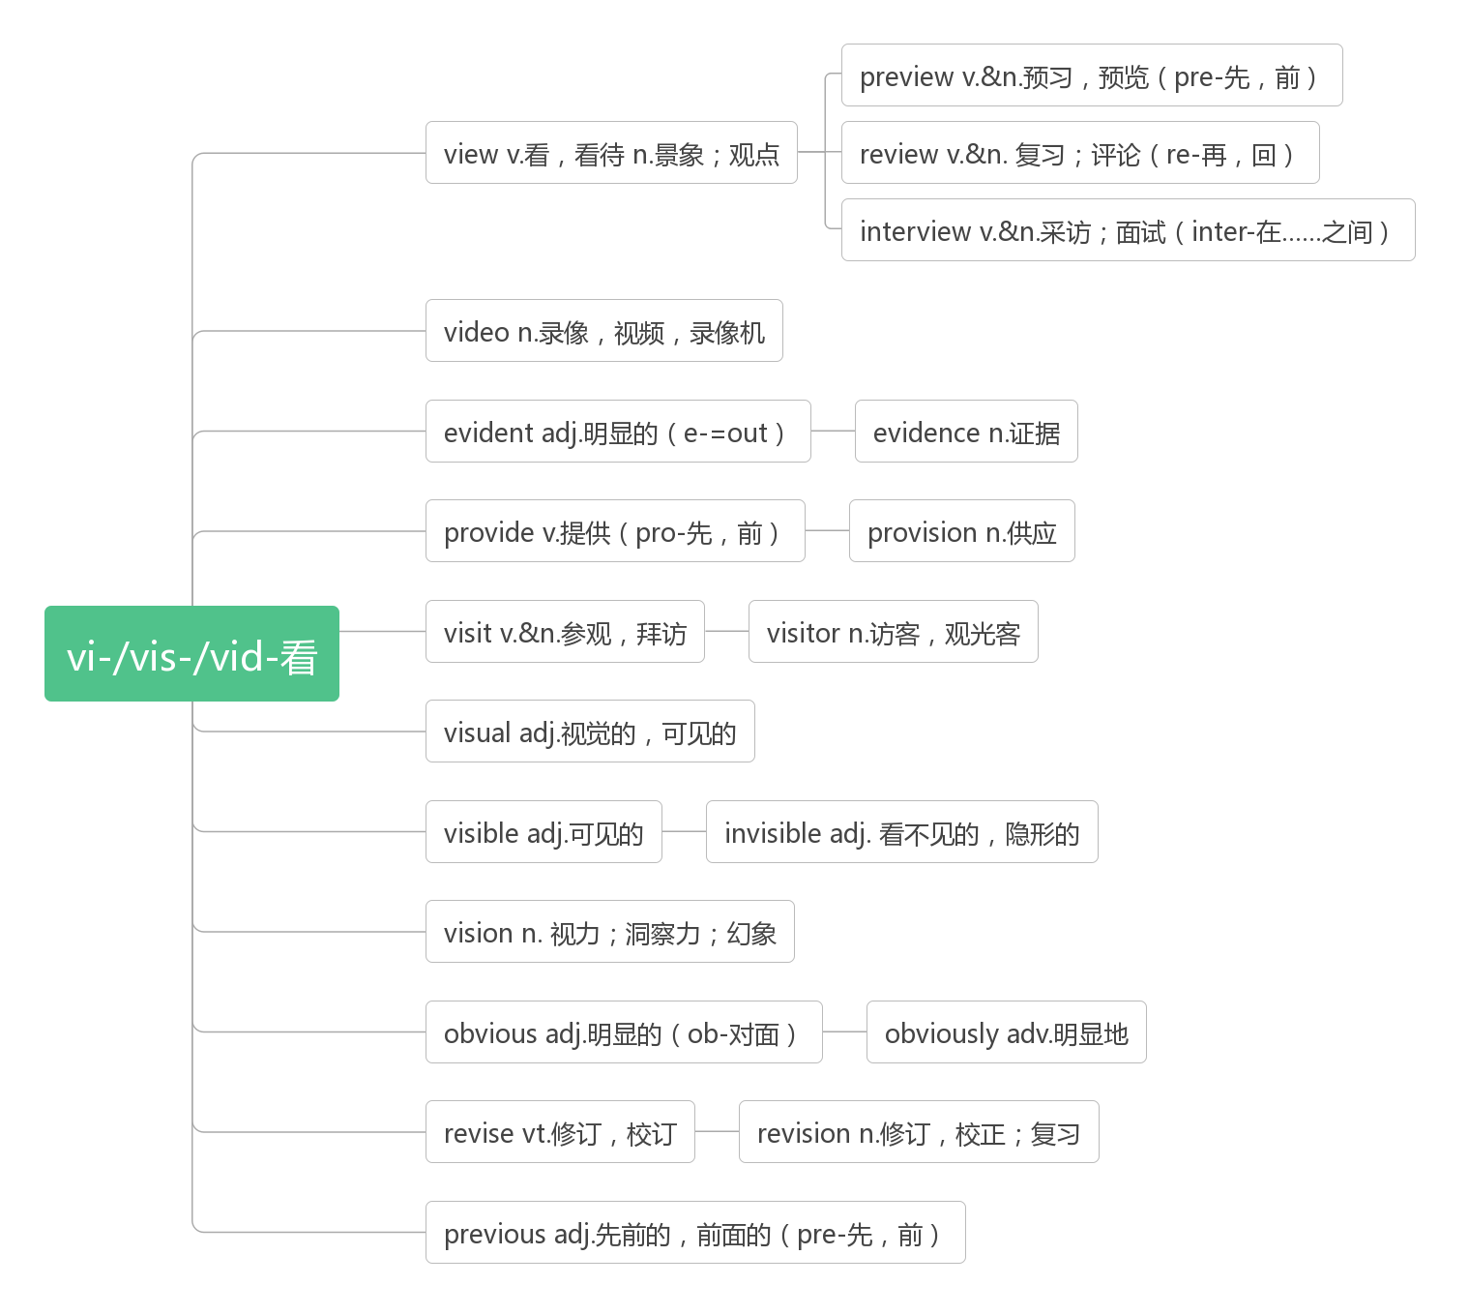

1. **employ [ɪm'plɒɪ; em-]vt. 使用，采用；雇用；使忙于，使从事于**

**词根词缀：em-(in里)+-ploy(用)**

Modem methods of tracking polar bear populations have been employed only since the mid-1980s, and are expensive to perform consistently over a large area. (2019全国I)

追踪北极熊数量的现代方法从20世纪80年代中期才开始使用，而且要在一大片区域内持续进行，成本很高。

According to the Dallas Area Cultural Advocacy Coalition, arts agencies employ more than 10,000 people as full-or part-time employees or independent contractors.(2018江苏)

根据达拉斯地区文化倡导联盟的数据，艺术机构雇佣了超过1万名全职或兼职员工或独立承包商。

The University of Adelaide employs a full-time staff of fire prevention professionals.(2018天津)

阿德莱德大学聘用了全职的消防专业人员。

**employment [ɪm'plɒɪm(ə)nt]n雇用； 使用；职业**

**employer [ɪm'plɒɪə]n. 雇主，老板**

**employee [emplɒɪ'iː]n. 雇员**

**unemployment [ʌnɪm'plɒɪm(ə)nt]n. 失业；失业率；失业人数**

**unemployed [ʌnɪm'plɒɪd]adj. 失业的；未被利用的**

1. **romantic [rə(ʊ)'mæntɪk]adj. 浪漫的；多情的**

**音意相通：罗曼蒂克，浪漫的**

He was very romantic and—of course—I miss him since he’s passed away.(2009浙江)

他很浪漫，当然，他去世后我很想念他。

The reality of mothering is frequently very different from the romantic ideal.

养育孩子的现实经常与浪漫的理想大相径庭。

**romance [rə(ʊ)'mæns]n. 传奇；浪漫史；风流韵事；冒险故事**

She loved him so much: it was a fairy-tale romance. 她深深爱着他：这是个童话般的浪漫故事。

It is ridiculous to suggest we are having a romance.暗示我们正在谈恋爱的说法真是太荒谬了。

1. **album ['ælbəm]n. 相册；唱片集；集邮簿；签名纪念册**

**破拆法：al-(all)+bum(布满) 助记：都布满了照片/作品的集子——相册；唱片集**

1. **impact ['ɪmpækt]vt.&n. 强烈影响；碰撞；冲击**

**词根词缀：im-(里)+-pact(挤压)：向里挤压——产生影响**

**have an impact on对……有巨大影响**

Gordon says the HUNCH program has an impact on college admissions and practical life skills. (2019全国II)

戈登说，HUNCH项目对大学录取和实际生活技能有巨大影响。

We can observe that artificial intelligence has already made an impact on our lives in many ways.(2019天津)

我们可以看到，人工智能已经在很多方面对我们的生活产生了影响。

Those who truly understand the economic impact and can work to change the patterns can create a wide range of career possibilities.(2018江苏)那些真正了解经济影响并能够努力改变模式的人可以创造广泛的职业机会。

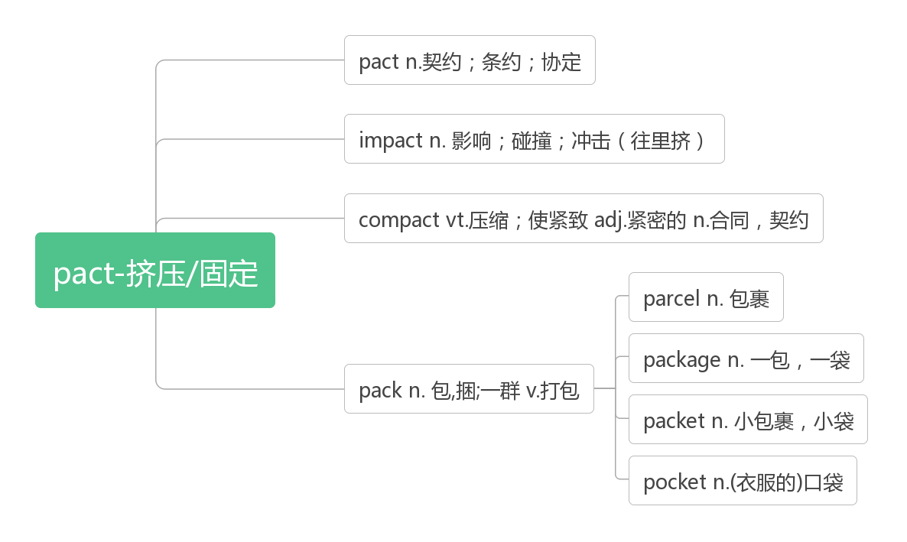

1. **aim [eɪm]vt.&vi.瞄准，对准；目的是n. 目的；目标**

**aim at 瞄准；旨在，针对**

**take aim (at) 瞄准，以……为目标**

**be aimed at旨在，目的是**

The aim of education is to teach young people to think for themselves and not follow others blindly.(2014浙江)

教育的目的是教会年轻人独立思考，而不是盲从。

All our projects aim to promote the development of poor and remote communities.(2019北京)

我们所有的项目都旨在促进贫困和偏远社区的发展。

Taking advantage of the new technologies, scammers(诈骗者) can aim at victims precisely.(2019北京)

利用新技术，诈骗者可以精确地瞄准受害者

The industry has also taken aim at the product that has appeared as its replacement.(2018浙江)

该行业还将矛头对准了替代产品。

What is the Mural Arts Program in Philadelphia aimed at?(2011全国)

费城的壁画艺术项目的目的是什么?

1. **set sth up安装好(设备或机器)**

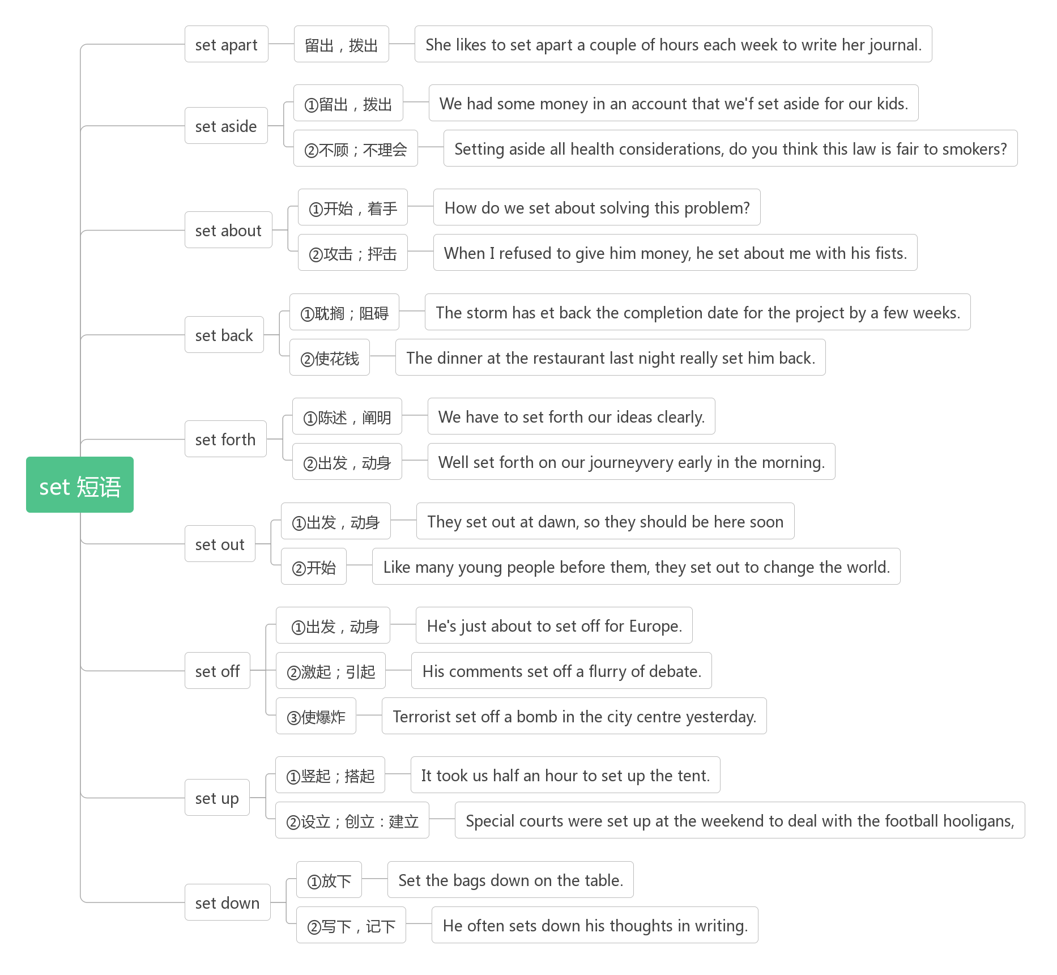

1. **equip [ɪ'kwɪp]vt. 装备，配备**

**破拆法：equ-(equal相同的)+-ip(ship船) 助记：想要航行成功，就要装备相同的船只。**

It's vital that new compulsory age-appropriate relationship and sex education lessons in England should help equip children to deal with the growing demands of social media.(2018江苏)

至关重要的是，英国新的适龄义务关系和性教育课程应该帮助孩子们应对日益增长的社交媒体需求。

Thus, these well-equipped people survived because they were the fittest.(2016北京)

因此，这些装备精良的人活了下来，因为他们是最适合生存的。

**equip sb. with sth.给某人装备……**

They equipped themselves with a pair of sharp axes and set off for the forest.

他们装备上两把锋利的斧子，向森林出发。

**be equipped with装备着，配备有**

All riders are equipped with reflective vests and safety lights.(2018全国I) 所有骑手都配备了反光背心和安全灯。

The floors of all campus buildings are equipped with manual(手动的) fire alarm systems which include fire alarm pull stations and pipes.(2018天津)所有校园建筑的楼层都配备了手动火灾报警系统，包括火灾报警拉站和管道。

**equipment [ɪ'kwɪpm(ə)nt]n. 设备，装备；器材【UC】**

They have all the equipment and advice you will need. 他们有你需要的所有设备和建议。

This has led companies and individuals to donate money to developing countries to buy computer equipment and Internet facilities.(2019江苏)这导致公司和个人捐钱给发展中国家购买电脑设备和互联网设施。

1. **try out试用；试验； 选拔； 试行**

It began when a teacher suggested I try out for the basketball team.(2011北京)

事情是从一个老师建议我参加篮球队开始的。

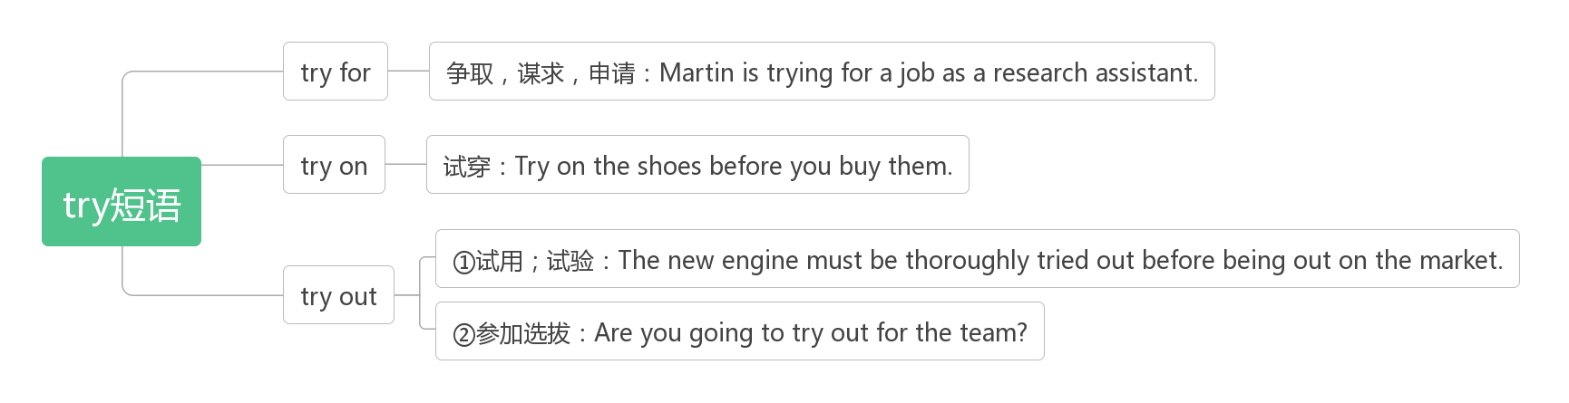

1. **talent['tælənt]n. 才能；天赋，天资；天才**

**破拆法：ta(他：上帝)+lent(借给)：他(上帝)借给你的能力——天赋**

They conclude that when task interdependence is high, team performance will suffer when there is too much talent，while individual talent will have positive effects on team performance when task interdependence is lower.(2019北京)

他们得出结论，当任务相互依存度高时，团队绩效会受到人才过多的影响，而当任务相互依存度低时，个体人才会对团队绩效产生积极的影响。

Griffon present the play by Rajiv Joseph, in which an origami artist invites a teenage talent and his teacher into her studio.(2019全国III)格里芬展示了拉吉夫·约瑟夫的剧本，在剧本中，一位折纸艺术家邀请一位十几岁的天才和他的老师来到她的工作室。

Moore wants to use her unique talent to help others find their smiles.(2019北京)

摩尔想要用她独特的才能来帮助别人发出微笑。

**have a talent for 对……有天赋**

All the football player on the playground cheered loudly, saying that I had a talent for football.(2019全国I)

操场上所有的足球运动员都大声欢呼，说我有足球天赋。

**talented ['tæləntɪd]adj. 有才能的；有天赋的**

**be talented at/in 对……有天赋**

The more I knew him the more I found he was talented at mathematics.

我越了解他，就越发现他在数学方面有天赋。

She is very talented in music and plays only by ear.

她对音乐很有天赋，而且演奏时不需要乐谱。

1. **piano [pɪ'ænəʊ]n. 钢琴**

**破拆法：pia(拍)+no(不) 助记：钢琴只能弹，不能拍。**

1. **assume [ə'sjuːm]vt. 假定；认为**

**词根词缀：as-(去)+sum-(拿)：去持有某种观念——假定，认为**

We assume that a large brain makes huge advantages.(2019江苏) 我们以为一个大的大脑会产生巨大的优势。

It is wrong to assume arts groups cannot make a profit.(2018江苏) 认为艺术团体不能盈利是错误的。

Why do we often assume that more is more when it comes to kids and their belongings?(2018全国III)

为什么当涉及到孩子和他们的财产时，我们总是认为越多越好?

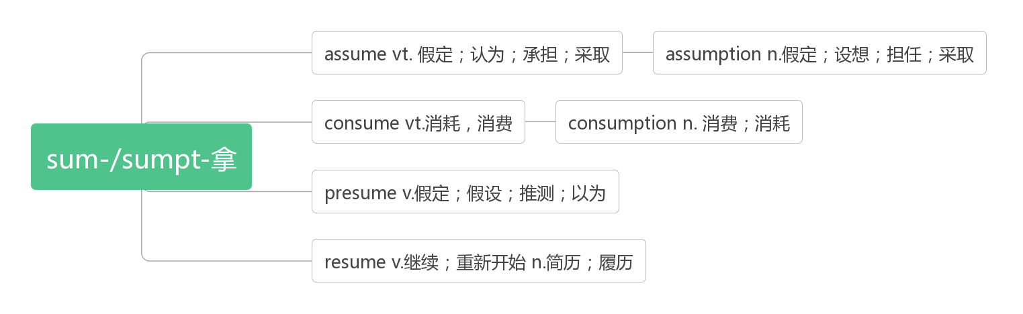

1. **add [æd]vi.&vt. 加；增加；补充说**

Just as in a game of tug-of-war(拔河比赛), whenever a person is added, everyone else pulls the rope with less force. (2019北京) 就像在拔河比赛中，每当一个新人加入，其他所有人拉绳子的力就会减少。

He added that he hopes people in other cities might try similar projects and post their own videos on the Internet.(2019浙江)

他补充说，他希望其他城市的人们也能尝试类似的项目，并在互联网上发布自己的视频。

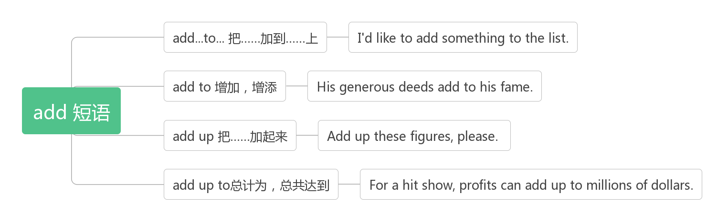

**addition [ə'dɪʃ(ə)n]n. 添加；加法；增加物**

**in addition此外**

In addition, most newspapers had little in them that would appeal to a mass audience.(2019全国III)

此外，大多数报纸几乎没有吸引大众读者的内容。

Standing up, it's easier to find food or enemies. In addition, their arms that are unnecessary for moving around are freed for other purposes, like throwing stones or signaling.(2019江苏)站起来，更容易找到食物或敌人。此外，他们不需要用来移动的手臂会被释放出来用于其他目的，比如扔石头或发信号。

**in addition to除……以外**

In addition to the school, the village has a clinic, which was also built with government support.(2014天津)

除了学校，村里还有一个诊所，也是在政府的支持下建成的

In addition to saving money, cheese brine(盐水) could also be a more eco-friendly option.(2020浙江一月)

除了省钱，奶酪盐水也是一种更环保的选择

**additional [əˈdɪʃənl] adj. 附加的，额外的**

Just before and an hour after each workout, the scientists took additional samples of the men’s blood and fat tissue.(2020江苏7月)就在每次锻炼前后一小时，科学家们采集了这些人的血液和脂肪组织的额外样本。

Working out in the morning provides additional benefits beyond being physically fit.(2018全国II)

除了身体健康，早上锻炼还有其他好处。

Interestingly, this trend isn’t evident in baseball, where additional individual talent keeps improving the team’s performance.(2019北京)

有趣的是，这种趋势在棒球运动中并不明显，因为在棒球运动中，个人的天赋会不断提高球队的表现。

**additionally [əˈdɪʃənəli] adv. 此外；格外的**

Additionally, the bus service will run on Sundays, every two hours.（牛津词典）

此外，公共汽车将于星期天运行，每两小时一班。

The birds are additionally protected in the reserves at Birsay.（柯林斯词典）

鸟类在伯赛的保护区格外地受到保护。

1. **disease [dɪ'ziːz]n. 疾病；弊病**

**词根词缀：dis-(不)+ease(舒服)：不舒服——疾病**

A mere five to 10 minutes A day of running reduced the risk of heart disease and early deaths from all causes.(2018全国I)

每天跑步5到10分钟就可以降低心脏病和各种原因导致的过早死亡的风险。

Simple improvements to infrastructure(基础设施) can reduce the spread of disease.(2016江苏)

基础设施的简单改进可以减少疾病的传播。

1. **ache [eɪk]vi. &n.疼痛；渴望**

**headache [ˈhedeɪk] n. 头疼**

**stomachache [ˈstʌməkeɪk] n. 胃疼**

**toothache [ˈtu:θeɪk] n.牙疼**

My hands started to ache as I turned the heavy metal wheels.(2013全国I)

当我转动沉重的金属车轮，我的手开始疼痛。

That afternoon,I raced home,sat down at the computer,and typed until my fingers ached.(2013天津)

那天下午，我跑回家，坐在电脑前，打字一直到手指疼痛。

Poor posture can cause neck ache, headaches and breathing problems.

姿势不当会导致颈部疼痛、头痛和呼吸困难。

**ache for想念，渴望**

I want to know what you ache for, and if you dare to dream of meeting your heart's longing.

我想知道的是你因什么而痛苦，想知道你是否敢于去梦想满足心灵的渴望。

1. **treat [triːt]vt. 治疗；对待；处理；款待n.请客，款待**

**破拆法：tr-(try试)+eat(吃):请试吃——请客，款待——对待;处理;治疗**

**It’s my treat.我请客**

**treat sb to sth. 用某物款待某人**

**treat ... as/ like... 把……当作……**

It was summer, and my dad wanted to treat me to a vacation like never before.(2018浙江)

那是个夏天，我爸爸想请我去度个前所未有的假。

The idea that the government would take over driverless cars and treat them as a public good would get absolutely nowhere here.(2017天津)认为政府将接管无人驾驶汽车并将其视为公共事业的想法，在这里绝对行不通。

Treat other people as you hope they will treat you. 己所不欲，勿施于人。

**treatment ['tri:tm(ə)nt] n. 治疗，疗法；处理；对待**

**under treatment 在治疗中**

After years of regular treatment, she finally became healthy.(2016天津)经过多年的定期治疗，她终于恢复了健康。

1. **from now/then on 从这/那时起**

From then on, I started to play my football with classmates after school.(2019全国I)

从那时起，我开始在放学后和同学一起踢足球。

My attitude changed from then on.(2012全国II) 从那时起，我的态度改变了。

From now on I will only be editing articles for PsyBlog.(2017浙江) 从现在开始，我只会为PsyBlog编辑文章。

From now on, I will expect nothing, and just take what I get. 从现在起，我将不再期待，只珍惜我所拥有的。

1. **lean [liːn]vt. 使倾斜vi. 倾斜；倾向；倚靠；依赖adj. 瘦的；贫乏的，歉收的**

People typically lean towards people they like and away from people they dislike.

面对喜欢的人，人们都是身体前倾，对不喜欢的人向后倾。

She was feeling tired and was glad to lean against him.她正感到有些疲倦，因此很高兴可以靠在他身上。

It is a beautiful meat, very lean and tender.这块肉很好，又瘦又嫩。

Friends are like walls. Sometimes you lean on them, but sometimes ifs just enough to know they are there.

朋友就像是墙壁，有的时候，你会靠在上面。但是有的时候，你只需要知道他们在那儿就好了。

1. **get through**

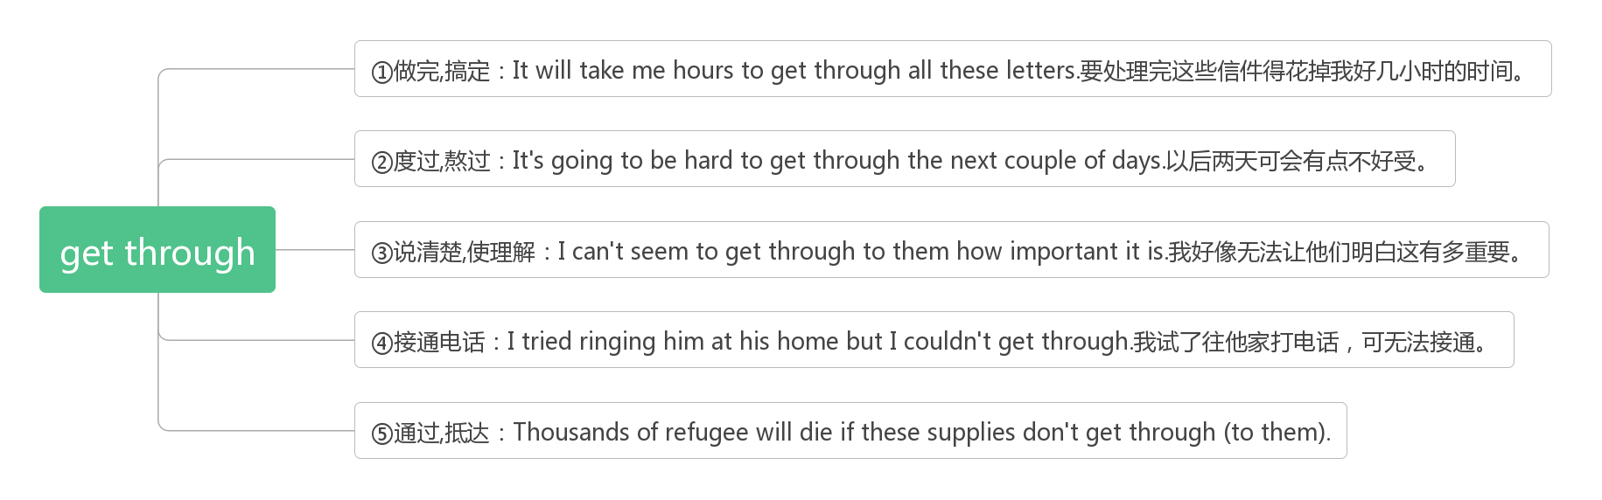

1. **moreover [mɔːr'əʊvə]adv. 而且；此外**

This certainly makes my own views clearer. Moreover, I can find out whether my reactions to an event are reasonable enough by reading about those of others on the Internet.(2016江苏) 这当然使我自己的观点更清楚。此外，我可以通过阅读互联网上其他人的反应来判断我对事件的反应是否足够合理。

In high school, I became curious about the computer, and built my first website. Moreover, I completed the senior course of Computer Basics, plus five relevant pre-college courses.(2016北京) 在高中的时候，我对电脑产生了兴趣，并建立了我的第一个网站。此外，我完成了计算机基础的高级课程，加上五门相关的大学预科课程。

1. **satisfy ['sætɪsfaɪ]vt. 使满足，使满意**

Reading satisfies my desire to keep learning.(2019天津) 阅读满足了我不断学习的欲望

She did have a network of close friends and family,and maybe this is what satisfied her.(2013天津)

她确实有一个由亲密的朋友和家人构成的网络，也许这就是让她满意的地方。

**satisfied['sætɪsfaɪd]adj.满足的，满意的**

**be satisfied with对……感到满意**

Students who take a well-planned year out are more likely to be satisfied with, and complete, their chosen course. (2015全国II) 经过精心规划的一年，学生更有可能对自己选择的课程感到满意，并完成课程。

Apparently satisfied that we caused no further threat, the bear moved off, destroying a fence as it went. (2014北京)

这只熊显然对我们没有造成进一步的威胁感到满意，它离开了，临走还毁坏了一个篱笆。

With over one million satisfied customers around the world, the new EP heats better and faster, saves more on heating bills, and runs almost silent.(2013北京)

新EP在全球拥有超过100万的满意客户，加热更佳、更快，节省了更多的取暖费，运行时几乎无声。

**satisfactory [sætɪs'fækt(ə)rɪ]adj. 令人满意的；符合要求的**

In respect to the content, the article is very good,but it is not satisfactory in other aspects.

就内容而言，这篇文章很好，但在其他方面还不能令人满意。

His work is far from satisfactory. 他的工作远不能令人满意。

**satisfaction [sætɪs'fækʃ(ə)n]n. 满意，满足**

**to one’s satisfaction 令某人满意的是**

He had more job satisfaction, a better marriage and was healthier. (2016天津)

他的工作满意度更高，婚姻状况更好，身体也更健康。

Pureness is not an attitude, it is one kind of satisfaction. 单纯不是什么态度，而是一种满足感。

The visiting minister expressed his satisfaction with the talks, adding that he had enjoyed his stay here.

正在访问的部长表达了他对谈话的满意，并且补充说他喜欢在这里停留的这段时间。

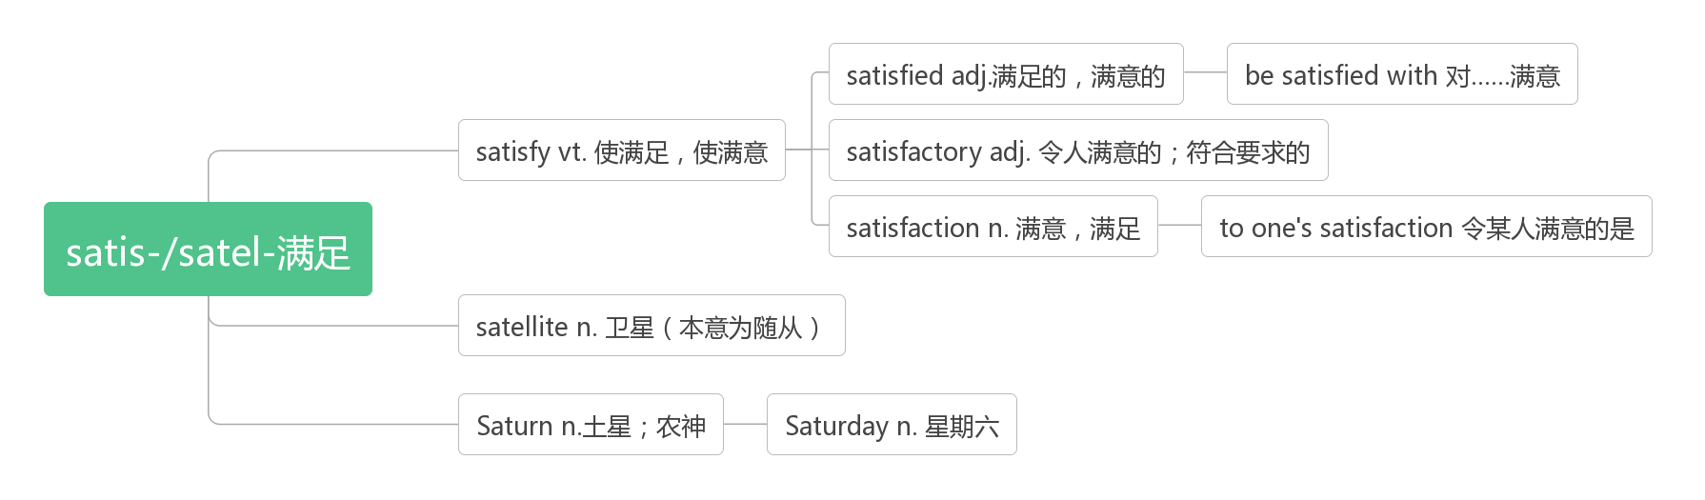

1. **various [ˈveərɪəs]adj.各种各样的，多样的**

**词根词缀：vari(变异，变化)+-ous(形容词后缀)：有变化的——各种各样的**

No matter what you like to do, there is a way to get involved in various activities on Earth Day. (2019北京)

不管你喜欢做什么，都有办法可以让你参与地球日的各种活动。

When a predator(捕食者)always eats huge numbers of a single prey(猎物)，the two species are strongly linked；when a predator lives on various species，they are weakly linked.(2019天津) 当捕食者总是吃大量的单一猎物时，这两个物种是紧密相连的;当捕食者以不同的物种为食时，它们的联系则较弱。

These data have been collected from various sources. 这些数据是从各方面搜集来的。

No matter what you like to do, there is a way to get involved in various activities on Earth Day. (2019北京)

不管你喜欢做什么，都有办法可以让你参与地球日的各种活动。

These data have been collected from various sources. 这些数据是从各方面搜集来的。

**variety[vəˈraɪətɪ]n. 变异体；多样化**

Most of us, in fact, progressively narrow the variety of our lives.(2019天津)

事实上，我们中的大多数人逐渐缩小了我们生活的多样性。

This nice-tasting pineapple contained four times more vitamin C than the old green variety.(2008全国I)

这种美味的菠萝所含的维生素C是以前的绿色品种的四倍。

It was a time when people were divided geographically, leading to many varieties of dialects and characters

那是一个中国人在地理上分裂的时期，导致了多种方言和文字的产生。

**vary[ˈveəri]vi.变异，变化**

Typing patterns vary from person to person.(2019全国I) 打字风格因人而异。

The effects of gossip vary depending on the situation.(2016浙江) 流言的影响因情况而异。

Cherries vary in colour from almost black to yellow. 樱桃的颜色由近乎黑到黄各不相同。

**a variety of = varieties of = various多种多样的；各种各样的**

Join us to taste a variety of/varieties of/various fresh local food and drinks. (2018全国III)

和我们一道品尝各种新鲜的本地食物和饮料。

Make sure that as you go from interview to interview, you are getting a variety of /varieties of /various answers.(2017浙江)

确保你从一个面试到另一个面试，会得到各种各样的答案。

I decided to leave London for a variety of / varieties of / various reasons. 由于种种原因，我决定离开伦敦。

1. **somehow ['sʌmhaʊ]adv. 不知怎的；以某种方式**

Somehow the boys had slipped away to the back lot with their kites.(2011浙江)

男孩们不知怎么地把他们的风筝溜到后院去了。

The landscape, beautiful on its own, somehow comes to life and breathes because this woman is engaging with it.(2017天津)

风景本身就很美，但不知何故却活了起来，呼吸了起来，因为这个女人在与它打交道。

|  |  |
| --- | --- |
| somehow | 表示“由于某种未知地原因”，所以意为“不知怎地，莫名其妙地”也可指“以某种未知地方式”。 |
| somewhat | somewhat 意为“从某种意义上讲；有几分”，相当于in a way, rather。 |
| anyhow | 意为“无论如何”，相当于 anyway；at any rate。 |

He could have finished it on schedule, but somehow he fell behind.他原本能按预定进度做完这件事的但不知怎么却落后了。

I am somewhat tired of this book. 我有点讨厌这本书。

It may rain, but anyhow I shall go out.I don’t mind the rain.可能会下雨，但无论如何我都要出去。我不介意下雨。

1. **rhetorical [rɪ'tɒrɪk(ə)l]adj. 修辞的；修辞学的；夸张的**

**破拆法：rhet-(write写)+-or(名词后缀，表示人)+-ical(形容词后缀)：写作者所使用的——修辞的。**

The writer showed great rhetorical skill. 该作者显示出非常出色的修辞技巧.

 It is a style which I have deliberately abandoned as too rhetorical.

这种文体风格我因为它过分藻饰华丽已经存心放弃了。

1. **metaphor ['metəfə]n. 暗喻，隐喻**

**破拆法：me(我)+tap(轻敲)+hor(horn号角)**：

**助记：我轻敲着号角，唱出一段隐喻：“如果冬天已经来临，春天还会远吗？”**

In poetry the rose is often a metaphor for love.玫瑰在诗中通常作为爱的象征.

1. **personification [pə,sɒnɪfɪ'keɪʃ(ə)n]n. 人格化；化身；拟人**

**词根词缀：person(人)+-ifi(-ify动词后缀)+cation(名词后缀)：拟人，化身**

She was the personification of elegance.她是优雅的化身。

1. **repeat [rɪ'piːt]vt.&vi. 重复，重做**

**词根词缀：re-(再，又)+peat-(pet-寻求)：再次寻求结果——重复，重做**

Female Australian superb fairy wrens were found to repeat one sound over and over again while hatching their eggs.(2017江苏)

研究人员发现，澳大利亚细尾鹩莺在产卵时，会一遍又一遍地重复同一种声音。

Some people believe whatever has happened before or is happening now will repeat itself in the future.(2014北京)

有些人相信，无论过去发生了什么，现在正在发生什么，将来都会重演。

**repetition [repɪ'tɪʃ(ə)n]n. 重复**

Repetition does not transform a lie into a truth.重复并不能把谎言变成真理。

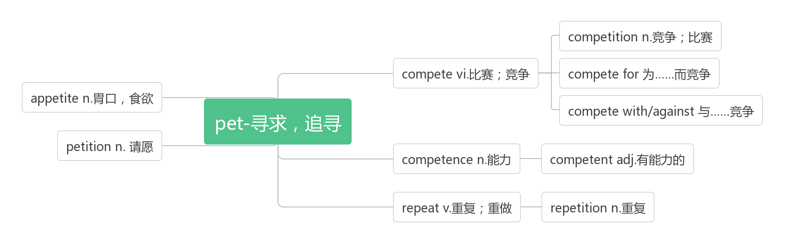

1. **simile ['sɪmɪlɪ]n. 明喻, 直喻**

**词源：similar(相似的)——>simile(明喻)**

It is a simile to compare her teeth to pearls.把她的牙齿比做珍珠是种比喻。

Students tried to use simile to write and describe people.同学们学习了运用比喻来描写人或事物。

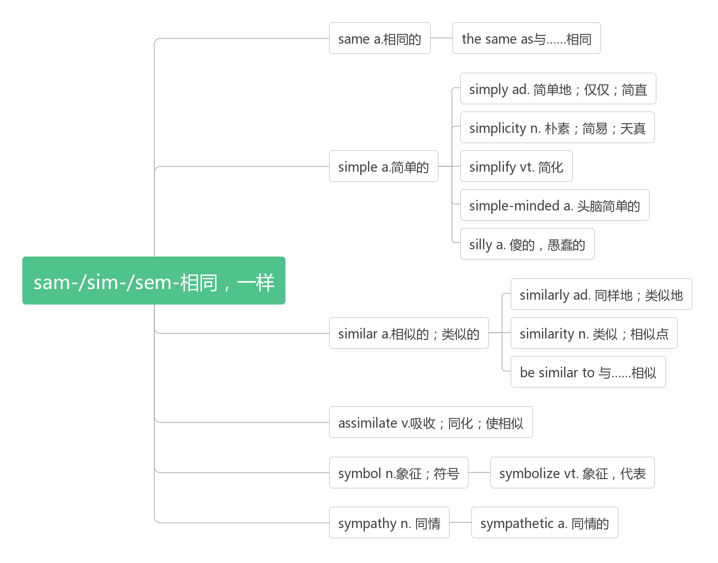

1. **outline ['aʊtlaɪn]n. 轮廓；大纲；概图vt. 概述**

**合成法：out(外部的)+line(线条)：外部的线条——轮廓；大纲；概图**

 make an outline of the article列文章的提纲

With the reporters giving an outline of the disaster, the whole nation was shocked at the damage and the victims’ extreme suffering. 随着记者们对灾难进行了概述，全国人民对损失和受害者的极度痛苦感到震惊。

These documents provided a broad outline of the Society's development. 这些文件勾画出了社会发展的大致框架。

1. **react [rɪ'ækt]vi. 反应；起反作用**

**react to对……作出反应**

They were not sure how the Americans would react to the new type of music.(2019浙江)

他们不知道美国人对这种新型音乐会有什么反应。

When you share a story with your friends, you care a lot more how they react.(2016全国III)

当你和朋友分享一个故事时，你会更关心他们的反应。

Oxygen will react to nearly all organic materials and metal. 氧几乎能与所有的有机物和金属发生反应。

**reaction [rɪ'ækʃ(ə)n]n. 反应；反作用**

What was the reaction of the public to Mrs.Robinson's decision?(2016全国I)公众对罗宾逊夫人的决定有何反应?

I do not get lost in my own personal reaction to what people are saying.(2007天津)

对于人们所说的话，我不会迷失在自己的个人反应中。

This produced a chain reaction,which made it possible for life to develop.这产生了连锁反应，使生命得以发展。

