**M3U4 Space Exploration**

**Assessment for Writing: Homes on Mars?**

**Period II**

1. **Teaching objectives**

**By the end of the class, the students will be able to:**

1. Explore some detailed points for assessment by assessing the essay on the textbook under the guidance of the teacher.
2. Analyze the peer’s works according to the Evaluation Sheet by group assessment to cultivate their critical thinking and enhance their abilities of assessment and cooperative learning.
3. Polish a typical paragraph of a student’s version by focusing on the content and language to cultivate their awareness of how to polish the most difficult and important parts.
4. Polish the peer’s works in group based on what they have learned to cultivate their abilities of bettering two important points and cooperative learning.
5. **Learning Procedures**

**Activity 1: Exploring the detailed points for assessment**

Students are to assess the essay on the textbook: *Homes on Mars?* accoding to the following Evaluation Sheet under the guidance of the teacher.

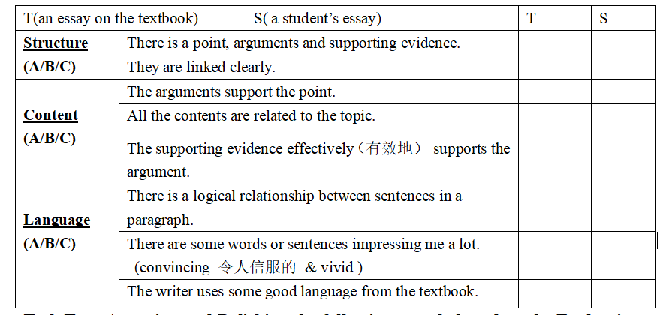

Based on the Evaluation Sheet, the teacher will mainly guide the students to focus on the following three aspects:

**Content:** Does the supporting evidence effectively support the argument?

**Language:** Is there a logical relationship between sentences in a paragraph?

Do any words or sentences impress you a lot? (vivid & convincing)

(*Intention: to help students learn how to assess the essay in a more specific way based on what they have learned in the class.*)

**Activity2: Assessing the peer’s works in group**

Students are to assess the peer’s work based on the above points. After discussion, two of the reporters will share their assessment to the class. Before assessing, the sudents are expected to learn some rules about assessing and to pay attention to some related topic expressions about how to assess an essay:

1.Read together at first.

2.Group members should put forward ideas actively according to the Evaluation Sheet and the leader collects the members’ ideas.

3. During the discussion, the leader should map out some places that you think need polishing on the essay.

4. You can turn to me for help if necessary.

T: Is there any volunteer to share your assessment about the essay with us?

*(Intention: to cultivate their critical thinking and enhance their ability of assessment and cooperative learning.*)

**Activity3: Polishing the essay all together**

Students are to be guided about how to polish a paragraph of a student’s version, focusing on the most important and difficult ones:

**Content:** Does the supporting evidence effectively support the argument? (Para.2)

**Language:** Is there a logical relationship between sentences in a paragraph? (②-③-④)

T: Do you think the supporting evidence in this paragraph effectively supports the argument? If not, how can we polish it?

*(Intention:to cultivate their awareness of how to polish the most difficult and important parts.)*

**Activity4: Polishing the essays in group**

Students are to polish their own group works in a group and later share their polished one with the class. Before assessing, the sudents are expected to learn some rules about polishing:

1. Decide on one paragraph to polish.

2. Group members should put forward ideas about how to polish it.

3. The leader directly polishes the places need improving with different colors.

4. You can turn to me for help if necessary.

T: Is there any volunteer to share the polished one with us?

(*Intention: to help students review what they have learnt and enhance their ability of language and cooperative learning.* )

**Activity5: Making a summary**

**T: How do we assess an essay from today’s class?**

(*Intention: to help students master what they have learned in the two classes fully.*)

**Assignment:**

**1. Please write an essay that gives your opinion about the idea of humans living on Mars independently. (You can find more evidence about Mars exploration on the Internet to make your essay more persuasive).**

**2.Please independently assess your essay according to the Evaluation Sheet on Writing and exchange it with your group members.**