语篇研读
主题语境：人与社会 语篇类型：说明文
【What】
本课阅读文本的标题为“The Chinese Writing System: Connecting the Past and the Present”,是一篇介绍汉字发展的说明性文章，主要介绍了汉字书写体系的发展历史及其重要作用。
【Why】
本文的重点在于其深刻的文化内涵。本文的价值取向在于让学生认识汉字的重要价值，学习中国历史，传承中华文明，传播中华文化，增强文化自信心和民族自豪感。
【How】
第一段说明汉字书写体系对中华文明传承的重要性; 第二段和第三段介绍汉字的发展和历史; 第四段、第五段和第六段着重阐述汉字的重要连接作用。本文包含两条主要线索：第一条是按时间顺序梳理了汉字书写体系数千年的发展历史，这是文本叙述的明线。第二条是呼应标题中的题眼“连接”（connecting）的一条暗线，说明汉字书写体系对中华文明传承数千年所起到的四个重要作用：1.连接时间上的过去与现在；2. 连接空间上生活在不同地域的人们；3.连接语言与艺术；4.连接中国与世界。
教学目标
1.根据文本标题及图片，预测文本的主要内容；
2.通过快速阅读，提取语篇主题，梳理文章结构，归纳各段大意，理解语篇类型；
3.通过扫读，梳理有关汉字书写体系的具体信息，探究汉字的重要价值，概括整合有关信息；
4.基于文本主题和本堂课所学语言知识，有逻辑地组织信息，发表个人观点。
5.形成正确的文化价值，树立传承中华文明、传播中国文化的社会责任感；
教学过程
Step1 Lead-in
- Ss. look at some pictures and guess what those characters are.
- How do they develop over time?
Step2 Reading
1.Pre-reading: Predict the content by looking at the title and picture.
2.While-reading:
Activity 1: Read for main idea of each paragraph, text type and structure
Activity 2: Focusing on the development
Para 2-4: the history/development of the Chinese writing system
Q1: What kind of words can show the development of the Chinese writing system clearly?
Q2: What happened to the Chinese characters at those important times?
Activity 3: Retell the history/development of the Chinese writing system
Activity 4: Para 5-6: the significance/importance of the Chinese writing system
Read para 4-6 to underline sentences including importance or important.
What does each importance refer to?
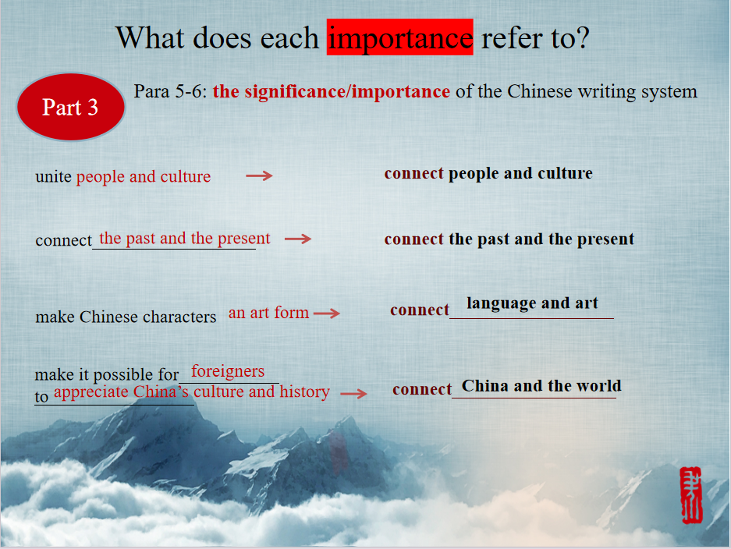
Summary
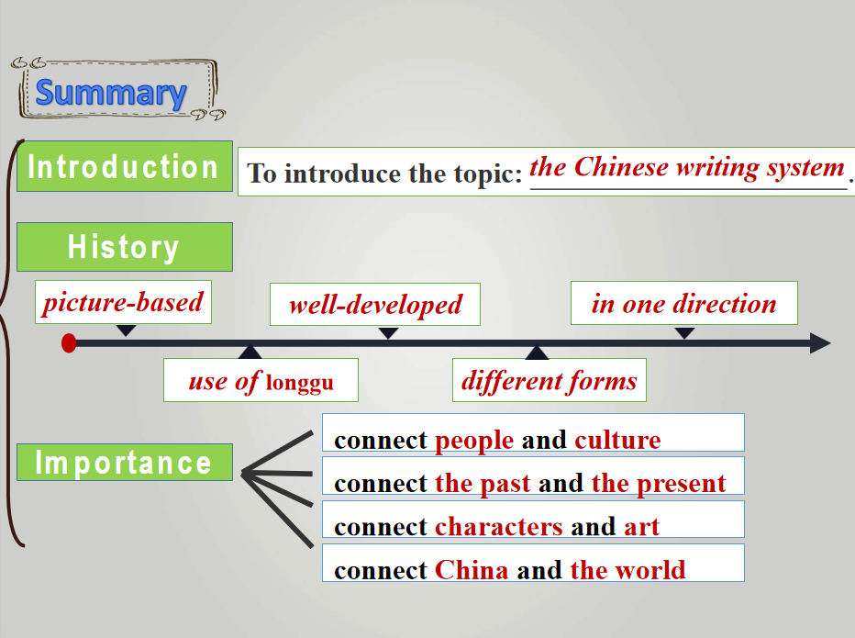
Step3 Post-Reading
1.Video-The evolution of Chinese
2.Thinking and sharing :As teenagers, what can we do to help to preserve , inherit (传承) and spread the Chinese characters?
Step 4 Assignment
Make a speech on the opening ceremony of the Festival of Chinese Characters in your school to call on students to make the Chinese writing system known to more people. Your speech should include:① a topic② the development, function and importance of the Chinese writing system;③ a conclusion.

