**金华十校2022-23学年第一学期期末调研考试读后续写**

**A Special Christmas 讲评 教学设计**

**Activity 1 1 Understanding The Characters and The Given Information**

Read the given text and answer these questions.

Q1: Who are the main characters?

Q2: What happened to “me ” before Christmas?

Q3: What was my life like at that moment? How do you know?

Q4: To my surprise, who came to help me?

Q5: What kind of person do you think Asther Heffeman is?

Q6: Why did she come over to my house on such a snowy day?

**[设计意图]** 理解所给文本的主要信息，抓住主要人物的性格特点，为下面的续写打基础。并通过Q5和Q6引导学生对professor Asther Heffeman的人物性格特点和她将如何帮助“我”做出合理的预测，以保持与原文在内容和人物性格方面的协同一致。

**Activity 2 Predict The Ending**

What information can you get from these two given sentences?

Para 1: I rushed out of the house, waving my hands.

Para2 : When I opened the envelope, inside I found some money and a note.

**【设计意图】**通过对所给段落首句的理解，引导学生既关注故事的结果，又关注每个续写段落情节的构架。通过启发学生自主提问，培养学生勾勒故事主要情节的能力。

**Activity 3 Wave The Plots With Vivid Language**

**(1) How to write para1?**

*Para 1: I rushed out of the house, waving my hands.*

Q1: What did I do/ say when I met my professor?

Q2: How did I feel?

Q3: Did she notice my embarrassment / poor situation ?

Version 1 of para 1. Please fill in the blanks to make it coherent.

I rushed out of the house, ________________ (朝她挥舞着双手). “”What are you doing out in this weather?” I asked ______________(当我们拥抱的时候). “Well, it‘s Christmas,” Esther said and _______________________________ (递给我一些礼物). I invited her inside, made her a cup of tea, and we talked beside the fireplace. What warmed me in this freezing winter was not only her gifts, but also her presence which gave me hope _______________________(一切都会变好的). As she got up to leave, she handed me an envelope. “This is for you,"she said as she kissed me on the cheek.

Summary : In this para1, how was their meeting ? Which advanced words or structures are used to create a vivid description of their meeting?

**[设计意图]** 搭建支架引导学生通过填空形式完成第一自然段的续写，并感悟在此段作者运用了 连续的动词，v-ing形式作状语，名词性从句（主语从句和同位语从句），定语从句等多样化的句式和结构，达到了行文流畅，自然体现情感的效果。

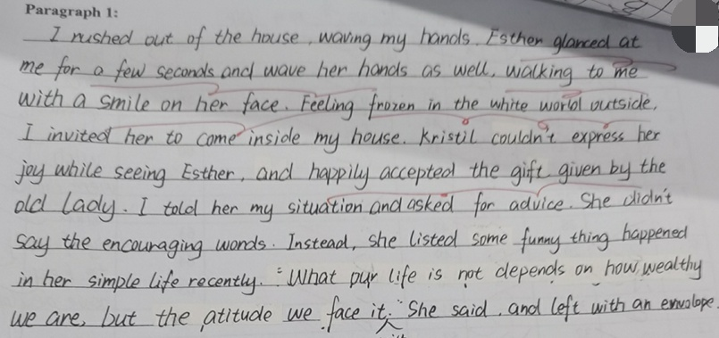Version 2 of para 1. Please find out the good points and some mistakes in it . (学生作品赏析)

学生自主表达，寻找该段的优点和缺点，然后总结归纳如下：

**Two main logical problems in para 1 :**

1. Kristil presented in para1, but actually she was at her classmate’s house for a birthday party at that moment.

2. The professor’s words and deeds should be considerate , not being too direct (Because she is understanding).

**读后续写写作技巧点拨**

Key 1: The characters’ behaviour, the settings and the plots must be logical.

Key 2: Try to reduce grammar mistakes and write authentic expressions.

**(2) How to write para2 ?**

*Para 2: When I opened the envelope, inside I found some money and a note.*

Q1: What was written on the note ?

Q2: How did I feel when I found the money and the note ?

Version 1 请学生来评价此段的优缺点。

When I opened the envelope, inside I found some money and a note. Hardly had I caught the first sight of the money I realised my professors’ purpose and kindness. Excited yet astonished, gratitude almost deprived me of all power of speech. Then, with trembling hands picking up that note, I went through the content,"Life is not just living through the storms, but dancing in the rain. Never lose heart to look forwand. ” With the wind beginning to cease its roar and sunshine took on the gloden color, warmth flooded over me.

**[设计意图]** 通过赏析para2的version 1 的优缺点，引导学生关注读后续写的第3个写作技巧。 Key 3 Use appropriate advanced vovabulary and sentence patterns to express the theme. （如运用倒装句 / 复合句 / with的复合结构 / 非谓语等）

**Version 2 of para2: （A sample）**

*When I opened the enrelope, inside I found some money and a note.* I gasped in shock. Tears of gratitude puddled in my eyes as I counted the dollar bills. $1.000 in total ! “I knew your situation, and just enjoy your Christmas with Kristil.” I was on the edge of crying out. I will. I promised to Esther in my heart. After buying a Christmas tree in a supermarket, I picked up Kristil and drove home. Her face lit up on seeing such beautiful a Christmas tree with shining stars. At that moment, the snow stopped. Some sunlight penetrated the clouds, bringing me warmth and hope.

**Activity 4 Practice and Improve Yourselves**

Let’s practice four scenes which will help you write better scenes in continuation writing.

Scene1 : 描写老友相见

Scene2 : 描写“我的尴尬” 和“她的安慰”

Scene3 : 描写深受感动

Scene4 : 描写环境 烘托主题

**[设计意图]** 读后续写往往是由许多个情节小片段组成，那么，在语境中创设生活中的常见小片段（sneces）让学生多多练习，不失为一种实用又高效的尝试。

**Activity 5: Another sample of the continuation writing and a summary by the teacher.**