**2024年1月九省适应性联考英语**

**应用文 讲评学案**

**PART 1 审题与写前点拨**

【题目呈现】

你校英文报计划举办主题为“携手行动，节约粮食”的作文比赛。请你写一则活动通知，内容包括：

1.介绍活动目的；

2.说明参赛要求。

注意：

(1)写作词数应为80个左右；

(2)请按如下格式在答题卡的相应位置作答。

**Welcome to Join the English Writing Competition！**

______________________________________________________________________________________________________________________________________________________________

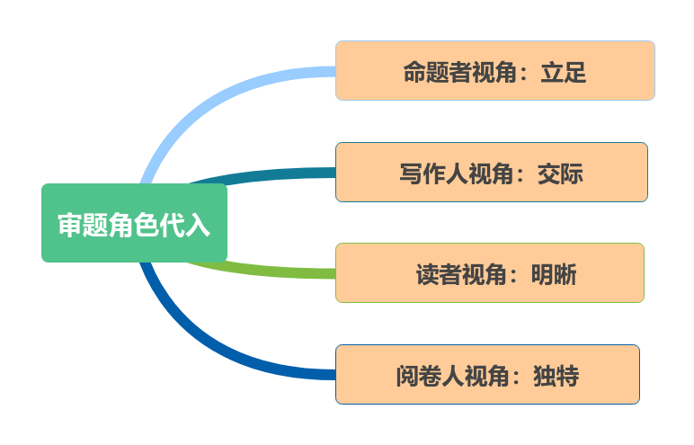

从命题者角度看，这则活动通知要求学生参加主题为“携手行动，节约粮食”的作文比赛。主要核心包含两大要点：

活动目的——在介绍活动目的时，可以借鉴新闻报道的客观陈述风格，以清晰明了的语言表达比赛的宗旨和意义。强调粮食节约的重要性，可能会包括 __________________________等方面。

参赛要求——在说明参赛要求时，可以采用更为正式的语言，类似于书信的语气，明确指出__________________________________________________等。此部分需要准确传达比赛规则，使学生明确了解要求的概况。

【基本信息把握】

|  |  |  |  |  |
| --- | --- | --- | --- | --- |
| 文体体裁 |  | | | |
| 写作人 |  | | | |
| 写作对象 |  | | | |
| 写作背景 |  | | | |
| 写作目的 |  | | | |
| 人称时态 |  |  |  |  |

**PART 2 列纲与分段写作**

①首段直入活动本身

书面通知类，不能错写成信件格式，阐明由英语报举办本次比赛活动及其主题，作为全文的引领段。

②次段述主题

第二段是整篇应用文写作的核心部分，也就是所说的“主体”（body），即围绕比赛目的与比赛要求两大维度，前者的理由偏理论化，从较为抽象的角度阐述，可阐述比赛在“育人”上的益处。后者则落地到具体实践，需要结合常规比赛要求的构成要件展开陈述。如“content；length；deadline；submission”多个角度。

③尾段表示再次呼吁

结尾可以适当写一写让学生积极踊跃参加活动的祈使句，与给出的标题形成呼应（echo)。

**【首段】**

Q1:首段如何迅速契合“书面通知”这一体裁特点？

___________________________________________________________________________

Q2:主题“携手行动，节约粮食”如何表达？

___________________________________________________________________________

Q3:以下两个句子是否可行？

___________________________________________________________________________

**Example1：**

I am excited to announce that our school's English newspaper is organizing an essay competition with the theme "Join Hands, Save Food." __________________________

**Example2:**

The upcoming English Writing Competition launched by our campus English newspaper with the theme "Join Hands, Save Food" is awaiting your participation. ________________________

**【次段】**

Q:要点1 “比赛目的”可以写哪些方面或角度？

______________________________________________________________________________

**混合角度：**

This competition aims to raise awareness about the importance of food conservation. By getting involved in, you can contribute to the global effort to reduce food waste, protect the environment, and show solidarity with farmers.

**感染他人共同致力于可持续未来**

Through your essays, it is hoped that everyone can be stimulated to adopt responsible eating habits and reduce food waste, jointly contributing to a sustainable future.

**Expansion:节约粮食相关目的素材**

Q:“参赛要求”有哪些必要方面或角度？

______________________________________________________________________________

【案例】

Participants are required to submit an essay in English with a word count of approximately 150-200 words. Your essay should reflect a positive and proactive approach towards food conservation, emphasizing the significance of the issue and offering practical suggestions.

**上述案例中包含了哪些“参赛要求”？有无重点缺失？**

______________________________________________________________________________

**【修改】**

Everyone interested is expected to submit an essay in English with approximately 150-200 words. Your essay should reflect a positive and proactive approach towards food conservation, emphasizing the significance of the issue and offering practical suggestions. （___________________________________________________________________)

**Expansion: 参赛要求一般的构成要素**

**【尾段】**

Q:在通知的框架下，如何表达激励参赛？______________________________________________________________________________

Let's join hands and take action together to build a society that values food conservation! Stay tuned for further updates and more details in the English newspaper.

Join us in making a difference through your words. Together, let's advocate for a sustainable future!

**PART 3 例文与范作评价**

**【例文】**

**Welcome to Join the English Writing Competition**

Launched by our school English newspaper with the theme "Join Hands, Save Food" , the upcoming English Writing Competition is awaiting your participation.

This competition aims to raise awareness about the food conservation and show solidarity with the industrious farmers , thus stimulating everyone to adopt sensible eating habits and jointly contribute to a sustainable future. Everyone interested is expected to submit an essay in English with approximately 150 words. Your essay should reflect a positive and proactive approach towards food conservation, which should be submitted to our editorial department by the end of this month.

Let's join hands and use the power of words to advocate for a society that values food conservation! Please stay tuned for further updates and more details in the English newspaper.

**【从下面几个内容角度评析此作】**

主题介绍：是否清晰地介绍了比赛的主题和发起方，是否能更直接地吸引读者的关注。

活动目的：是否完整表达出活动的目的，目的的阐述是否多元不单一。

参赛要求：是否阐述非常清晰，包括字数要求、截止日期和提交方式。是否提供了其他相关细节，以使通知更全面。

鼓励和呼吁：是否通过鼓励参与者以积极主动的态度对待节约粮食，是否增强了通知的感染力。

你觉得本文的得分是_________

理由与可取之处：______________________________________________________________________________________________________________________________________________________________

**PART 4 迁移与相似任务**

**【体裁迁移】**

你受学生会委托为校宣传栏“英语天地”写一则通知，请大家观看一部英文短片Growing Together，内容包括：

1．短片内容：学校的发展；

2．放映时间、地点；

3．欢迎对短片提出意见。

注意：

(1)写作词数应为80个左右；

(2)请按如下格式在答题卡的相应位置作答。

_______________________________________________________________________________

_______________________________________________________________________________

_______________________________________________________________________________

_______________________________________________________________________________

_______________________________________________________________________________

_______________________________________________________________________________

_______________________________________________________________________________

_______________________________________________________________________________

_______________________________________________________________________________

_______________________________________________________________________________

_______________________________________________________________________________

**【参考范文】**

To enrich students' campus life, the Students’ Union is going to invite all the students to enjoy an English movie called Growing Together, which mainly focus on the school development. （活动背景和意义）

The movie is scheduled in the lecture hall of the Art Building from 20:00 p.m to 20:30 p.m. on Sunday evening. （活动时间地点）This movie will not only arouse the pride of all the students in our school, but also serve as a motivation for everyone to study hard.（活动意义） 【Those who intend to participate in it are welcome to see it for free. Meanwhile, you are required to be there 10 minutes earlier and while watching the film, please keep quiet and clean.（注意事项）】

Hopefully, you would make it to our activity. Any comments and suggestions are welcome.

The Students' Union

**【题材迁移】**

10月16日是世界粮食日(World Food Day),你校为了提高学生珍惜粮食的意识举办了一系列活动。假定你是校英语报的记者，请你为校英语报写一篇活动报道。内容要点包括:

1.活动过程;

2.活动反响

注意:

1.写作词数应为80左右;

2.请在答题卡的相应位置作答.

_______________________________________________________________________________

_______________________________________________________________________________

_______________________________________________________________________________

_______________________________________________________________________________

_______________________________________________________________________________

_______________________________________________________________________________

_______________________________________________________________________________

_______________________________________________________________________________

_______________________________________________________________________________

_______________________________________________________________________________

_______________________________________________________________________________

_______________________________________________________________________________

_______________________________________________________________________________

**【参考范文】**

Recently, in honor of World Food Day, our school organized an impactful event to arouse the public's awareness of food crisis.

To emphasize the global food security issues, the event began with insightful speeches from some distinguished guests. At the same time, a captivating exhibition vividly illustrated global food challenges. Everyone present was spurred by the powerful visualizations.The highlight of the event was a fund-raising ceremony to support a local charity.

Needless to say, the activity was significant. It served as a powerful reminder of the collective duty we bear in addressing global food challenges, fostering a sense of commitment among participants.