*2022年6月高考 考前惊鸿一瞥*

**应用文写作**

**Ⅰ.语篇的外貌：格式正确，拼写无误**

1.书信体：开头称呼语

① 熟悉的朋友 , 如：Jason Bennet / Sara Smith

英美人姓名的顺序与中国人的完全相反,“Mr./Ms. + 名”是不规范的写法，不应该使用Mr. Jason 或 Ms. Sara ，而是 Dear + first name，如： Dear Jason / Sara,

② 第一次发邮件联系对方，只知道姓名性别 , 如：Jason Bennet / Sara Smith

最为妥当的方式使用“Dear Mr. / Ms.加对方的姓氏 family name ”

不知道已婚或者未婚的女士，一律用Ms.更为稳妥。

如：尊敬的班纳特先生/史密斯女士/埃利斯小姐:Dear Mr Bennet / Ms White / Miss Elis，

③ 不知道对方的姓名，但知道对方的头衔/身份

使用“Dear+ Title ”来称呼对方，显得非常礼貌

如：尊敬的老师/编辑/校长/经理: Dear Teacher / Editor / Headmaster / Manager,

④ 无法确定对方的身份和具体称呼

如：至相关人员 /敬启者/致有关人士: Dear Sir or Madam, 或 To whom it may concern，

2.落款

①书面通知: The Students’ Union

October 10th, 2020

②口头通知 / 演讲稿： Thank you!

③信件邮件：写给长辈上级 Yours respectfully, 此致敬礼

Li Hua

写给商务/平辈朋友 Yours cordially/ faithfully/ genuinely, 真诚的/热忱的/忠诚的

Li Hua

④倡议书：The Students’ Union

3.非书信类格式

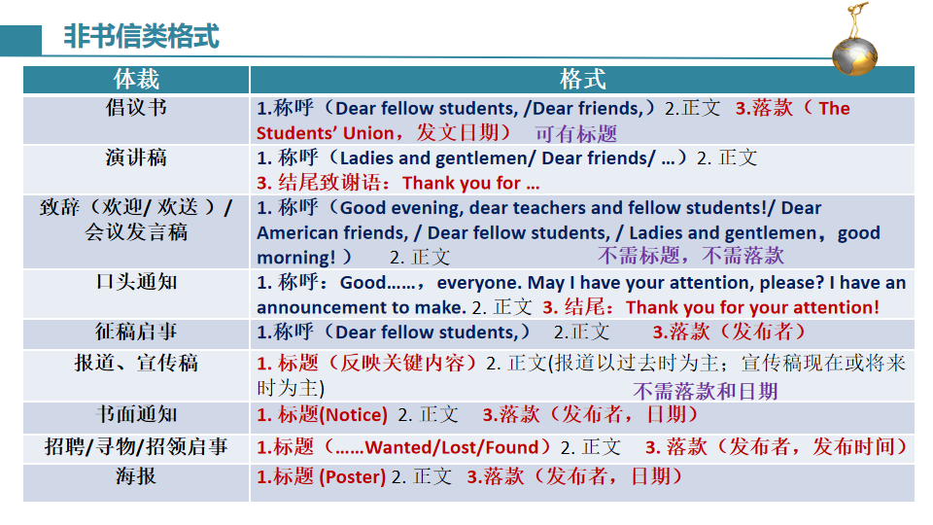

**4.表达时间和地点:** 一般来说, 地点在前,时间在后；时间地点均由小到大；“在…上/下/本+时间”的表达， last/next/this Wednesday/week 前不加介词in/on；表达“上午/下午”，可在时间后加上a.m./ p.m.

Ex1: 比赛定于6月13日下午6点在学校礼堂举行，持续两个小时。

Ex2: 根据之前的安排，为外国学生量身定做的比赛将于下周周五上午9点至11点举行，主题为中国美食文化。

Ex3: 随着新年的临近，我校将于2021年1月1日在学校音乐厅举办新年晚会。

Ex4: 我校举办的中国传统美术作品展于5月1日至5日在活动中心举行，为期5天。昨天我有幸参观了它，并给我留下了深刻的印象。

Ex5: 昨天我参观了学校美术馆举办的6月6-10日的中国传统画展。

Ex6:为了激发学生对阅读的兴趣，我校将于3月19日下午2时在教学楼201室举行一次活动。

5.常用地点的名词：

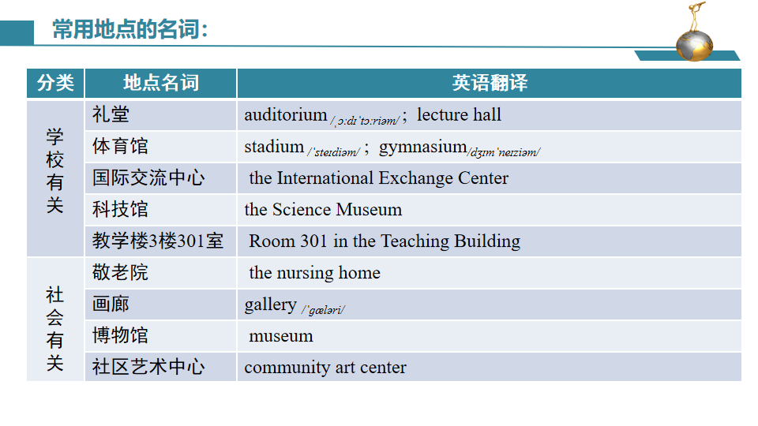

6.常见国家的相关表达

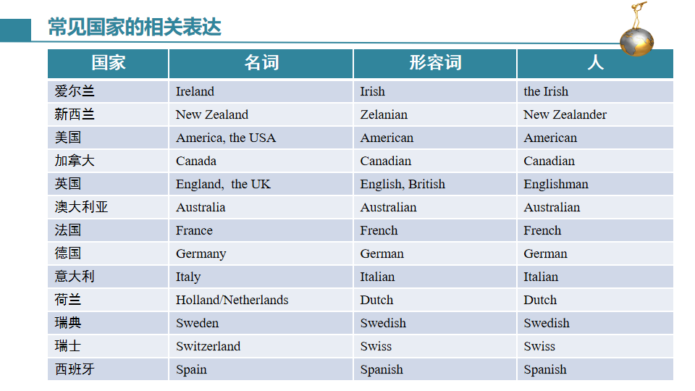

7.常见易错表达

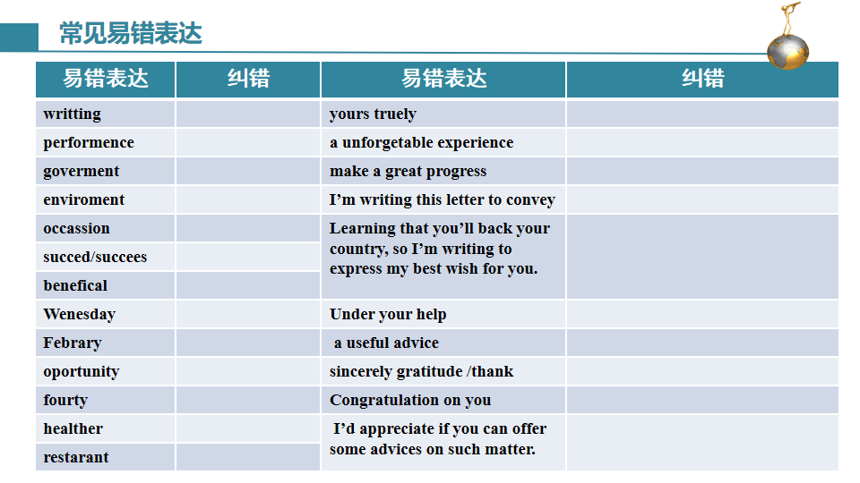

**Ⅱ.语篇的严谨：审题细心，角色代入**

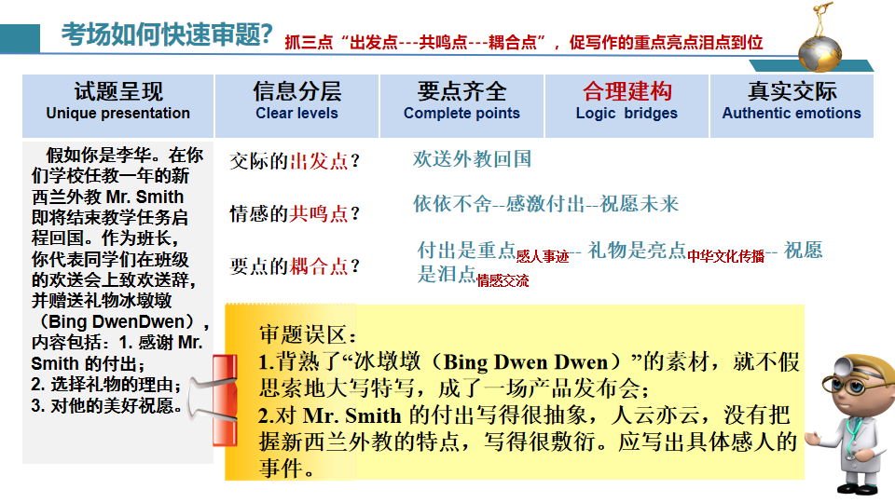

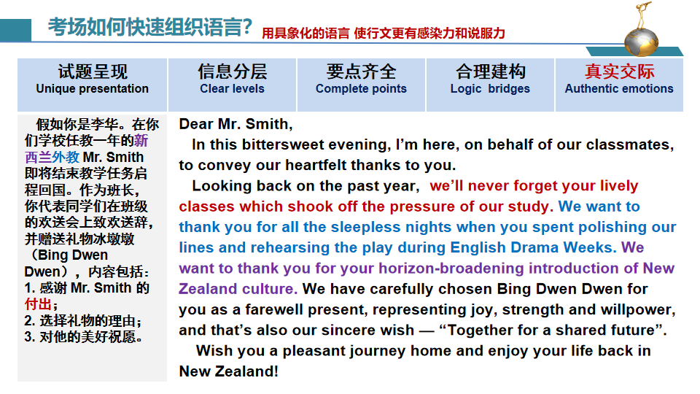

**Ⅲ.语篇的风格：词汇丰富，语义连贯**

|  |  |
| --- | --- |
| **常用词汇** | |
| 老年人 | the aged /senior citizens / seniors /the elderly |
| 指导度过复杂多元的青春期 | navigate through diverse and complex adolescence |
| 志趣相投的同学友谊的催化剂 | a catalyst /ˈkætəlɪst/ for friendship between like-minded peers |
| 语言技能的助推器 | a booster for linguistic/lɪŋˈɡwɪstɪk/ skills |
| 寻求您建设性指导 | seek for constcuctive guidance |
| 修改我的草稿/台词 | polish my draft/lines |
| 衷心感谢 | heartfelt appreciation /cordial thanks /sincere gratitude |
| 不经意的善举 | action of random kindness |
| 及时的... 对我意味很多 | your timely ... means a lot to me |
| 陷入极大的麻烦中 | be caught in numerous trouble/dilemma |
| 根据事先的安排 | according to the prior arrangement |
| 报名参加比赛 | sign up for/ enroll for/ enter for the contest |
| 万众一心，众志成城 | Together, individuals can make a difference. |
| 联合活动/共同努力 | joint activities / effort |
| 尽一切努力；尽所有努力 | exert /ɪɡˈzɜːt/  every effort |
| 产生积极/深远影响 | exert positive/ farreaching influence on |
| 丰富课外文化生活 | enrich extra-curricular /kəˈrɪkjələ/ cultural life |
| 深入彻底的讨论/研究/ 访谈 | in-depth discussion/study/ interview |
| 必看的节目/网站/景点 | must-see shows/ website/ attractions |
| 周密策划/精心装饰的 | elaborately /ɪˈlæbərətli/  planned/ decorated/ designed |
| 刺绣引起我的共鸣 | embroidery in Chinese culture still resonates /ˈrezəneɪt/ with me |
| 跨文化视野 | cross-cultural notions and vision |
| 品尝地道的英语 | savour a dip of authentic English |
| 迷人的十二生肖 | twelve appealing Chinese zodiac /ˈzəʊdiæk/ |
| 领会到体育的独特魅力 | fully appreciate the unique charm of sports |
| **常见赠礼** | |
| 1.这里有一些中国结，在中国象征着和平和友好，祝愿你们幸福、繁荣和学术进步。 | Here are some Chinese knots for you, symbols of friendliness and peace in China, wishing you greater happiness, prosperity and academic progress. |
| 2.送你一本孔子的《论语》，中国传统文化的精髓的折射。 | Attached to the letter is a book The Analects /ˈænəlekts/  by Confucious, a reflection of essence /ˈes(ə)ns/ of Chinese culture. |
| 3.我们精心为您挑选了冰墩墩作为送别礼物，它代表着欢乐、力量和毅力，也是我们真诚的祝福——“携手共进，共铸未来”。 | We have carefully chosen Bing Dwen Dwen for you as a farewell present, representing joy, strength and willpower, and that’s also our sincere wish — “Together for a shared future北京冬奥会口号”. |
| 4.请原谅我的过错。我还送你一个精致的瓷器茶杯，以弥补给你带来的不便。 | Please forgive me for my fault. I also send you a delicate chinese tea cup to make up for any inconvenience caused. |
| **评价活动反响/意义/收获** | |
| 1.唤起... 的意识 | arouse one's awareness/consciousness of |
| 2.陶冶情操 | cultivate/ nourish/ˈnʌrɪʃ/ /nurture one’s mind |
| 3.培养主动性、想象力和创造力 | cultivate/ foster initiative, imagination and creativity |
| 4.收获一次有益且愉快的经历 | harvest a rewarding and enjoyable experience |
| 5.塑造学生的世界观，人生观和价值观 | shape students’ outlook on world, life and value |
| 6.为校园生活增添新的色彩 | add a new dimension/ flavor to campus life |
| 7.提高了我们的身体和心理素质 | improve/facilitate /fəˈsɪlɪteɪt/ our physical and psychological quality |
| 8.促进不同文化之间的相互了解 | Boost mutual /ˈmjuːtʃuəl/ understandings between various cultures |
| 9.激发对... 的兴趣/好奇心 / 热情 | stimulate/ spark/ trigger/ fuel one’s interest in/ curiosity about/ passion for ... |
| 10.不仅能加强我们的毅力，也能增进我们的友谊 | Not only can it strengthen our perseverance, but it enhances our friendship. |
| 11.提供一个极好的平台来提升…… | provide a fantastic/ splendid/ stunning/ brilliant/ superb platform to elevate /enhance /motivate... |
| 12.促进志趣相投、热爱汉语学习的同学之间的友谊. | a catalyst /ˈkætəlɪst/ for friendship between like-minded peers sharing similar passion in Chinese learning |
| 13.培养/建立 成就感/归属感/优越感/责任感和团队精神 | cultivate/ build a sense of achievement/ belonging / superiority /suːˌpɪəriˈɒrəti/ /responsibility as well as the spirit of teamwork |
| 14.消除误解/ 偏见 /负面情绪/ 疲劳和压力 | remove / eliminate /ɪˈlɪmɪneɪt/ /erase the misunderstanding/ prejudice/ negative emotions /fatigue /fəˈtiːɡ/  and pressure |
| 15.这项活动强调学生的全面发展，特别是在身体健康和心理耐力方面。它还提高了教师的士气，使他们意识到定期锻炼的重要性。 | This activity emphasized students’ overall development, especially in physical health and mental endurance /ɪnˈdjʊərəns/ 忍耐力 . It also boosted morale /məˈrɑːl/ n. 士气，斗志 of the teaching staff, awaking them to the importance of regular workout. |
| 16.虽然活动很有挑战性，但每个人都很享受，所有参与者都从中受益。 | Challenging as the activity was让步状从, everyone enjoyed it and all the participants benefited a lot from it. |
| 17.旨在与污染作斗争的同时，享受美好的户外，越野生态背包跑 捡起食品包装等垃圾，并为沿途的环境保护做贡献! | Aimed to fight against pollution while enjoying the great outdoors, the Cross-Country Eco-Race Carry is designed to pick up food packaging and other such trash /træʃ/n. 垃圾while running, and contribute to environmental protection along the route! |
| 18.在欣赏这些画作的同时，我也被那些才华横溢的同学们展现出来的高超绘画技巧所折服。与此同时，那些熟悉的风景也会加深我们对家乡的爱。  不要错过这个难得的机会，让您沉浸在这些精美的艺术品中，重新发现我们家乡的魅力。 | While admiring all those paintings, I was amazed at the excellent painting techniques showcased */ˈʃəʊkeɪs/展示（本领、才华或优良品质）*by those talented schoolmates. Meanwhile, those familiar well-illustrated*/ˈɪləstreɪt/（用示例、图画等）说明，解释* landscapes are bound to deepen our love for our hometown.  Do not miss this rare opportunity to immerse yourself in those delicate artworks and rediscover the charm of our hometown. |
| **联系方式/报名方式/投稿方式** | |
| 1.鉴于你的口才和对中文的巨大热情，我想知道你是否对这次比赛感兴趣，那么你应该在周三之前在我们学校的网站上或到我们101房间的办公室提交你的申请。 | Given your superb eloquence */ˈeləkwəns/* and immense enthusiasm in Chinese, I'm wondering if the contest holds a fascination for you, in which case you are supposed to submit your application on our school website or to our office in Room 101 before Wednesday. |
| 2.如果您在北京时间5月10日下午6点有空，请在Zoom上点击进入号码(1234)。 | If you are available at 6:00 p.m. (Beijing Time), May 10th, click in the entry number (1234) on Zoom. |
| 3.如果找到，请尽快打电话153767676与我联系。 | If found, please contact me at 153767676 at your earliest convenience. |
| 4.每份投稿需在5分钟内以MP4格式录制。 请在5月15日前将作品发送至Student Union @126.com。 | Every submission needs to be recorded in a video format of MP4 within five minutes. Please send your work to Student Union @126.com before May 15th. |
| **提出建议/态度/观点** | |
| 1.我认为你会展示非凡的表现。 | I'm deemed that you'll showcase your extraordinary performance. |
| 2.我相信你的闪光想法一定会被欣赏。 | I'm sure that your sparkling thoughts will definitely be appreciated. |
| 3.我相信这对你来说将是一场盛宴。 | I’m positive it will be a feast for you. |
| 4.我强烈呼吁每个人都参与到捐款中来。 | I strongly appeal to everyone to get involved in the donations. |
| 5.强烈建议您亲自前来欣赏这些精美的艺术品。不要错过它! | It is highly recommended that you come and relish */ˈrelɪʃ/尽情享受* the delicate artworks by yourself. Don’t miss it! |
| 6.我敢打赌它永远不会让你不满意。 | I bet it will never fail to satisfy you. |
| 7.不要错失如此简单的快乐哟！ | Never deprive yourself of such simple pleasures! |
| **报道/宣传稿的标题 / 主题** | |
| **报道/宣传稿的标题：醒目精炼**  1. 你绝对不想错过的特殊比赛 | A Special Contest You Won’t Want to Miss |
| 2. 2021年6月浙江卷应用文“ 参观国画展的宣传报道”：  一场印象深刻的展览  一场优秀的中国画展览  让人无法抗拒的中国画展览  和我一起参加艺术展 | An Impressive Exhibition  An Excellent Chinese Painting Exhibition  The irresistible Chinese Painting exhibition  Join Me To The Art Exhibition |
| 3.向河南灾区捐款捐物的倡议书：  帮助河南刻不容缓  河南需要你的帮助  一起帮助做得更好 | Helping Henan can’t be delayed  Henan needs your help  Helping together, being better |
| **活动主题：押韵，朗朗上口**  工作产生快乐  劳动培养孕育光荣  拥抱劳动, 享受热爱  振作起来，拥抱自然  关爱贫困学生，分享爱心  从商到清:中国艺术的历史 | themed “Working generates pleasure”  Labor fosters/ breeds glory  Embrace labor, Enjoy love  Brace Yourself, Embrace Nature”  Caring poor students, sharing love”  From Shang to Qing: Chinese Art Through the Ages |
| **演讲的主题**  应该正确地做事还是做正确的事  “世界公民”应具备的素质  没有人是一座孤岛  山川异域，风月同天 | Doing things right or doing right things  The qualities of a “global citizen”  No person is an island  Miles apart, close at heart |
| **介绍、回忆或描写活动** | |
| 1.具有建设性、创造性和合作性的方法 | in a constructive, creative and cooperative way |
| 2.参与服务社区，传播垃圾分类知识，为敬老院的老人带去温暖。 | participate in serving communities, circulating knowledge about garbage classification and bringing warmth to the elderly in the nursing home. |
| 3.对双减政策实施后学生课业负荷进行问卷调查 | carry out a questionnaire about students’ school workload after the double-reduction policy |
| 4.对垃圾分类进行调查，试图找出阻碍其有效运行的原因，并在可能的情况下提出一些切实可行的解决方案。 | conduct a survey about garbage classification, in an effort to find out what prevents its effective operation and if possible, put forward some practical solutions. |
| 5.抽出时间陪伴留守儿童，减少他们的孤独感。 | spare time to keep the left-behind children company so that they may suffer from less loneliness. |
| 6.我们最好乘坐公共交通工具或与朋友拼车，使我们的环境有很大改观。 其次，骑自行车是节能减排的一个明智的解决方案，这也是我们锻炼身体的一个极好的方式。 如果时间允许，散步可以让你放松并欣赏沿途的风景。 | We’d better take public transportation or carpool with friends, making a great difference to our environment. Secondly, bicycling is a wise solution to energy conservation and emission reduction, which is also a superb way for us to do exercise for our health. Time permitting, walking allows you to relax and enjoy the scenery along the way. |
| 7.各种各样的中国传统文化表演，包括民间音乐、中国传统戏剧、相声、舞狮和中国武术。此外，还将上演根据英国剧作家莎士比亚的代表作《哈姆雷特》改编的英国剧。 | A wide variety of performances featuring traditional Chinese culture will be put on stage, including folk music, traditional Chinese operas, cross talk, lion dance and Chinese martial arts. Besides, an English drama based on British playwright Shakespeare’s masterpiece Hamlet will be performed. |
| **文化交流活动** | |
| 1.放烟花炮竹 | set off fireworks and crackers |
| 2.剪纸窗花 | paper-cut (for window decoration) |
| 3.逛庙会 | stroll temple fairs |
| 4.包饺子 | make dumplings |
| 5.猜灯迷 | guess the lantern riddles |
| 6.吃团圆饭 | enjoy a family reunion dinner |
| 7.展示中国古代的艺术天才 | display the Chinese artistic genius from ancient times |
| 8.具有非凡的美丽和品质 | be of exceptional beauty and quality |
| 9.沉浸在丰富多样的传统习俗中 | be immersed in its rich/ abundant/ diverse traditional customs. |
| 10. 打开一扇了解中国书法之美和背后的故事的门 | open a door to understanding the beauty of Chinese calligraphy and the stories behind. |
| 11.越剧不仅可以让你接触到中国的传统文化，还可以让你耳目一新的享受 | Not only can Yue Opera expose you to a traditional Chinese culture, it also brings a feast for both your eyes and ears. |
| 12.因为你擅长中国武术/ 相声/书法/京剧/中华经典文学朗诵，你可以现场表演, 给评委留下深刻印象。 | Because you are good at Kung fu / cross-talk/ calligraphy/ Beijing Opera/ Chinese Classics Recitation, it is more advisable to demonstrate your specialty/ˈspeʃəlti/  on the spot, leaving the judges a deep impression. |
| 13.因为你很喜欢中国文化，尤其是端午节/中国茶文化/中医，如果你能把你知道的介绍给面试官，这也是一个新奇的想法。 | Since you take a great fancy to Chinese culture, especially the Dragon Boat Festival/ Chinese tea culture/ traditional Chinese medicine, it would also be a novel idea if you could introduce what you know to the interviewers. |
| 14.你读一些关于孔子的书是明智的，这有助于更好地理解中国传统文化。 学习一些中国的问候语也是有用的。 此外，穿汉服会让你在求职者中脱颖而出，给面试官留下深刻印象。 | It would be wise of you to read some books about Confucius, which helps to better understand traditional Chinese cultures. It would also be beneficial to learn a few Chinese greetings. Additionally, Wearing Han-style clothing will surely make you stand out among the candidates and impress the interviewers greatly. |
| 15.为了让您在这里留下难忘的回忆，我们将安排各种活动。 欢迎会结束后，我们将带你参观学校，让你更熟悉它。 然后你将参加一节中文课，在那里你可以品尝到中文的美。 中午,你可以享受一些中国的传统美食佳肴。 接下来的几个小时，您将体验剪纸，探索中国艺术的魔力。 | To make your stay here memorable, various activities will be arranged. After the welcome meeting, we will show you around the school so that you can be more familiar with it. Then you will attend a Chinese class where you can savour a dip of the beauty of Chinese. At noon, you can enjoy some traditional Chinese delicacies /ˈdelɪkəsi/佳肴. The following hours you will experience paper cutting, exploring the magic of Chinese art. |
| **人物及交际** | |
| 1.增强自信 | boost my confidence |
| 2.文化使者 | cultural envoy /ˈenvɔɪ/ |
| 3.增进国际友谊 | promote friendship between nations |
| 4.从不同视角看待世界 | view the world from a different angle |
| 5.对自己的文化有深入的了解 | give sb more insight into one’s culture |
| 6.获得全球视野 | gain a global perspective |
| 7.构建人类命运共同体 | build a shared future for all |
| 8.对汉语的热情 | ardent zest for Chinese |
| 9.增进人们对文化多样性的理解 | increase people’s understanding of cultural diversity |
| 10.（省级）非物质文化遗产传承人 | a successor of the Provincial Non-Material Culture Heritage |
| 11.作为文化交流使者在中外文化之间架起一座桥梁 | act as a cultural messenger building a bridge between cultures |
| 12.对中国有浓厚的兴趣和深刻的了解 | have a keen interest and profound understanding in China |
| 13.热爱中国传统文化，精通地道的中文 | a keen enthusiast for traditional Chinese culture with proficiency in authentic Chinese |
| 14.软技能，如合作能力，自我管理能力和决策能力，被认为是除课堂之外的成功必备。 | Soft skills like cooperation, self-regulation and decision-making are perceived as essential for success beyond the classroom. |
| 15.你需要SMART目标 (即具体的，可衡量的，可实现的，相关的，有时间限制的)来为成功作准备。 | You probably need SMART goals that are specific, measurable, achievable, relevant and time-bound to prepare for success. |
| 16.在过去一年里，在大家帮助下，我们适应了新的环境，成为了更加自主的学习者。 | The past year witnessed how we adapted to the new surroundings and became more autonomous /ɔːˈtɒnəməs/ learners with the unreserved/ˌʌnrɪˈzɜːvd/ help of all of you. |
| **李华是否要自我介绍？** | |
| 如果是老朋友或熟悉场所，没有必要。  如果是与陌生人交往或陌生环境，可以：  “自我介绍（不能只是I’m Li Hua ）  +亮明身份(同位语)  +相关信息（定从）/ 交际目的” | * I am Li Hua, a passenger of flight FL753. * I am Li Hua, a reporter of the school newspaper，who will ask you for an interview appointment after knowing that you will visit our school. * I am Li Hua, a high school graduate from China. I am writing to apply to be a volunteer in your animal conservation program during my summer break. * I’m Li Hua. On behalf of our school, I feel greatly privileged to convey warm welcome to you. |
| **问候语要写吗？** | |
| 常用于老朋友之间寒暄，消除距离感，产生交际效应。 | |
| 1.一切都好吗? | How is everything going? |
| 2.你最近过得怎么样? | How are you getting along these days? |
| 3.见信好。 | I hope this mail finds you well. |
| 4.这封信捎来我发自内心的对你生日的祝福。 | This letter is coming all the way from my heart to convey my best wishes for your birthday. |
| 5.你们队赢得辩论比赛并不令人意外。 | It came as no surprise that your team won the debate competition. |