**读加思续评改**

**—读后续写之六环法**

**礼泉县教育局教研室 高小聪**

**Contents：**

**Ⅰ. Teaching Principle**

**Ⅱ. Learning about Continuation Writing**

**Ⅲ.Taking on the Writing Task**

**Ⅳ.Teaching procedures**

**Processing**

**Reading**

**Thinking**

**Continuing**

**Evaluating**

**Improving**

**Ⅴ.Summary**

1. **Teaching Principles：**

**英语学习活动观**

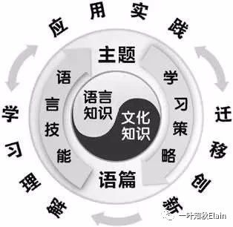

英语学习活动观强调，语言学习活动的主体是学生，语言学习活动的过程是学习者发现、获取、概括和探究意义的过程，也是学生主动参与、获取和学习新知的过程。**英语学习活动观的核心思想是：在体验中学习，在实践中运用，在迁移中创新。**

—程晓堂教授

**Ⅱ. Learning about the Continuation Writing**

**读后续写的要求：**

提供一段350词左右的语言材料，要求考生依据该材料内容、所给段落开头语进行续写(150词左右)。

**读后续写特点：**

是一种将阅读与写作紧密结合的考查形式，提供的语言材料以故事类记叙文为主。

**读后续写考查考生四个方面的能力：**

①把握短文关键信息和语言特点的能力。

②语言运用的准确性和丰富性的能力。

③上下文的衔接能力。

④对语篇结构把控的能力。

⑤ 创造性思维的能力。

**Ⅲ.Taking on the writing task**

**《高中同步测控优化设计》人教版英语必修第三册U5SectionⅣ Writing（读后续写）**

第二节（满分25分）

阅读下面材料，根据其内容和所给段落开头语续写两段，使之构成一篇完整的短文。

**P1. 1_____ 80-year-old man** was sitting on the sofa in his house along with his 45-year-old **2_________ (high) educated** son. **Suddenly** a crow **3________ (perch) on the tree** near their window. The father asked his son,“What is this? The son replied,"It is a crow.”

**P2. After a few minutes,** the father asked his son **the second time**,“What is this?" The son said,“Father, I have just now told you. It's a crow.”

**After a little while,** the old father again asked his son **the third time**,“What is this?”

**P3.** **At this time** some **4___________ (express) of irritation(恼怒)**was felt in the son's tone **when** he said to his father **5____________(willing)**.“It's a crow, a crow.” **A little while after**, the father again asked his son the fourth time,“What is this?”

**P4.This time**,the son **6 _________ (shout) at his father**,“Why do you **keep 7______(ask)** me the same question **again and again**, **although** I have told you so many times‘IT IS A CROW'? Are you **not able 8_____________(understand)** this?

**P5.Later** the father went to his room and came back with an old tattered(破旧的)diary, which he **9_____________(maintain) since** his son was born. **On** opening a page, the father asked his son to read that page. When the son read it, the following words 10_____________(write) in the diary:

**P6.**“Today my little son 11_________ (age) three **was sitting with me on the sofa, when a crow sat on the window**. My son asked me 23 times 13_______ it was, and I replied to him all 23 times that it was a crow. **I 14_______ (hug) him lovingly each time he asked me the same question.** I did not **feel 14____________ (irritate)** at all but I rather felt **15_________ (affect) for** my innocent son.”

 注意：

1.续写词数应为150左右。

2.请按如下格式作答。

After reading the diary, the son's eyes were filled with tears.______________________________________________________

Feeling ashamed, the son held his father’s hands gently.______________________________________________________

**Ⅳ.Teaching procedures：**

**Step I. Reading for the theme and main idea**

**Activity1.**

Adapting the given text into a grammar filling exercise prompts the Ss.to read the story carefully.

**Purpose2.**

Acquire the key lexical chunks，summarize its main idea and grasp the theme.

**Lexical Chunks**

|  |  |  |
| --- | --- | --- |
| **序号** | **描述** | **英文** |
| **1** | **一位80岁的老人** | **an 80-year-old man** |
| **2** | **受过高等教育的** | **highly-educated** |
| **3** | **飞落在树上** | **perch on the tree** |
| **4** | **生气的表情** | **expression of irritation** |
| **5** | **不乐意的** | **unwillingly** |
| **6** | **朝某人大吼** | **shout at sb.** |
| **7** | **反复做某事** | **keep doing sth.** |
| **8** | **能够做某事** | **be able to do sth.** |
| **9** | **记/写日记** | **maintain a diary** |
| **10** | **疼爱地拥抱某人** | **hug sb. lovingly** |
| **11** | **感觉很生气** | **feel irritated** |
| **12** | **感觉很爱某人** | **feel affection for sb.** |

**Main idea:**

The original text narrates a **highly-educated** son aged 45 got **irrigated** with his 80-year-old father at the same question four times. **However**, when he was young he asked the same question twenty-three times, Father responded to it **patiently** every time, which made the son **ashamed** and **emotional**. Then what would happen?

**The Theme: (Family affection)**

**The different expressions of the same theme:**

1.Family affection lies in small **actions**—a warm greeting, an accompany and a chat. We should treat parents as patiently and affectionately as they do us.

2. Father’s repeating the same question is **not a sign of forgetfulness but a reflection of patience and affection** Father showed him.

3. Respecting the elderly and caring for the young is **a fine tradition** of the Chinese nation. We should call on parents as often as possible. **Accompanying them patiently** will be **a comfort and pleasure** to them.

**...**

**Step II. Processing the information**

**Activity2.**

**Extract the key clues, filter out the useful information**

**Purpose:**

Draw out drawing out the story mountain laying the foundation for continuation writing.

**Father: patient,**

**affectionate,**

**loving**

**Son:**  **innocent**

**Climax:Father’s diary read Son’s funny thing—twenty-three asking-and-answering activities**

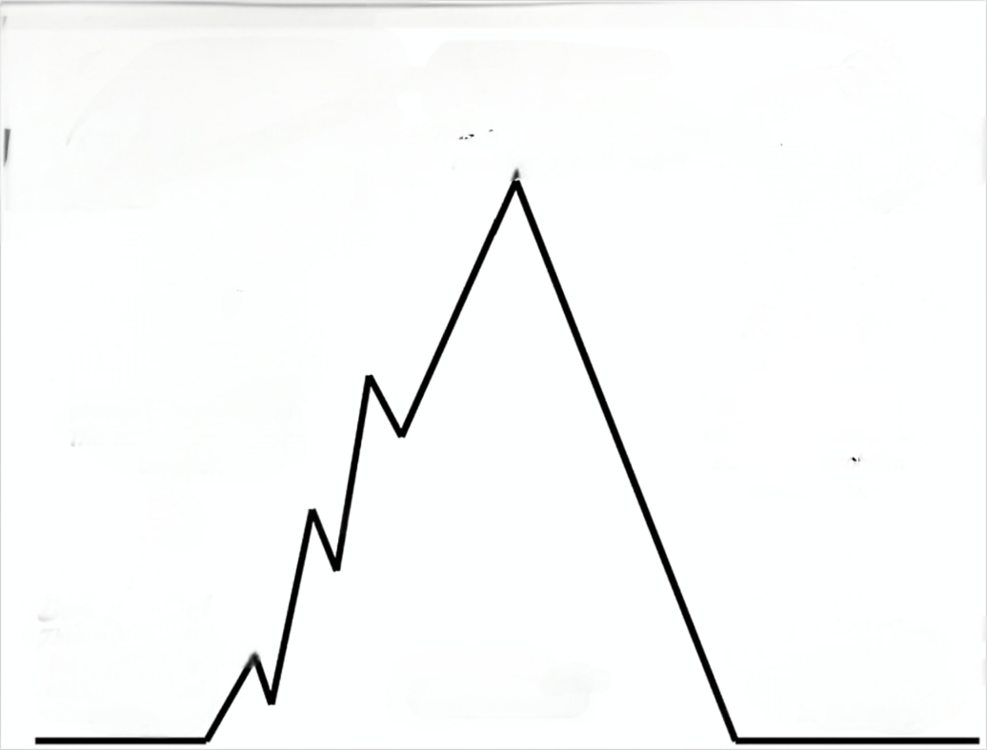

**Rising action：The third and fourth asking-and-answering activities**

**Falling action:**

**After reading the diary, the son's eyes were filled with tears. ... ?**

**Father: interested ,**

**Persistent**

**Son: impatient,**

**a little irrigated,**

**fly into a rage(angry)**

**Ending:**

**Feeling ashamed, the son held his father’s hands gently. ... ?**

**Beginning: They began his first two question-answer activities**

**g**g

**Father and Son:**

**Peaceful and happy**

**Settings:**

**Father and Son was sitting on the sofa when a crow perched on a tree/ the window during the two different periods.**

**The same Question and answer:**

**—What is this?**

**—It’s a crow.**

**StepⅢ. Thinking**

**Activity3.** According to **the narrative line, emotional line and the first sentence** of each paragraph of the continuation writing, think about the questions below.

**Purpose: Predict the story’s ending and highlight the theme.**

**续写Para1.**

1. Why were Son’s eyes filled with tears？
2. What would the son do and say?
3. How would he feel about what Father maintained in the diary?

**续写Para2.**

1. Why did Son feel ashamed?
2. What would Father react to Son’s changeable behaviors?
3. What inspiration does this story gives us?

**StepIV. Continuing + StepV. Evaluating +StepVI. Improving**

**Based on Reading, Combing, Thinking, the Ss get down to writing.**

**Purpose:**

Learn through experience, apply in practice, and innovate through transfer.

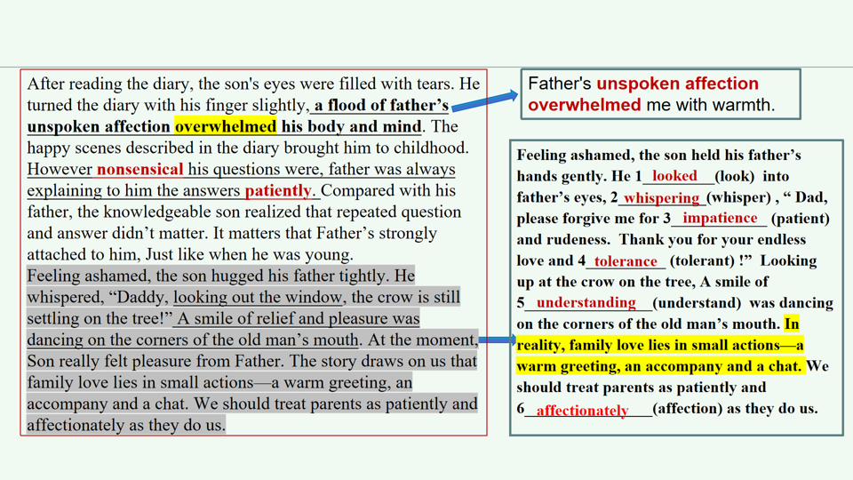**作品 1 机评+师评**

**档次：第六档（18-21 分）**

**内容：**

**续写合理，通过对比父子对待同一问题的相反态度（patient impatient)，突出主题，结尾升华亲情，但情感转折稍显突兀。**

**语言：**

**词汇较丰富（如“overwhelmed” “nonsensical”），句式多样（无灵主语句、让步状语从句、宾语从句、主语从句、非谓语动词、拟人等）。**

**结构：**

**段落衔接自然，但第二段结尾说教感较强，可通过细节描写替代直接总结。**

**建议：**

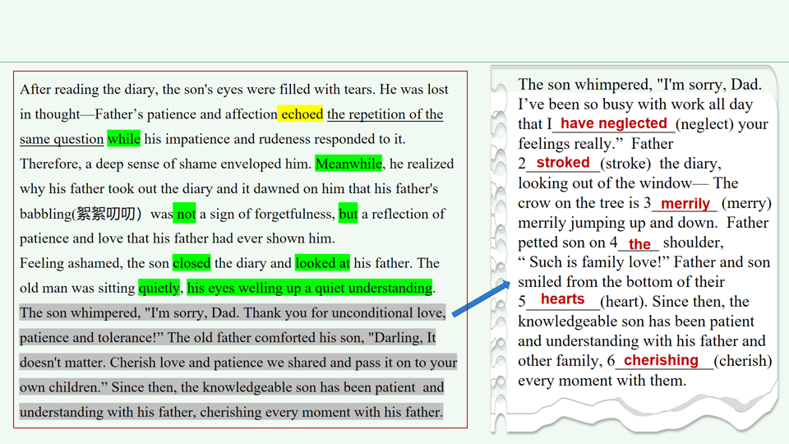 **调整结尾，用具体动作（如拥抱、重复童年互动）、环境描写等替代抽象总结。**

**作品 2 机评+师评**

**档次：第六档（18-21 分）**

**内容：**

**续写逻辑清晰，通过父子对话深化主题，但父亲的台词稍显直白，缺乏情感张力。**

**语言：**

**词汇准确（如 “echoed”“reflection”），句式较多样，但个别地方语言不精炼（the repetition of the same question ）。**

**结构：**

**段落连贯，过渡自然，结尾点明传承爱的主题，但细节描写不足，情感表达较平淡。**

**建议：**

**增加具体场景描写（如父亲抚摸日记的动作、儿子的细微表情）。 优化对话，使其更符合人物性格（如父亲用沉默代替说教）。**

**作品 3 机评+师评**

**档次：第五档（15-17 分）**

**内容：**

**续写情感真挚，通过细节描写（如颤抖的手、拥抱）增强感染力，但部分情节（如父亲流泪），情绪渲染过渡。**

**语言：**

**用词简单恰当，如(loving, impatient, worn-out, Knowledgeable, tears streaming），但句式较单一。**

**结构：**

**段落衔接合理，句与句之间衔接自然，但第二段后半部分逻辑跳跃，需加强过渡。**

**建议：**

**修正语法错误，丰富句式结构（如使用复合句）。**

**调整父亲流泪的情节，使其更自然。**

After reading the diary, the son's eyes were filled with tears. His shaking hands touched the worn-out diary again and again. Unbelievably, father was so loving and patient while he was rude and impatient, faced with the same situation. The son called to mind how patiently his father treated him. On the contrary, he shouted at father just because of the repeated question. The son looked up, finding his father watching him with a smile, still a warm expression father showed him many years ago.

Feeling ashamed, the son held his father's hands gently. Knowledgeable as he is, he didn't realize that his elderly father also needs to be treated patiently. On thinking of his carelessness and rudeness, the son turned and hugged his father tightly, tears streaming down his face, " I beg your forgiveness, Dad", “I never blamed you, Darling," said the father. The son found his chest was warm because of his father's tears

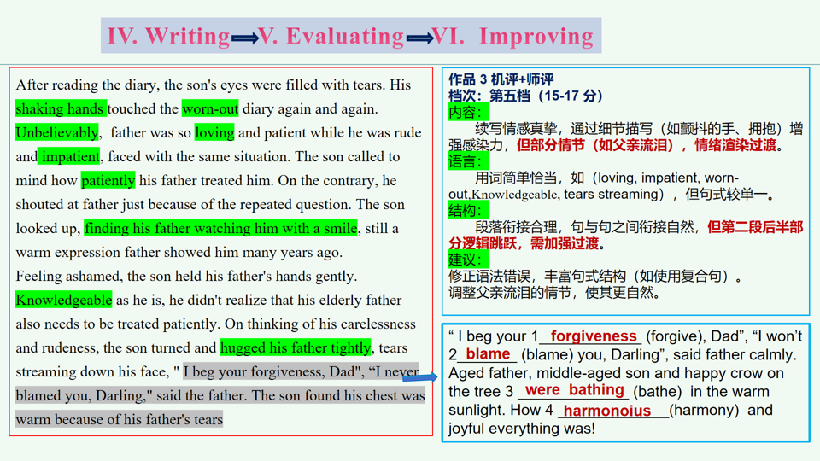

**Ⅴ. Summary**

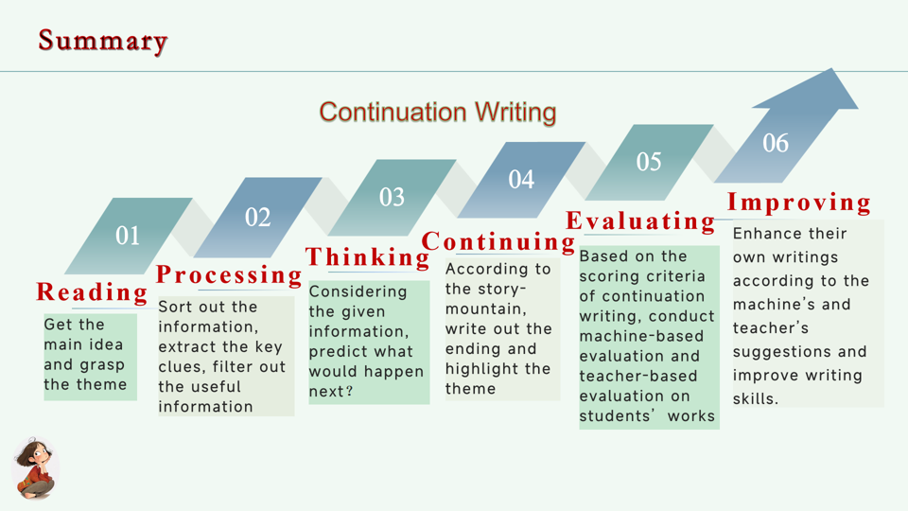

**Concluding Remark:**

**阅读是吸收，写作是倾吐，倾吐能否合于法度，显然与吸收有密切的关系。**

**— 叶圣陶**