**教学设计**

【主题语境】：人与自然——人与动物

【语篇类型】：记叙文

【语篇分析】：

本文共七段，349词。文章讲述了男孩要离家上大学了，父母开车几小时把他送到学校，在校门口父母及Poppy（狗）与男孩依依惜别。回家后，父母感到十分失落，Poppy也非常忧伤，甚至茶饭不思，于是妈妈提议给Poppy寻一只小狗作伴。那么小狗的到来会给Poppy和这个家庭带来怎样的改变？男孩回家后发现家中的变化又会有怎样的反应？这就是留给学生的续写任务。

本文语言简洁流畅，表达地道，极具画面感的描述增添了故事的立体感。故事内容贴近学生生活，尤其是高三学子，即将离家去上大学，通过本文的学习，能够唤起学生对父母的理解和感激之情。

【教学目标】：学生在学完本篇文章后，能够:

1.梳理记叙文的故事主线，根据文本信息分析推断各角色的性格特点，发展逻辑思维能力；

2.理解文化差异，深入解读作者的写作意图，进而学会分析文本的主题，发展批判性思维能力；

3.基于主题和段首句的分析，预测情节的发展方向，发展创造性思维能力；

4.感知文本的语言风格，并进行模仿创作，学会语言的迁移使用，实现语言协同。

【教学重点】：

本文的明线是家庭成员的分离——新成员的到来，暗线是一家人，尤其是Poppy的情感变化，因此本文的重点在于厘清情感主线，抓住一家人由悲到喜的转变。

【教学难点】：

1.解读作者的写作意图的和理解语言背后的文化差异。在西方社会，狗作为家庭成员，有着与人类同等的地位和待遇，这一点，从文中对Poppy的人称代词的使用和细致入微的描述可见一斑。作者所要表达的除了家庭亲情之外，还要通过人与动物（狗）的和谐相处彰显人性的闪光点，这是需要教师着力引导之处。

2.学会仔细的观察和展开丰富的想象。本文的故事情节围绕Poppy的情绪波动展开，情绪难题随着小狗的出现而解决，这种缓和型矛盾冲突，起伏小，要写得出彩必然依赖于观察能力和想象能力。

【教学难点】：

**Step I Free talk**

T invites Ss to watch a short video and then answer the following two questions：

1. What do you think the dog in the video is like? (for example: sad, pitiful, cautious, cute, lovely, faithful, …)

2. How do you know?

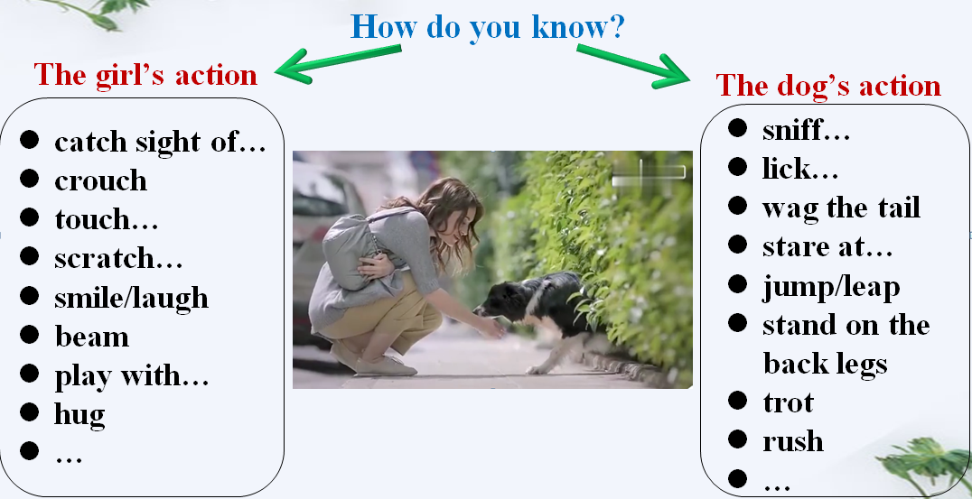

【设计说明】以公益视频导入，激活学生已有的关于狗的认知和经验。通过讨论引发学生思考人与狗之间的关系，并铺垫人狗互动的相关词汇，搭建语言支架。

**Step II Reading**

1. Reading for basic information

T asks Ss to skim the text and try to find the six elements of a story(5W1H).

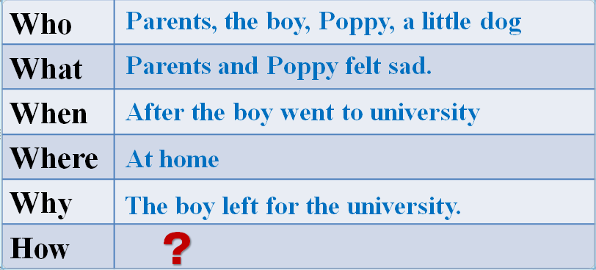

【设计说明】浏览全文，获取梳理记叙文的六要素，了解故事梗概。

2. Reading for plot

T asks Ss to read the text again and try to get the main idea of Para.1-3, Para.4-5, Para.6-7.

T invites Ss to think about the development of the plot.

【设计说明】扫读全文，概括各部分大意，理解本文的发展主线，抓住故事明线：悲伤话别——情绪低落——母亲提议——？以及故事的暗线：悲——喜，为续写部分的情节展开做好铺垫。

3. Reading for language

T asks Ss to read the text a third time and answer the following questions:

(1) Para. 1-3: How do you know they felt sad at the boy’s departure?

(2) Para. 4-5: How do you know they were in a bad mood at home?

【设计说明】分段细读文章，品味语言特点，感知并理解语言所表达的意义，学会如何使用细致入微的动作描写增添故事的画面感。

4. Reading for characters/ theme

T invites Ss to think about:

(1)What does “get the better of” (Para.1) mean?

(2) What’s the boy like? Why do you think so?

(3) What about his parents? Why?

(4) What’s the relationship between the boy and Potty?

【设计说明】学会在语境中学习语言，深入理解语篇，分析判断故事角色的性格特点，推理论证文章的主题，为续写故事找准方向。

5. Reading the given sentences

T asks Ss to read the last paragraph and the given sentences carefully and requires them to spot the key words of each sentence.

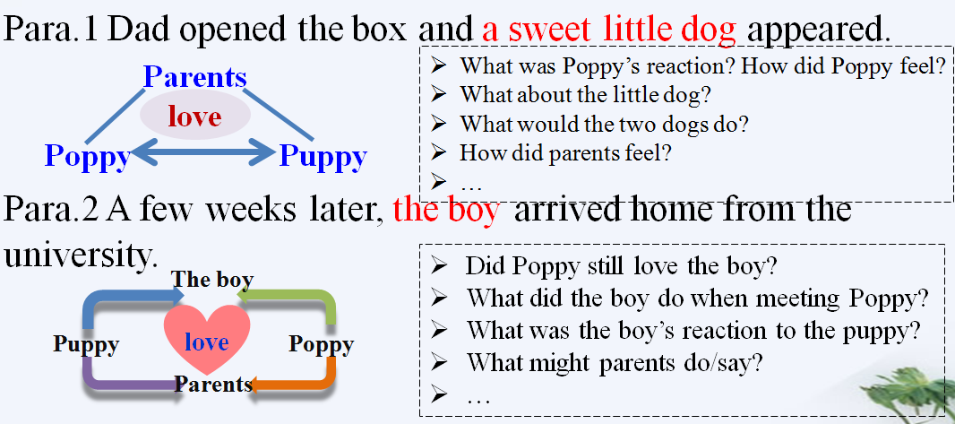

【设计说明】细读最后一段及两个段首句，寻找其中的情节联系。找出段首句中的关键词，以关键词为核心，辐射本段的信息。以问题为导向，展开丰富的想象，设计故事情节。

**Step III Writing**

1. T asks Ss to keep the following tips in mind when writing.

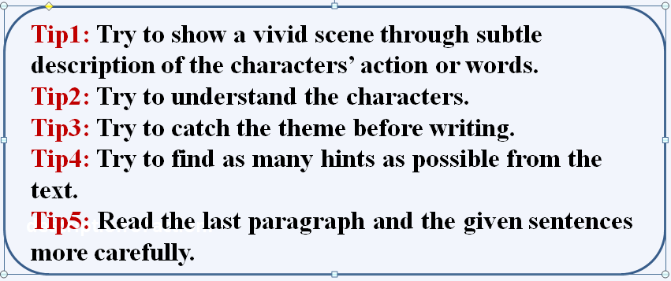

2. T asks Ss to write.

【设计说明】根据所给建议和本堂课所学语言，进行续写。

**附录:**

下水作文

**Para.1 Dad opened the box and a sweet little dog appeared.** Poppy stared at the puppy, surprised and excited. She approached cautiously, barked and then started to lick his face. The little dog jumped out of the box, wagged his tail and barked in a friendly way. He sniffed every corner of the new home, and then ran around Poppy, which brought great joy to the old girl. Watching the happy scene, Dad and Mom looked at each other, beaming proudly.

**Para.2 A few weeks later, the boy arrived home from the university.** As he entered the doorstep, Poppy trotted to him and got up on his back legs, trying to lick her old friend. The boy crouched, put his arms round Poppy’s neck and scratched her behind the ears. Suddenly, he noticed a little head poke out of the kennel. He felt so puzzled that he turned to his parents. “We’ve got the puppy for Poppy. Now she is as cheerful as before.” Mom chuckled with delight. “What a good idea!” The boy hugged both dogs, smiling.