教材分析：
《小王子》是法国作家安托万·德·圣·埃克苏佩里于1942年写成的著名儿童文学短篇小说。本书的主人公是来自外星球的小王子。书中以一位飞行员作为故事叙述者，讲述了小王子从自己星球出发前往地球的过程中，所经历的各种历险。作者以小王子的孩子式的眼光，透视出成人的空虚、盲目，愚妄与死板教条，用浅显天真的语言写出了人类的孤独寂寞、没有根基随风流浪的命运。同时，也表达出作者对金钱关系的批判，对真善美的讴歌。
童话，是孩子开启心智的主要媒介。孩子们通过童话中展现的奇妙情节发散思维、认识世界，并能从中直观认知美与丑、善与恶、好与坏。《小王子》用凝练的语言渗透了作者对人类及人类文明深邃的思索，讨论的主题是“关系”：与自己的关系，与朋友的关系，与爱人的关系，与万物的关系，与宇宙的关系。相信每个人都能从中领悟到受用终身的人生哲理。

Part 1 :Warming-up
What's this?

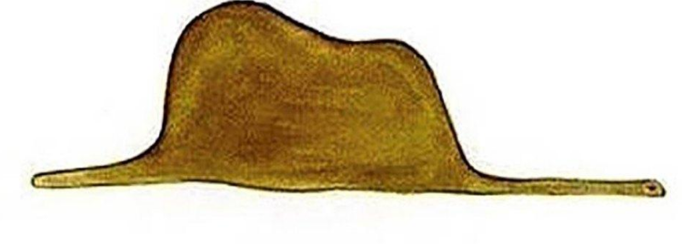

Part 2 :Introduction
About the author:
安东尼·圣埃克苏佩里 (1900-1944)飞行员，作家。生于法国里昂贵族家庭。小王子是他最著名的作品其阅读率在西方仅次于《圣经》。
About the book:
It is the second best selling book in the world (ranked behind Bible)
Have been published for 100 million copies in 190 languages
Part 3:Discussion
1.How many planets have the little prince been to ?
2.What are the writer’s opinion of the grown-ups?
3.What have you learned form the book?
Part 4:Selected Sentences
★ It is only with the heart that one can see rightly；what is essential is invisible to the eyes.
★ It is the time you have wasted for your rose that makes your rose so important.
★ You become responsible, forever, for what you have tamed.
★ In the course of this life I have had a great many encounters with a great many people who have been concerned with matters of consequence.
★ And yet my little man seemed neither to be straying uncertainly among the sands, nor to be fainting from fatigue or hunger or thirst or fear.
★ I jumped into my feet, completely thunderstruck.
★ And I was obliged to make a great mental effort to solve this problem.

