**Unit 2 Book 2 学案**

1. **poster ['pəʊstə] n. _______,________,__________**

**post [pəʊst] n._______,_______,_______,_______vt._______,_______,_______**

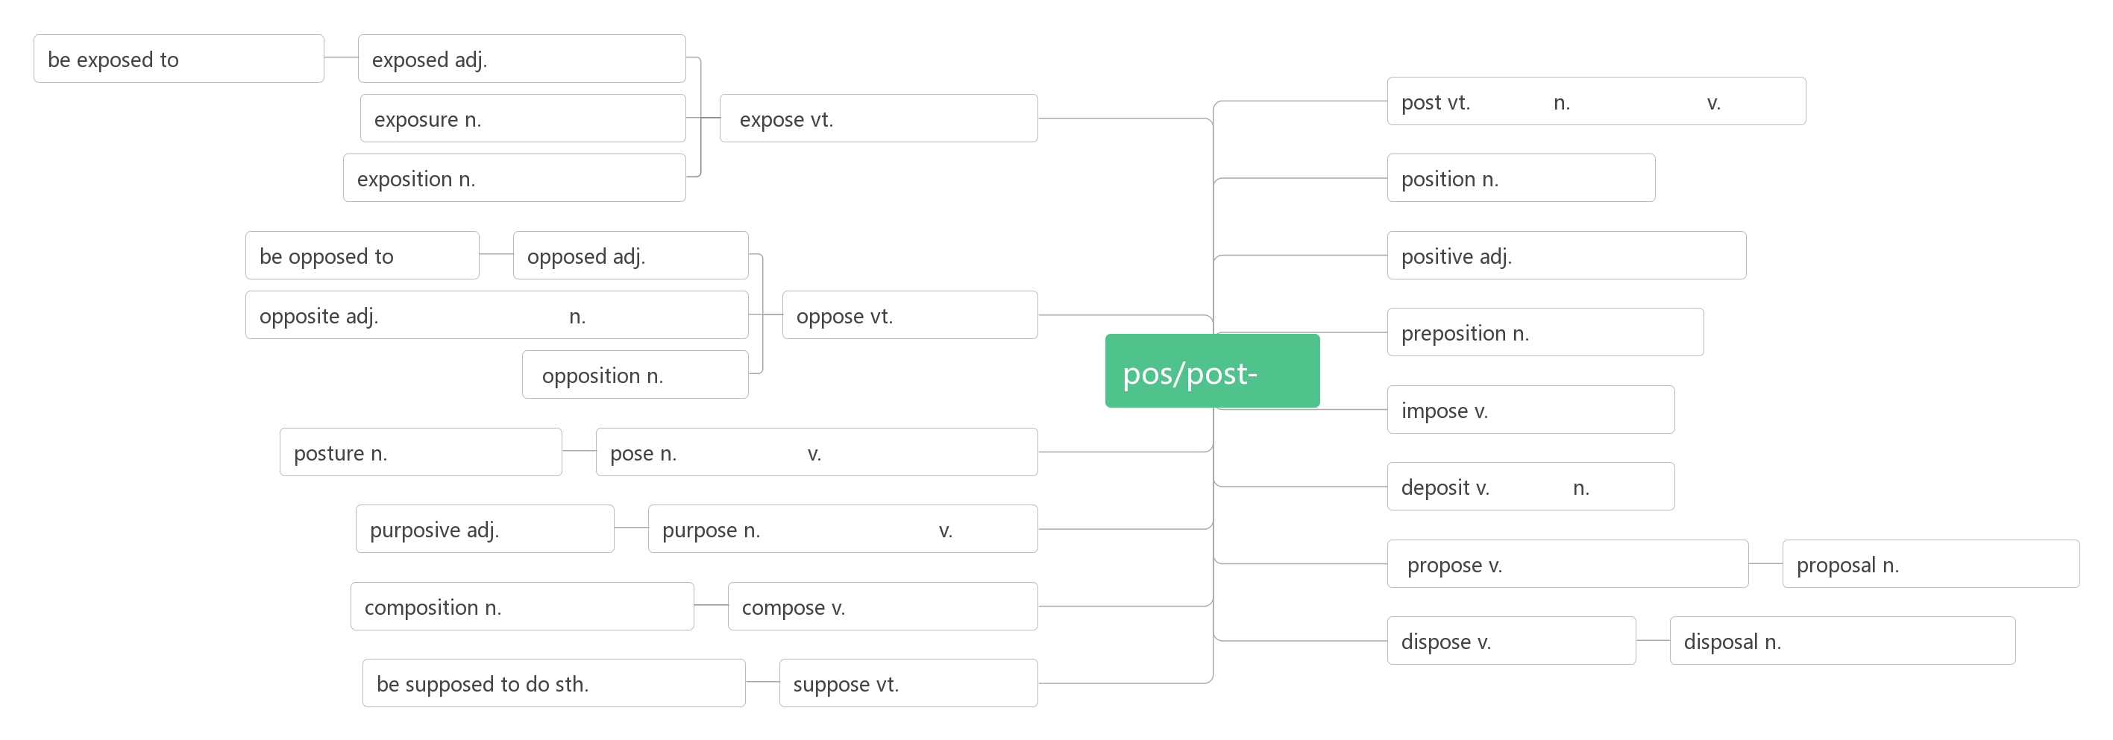**2. illegal [ɪ'liːg(ə)l] adj.________,_________**

**legal ['liːg(ə)l]adj. _________;_________;_________**

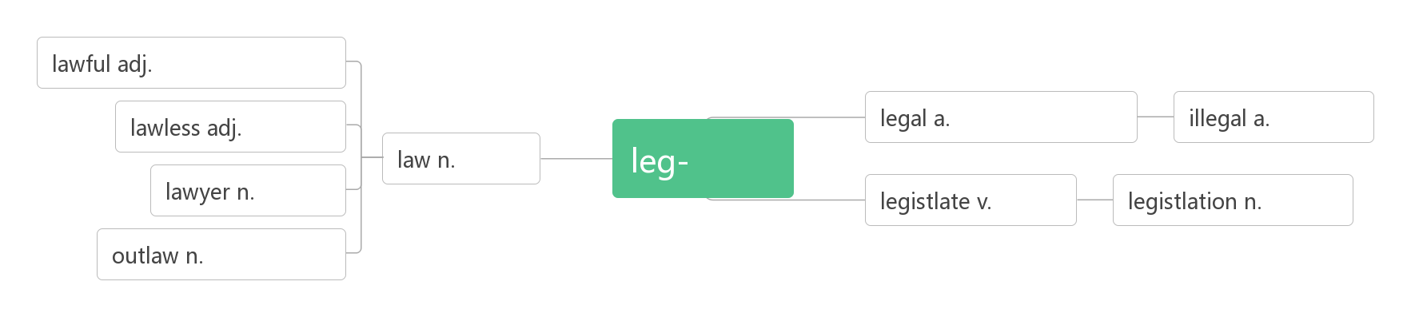

1. **hunt[hʌnt]vt.vi.&n.________;_________**

**_______________搜寻，寻找**

**_________['hʌntə] n. 猎人；猎犬；搜寻者**

1. **immediately [ɪ'miːdɪətlɪ] adv. ________,________conj. _____________**

**词根词缀：im(in-没有)+media(中介,中间)+te(adj.)+ly(adv.):没有中间耽搁的——________,_________**

**____________ [ɪ'mi:dɪət] adj. 立即的；直接的**

1. **species['spiʃiz]n.________**

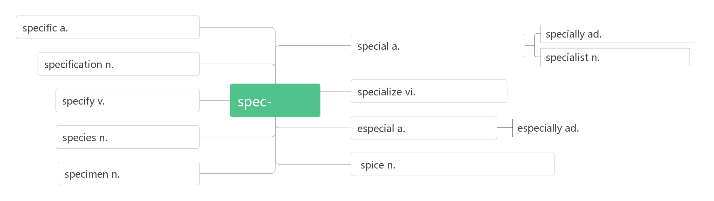

1. **shark [ʃɑːk]n. _________;_________vt.&vi. ________,_________**
2. **fin [fin] n.________**
3. **on earth _____________；（放在疑问词之后表示强调）_______;________**
4. **die out________;_______;__________**

|  |  |
| --- | --- |
|  | 灭绝，灭亡，彻底消失：强调最终彻底消失的结果（风住尘香花已尽） |
|  | 减弱，渐渐消失：由强到弱逐渐减弱而消亡，如风，火等（思君如满月，夜夜减清辉） |
|  | 减弱，消失：由近及远逐渐远去而消失（笑渐不闻声渐消，多情却被无情恼） |
|  | 相继死去，一一凋零（无边落木萧萧下） |

1. **alarm [ə'lɑːm]n._______;_______;_______vt. _______;_________**

**破拆法：al(all)+arm(武装)：敌人来临，所有人都武装起来——________,________**

**alarming[ə'lɑːmɪŋ]adj.______________,______________** 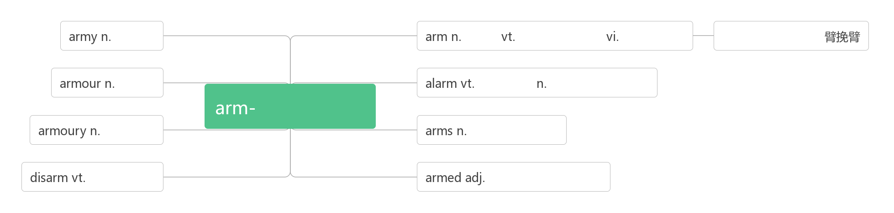

1. **rate[reit]n.________;________vt.____________**

**rating ['reiting]n.________;_________**

1. **extinct [ɪk'stɪŋkt]vt. ________;________adj. ________;________:_________**

**词根词缀：ex(外)+stin(stand站)+ct：站到历史舞台的外面——__________**

**___________ [ɪk'stɪŋkʃən] n. 消失；灭绝；废止**

1. **mass [mæs]n.________;________;________;________adj._________;________;_________**

**_______________/____________ 许多的，大量的**

1. **habitat ['hæbɪtæt]n. _________**

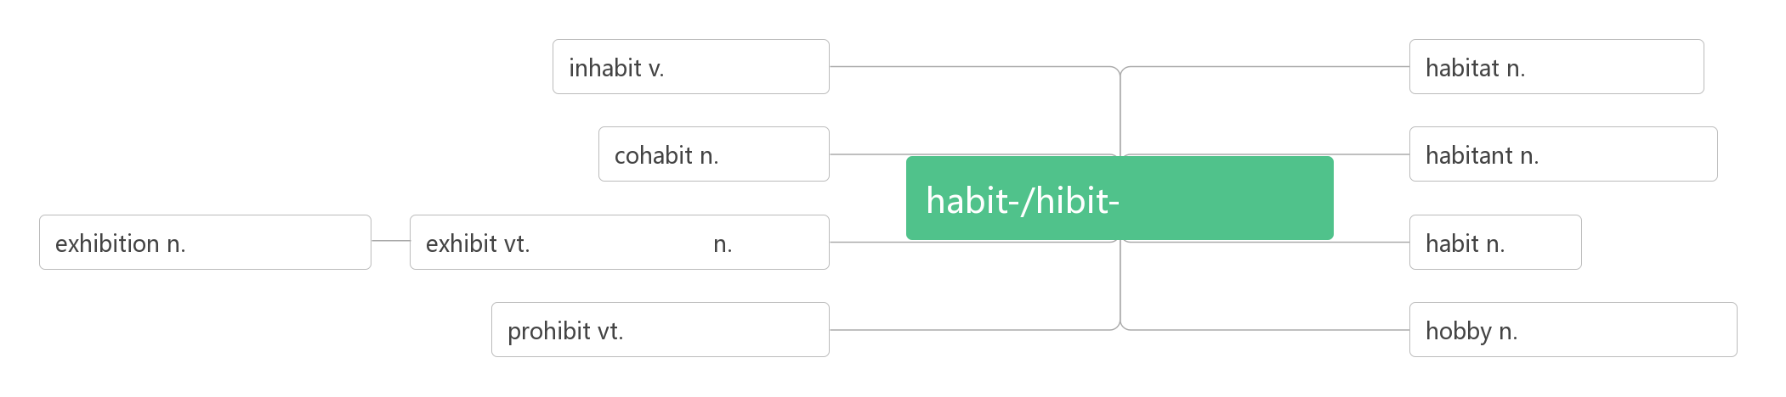

1. **aware [ə'weə] adj. ___________;__________**

**____________ 知道，意识到**

1. **endanger [ɪn'deɪn(d)ʒə] vt._______;_____________**

**______________ [ɪn'deɪndʒəd] adj. 濒临灭绝的；有生命危险的**

1. **average ['æv(ə)rɪdʒ]n. _______;_________adj. __________;_________**

**破拆法：aver(every每个)+age(名词后缀)：每个人都一样的——_________**

**____________ 平均**

1. **prince [prɪns]n. _______;________;________**

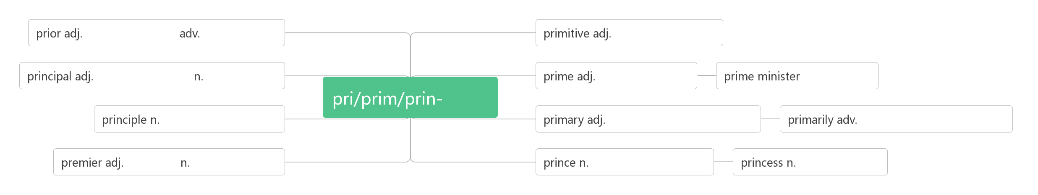

1. **progress ['prəʊgres]vi.&n. _______,________;_______**

**_________________ 取得进步，取得进展**

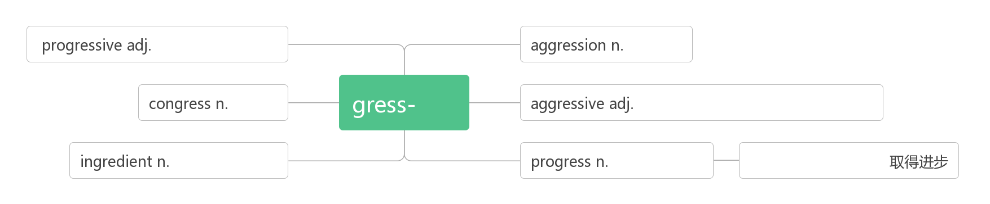

1. **concern [kən'sɜ:n]vt. _______;________;_________n. _______;________;__________**

**_____________________________ 关心，担忧，在意**

**_________________________ 就……而言**

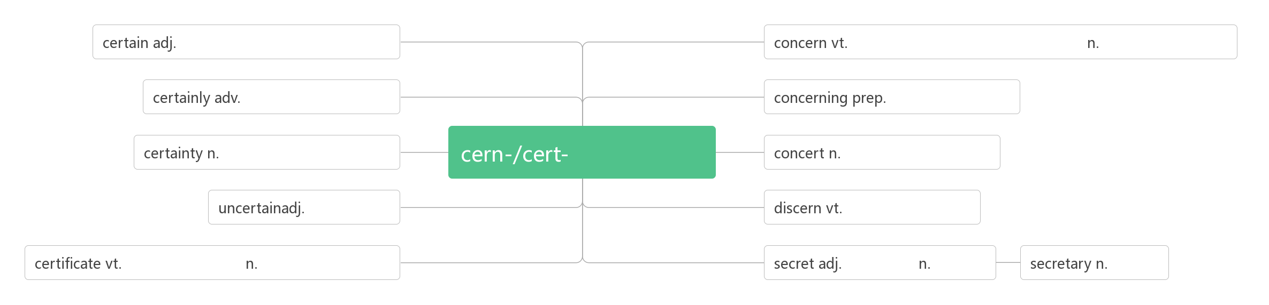

1. **living ['lɪvɪŋ]adj. _______;________；n. _______;_______;________**

|  |  |
| --- | --- |
|  | 意为“健在的”，为live的现在分词，强调存在在世界上，可用来指人或物，作[定语](http://www.so.com/s?q=%E5%AE%9A%E8%AF%AD&ie=utf-8&src=internal_wenda_recommend_textn" \t "https://wenda.so.com/q/_blank)或表语。 |
|  | 意为“活的”，表示活着的状态，侧重说明没死，既可指人，也可[指物](http://www.so.com/s?q=%E6%8C%87%E7%89%A9&ie=utf-8&src=internal_wenda_recommend_textn" \t "https://wenda.so.com/q/_blank)；可作[表语](http://www.so.com/s?q=%E8%A1%A8%E8%AF%AD&ie=utf-8&src=internal_wenda_recommend_textn" \t "https://wenda.so.com/q/_blank)，[后置定语](http://www.so.com/s?q=%E5%90%8E%E7%BD%AE%E5%AE%9A%E8%AF%AD&ie=utf-8&src=internal_wenda_recommend_textn" \t "https://wenda.so.com/q/_blank)或宾补。 |
|  | live 意为“活着的”时，通常指物，不指人，常用来作定语放名词的前面。还指“实况转播的”。 例如:a live wire 有电的电线，a live fish 一条活鱼，a live broadcast 现场直播 |
|  | 意为“活泼的”，“活跃”，“充满生气的”，可作定语、表语或宾补，既可指人，又可指物。 |

**__________________谋生**

1. **adapt [ə'dæpt]vt._________;________vi._______**

**adapt to________**

**____________ [ædəp'teɪʃ(ə)n] n. 适应；改编；改编本**

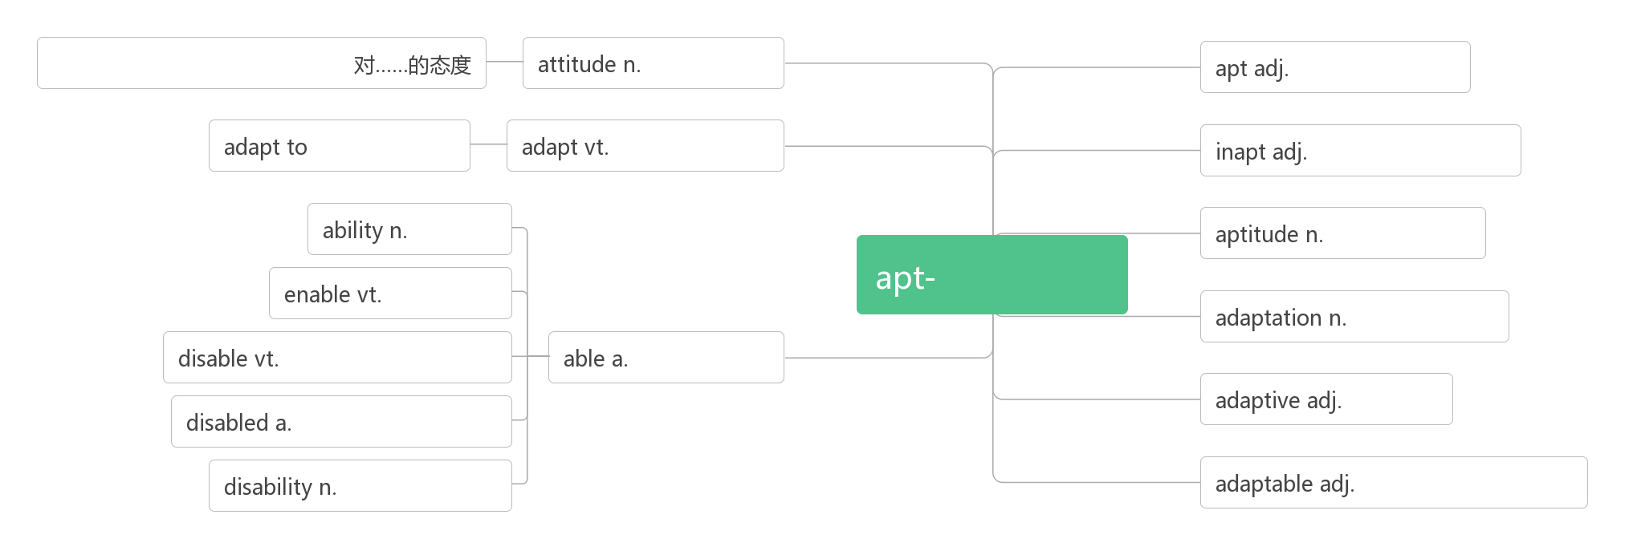**22. measure ['meʒə]n. _______;_______;_______;_______vt. ______;_______vi. __________**

**词源：与meter同源，me=>mea, s=>t(字母顺位迁移)，er=>ure(同音同意)：meter即_______的尺度。**

**______________________采取措施做某事**

1. **pressure ['preʃə]n. ________;________,________**

**________________在压力下；承受压力**

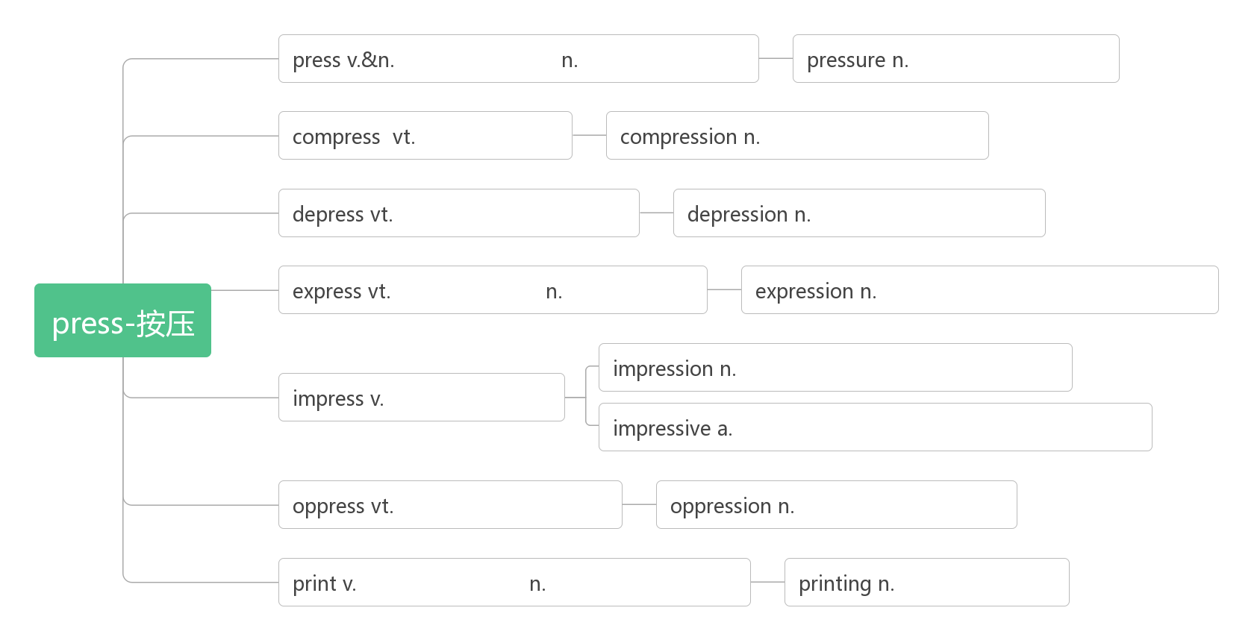

1. **whale [weɪl]n.________**

**破拆法：w(我)+h(喝)+al(all一切)+e：鲸吞 助记：作为地球上最大的动物，我可以喝下一切。**

1. **antelope ['æntɪləʊp]n. _______**

**破拆法：ante(前)+lope(slope斜坡)：斜坡前面 助记：_______通常生活在斜坡前面的高原上。**

1. **reserve [rɪ'zɜːv] n.（动植物）_________；_______（量）vt.________;________;________**

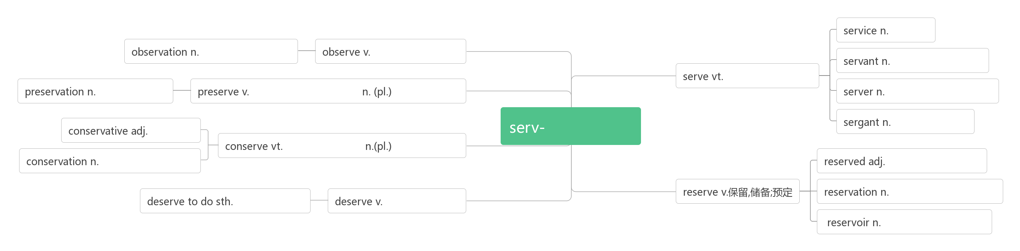

1. **plain [pleɪn]adj. _______;________;_________n. ________**

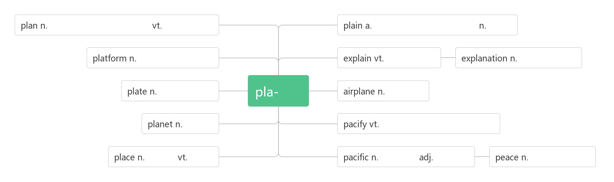

1. **make out_______;________;_________**

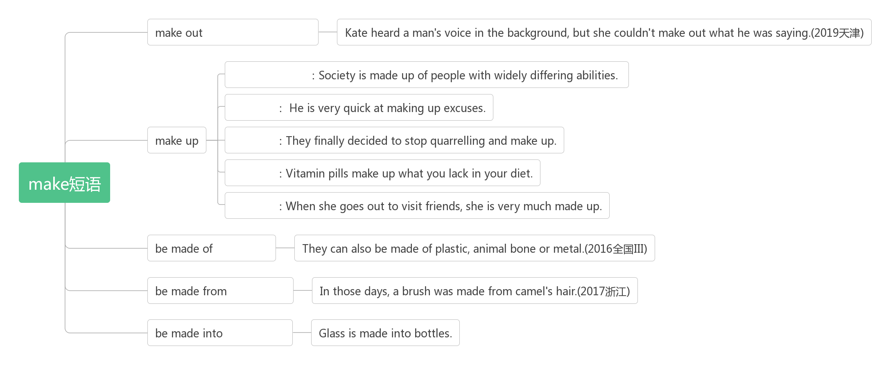

1. **herd [hɜːd]n.________;________;__________**

**破拆法：her+d:她的 助记：整个_______都是她的**

1. **observe [əb'zɜːv] vt. ________;________;________;________**



1. **beauty ['bju:ti] n._____;_________;___________**

**_____________ [ˈbjuːtɪf(ə)l] a. 美的，美丽的**

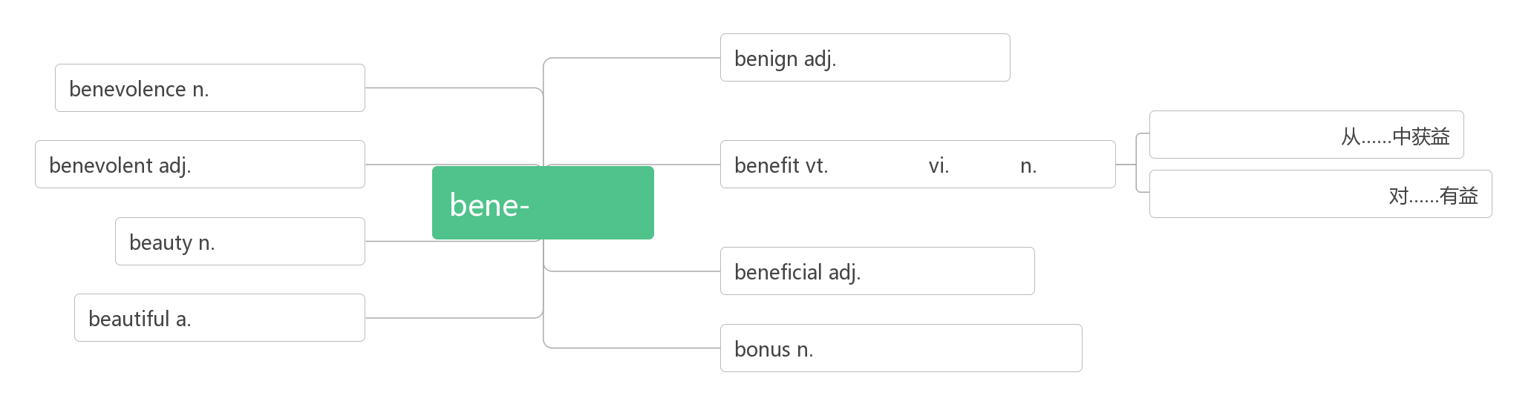

1. **remind [ri'maind] vt.________;__________**

**___________________ 使某人想起**

**_____________________ 提醒某人做某事**

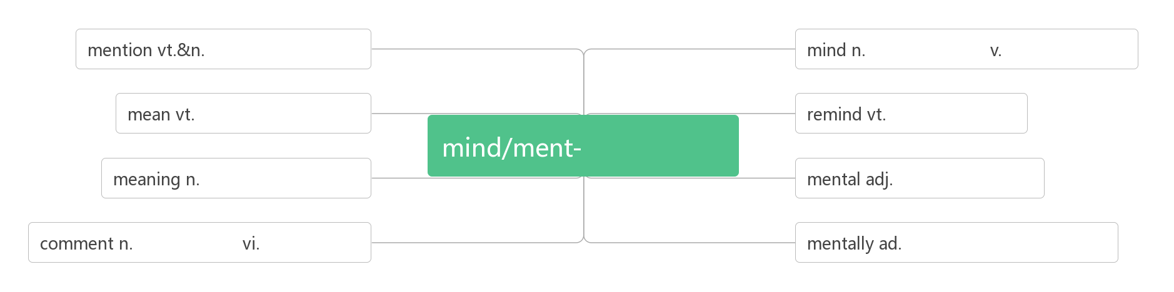

1. **fur [fɜː]n._______;________**

破拆法：fu(富)+r(人)：富人 助记：富人才穿得起_______

1. **sacred ['seikrid]adj.________**

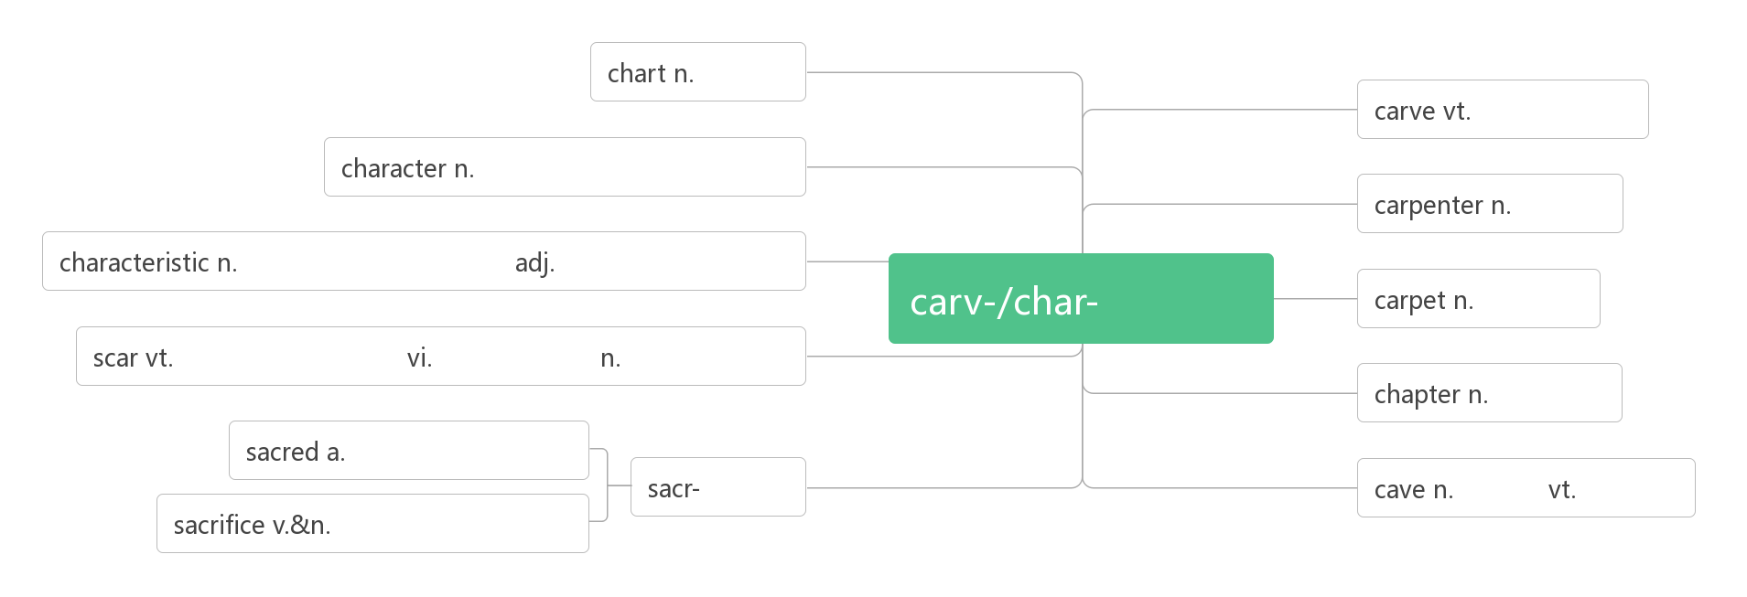

1. **shoot [fu:t] vt. & vi._______;________;_______;_______(_______,________)**

**音意相通：射他**

**_______ [ʃɒt] n.发射；投篮；拍摄；尝试**

1. **profit ['prɒfɪt]n._______,_________vi. _______,_______vt. __________**

**词根词缀：pro-(向前)+fit(做)：向前做的动力——________,________**

**__________________ 盈利**

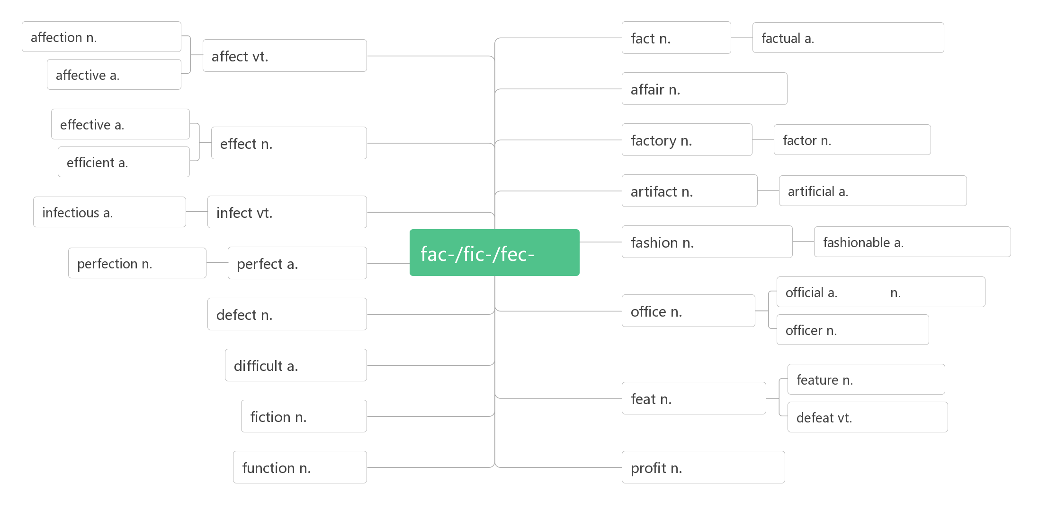

1. **watch [wɒtʃ]vt.&vi._______;_______;_______;________n.________;________;_________**

**watch over________,________,________**  **watch out (for)________,________,_________**

**watch for________,________ on watch ________;________**

1. **day and night____________,_____________ day in and day out** **_______________**

**day after day** **__________________ day by day __________,__________**

**daily [ˈdeɪlɪ] a. ________,________ ad. _______ n. _______**

**daylight [ˈdeɪlaɪt] n. ________,_________;_________**

1. **attack[ə'tæk] n., vi. & vt.________,________;________**

**词根词缀：at(去，在)+tack(大头钉，钉住)：用钉子扎某人——________,________**

**______________________受到攻击**

1. **effective[ɪ'fektɪv] adj._________;__________**

**词根词缀：ef(向外)+fect(做)+ive(adj.后缀)：做到对外面产生影响的——__________;_________**

1. **recover [rɪ'kʌvə]vi. ________,_________vt.___________,_________**

**___________ [rɪ'kʌv(ə)rɪ]n. 恢复，复原；痊愈；重获**

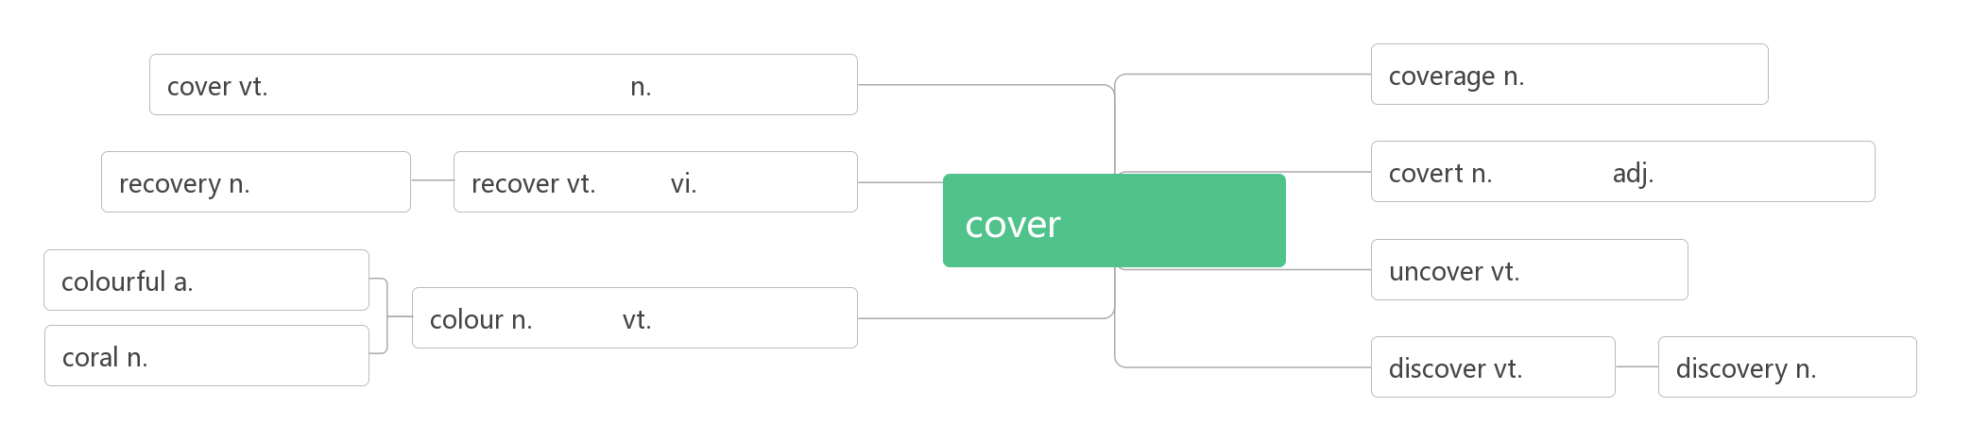

1. **remove [rɪ'muːv] vt.vi. &n.________;________;________**

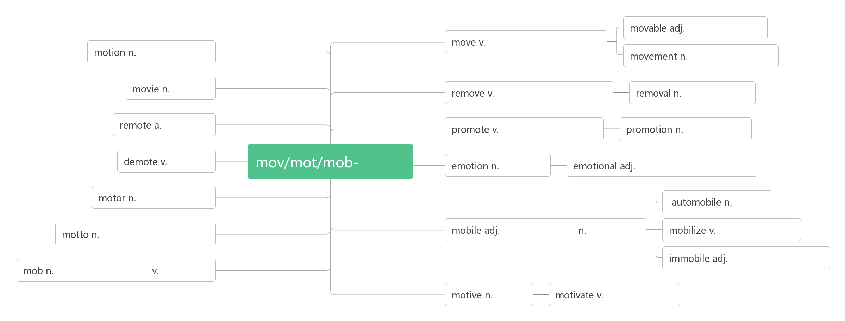**42. intend [ɪn'tend]vt.&vi. ________,________,_________**

**be intended for_______________**

**____________ [ɪnˈtenʃ(ə)n] n. 打算, 计划, 意图**

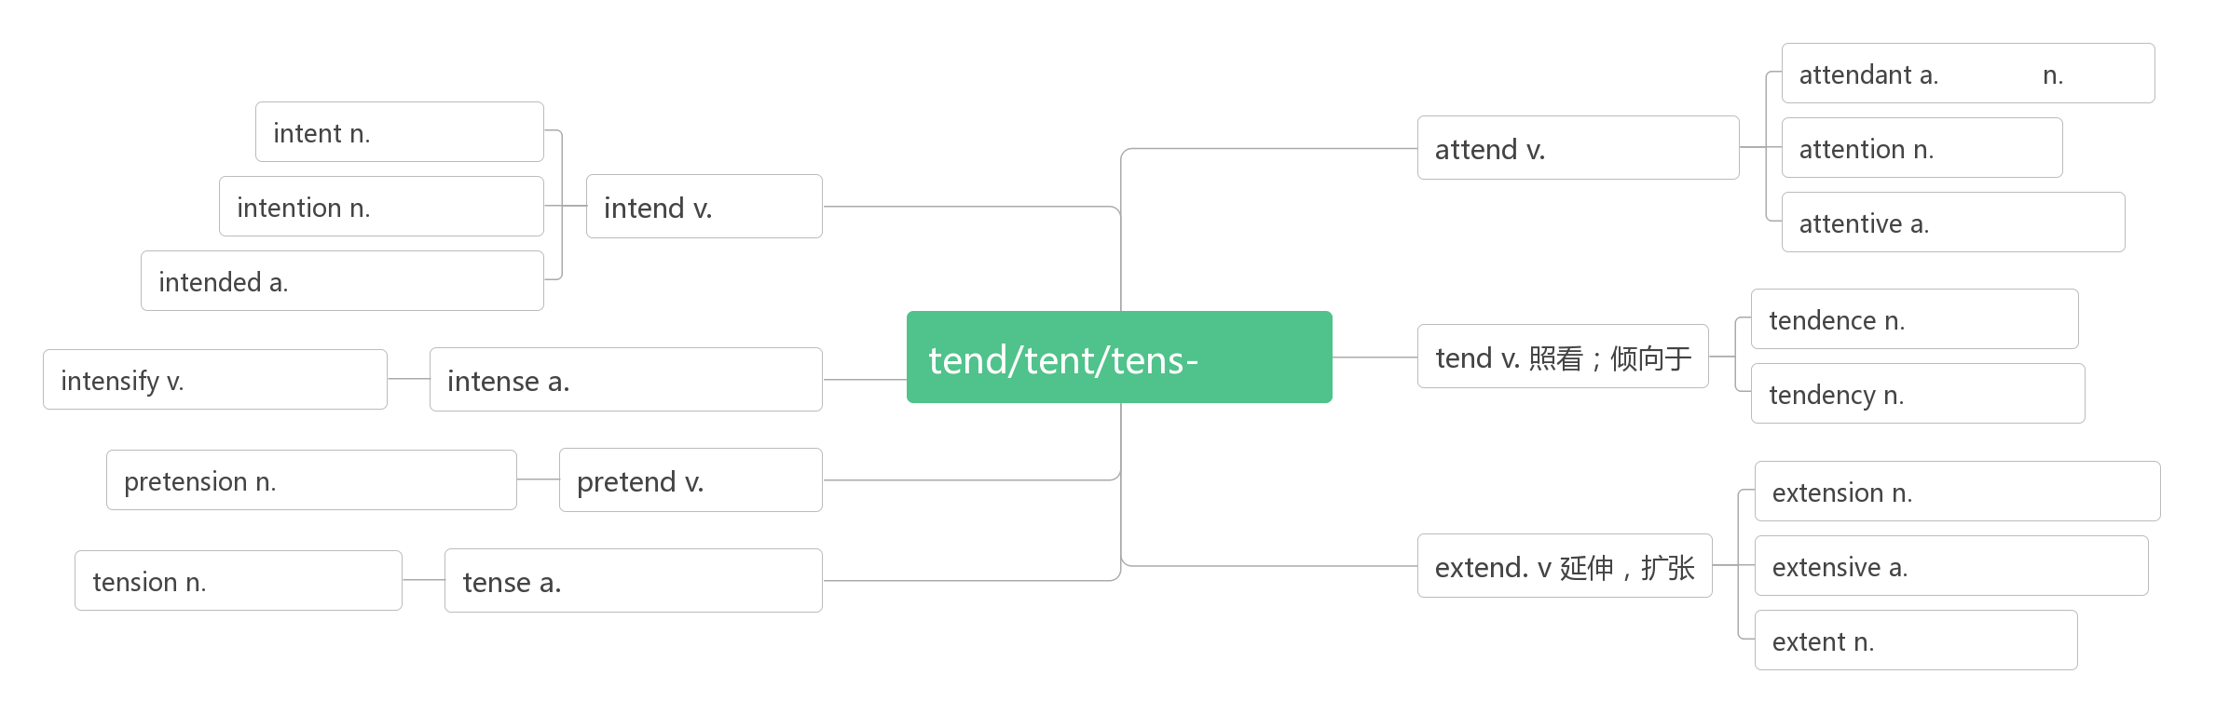

1. **threat [θret]n. _______,_______**

**破拆法：t(他)+h(喊)+re(再次)+at(attack): 他喊着要再次攻击我们——_______**

**threaten ['θret(ə)n]vt.&vi. ________;________;_________**

1. **exist [ɪg'zɪst]vi. ________;________**

**____________ [ɪɡ'zɪstəns]n. 存在，实在；生存；存在物**

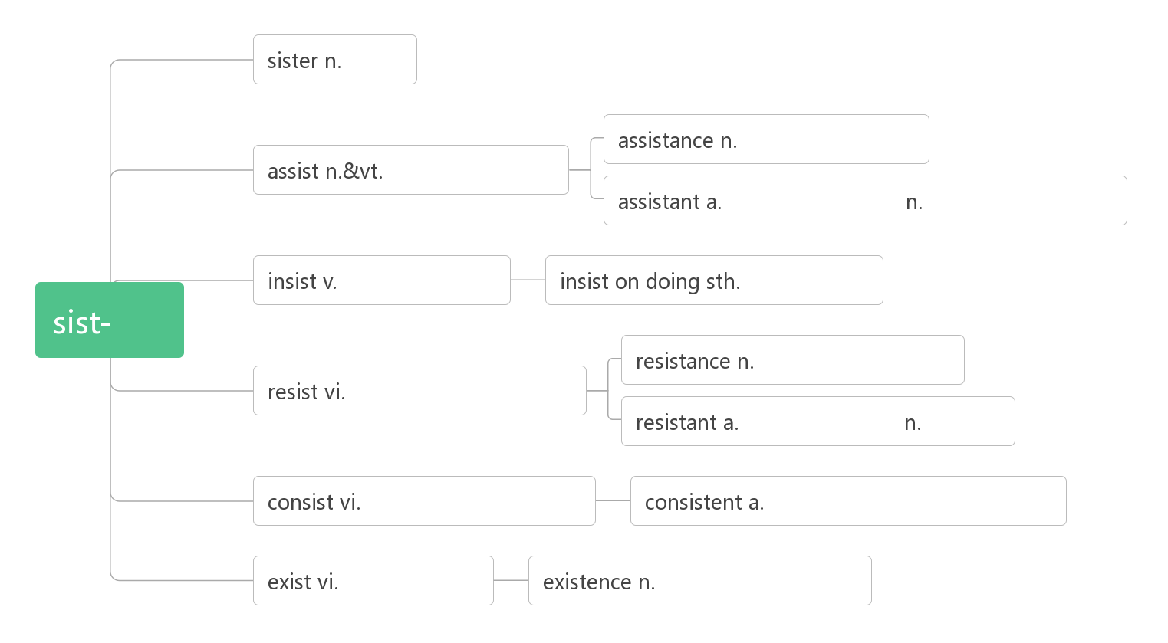

1. **harmony['hɑːmənɪ]n. ________;________；________**

**破拆法：harm(伤害)+mony(money钱)：谈钱伤感情——谈到钱就有损_______。**

**____________________ 与……和谐相处**

**________________ [hɑ:'məʊnɪəs]adj. 和谐的，和睦的；协调的**

1. **goods [ɡʊdz] n.________;__________**

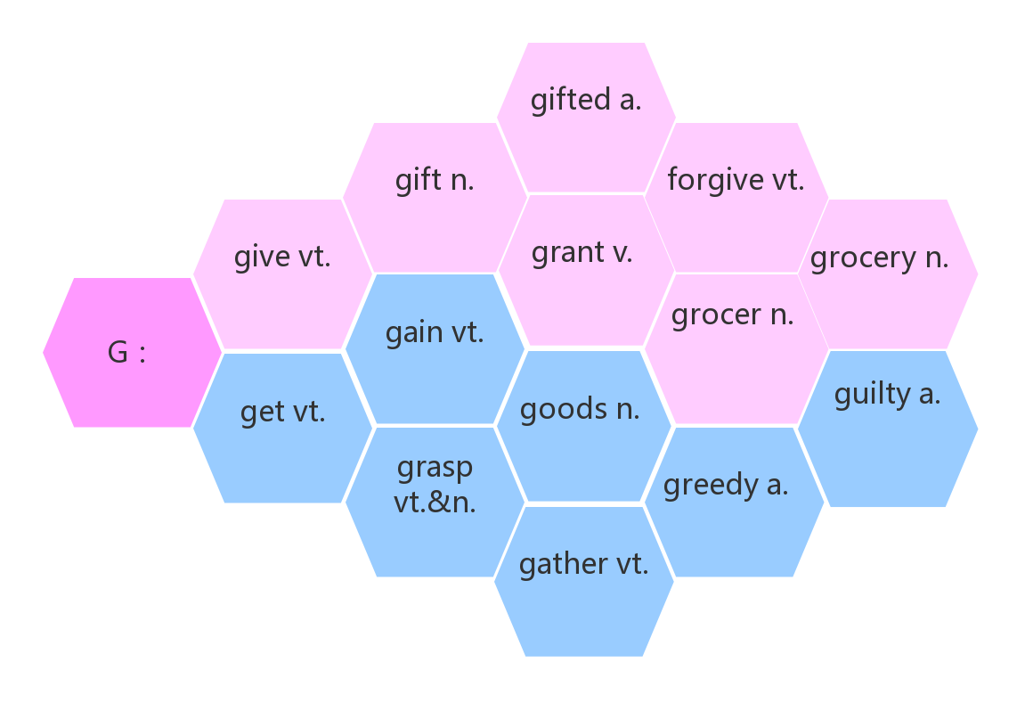

1. **creature ['kriːtʃə]n. ________,_________;_________**

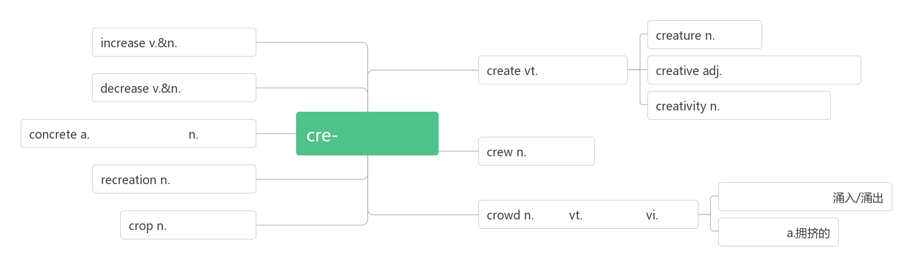

1. **deer[dɪə]n. _____ (pl:_________)**
2. **kangaroo[,kæŋgə'ruː]n. ________**

**破拆法：kan(看)+ga(gather收集)+roo(root树根):看，那只_______在收集树根。**

1. **reduce [ri'dju:s] vt._________**

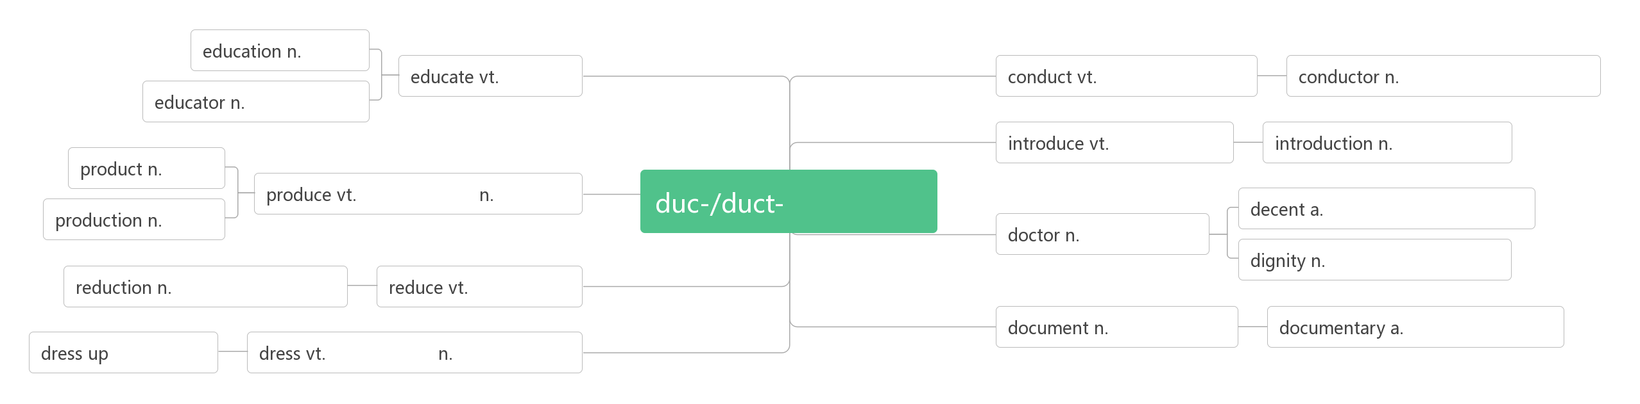

1. **due [dju:] adj._________;________;_________**

**__________由于，因为(prep.)**

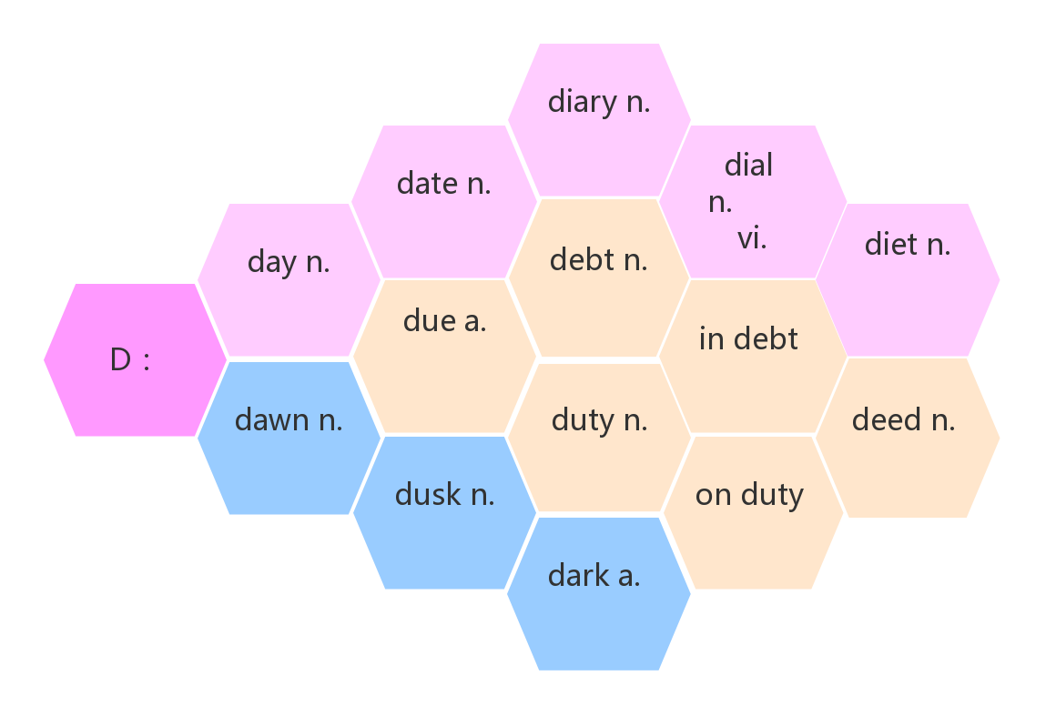

1. **blog [blɒɡ]n.________,___________vi._________**

**_____________博文；博客帖子**

**__________[ˈblɒɡə(r)]n.博客作者；博主**

1. **engine ['endʒɪn]n. _________,_________;__________**

**___________ [endʒɪ'nɪə]n. 工程师；火车司机**

**_________________（互联网上的）搜索引擎**

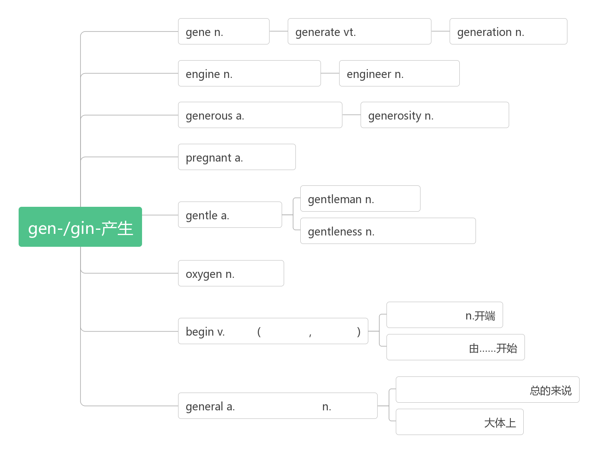

1. **chat [tʃæt]vi.&n.________;________vt.________;_____________**
2. **stream [stri:m]vt._______;_______vi._______ n._______;________**

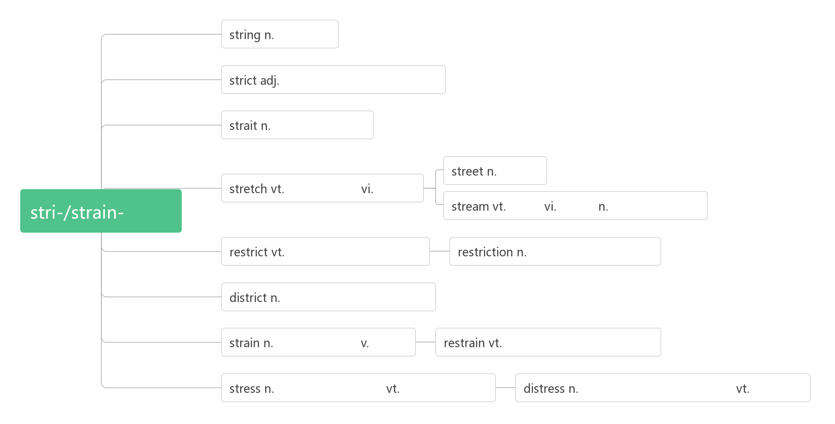

1. **identity [aɪ'dentɪtɪ] n. ________;_________;_________;________**

**词根词缀：ident-(等同)+ity(名词后缀)：等同于一个人的属性——________**

**____________= Identity Card身份证**

**___________[ai'dentifai] vt.识别，鉴别; 确认**

**________________ [aɪdentɪfɪˈkeɪʃ(ə)n] n. 鉴定，辨别**

1. **convenient [kən'viːnɪənt] adj. _________,_________**

**词根词缀：con-(都)+veni(来)+ent(形容词后缀)：大家都来到一起做事——_________,_________**

**convenience [kən'viːnɪəns]n._________,_________,__________**

**________________________ 为了方便起见**

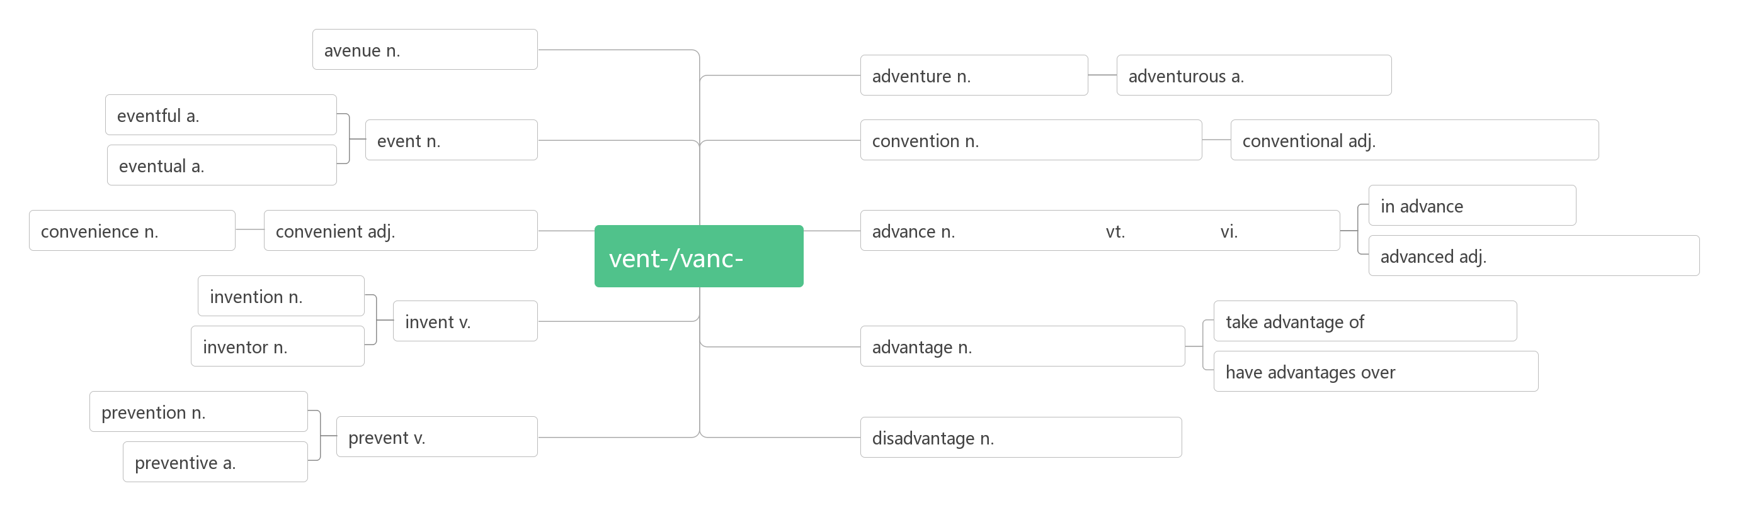

1. **cash [kæʃ]n.________,________vt. _______;____________**

**_______________________ 用现金/支票支付**

**_______________ 兑换支票**

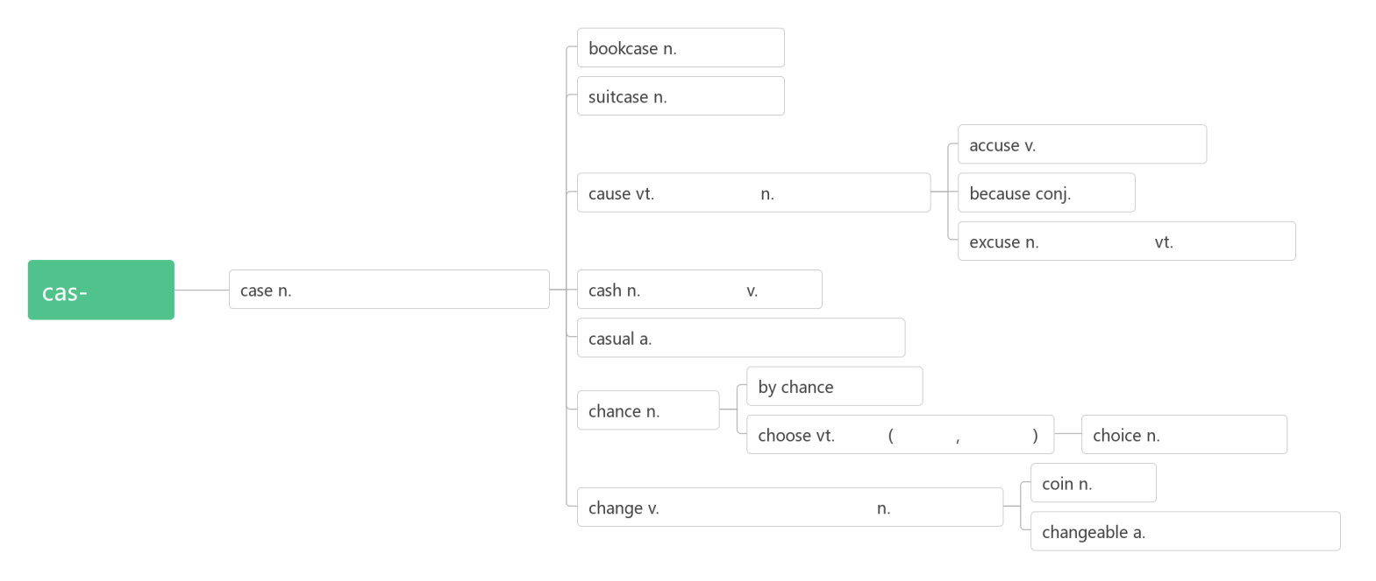

1. **update [ʌp'deɪt]vt. _______;_______________n. _______;___________**

**data ['deɪtə]n._______;________**

**database ['deɪtəbeɪs]n._________,_________**

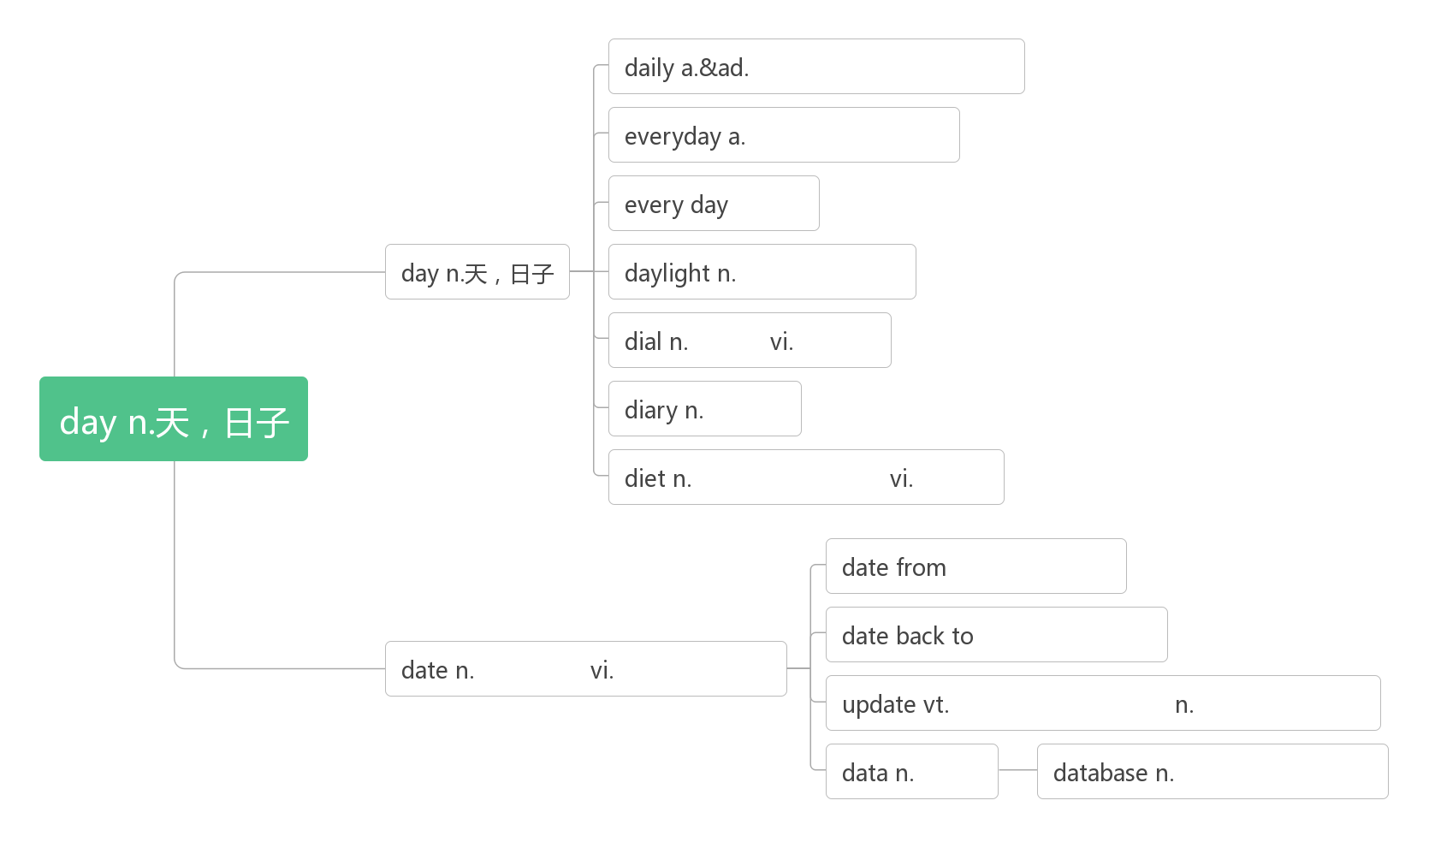

1. **ware [weə]n.________;________;________**

**software ['sɒf(t)weə]n.________**

**hardware ['hɑːdweə]n. _________;____________**

1. **network ['netwɜːk] n. _______;_________;__________**
2. **stick[stɪk]vt. ____,____,________,_______vi. _______;_______;_______n. ____;________(________,________)**

**stick to________**

**be stuck in ________,_________,___________**

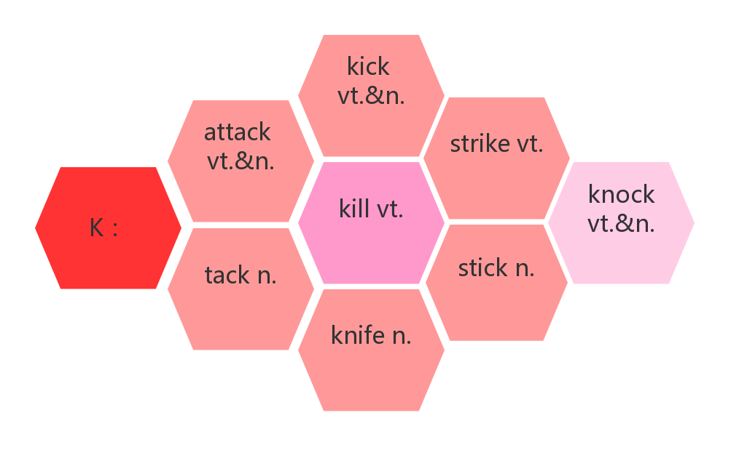

1. **company ['kʌmp(ə)nɪ]n. _______;________;________;_______**

**词根词缀：com-共同+pan(平底锅)+y：共同在一个锅里吃饭的人——_______——________——_______**

**____________________ 陪伴某人**

**______________ [ə'kʌmpənɪ]vt. 陪伴，伴随；伴奏vi. 伴奏，伴唱**

**____________ [kəm'pænjən]n. 同伴**

1. **surf [sɜːf]vt.&vi._______;________**

**___________________ 网上冲浪**

1. **benefit ['benɪfɪt]vt.________vi. _______,_______n. _______,________,_________**

**词根词缀：bene-(好)+fit-(做)：做对别人有好处的事——_________;________**

**__________________ 得益于；从……中获益**

**__________________ 对...有好处**

**______________[benɪˈfɪʃ(ə)l] adj.有利的，有益的；有帮助的**

1. **distance ['dɪst(ə)ns]n. _________;_________**

**词根词缀：dis-(分开)+stan(站)+ce：站得很开——有了“________”**

**________________在远处，在远方**

**________________从远处，从较远的距离**

**_____________ ['dɪst(ə)nt] adj. 遥远的**

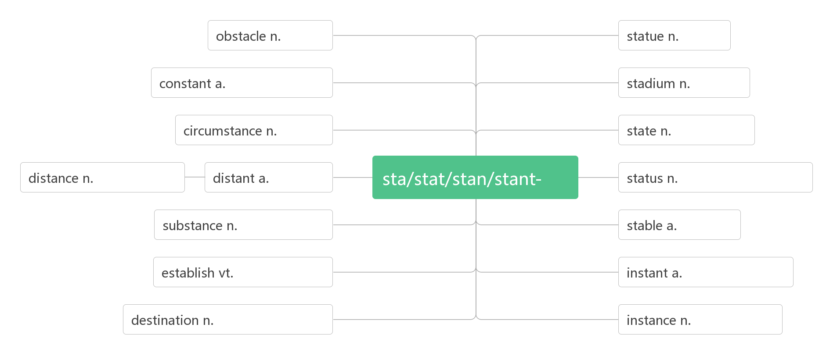

1. **inspire [ɪn'spaɪə]vt. ________;________;________;____________**

词根词缀：in-(里)+-spire(呼吸，气息)：智慧女神向你脑中吹了口气——_______,_______,_________

**______________ [ɪnspɪ'reɪʃ(ə)n] n. 灵感；鼓舞**

1. **now that________;________**

1. **access ['ækses]vt. ________;_______;_______n. _______;________;________**

**have access to_________,_________,_________**

**accessible [ək'sesɪb(ə)l] adj.___________；___________；___________**

**be accessible to_______________________________**

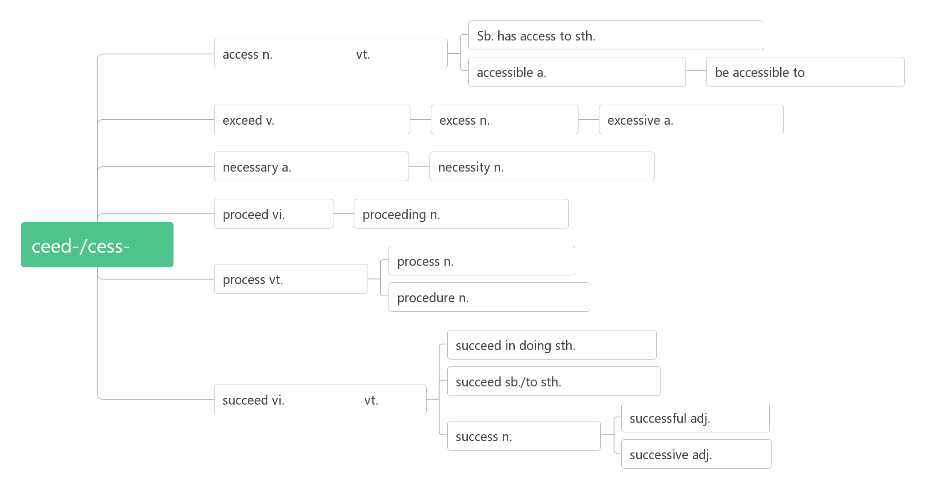

1. **charity ['tʃærɪtɪ]n. ________;________;___________**

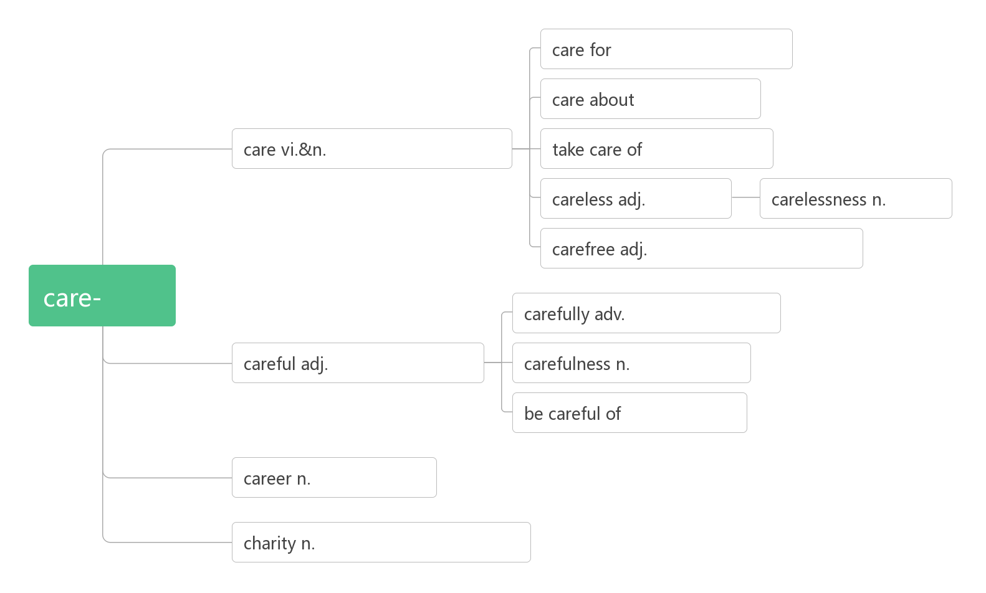

1. **insect ['ɪnsekt]n. ________**

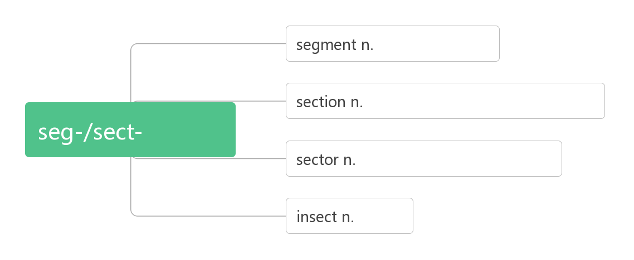

1. **neighbourhood ['neɪbəhʊd]n. ________;______________;________;_____________**

**______________ [ˈneɪbə(r)] n.邻居**

1. **binoculars [bɪ'nɒkjʊləz]n._______________**
2. **bird field guide _____________**
3. **search [sɜ:tʃ]vt. vi.&n.________;________;_________**

**_____________________(搜查某处)寻找某物**

**________________ 以寻找**

**___________ [rɪˈsɜːtʃ] vt.vi.& n. 研究，调查**

1. **dolphin ['dɒlfɪn] n. ________**
2. **koala [kəʊ'ɑ:lə]n. ________,________**
3. **stir [stɜː]vt.vi.&n. ________;________;________**

**__________激起**

1. **emotion [ɪ'məʊʃ(ə)n]n.________;________**

**词根词缀：e-(外)+mot-(动)+ion(名词后缀)：向外迸发的东西——________;________**

**____________ [ɪ'məʊʃ(ə)n(ə)l]adj. 情感的；情绪化的；易激动的；感人的**

1. **skin [skin] n._____;_________**
2. **usual ['juːʒʊəl]adj. ________,_________,_________**

**词根词缀：us-(use)+-ual(形容词后缀)：_________,_________**

**______________像往常一样**

**__________ ['juʒuəli]adv. 通常**

**____________[ʌn'juːʒʊəl]adj. 不寻常的；与众不同的；不平常的**

1. **Tibet [tɪ'bet]n. _______**

**词源谐音：吐蕃**

**Tibetan [ti'betən]adj._________,_________n. ________;__________**