**Unit 4 Discovering Useful Structures**

**The infinitives---attribute & adverbial**

**教材分析**

该板块的活动主题是“描述关于太空的事实以及人类探索太空的努力”。当人们探讨太空探索这一话题时，无论是听说、读写中，还是从语义建构、语用功能上看，不定式作定语和作状语的用法是本单元的重点内容。这一板块就是为了让学生掌握并运用这一结构描述已知的太空事实、太空探索历史上的重大事件和重要人物的成就。本节课以神州十三号太空探索为例，加入思政元素，创设了航天员翟志刚、王亚平、叶光富的太空探索语境。这让学生更加容易理解非谓语不定时的用法，从而激发学生的学习兴趣，使学生增强的爱国热情以及为祖国繁荣昌盛而奋斗的决心和使命感及民族自豪感。

教学过程践行英语学习活动观，着力提高学生学用能力。通过个人性化的作业满足学生个性发展需求，同时实施任务后的自我评价、同伴互评和老师评价，并完善英语课程评价体系和促进核心素养有效形成。

**学情分析**

学生在初中阶段已经学习过不定式用作目的状语，对不定式用法有了初步的感知。本单元增加了不定式作结果状语的用法。当不定式用作定语时，可用来修饰名词、代词、数词等。当不定式用作状语时，可表示目的、结果、原因以及伴随状况等。

**教学目标**

1. 引导学生归纳动词不定式作定语和作状语的意义和用法并能在语境中正确运用。
2. 培养学生合作学习，归纳、迁移和创新的语言学习能力。

3.增强学生的爱国热情以及为祖国繁荣昌盛而奋斗的决心和使命感及民族自豪感。

**教学步骤**

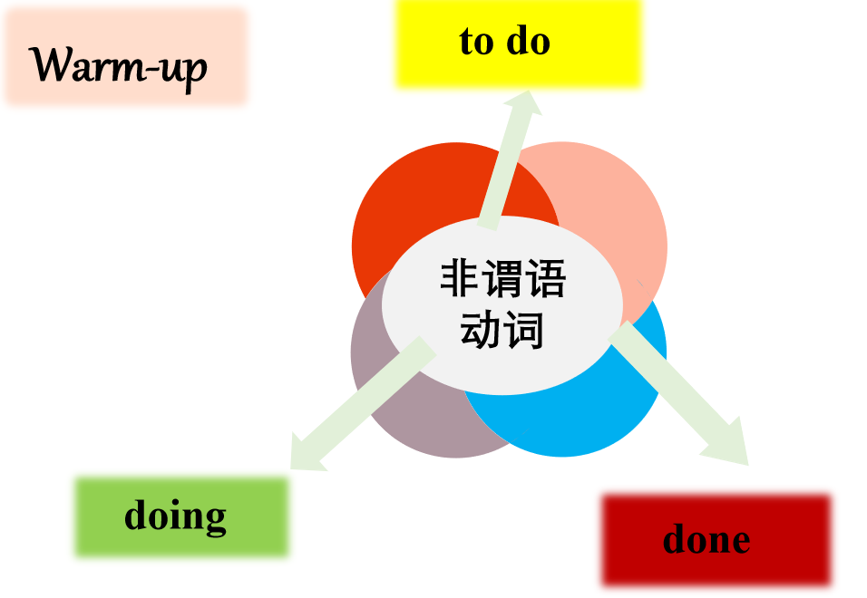

**Lead-in ：Enjoy a Video.** 【Activate and engage students. Understand and apply.】

Q1: Who is mentioned in the video?

**Presentation**

1. **The infinitives---attribute**

【要求学生结合插图语境，观察所给句子，填入正确形式，理解动词不定式在句中作定语的功能和意义，同时归纳不定式作定语的用法。】

**1. 动词不定式作定语放在名词或不定代词something, nothing, anything等后面作后置定语。**

Wang Yaping’s partners give her something red （play）.

1. **当修饰的名词前有the only, the next, the best, the first, the last, 以及由序数词或形容词最高级修饰的名词常常用不定式作定语。**

Wang Yaping is the first female （go）into the space.

1. **当修饰的名词是ability, ambition, attempt, chance, courage, desire,**

**decision, effort, failure, moment, promise, right, time, wish …**

Wang Yaping has the ability and courage (go) into the space.

1. **名词与定语之间存在动宾，主谓，同位关系。**

Shenzhou XIII astronauts have a lot of mental and physical training

(attend).

They’re the excellent people (finish) the the mission.

They had the mission (carry out) in space.

**Fill in the blank. 【Understand and apply.】**

1. The airport __________ (complete) next year will help promote tourism in this area.

2. Do you have something _______ (finish) tonight?

3. The best way _______ (improve) your English is to join an English club.

4. Yang Liwei was the first Chinese astronaut (go) into the space in 2003.

**二． The infinitives---adverbial**

【要求学生结合插图语境，观察所给句子，填入正确形式，理解动词不定式在句中作状语的功能和意义，同时归纳不定式作状语的用法。】

1. 目的状语：置于句首或句末，为加强语气，常与in order或so as组成短语。

Zhai Zhigang, Wang Yaping and Ye Guangfu got together (paste) couplets.

celebrate the year of the tiger, Zhai Zhigang, Wang Yaping and Ye Guangfu got together to paste couplets.

1. 不定式作目的状语可转换为so that/in order that引导的目的状语从句。

They studied very hard in order to be the very elite in their scientific fields.

=They studied hard they could be very elite in their scientific fields.

=They studied very hard they could be very elite in their scientific fields.

1. 不定式作原因状语和结果状语

（1）原因状语：多用于“sb.+be+adj.+to do”句型中。

He was delighted (finish) couplets.

（2）结果状语：多见于“too...to（太...以不能）”；“enough to...”；“only to do”“so/such...as to（如此...以至于）句型中。

He was outstanding enough to finish couplets.

高考链接：不定式和现在分词作结果状语的区别

1. The astronaut landed on the moon only (find) that he floated.
2. There’s no gravity on the moon, (leave) the ball float around.

**Task 1 Look at the following sentences and focus on the italicised infinitives. In pairs, discuss their functions and meanings.**

【巩固动词不定时的定语和状语功能，培养学生的归纳能力】

1. I trained for a long time to fly airplanes as a fighter pilot.
2. As we all know, an astronaut needs to be healthy and calm in order to work in space.
3. First of all, you must be intelligent enough to get a related college degree.
4. Some scientists were determined to help humans realise their dream to explore space.
5. On 12 April 1961, Yuri Gagarin became the first person in the world to go into space.

**Task 2 【**学生在理解语篇内容的基础上，能够基于语境正确使用不同的非谓语动词形式，其中包括动词不定式作定语和作状语的用法。这一活动不仅是为了巩固学生对本单元核心结构的理解，使他们学会迁移运用，还包括巩固和复习其他非谓语动词形式，让学生学会辨别这些非谓语动词在意义和用法上的不同，从而能够正确运用这些结构。**】**

Sending people to other planets or even beyond the solar system is not an easy goal________(achieve). One of the problems is that the trip would take a very long time. For example, _______ (use) current technology, it would take over two years _____ (get) to the closest planet, Mars, and back. Although light is the fastest thing______ (know)in the universe, it could take more than four years to reach the nearest star system. Will scientists figure out a way ________ (store) sufficient food and water for the long journey?

Is it possible to travel faster than light? No one knows the answers yet. However, space scientists never give up. They are experimenting with growing crops in space so as _______ (help) astronauts get enough food on longer journeys through space.

**Task 3 高考链接:【**学会迁移运用，还包括巩固必修三前面三个单元已学过的doing 和to do非谓语动词形式，让学生学会辨别这些非谓语动词在意义和用法上的不同，从而能够正确运用这些结构。**】**

1. Picking up her “Lifetime Achievement” award, proud Irene declared she had no plans ______ (retire) from her 36-year-old business. (2019·全国II卷)

2. Modem methods of tracking polar bear populations have been employed only since the mid-1980s, and are expensive _________ (perform) consistently over a large area. (2019·全国I卷)

3. The project______________ (accomplish) by the end of 2021, will expand the city's telephone network.

4. I have a lot of readings (complete) before the end of this term. (2010 山东)

5. The ability (express) an idea is as important as the idea itself. (2011 湖南)

6. ________ (learn) more about China, don’t hesitate to contact us and be the first ________ (sign) up for the activity.

7. They make vehicles (to carry) brave people into space to find out the secrets of the universe.

8. (2021·河南)The teen's act soon spread quickly (inspire) kids and adults worldwide to take action．

**Assignment【**一方面，学生学会在语境中迁移创新运用非谓语动词的用法。另一方面，培养学生的思辨能力。理解太空探险意义。**】**

假定你是李华, 最近你班举行了一次班会，班会的主题是:太空探险意义。请结合以下内容,用英语给校报写一篇文章,客观地介绍讨论的情况并表达你自己的观点。

|  |  |
| --- | --- |
| **赞同者** | **反对者** |
| **1.获得新的知识;** | **1.耗资巨大;** |
| **2.从太空取得新资源；** | **2.宇航员的安全问题。** |
| **3.扩大人类的生存空间。** |  |

注意:1.词数80左右，至少用上2-5个非谓语表达句子，涉及 to do, doing和done的用法。

2.可适当增加细节,以使行文连贯。

Dear Editor,

We had a discussion over whether it's necessary to carry out the outer space explorations at a class meeting the other day.

Some of us think it important to research the outer space. First, people carry out their explorations so as to get a better understanding of the outer space. Second, new resources can be found there for humans to use, facilitating human’s life. However, others don't believe so. In their opinion, not only does this kind of exploration cost too much money, but also it’s very dangerous for astronauts to do such work.

All in all, I think such explorations into the outer space are worth trying out.