**UNIT 5 WORKING THE LAND**

**READING FOR WRITING**

**CHEMICAL VERSUS ORGANIC FARMING**

**【活动主题】**

该部分以“评估化学耕作和有机耕作" (Evaluate chemical farming and organic famring为活动主题"，思考耕作方式与农业可持续发展的问题。学生先阅读文本，了解化学耕作和有机耕作的概念以及各自的优缺点，再结合自己的理解选取其中一种耕作方式，使用论据，论证为什么该耕作方式更好，表达倾向性的观点。整个活动需要学生结合文本内容和自己的理解深人思考，着重训练思维的逻辑性和批判性。

**【文本分析】**

整体而言，该阅读文本是一篇说明文。文本分别介绍了化学耕作和有机耕作两种耕作方式的特点，分析了各自的优缺点，最后的结论是人类如果想要既吃得饱又吃得健康，同时保持环境的可持续发展，还有很长的路要走。文本启发读者从多角度思考农业耕作的方式，辩证地看待化学耕作和有机耕作的问题。在文本结构上，作者采用了“先分后总”的信息组织方式， 先介绍化学耕作方式，再介绍有机耕作方式，最后谈了自己的看法——其实， 目前并没有种耕作方式可以解决全部问题。文本使用了说明、举例、对比等写作手法，并运用了大量的语篇标识词，例如:表示转折的however、 but, 表示举例的for example、for instance，表示并列和递进的and、also,表示补充信息的的in addition，用以引出不同信息的as for、as an alternative，用以引出原因和结论的because、therefore，等等。用这些标识词连接句子、构成语篇，也体现了文本较强的逻辑性和所说明内容的全面性。

**【教学重点】**

引导学生自己总结并找出阅读语篇的特点以及作者的写作意图；帮助学生熟悉辩论式的写作模式，提升学生深度思考和探究问题的能力。

**【Teaching aims】**

1. **Linguistic ability :** learn to express one’s opinion with supporting evidence and reasons
2. **Learning ability :** understand argumentative essay and then write it down; learn to use transitional words
3. **Cultural character :** know different forms of farming and their influence on farmers and consumers, on China and the whole world
4. **Thinking ability :** learn touse mind maps to organize information;learn to develop students’ critical and creative thinking

**【Teaching procedure】**

**Task 1: Warming up**

Travel in Lanling during the National Day

**Task 2: Lead-in**

Watch a short video about organic farming ( before watching, give student a question: What the video will tell us)

**Task 3: Skimming and scanning**

1. Divide students into 2 groups and let them find out key information.

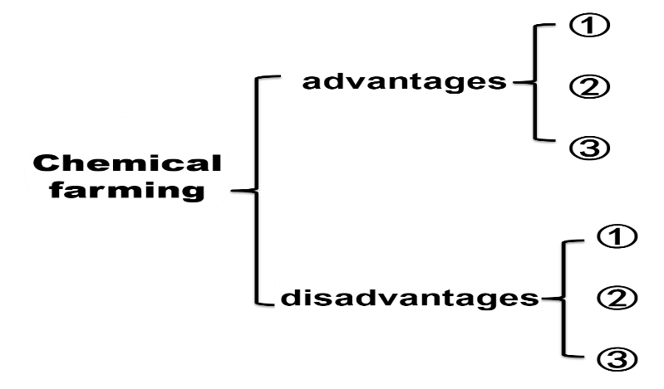

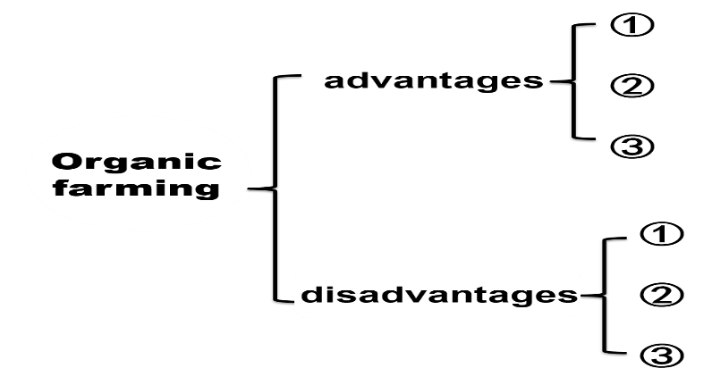

1. Try to figure out the strcture of this passage.

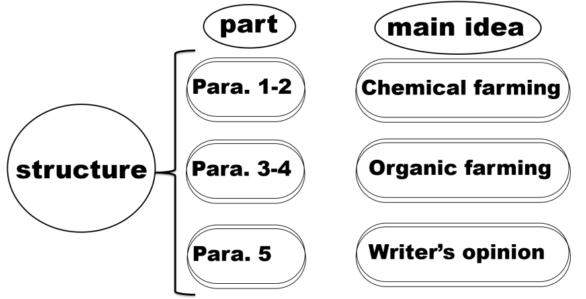

**Task 4: Brainstorming**

What **other** advantages and disadvantages can you think of ? Discuss in divided groups and then make a list.

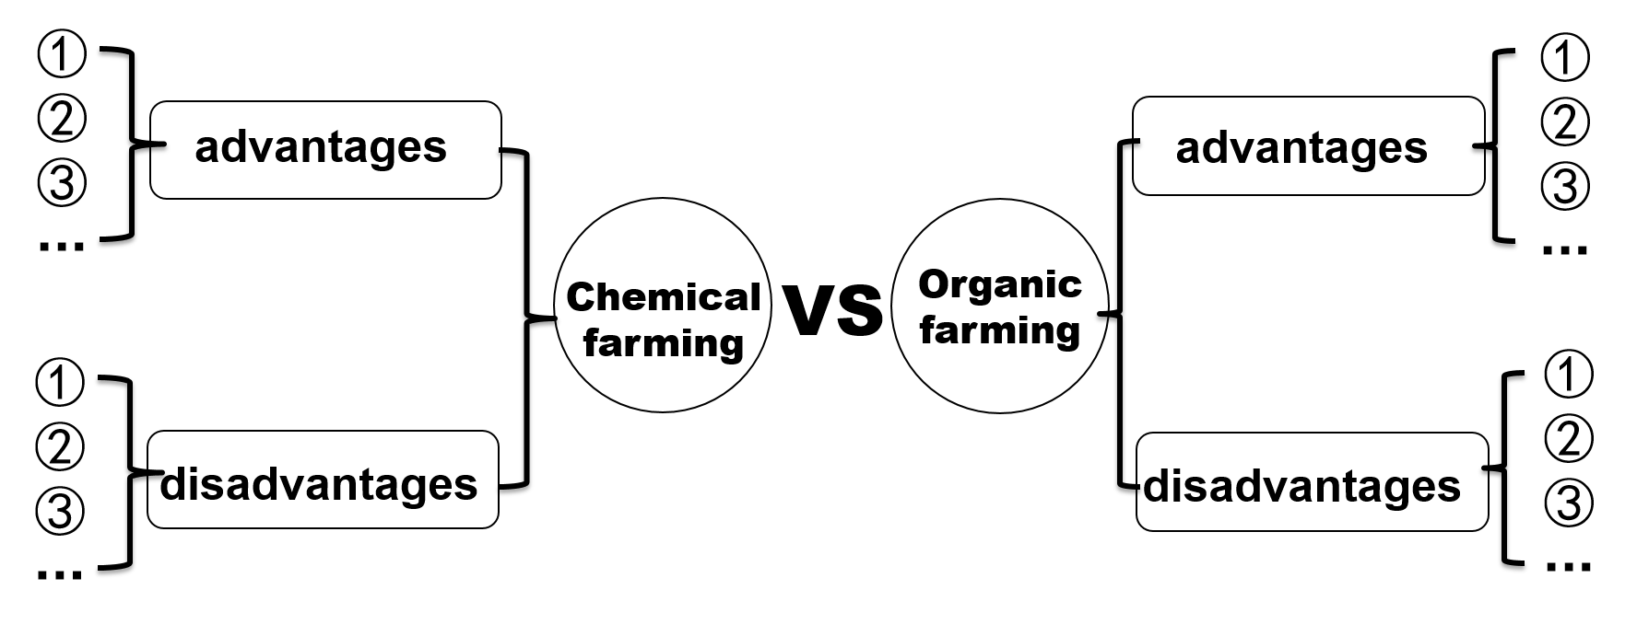

**Task 5: Writing**

Which farming do you support ? Chemical or organic farming ? Write an argumentative essay(议论文) to show your opinion.

**1. Structure**

Part 1. Topic sentence (opinion/ attitude)

Part 2. Points and details

1）advantages

2）transitional words（过渡词）

Part 3. Conclusion (meaning/influence)

**2. Words and sentence patterns for argumentative essay**

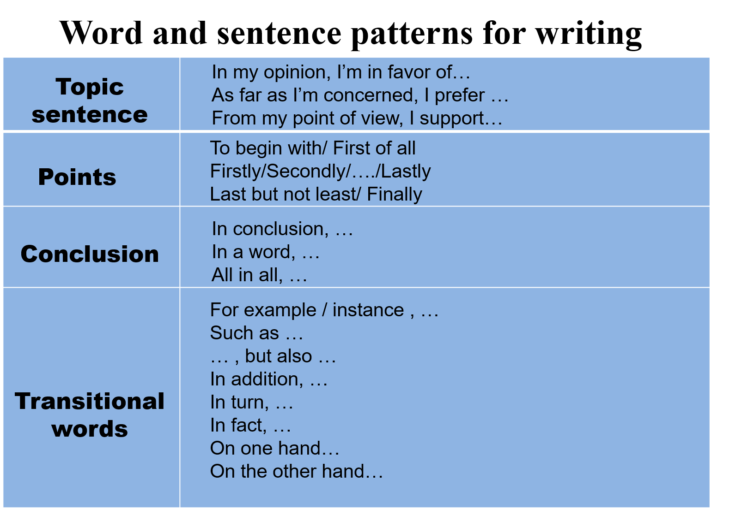

1. **Write an argumentative essay to express one’s opinion**

**Pattern:**

In my opinion, I support…______________________

Firstly, (advantage 1 & detail)

____________________________________________

Secondly, (advantage 2 & detail)

____________________________________________

Finally, (advantage 3 & detail)

____________________________________________

All in all, ____________________________________

1. **Evaluating and editing**
2. Show some students’ writings (teacher’s evaluation for example)
3. Exchange one’s writing with his/her partner (students’ evaluation)
4. Show a sample

**Task 7: Creative thinking**

What will farming become in the future ?

**Intelligent Agriculture（智慧农业）**

Show some pictures and a short video about the magical Intelligent Agriculture

**Task 8: Homework**

Polish your writing by changing different words, sentence patterns and clauses and adding some details to make your essay better in structure and expression.