**高考阅读理解——任务型阅读**

**A**

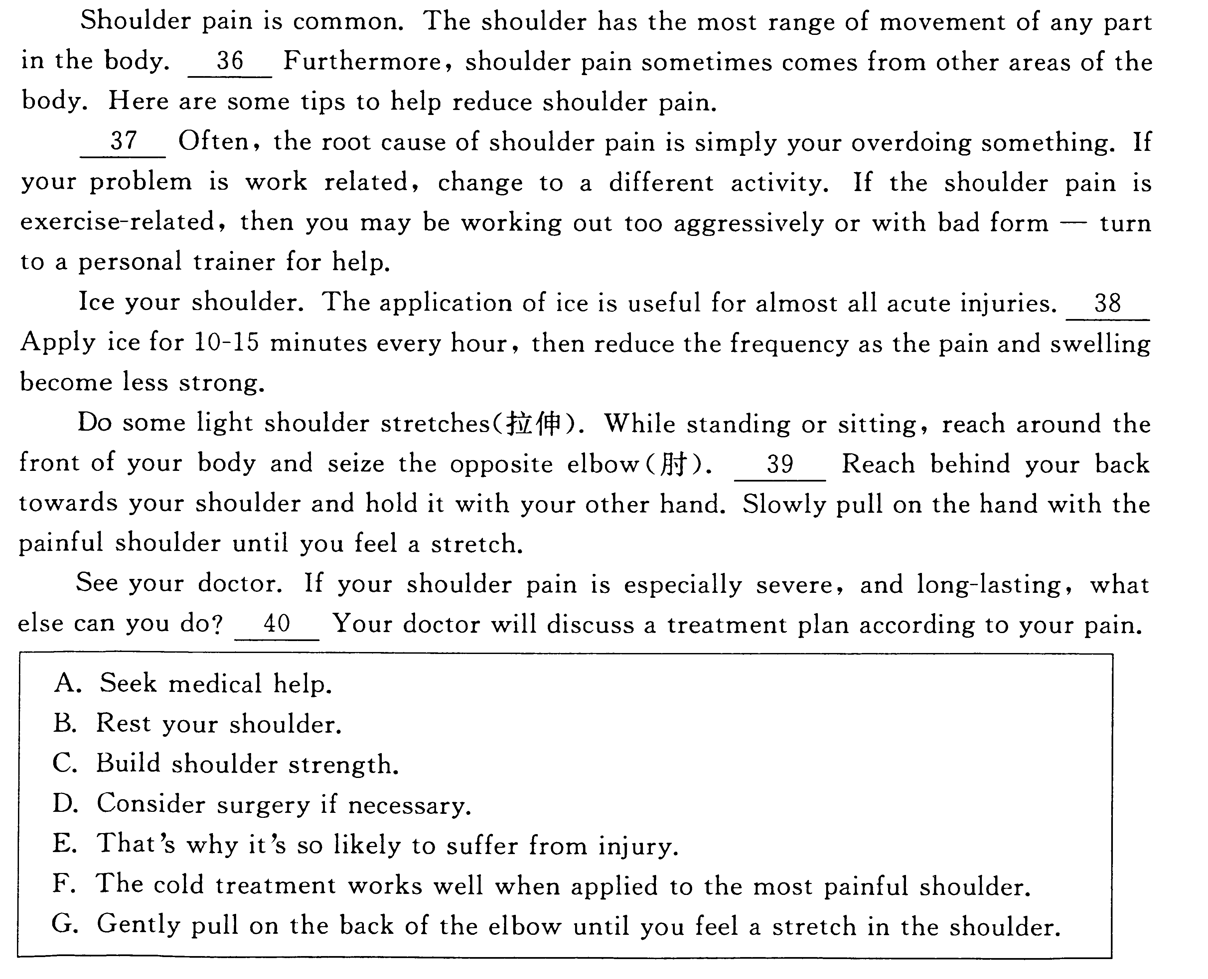

**B**

Move into a new home in a new neighborhood is an exciting experience. Of course, you want to make sure that you become an accepted and valuable part of your new neighborhood. The easiest way to accomplish this is to make sure you conduct yourself as a good neighborhood should. 1

Perhaps one of the most important things you can do ad a good neighbor is to keep your property neat, clean, and in good repair...

Second, take the overall appearance of the neighborhood seriously...

2 If a neighbor is going to be out of town, offer to collect mail and newspaper. If a neighbor suffers an illness, offer to do the grocery shopping. Let them know that you are there to help in a way that is acceptable, while still respecting the privacy of your neighbor.

3 By following the basic rules of respecting others, taking care of what belongs to you, and taking pride in the appearance of the neighborhood in general, you will quickly become a good neighbor that everyone appreciates.

A. In general, keep an eye on their property while they are gone.

B. A good neighbor is also one who likes to help out in small ways.

C. Being a good neighbor is more or less about considerate behavior.

D. Sometimes neighbors may go to the supermarket together to do shopping.

E. Should you come across waste paper thrown out of a passing car, pick it up.

F. People tend to take pride in keeping everything in their street fresh and inviting.

G. Here are a few tips to help you win over everyone in the neighborhood quickly.

**C**

Reading is important. But the next step is making sure that you remember what you've read! 1 You may have just read the text, but the ideas, concepts and images may fly right out of your head. Here are a few tricks for remembering what you read.

● 2

If the plot, characters, or word usage is confusing for you, you likely won't be able to remember what you read. It's a bit like reading a foreign language. If you don't understand what you're reading, how would you remember it? But there are a few things you can do...Use a dictionary; look up the difficult words.

● 3

Does a character remind you of a friend? Does the setting make you want to visit the place? Does the book inspire you, and make you want to read more? With some books, you may feel a connection right away. But other books require a bit more work on your part. How willing are you to make the connections happen?

A. Are you confused?

B. Are you connected?

C. Practice makes perfect.

D. What's your motivation?

E. Memory is sometimes a tricky thing.

F. Marking helps you remember what you read.

G. You can do the same thing when you read the text!

**D**

Rock music consists of many different styles. Even though there is a common spirit among all music groups, they make very different music. 31 At that time the Beatles entered the world of music from Liverpool.

　　After they were given an invitation to appear live on BBC, the Beatles quickly became famous in Britain with nationwide tours. By mid-1963, the Beatles had been extremely popular in England. 32 They held large concerts and performed at clubs. They became the hottest thing on the pop music scene in England. They began as a modestly successful musician group and ended the year as show business legends (传说). John Lennon and Paul McCartney were named composers of the year.

　　 33 They were not sure how the Americans would react to the new type of music. Beatlemania hit New York on February 7, 1964. Hundreds of fans jammed the airport to greet them. 34 The concert was broadcast live and attracted the largest one night audience in the history of television up to that time. The Beatles were described as a British invasion (入侵) by local and nationwide newspapers at that time. Their victory in America was still remembered as a major turning point in the history of rock and roll. Thanks to the Beatles, a lot of opportunities were opened up to new faces on the market. 35

A. They decided on a tour to the United States in 1964.

　B. Even their hairstyles became major trends at that time.

　C. Rock music developed in the 1950s and the early 1960s.

　D. However, their songs changed the lives of generations to come.

　E. Many rock bands were able to follow in the footsteps of the Beatles.

　F. They appeared in the films A Hard Day's Night (1964) and Help! (1965).

　G. They performed their first concert in America at CBS television's 53rd street studio.

**E**

If anyone had told me three years ago that I would be spending most of my weekends camping. I would have laughed heartily. Campers, in my eyes, were people who enjoyed insect bites, ill-cooked meals, and uncomfortable sleeping bags. They had nothing in common with me. 36

The friends who introduced me to camping thought that it meant to be a pioneer. 37 We sleep in a tent, cooked over an open fire, and walked a long distance to take the shower and use the bathroom. This brief visit with Mother Nature cost me two days off from work, recovering from a bad case of sunburn and the doctor’s bill for my son’s food poisoning.

I was, nevertheless, talked into going on another fun-filled holiday in the wilderness. 38 Instead, we had a pop-up camper with comfortable beds and an air conditioner. My nature-loving friends had remembered to bring all the necessities of life.

39 We have done a lot of it since. Recently, we bought a twenty-eight-foot travel trailer complete with a bathroom and a built-in TV set. There is a separate bedroom, a modern kitchen with a refrigerator. The trailer even has matching carpet and curtains.

40 It must be true that sooner or later, everyone finds his or her way back to nature. I recommend that you find your way in style.

A. This time there was no tent.

B. Things are going to be improved.

C. The trip then took me on was a rough one.

D. I was to learn a lot about camping since then, however.

E. I must say that I have certainly come to enjoy camping.

F. After the trip, my family became quite interested in camping.

G. There was no shade as the trees were no more than 3 feet tall.

**F**

Have you ever visited a garden that seemed just right for you, where the atmosphere of the garden appeared to total more than the sum of its parts? 31 But it doesn't happen by accident. It starts with looking inside yourself and understanding who you are with respect to the natural world and how you approach the gardening process.

**Know why you garden**

Some people may think that a garden is no more than plants, flowers, patterns and masses of color. Others are concerned about using gardening methods that require less water and fewer fertilizers (肥料). 32 However, there are a number of other reasons that might explain why you want to garden. One of them comes from our earliest years.

**Recall your childhood memories**

Our model of what a garden should be often goes back to childhood. Grandma's rose garden and Dad's vegetable garden might be good or bad, but that's not what's important. 33 —how being in those gardens made us feel. If you'd like to build a powerful bond with your garden, start by taking some time to recall the gardens of your youth. 34 Then go outside and work out a plan to translate your childhood memories into your grown-up garden. Have fun.

A. Know why you garden.

B. Find a good place for your own garden.

C. It's our experience of the garden that matters.

D. It's delightful to see so many beautiful flowers.

E. Still others may simply enjoy being outdoors and close to plants.

F. You can produce that kind of magical quality in your own garden, too.

G. For each of those gardens, write down the strongest memory you have.

**G**

Secret codes keep messages private. Banks, companies, and government agencies use secret codes in doing business, especially when information is sent by computer.

People have used secret codes for thousands of years. 1 . Code breaking never lags far behind code making. The science of creating and reading coded message is call cryptography.

A. It's very hard to break a code without the code book.

B. In any language, some letters are used more than others.

C. Only people who know the keyword can read the message.

D. As long as there have been codes, people have tried to break them.

E. You can hide a message by having the first letters of each word spell it out.

F. With a code book, you might write down words that would stand for others words.

G. Another way to hide a message is to use symbols to stand for specific letters of the alphabet.

**H**

Lots of people find it hard to get up in the morning and put the blame on the alarm clock. In fact, he key to easy morning wake-up lies in resting your body clock 1 ,That’s Here is how to make one．

Rethink mornings. Now that you know why you want to wake up, consider re-arranging your morning activities. If you want time to have breakfast with your family, save some time the night before by setting out clothes, shoes, and bags. 1 ,That’s a quarter-hour more you could be sleeping if you bought a coffee maker with a timer.

A. Get a sleep specialist.

B. Find the right motivation.

C. A better plan for sleep can help.

D. And consider setting a second alarm.

E. If the steps you take are working, keep it up.

F. Stick to your set bedtime and wake-up time, no matter the day.

G. Reconsider the 15 minutes you spend in line at the café to get coffee.

**I**

Interruptions are one of the worst things to deal with while you’re trying to get work done. 1 , there are several ways to handle things. Let’s take a look at them now.

1. If you’re busy, don’t feel bad about saying no
2. When you want to avoid interruptions at work
3. Set boundaries for yourself as your time goes
4. If you’re in the other person’s office or in a public area
5. It’s important that you let them know when you’ll be available
6. It might seem unkind to cut people short when they interrupt you
7. Leave it open when you’re available to talk and close it when you’re not

A. It's very hard to break a code without the code book.

B. In any language, some letters are used more than others.

C. Only people who know the keyword can read the message.

D. As long as there have been codes, people have tried to break them.

E. You can hide a message by having the first letters of each word spell it out.

F. With a code book, you might write down words that would stand for others words.

G. Another way to hide a message is to use symbols to stand for specific letters of

the alphabet.