**Teaching Design**

**for Unit 5 Working the Land Using Language 1 Exploring the World Hunger Problem**

1. **Teaching Analysis**:

The world hunger problem is a topic familiar to students. But students know few about the causes that lead to the problem and the possible solutions. And under the outbreak of Covid-19, the world hunger problem is becoming more severe, which is a phenomenon worth discussing and thinking about. Thus, in this class, certain background information and latest situation of world hunger problem would be offered. And in this listening context, opinions and facts would be involved, which is difficult for ss to capture in the listening. Thus, the skills like how to identify the supporting evidence and listen for opinion would be trained.

1. **Teaching Aims:**
2. To identify for the main setting for the listening.
3. To figure out details by listening for supporting evidence and opinions.
4. To evaluate the possible causes and solutions to the world hunger problem by thinking about what they can do.
5. **Teaching Procedures:**

**Step1: Lead-in**

Two pictures of Chinese meals in different periods.

Watch a video about the present hunger problem under the outbreak of Covid-19.

Discuss: what are the possible causes to hunger problem?

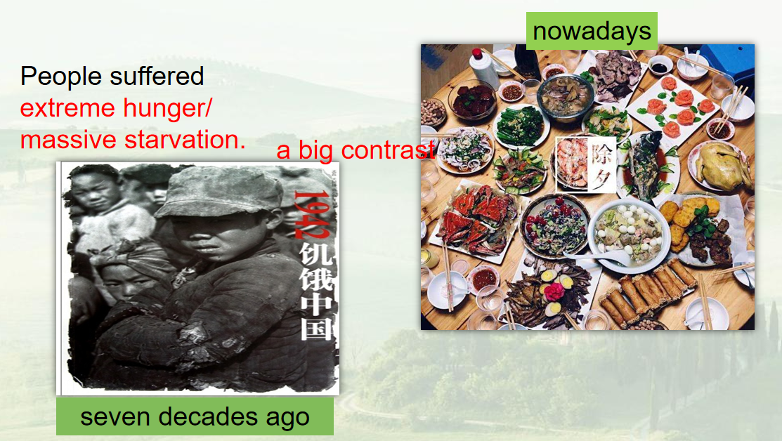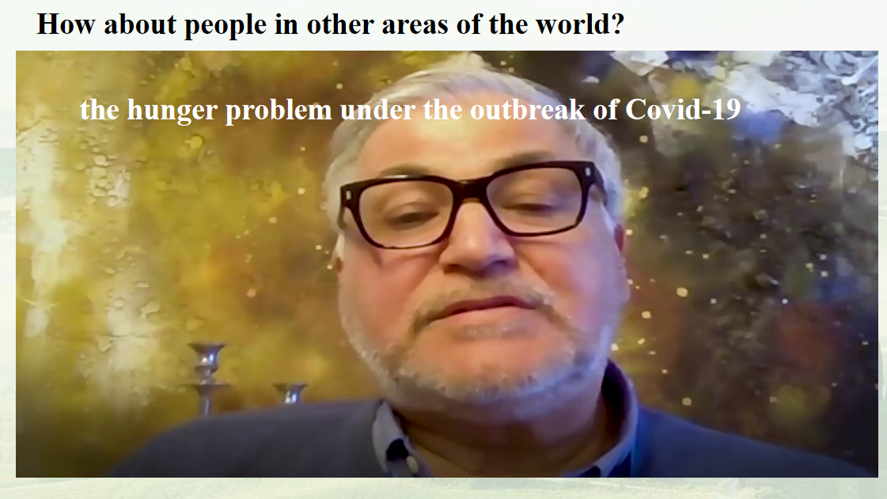

(Aims: to elicit the topic and lead ss to think about the causes to hunger, the present situation and people in other areas.)

**Step 2: Listening**

1. Listen for the main setting.

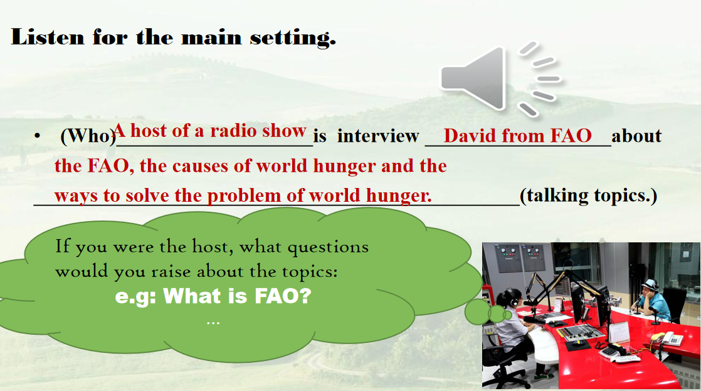

1. Listen for the answers to the questions.

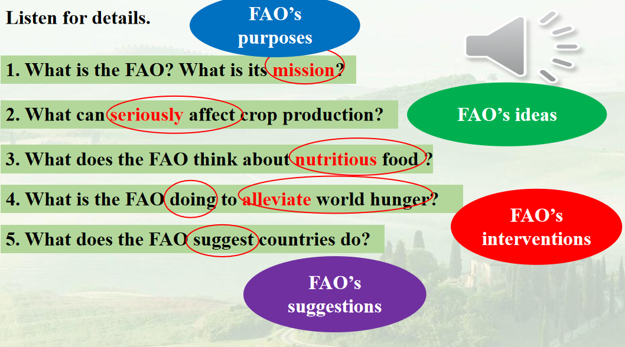

(Aims: to fully understand the listening context and train ss listening strategy like predicting.)

**Step 3: Listen for opinions and supporting evidence.**

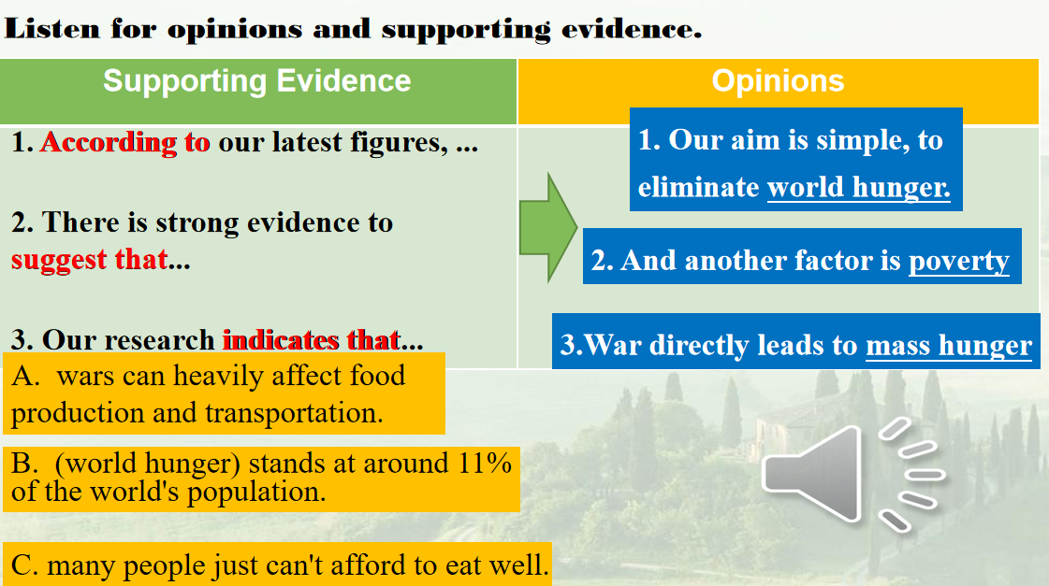

Guide ss to focus on signal marks about showing evidence and expressing opinions.

( Aims: to train the strategy and figure out details by listening for supporting evidence and opinions. )

**Step 4: Listen for Thinking.**

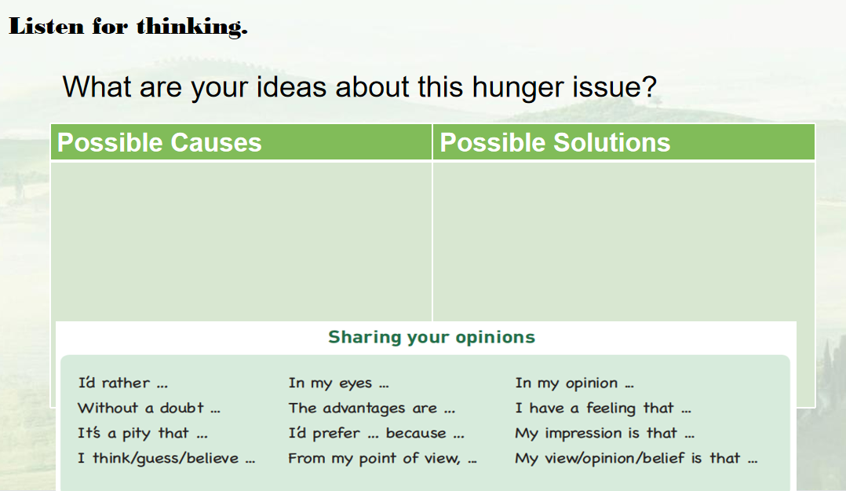

Watch the videos about the solutions and food waste and losses.

(Aims: to extend ss thinking by exploring other possible causes and effective solutions.)

**Step 5: Extensive Activities**

Discuss what we can do and design activities for FAD.

(Aims: to raise ss awareness of a Community of Shared Future for Mankind by connecting themselves to the alleviating world hunger problem.)

**Step 6: Homework**

Make a speech as representative of FAO in school to appeal students to pay attention to the hunger problem and make contributions.

(Aims: to extend ss horizons and offer them the ways to explore more about world hunger problem.)