**202302杭州八县市高二期末应用文讲评**

**原题：**

假定你是李华，从互联网（the Internet）上得知一个国际中学生组织将在新加坡（Singapore）举办冬令营，欢迎各国学生参加。请写一封电子邮件申请参加。

内容包括：

1．自我介绍（包括英语能力）;

2．参加意图。

**Worksheet：**

**一、Read and understand the requirements**

1. What kind of practical writing is it? _____________________________________
2. What kind of person should be adopted while writing? __________________________
3. What kinds of tenses should be adopted? _________________________________________________________________________

**二、The structure of an application letter**

1. Usually, when will people write an application letter ?
2. Who are the intended readers? How do we usually address them?
3. If you want to gain the recognition of the receiver, what should be included in your letter?

______________________________________________________________________________

What is the structure of an application letter?

|  |
| --- |
|  |

Part 1: __________________________________________

Part 2: 申请理由，阐述优势（_____________________________________________）

Part 3: ___________________________________________

**三、How to organize each part**

**Part 1: 夺人眼球开头句**——开篇表意，提出申请

（1）Student1’s beginning:

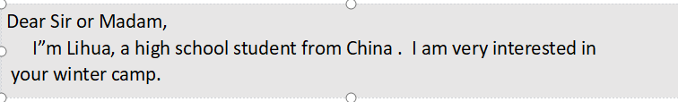

How to polish it? Have a try.

1. 举一反三 More sentences to express eagerness for an application.

|  |
| --- |
|  |

**Part 2 亮点出彩篇中句**

—— 阐述优势(资格、性格特征、语言能力、交际能力和相关经验）

Q: How to show your qualifications and advantages?

Work in groups and come up with as many sentences as you can .

**Practice 亮点出彩篇中句**

1. have a good command of oral /spoken English (必备硬件：语言能力）

我认为我能成为一名好的冬令营成员。（总起）

I believe I am qualified to be a good member of the winter camp.

★ 首先，我英语非常流利，这使得我能够很好地/ 很轻松地与来自其他国家的成员进行交流。

Firstly, I have a good command of spoken English,_____________________________________.

( which enables me to communicate with other people with ease; enabling me to communicate with other people with ease)

★ 能够流畅地用英语进行交流，这是我优势之一。（v-ing 或者 with的复合结构）

__________________________ is one of my biggest advantages/strengths.

________________________ , I can communicate well with others.

( Being fluent in spoken English; With fluent spoken English)

1. be optimistic and enthusiastic 或 previous experiences （软件优势：性格特点或以前的经历）

★ 乐观又热情，我会积极地参与各种活动。

____________________, I will actively take part in various activities

（Optimistic and enthusiastic）

★ 我不仅善于交际，而且乐于承担责任，我会积极地参与各种活动。

____________________________________, which will contribute to my participation in all kinds of activities. ( Not only am I sociable, but also I am responsible)

★ 我曾经参与过类似的活动，我相信我可以向大家更好地介绍中国，同时也增进对他国文化的理解。

____________________________________, I’m confident that I can introduce my country China to students from other countries, and meanwhile learn about their countries as well. ( Having acquired some relevant experiences ）

1. broaden my horizons as well as improve myself

★ 我相信这次活动不仅能拓展我的视野，更能给我提供一个好的交友的机会。

________________________________________, but also provide me with a good platform / opportunity to make more friends.

(I believe this activity will not only broaden my horizons )

★ 参加冬令营不仅能丰富我的阅历，而且能让我对其他国家的文化有更深刻的认识。

________________________________________, but also _____________________________.

(Not only will this activity enrich my life experience; help me gain a deeper glimpse of other cultures)

**Part 3 韵味无穷结尾句** （结尾点题，盼回复）

The ending of an application letter should be ____________________________________.

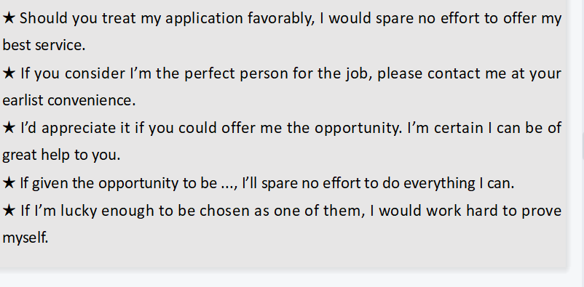

Practice 韵味无穷结尾句

★ 如果你认为我能成为一名合格的冬令营成员，请尽快联系我。

_____________________________________________________________________________

★ 如果能给我这个机会，我将不胜感激。我不会让您失望的。

_____________________________________________________________________________

★ 如果有机会成为冬令营的一员，我将竭尽全力做到最好。

_____________________________________________________________________________

1. **Polish a student’s version**

**A student’s version How to polish it? (Please write on the right)**

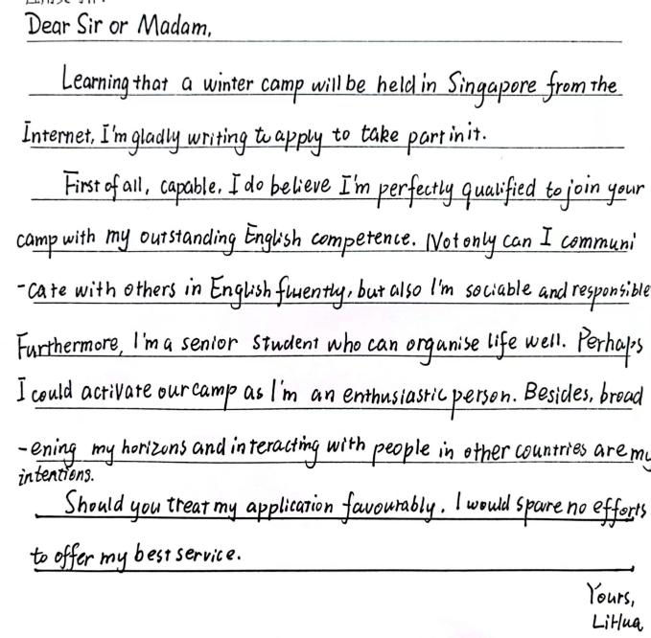

**Appreciate an official version and the teacher’s version**

1. **Homework**

假定你是李华，寒假在纽约学习，得知当地艺术家协会要举办中国书法展览。请写一封信请做志愿者。

内容包括：

1．写信目的；

2．个人优势；

3．能做的事情。

注意：（1）写作字数应为80左右。

（2）可以适当增加细节，以使行文连贯。