**M3U4 Space Exploration**

**Period 1 Listening and Speaking**

**Teaching Objectives：**

By the end of the class, students will be able to

1. master the new words in this period: universe, procedure, astronaut, gravity and so on

2. think and work out the requirements of being an astronaut

3. improve their listening skills of identifying the numbers with similar pronunciations

4. further think about the reason why people are willing to be an astronaut despite the difficulties, and if they are willing, too

**Teaching Important and Difficult Points：**

How to make students work out the requirements of being an astronaut, and write down the requirements while listening.

How to make students connect themselves with the astronauts.

**Teaching Procedures:**

**hundred**

**thousand**

**million**

**____________关于**

**Step 1: Lead-in**

**Activity 1: Enjoy a short video before class.**

Students will be asked to enjoy a short video about the universe and answer the following questions:

Q1: What’s your impression on the universe?

The universe is ___________(big, beautiful, enormous, mysterious...)

T: The universe has so many characters that no wonder people have always trying to “make friend” with it.

Q2: So who can help us to get familiar with it? (With the aid of the astronauts)

**Activity 2: Know some astronauts at home and abroad**

Students will be asked to look at some pictures of the astronauts and answer the following questions:

Q1: When it comes to the astronauts, who can you name at home and abroad? The first person? (Yang Liwei)

Q2: Why did Yang sit in the chair when coming back to the earth? (gravity)

Q3: Do you know any other astronauts? Maybe can you match the following astronauts with their achievements?

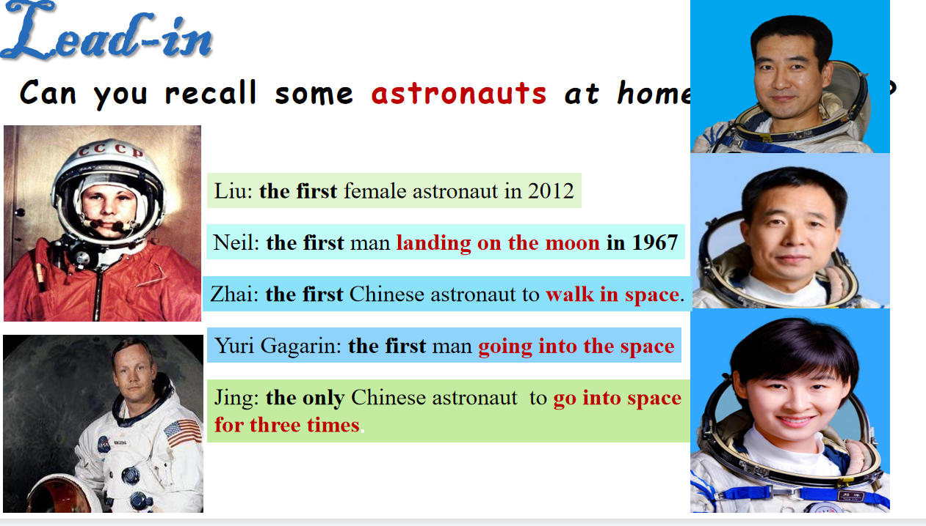

Teacher: Just as we know, that the universe is mysterious but dangerous too, let’s look at some reports these astronauts have experienced.

Q4: What do you think of the job of “astronaut” ?

Teacher: And these decide the requirements of being an astronaut will be very high.

Q5: Do you know the selection requirements or the procedure?

(此环节目的一方面在于帮助学生激活有关宇宙、太空的背景知识，另一方面在于帮助学生了解一些关于国内外宇航员的基本信息；通过相关报道了解宇航员这份工作的使命感和危险性，从而引导他们敬佩国内外的宇航员，并向他们的精神学习）

**Step 2: Listening**

**Activity1: listen and decide T or F**

Students will be asked to look at the following five sentences underline the key words:

1. The conversation happened in a stadium.

2. The audience is curious about how Yang Liwei became the first Chinese astronaut.

3. Mr Yang always believed that he would become an astronaut one day.

3. Mr Yang was selected to attend pilot training with 13 other people.

4. To become an astronaut in China, you have to have 1,350 hours of flying experience.

5. Astronauts not only had to learn how to use space equipment, but also had to do a lot of mental and physical training.

**Listening tip:** Before listening, you can underline the key words in the statements;

while listening, you can take notes to correct the mistakes.

**Activity2: Listen for the detailed information**

Students will be asked to look at the following five sentences and answer the questions:

1. Yang Liwei graduated from college at the age of ____.

2.Before he joined China’s space programme, Mr Yang trained as a fighter pilot for ___years.

3.Mr Yang was one of the ____ pilots who were chosen to train for space flights.

4.At the time when Mr Yang entered the space programmes, astronauts had to shorter than ____cm in height and less than ___kg in weight.

5.Mr Yang became China’s first astronaut when he was ___ years old.

1. What kind of words can be write down in the missing blanks?

2. While listening for numbers, what should we pay attention to?

**Listening tip:** Pay special attention to big numbers as well as those that sound quite similar such as 13 and 30, 14 and 40, etc.

**Activity3: Listen and choose**

Students will be asked to listen one more time choose the correct requirements of being an astronaut.

1. What degree should an astronaut get?

A. high school degree B. college degree C. master degree

2. What experience should an astranaut have?

A. 1,350 hours of flying experience

B. be a master

C. rich experience of fighter

3. How many courses should an astronaut learn?

A. 2 B.3 C.4

4. What special training should an astronaut experience?

A. using space equipment B. physical and mental training C. both A and B

5. To be an astronaut, the following health condition shoule be contained, except ?

A. physical health B. mental health C. proper body shape D. good appearance

**Step 3: Discussion**

1. We know it is extremely difficult to be an astronaut, but why are there still many people are making efforts to be an astronaut?

2. Do you want to be an astronaut? Why?(based on the requirements)

3. To be or to be like an astronaut, what should we do now?

(此环节目的在于锻炼学生说的能力，同时了解学生面对一份神圣的，有使命感的职业的态度如何，由此侧面了解学生面对困难的处事态度。基于此，引导学生要主动接受挑战，或是转换思路寻找其他相关的方法）