**The World**（**1001-1015**）材料分析和教学目标：

本次选用的材料：①*Newsweek*的*Climate Hero or Villain?*（AI是气变拯救者还是加害者？）、②*The Times* 的*To keep your heart healthy, sit down and enjoy a cuppa*（为了保持心脏健康，坐下来喝杯茶吧 ！）、③*New Scientist* 的*World’s oldest cheese found on Chinese mummies* （中国木乃伊上发现世界上最古老的奶酪）、④*Los Angeles Times*的*Box office success now measured by capturing the zeitgeist*（时代精神——衡量票房成功与否的标准）和⑤BBC的新闻报道。通过语法填空、阅读理解、分析长难句、翻译句子、听力填空和词汇拓展等方式，让学生从多角度提升学习兴趣，提高分析句子、运用词块和听力能力。外媒英语新闻可以让学生体验真实语境下的语言运用，拓展学生的国际视野，了解时事，逐步提升跨文化沟通能力，形成正确的世界观、人生观和价值观。

**教学思路：**

**Part 1: News Report 1 *Newsweek* (October 4, 2024 P20)**

**Climate Hero or Villain? AI是气变拯救者还是加害者？**

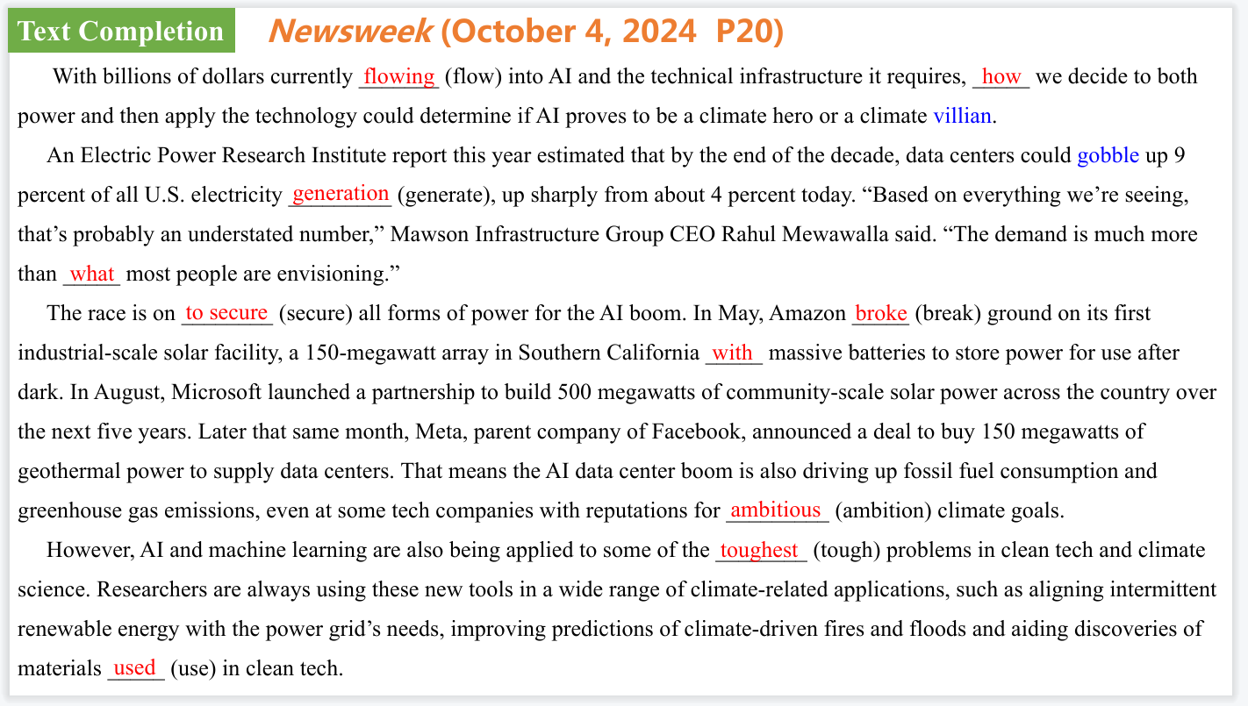

【设计意图】通过语篇填空的形式帮助学生理解新闻的主要内容，同时训练语言语法的运用能力：在语篇的视角下如何正确使用所给词汇，根据语法规则确定词汇的正确形式，使得文章通顺，激活学生的思维和语言。该新闻主题语境是关于“人与社会”中“社会热点问题”这一子主题，通过学习让学生了解关于AI对于气候变化究竟是福是祸的问题。

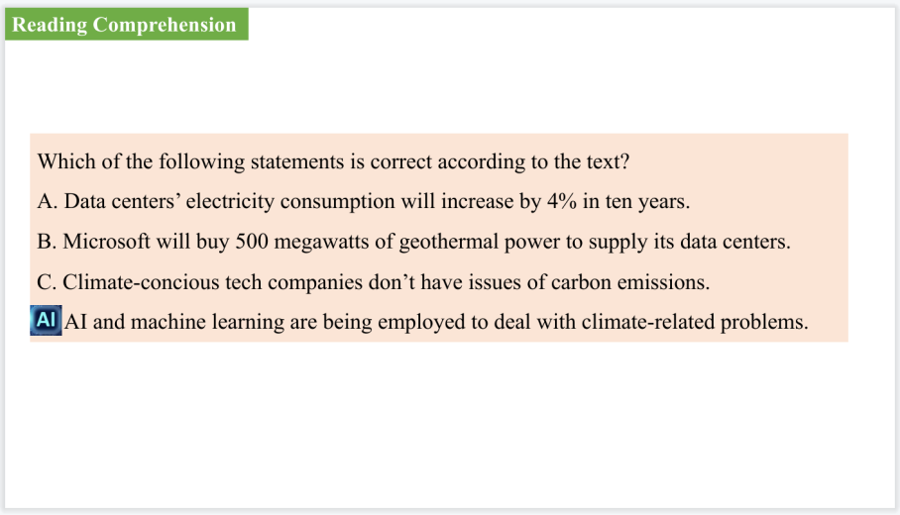

【设计意图】通过阅读理解的形式帮助学生理解新闻的主要内容。



【设计意图】对文本中的词汇进行解读，并通过翻译句子对其进行巩固。

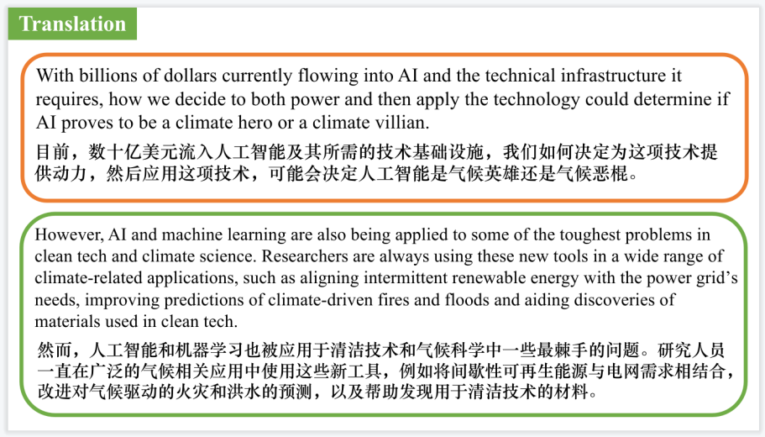

【设计意图】对文中的两个句子进行翻译练习，对其中单词、词组、句法进行巩固并关注句子结构。

**Part 2: News Report 2 *The Times*（October 9, 2024 P1)**

**To keep your heart healthy, sit down and enjoy a cuppa**

**为了保持心脏健康，坐下来喝杯茶吧 ！**

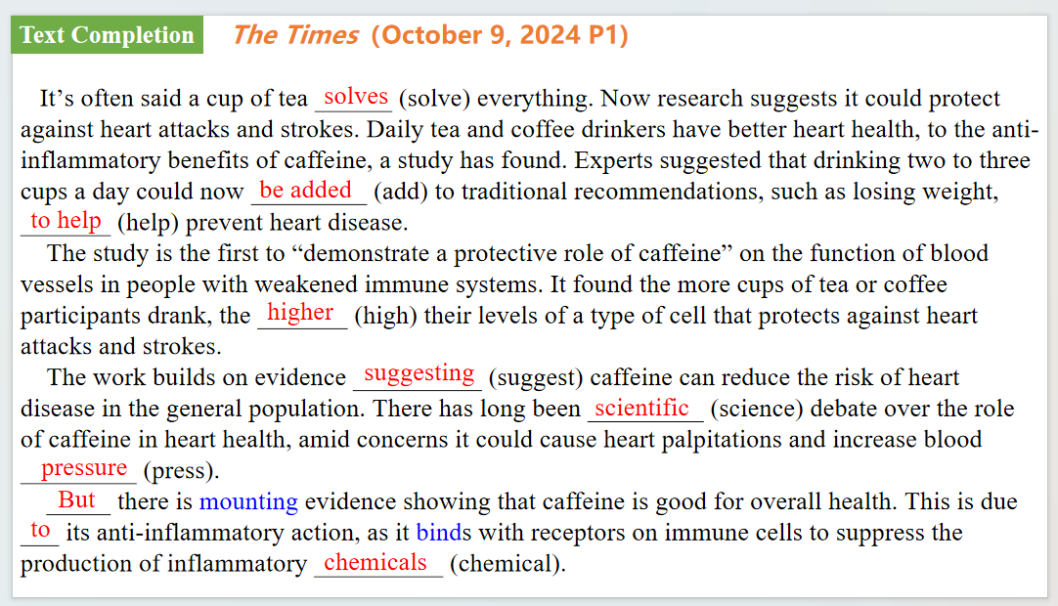

【设计意图】通过语篇填空的形式帮助学生理解新闻的主要内容，同时训练语言语法的运用能力：在语篇的视角下如何正确使用所给词汇，根据语法规则确定词汇的正确形式，使得文章通顺，激活学生的思维和语言。该新闻主题语境是关于“人与社会”中“社会热点问题”这一子主题，通过学习让学生了解喝茶的益处。



【设计意图】对文本中的词汇进行解读，并通过翻译句子对其进行巩固。

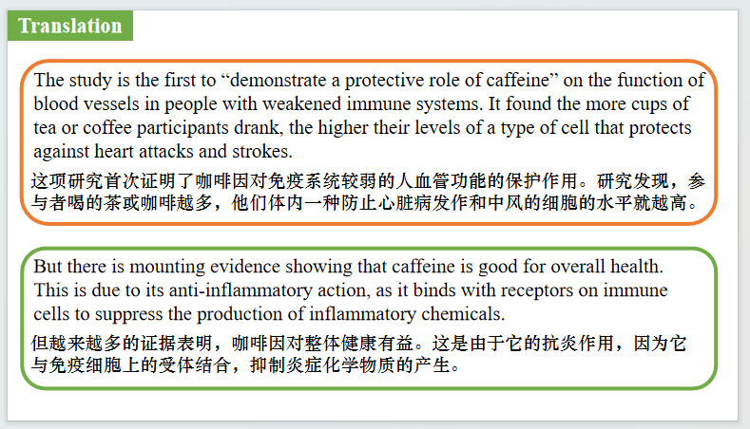

【设计意图】对文中的两个句子进行翻译练习，对其中单词、词组、句法进行巩固并关注句子结构。

**Part 3: News Report 3 *New Scientist*  (October 5, 2024 P13)**

**World’s oldest cheese found on Chinese mummies**

**中国木乃伊上发现世界上最古老的奶酪**

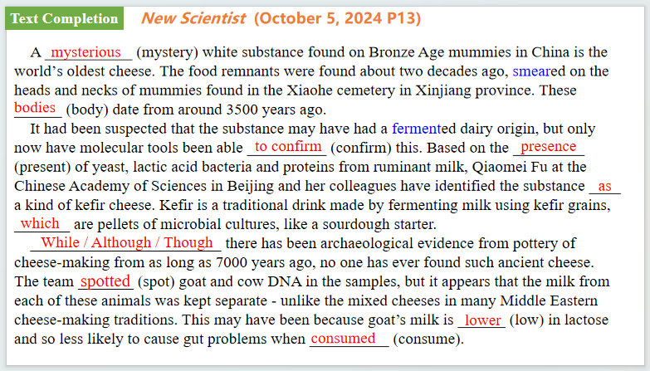

【设计意图】通过语篇填空的形式帮助学生理解新闻的主要内容，同时训练语言语法的运用能力：在语篇的视角下如何正确使用所给词汇，根据语法规则确定词汇的正确形式，使得文章通顺，激活学生的思维和语言。该新闻主题语境是关于“人与社会”中“社会热点问题”这一子主题，通过学习让学生了解中国木乃伊上发现世界上最古老的奶酪的科学发现。



【设计意图】对文本中的词汇进行解读，并通过翻译句子对其进行巩固。



【设计意图】对文中的两个句子进行翻译练习，对其中单词、词组、句法进行巩固并关注句子结构。

**Part 4: News Report 4  *Los Angeles Times* (October 7, 2024 A9)**

**Box office success now measured by capturing the zeitgeist**

**时代精神——衡量票房成功与否的标准**

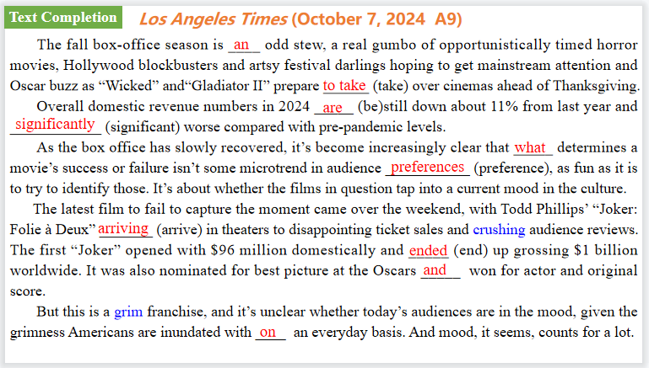

【设计意图】通过语篇填空的形式帮助学生理解新闻的主要内容，同时训练语言语法的运用能力：在语篇的视角下如何正确使用所给词汇，根据语法规则确定词汇的正确形式，使得文章通顺，激活学生的思维和语言。该新闻主题语境是关于“人与社会”中“社会热点问题”这一子主题，通过学习让学生了解关于目前衡量票房成功与否的标准。



【设计意图】对文本中的词汇进行解读，并通过翻译句子对其进行巩固。



【设计意图】对文中的两个句子进行翻译练习，对其中单词、词组、句法进行巩固并关注句子结构。

**Part 5: BBC News 10/06/2024**

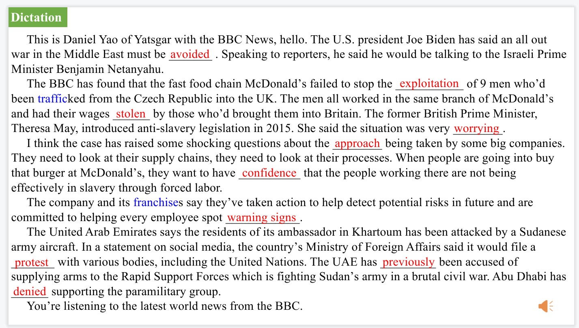

【设计意图】听一则材料，通过听力填空的方式理解文本，考察听力辨识词汇的能力。



【设计意图】对文本中的词汇进行解读，并通过翻译句子对其进行巩固。

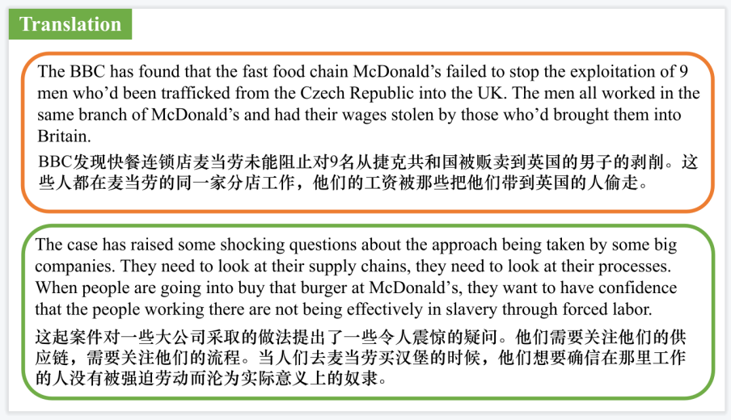

【设计意图】对文中的两个句子进行翻译练习，对其中单词、词组、句法进行巩固并关注句子结构。

附：外刊原文

**Part 1: News Report 1 Newsweek (October 4, 2024 P20)**

**Climate Hero or Villain? AI是气变拯救者还是加害者？**

With billions of dollars currently flowing into AI and the technical infrastructure it requires, how we decide to both power and then apply the technology could determine if AI proves to be a climate hero or a climate villian.

Estimates of AI energy use vary greatly, but one study found that generating an AI image for one popular model used as much power as fully charging a cellphone. Another study found that web searches with generative AI used 10 times the energy needed for a standard search. Training a large language model is also energy intensive. Training OpenAI’ ChatGPT-4, by one estimate, may have used as much energy as 4800 average American homes over a year.

An Electric Power Research Institute report this year estimated that by the end of the decade, data centers could gobble up 9 percent of all U.S. electricity generation, up sharply from about 4 percent today. “Based on everything we’re seeing, that’s probably an understated number,” Mawson Infrastructure Group CEO Rahul Mewawalla said. “The demand is much more than what most people are envisioning.”

The race is on to secure all forms of power for the AI boom. On the other side of Pennsylvania, Amazon Web Services purchased a date center in March attached to Susquehanna Steam Electric Station nuclear plant. Then in May, Amazon broke ground on its first industrial-scale solar facility, a 150-megawatt array in Southern California with massive batteries to store power for use after dark.

In August, Microsoft launched a partnership to build 500 megawatts of community-scale solar power across the country over the next five years. Later that same month, Meta, parent company of Facebook, announced a deal to buy 150 megawatts of geothermal power to supply data centers.

But even with those mass-megawatt clean energy investments, the bulk of U.S. electricity in most parts of the country still comes from burning fossil fuels, especially natural gas. As utility companies anticipate a spike in demand, some gas-fired generation is being expanded while retirements of some old, dirty coal burners are being delayed.

That means the AI data center boom is also driving up fossil fuel consumption and greenhouse gas emissions, even at some tech companies with reputations for ambitious climate goals.

Critics in some environmental groups said the numbers reveal a different priority. “They are interested in winning the AI market, and they’re going to do anything in their power, including paving over the environment, to get there,” Michael Khoo, Climate Disinformation Program director at Friends of the Earth, told Newsweek. “I feel pretty despondent about the prospects of Silicon Valley ever meeting climate targets if they continue on this path.”

However, AI and machine learning are also being applied to some of the toughest problems in clean tech and climate science. Researchers are always using these new tools in a wide range of climate-related applications, such as aligning intermittent renewable energy with the power grid’s needs, improving predictions of climate-driven fires and floods and aiding discoveries of materials used in clean tech.

**Part 2: News Report 2 *The Times*（October 9, 2024 P1)**

**To keep your heart healthy, sit down and enjoy a cuppa**

为了保持心脏健康，坐下来喝杯茶吧 ！

It’s often said a cup of tea solves everything. Now research suggests it could protect against heart attacks and strokes. Daily tea and coffee drinkers have better heart health, linked to the anti-inflammatory benefits of caffeine, a study has found. Experts suggested that drinking two to three cups a day could now be added to traditional recommendations, such as losing weight, to help prevent heart disease.

The study is the first to “demonstrate a protective role of caffeine"on the function of blood vessels in people with weakened immune systems. It found the more cups of tea or coffee participants drank, the higher their levels of a type of cell that protects against heart attacks and strokes.

The work builds on evidence suggesting caffeine can reduce the risk of heart disease in the general population.There has long been scientific debate over the role of caffeine in heart health, amid concerns it could cause heart palpitations and increase blood pressure.

But there is mounting evidence showing that caffeine is good for overall health.This is due to its anti-inflammatory action, as it binds with receptors on immune cells to suppress the production of inflammatory chemicals.

The new research, from Sapienza University in Rome,in the journal Rheumatology, looked at 31 patients with lupus,a condition in which the immune system attacks its own tissues, raising the risk of heart disease.Caffeine appeared to promote the growth and regeneration of endothelial cells,which line the inside of blood vessels and the heart.Having more of these cells helps to repair blood vessels and prevents the build-up of fatty plaque in the arteries.

Dr Fulvia Ceccarelli, the study leader said it highlighted the "possible role of diet in controlling the disease", adding:“ It will be necessary to confirm the results through a longitudinal study, aimed at assessing the real impact of coffee consumption on the disease course".

**Part 3: News Report 3 *New Scientist*  (October 5, 2024 P13)**

**World’s oldest cheese found on Chinese mummies**

**中国木乃伊上发现世界上最古老的奶酪**

A mysterious white substance found on Bronze Age mummies in China is the world’s oldest cheese.

The food remnants were found about two decades ago, smeared on the heads and necks of mummies found in the Xiaohe cemetery in Xinjiang province. These bodies date from around 3500 years ago.

It had been suspected that the substance may have had a fermented dairy origin, but only now have molecular tools been able to confirm this. Based on the presence of yeast, lactic acid bacteria and proteins from ruminant milk, Qiaomei Fu at the Chinese Academy of Sciences in Beijing and her colleagues have identified the substance as a kind of kefir cheese.

Kefir is a traditional drink made by fermenting milk using kefir grains, which are pellets of microbial cultures, like a sourdough starter. Fu says the substance was no longer immediately recognisable as kefir cheese.“Due to their age, these pale-yellow cheese samples smelled of nothing and were powdery to touch and a little crumbly," she says.

While there has been archaeological evidence from pottery of cheese-making from as long as 7000 years ago, no one has ever found such ancient cheese.

The team spotted goat and cow DNA in the samples, but it appears that the milk from each of these animals was kept separate -unlike the mixed cheeses in many Middle Eastern cheese-making traditions.This may have been because goat's milk is lower in lactose and so less likely to cause gut problems when consumed.

Fu and her colleagues also recovered the DNA of Lactobacillus kefiranofaciens bacteria from the dairy samples, which they compared with the genomes of modern strains used to make kefir. The modern strains have evolved in line with the preferences of cheese consumers, says Fu. For example,strains that cause less of an immune response in the human intestine have been selected.

**Part 4: News Report 4  *Los Angeles Times* (October 7, 2024 A9)**

**Box office success now measured by capturing the zeitgeist**

**时代精神——衡量票房成功与否的标准**

The fall box-office season is an odd stew, a real gumbo of opportunistically timed horror movies, Hollywood blockbusters and artsy festival darlings hoping to get mainstream attention and Oscar buzz as “Wicked” and“Gladiator II” prepare to take over cinemas ahead of Thanksgiving.

Then there’s “Megalopolis,” which defies categorization, for better or worse.

The $120-million self-financed passion project from Francis Ford Coppola bombed, as expected, with $4 million in domestic ticket sales and earning a brutal“D+” rating from audience polling firm CinemaScore. Professional critics were wildly split on it. Moviegoers were baffled by it. It was never going to be a big commercial success.

And yet, shouldn’t we be kind of happy that it exists?

Coppola, maker of “The Godfather,” “Apocalypse Now” and “The Conversation,” put his own millionson the line to make it happen, even selling off a portion of his wine empire to raise the money. He covered the production budget, plus marketing and distribution costs. Lionsgate took the reputational gamble to release it in the U.S. for a fee and no financial risk.

Disasters like this used to bankrupt studios. With“Megalopolis,” it’s hard to see who’s hurt by the failure, other than Coppola’s estate.

Oh, and let’s not forget the marketing consultant who used artificial intelligence to generate fake quotes from real critics that ended up being used in a trailer. (Lionsgate pulled the video and apologized for it.)

Lionsgate film boss Adam Fogelson said in an emailed statement that the company was proud to release the movie, adding that,“like all true art, it will be viewed and judged by movie audiences over time.” If“Megalopolis” turns out to be remembered as a curiosity or an extremely expensive museum piece — truly art for art’s sake — that’s fine. If future audiences revere it as a misunderstood gem, all the better.

But it just was never going to hit the zeitgeist, and that’s what makes or breaks movies in 2024. Meanwhile, DreamWorks Animation’s “The Wild Robot,” an acclaimed family film based on an illustrated children’s book, topped expectations with $35 million in ticket sales from the U.S. and Canada, a solid start for a nonsequel in a hopeful sign of the health of the animation business.

Overall domestic revenue numbers in 2024 are still down about 11% from last

year and significantly worse compared with pre-pandemic levels.

As the box office has slowly recovered, it’s become increasingly clear that what

determines a movie’s success or failure isn’t some mi crotrend in audience preferences, as fun as it is to try to identify those. It’s about whether the films in question tap into a current mood

in the culture. That’s what the game is all about now, and it’s what makes the business so difficult to predict.

After all, what determines the zeitgeist? Is it originality? Not necessarily. Is it animation or family appeal? No. Is it critics’ reviews? Definitely not, though they don’t hurt. It’s an intangible attribute. Is it marketing? Sure, a good campaign can amplify something that already has the juice, but it can’t create it on its own. “Longlegs”had it. So did “Inside Out 2” and “It Ends With Us.” Good luck trying to mine any universal takeaways from such an eclectic group of hits.

The latest film to fail to capture the moment came over the weekend, with Todd Phillips’ “Joker: Folie à Deux” arriving in theaters to disappointing ticket sales and crushing audience reviews. The Warner Bros. sequel comes five years after the original, which definitely created a cultural wave.

The new film opened with a bruising $40 million in the U.S. and Canada, according to studio estimates, and received a “D” CinemaScore grade, a poor result considering its reported budget of at least $190 million before marketing. The first “Joker” opened with $96 million domestically and ended up grossing $1 billion worldwide. It was also nominated for best picture at the Oscars and won for actor and original score.

Analysts weren’t expecting the follow-up, an ambitious quasi-musical with Lady Gaga starring alongside Joaquin Phoenix, to reach those heights. Most prognosticators projected an opening of $50 million to $60 million in North America based on the most recent audience tracking surveys, which were lower than earlier estimates.

The previous “Joker” tapped into a certain national vibe. It was also, in a dark and semi-grounded way, a fresh take on the supervillain origin story trope.

But this is a grim franchise, and it’s unclear whether today’s audiences are in the mood, given the grimness Americans are inundated with on an everyday basis.

And mood, it seems, counts for a lot.