课 题 |  |  | 如何基于语篇衔接理论解决七选五题？
教  学  目  标 | 知识目标 |  | 1.从整体上把握文章的逻辑结构和内容上的联系，理解句子之间、段落之间的关系。  2.理解和运用“3-4-5”策略解决七选五题。
教  学  目  标 | 能力目标 |  | 3.培养个人学习能力和合作学习能力。
教  学  目  标 | 德育目标 |  | 增强网络防护意识，保护个人隐私并安全上网。
教 学 重 点 |  |  | 1.从整体上把握文章的逻辑结构和内容上的联系，理解句子之间、段落之间的关系。  2.理解和运用“3-4-5”策略解决七选五题。
教 学 难 点 |  |  | 理解并迁移运用“5”策略中的①复现（ 原词、同义词、近义词、反义词、派生词复现等）、②指代和⑤逻辑关系。
课 型 |  |  | 阅读 | 教法 | 任务型教学法 | 教具 | 教材、多媒体课件、黑板、粉笔
流程 |  | 教学过程与方法 |  |  |  |  |  | 二次备课
Step 1 Lead in
T invites Ss to play jigsaw puzzles and asks the winner the key to this game. Then T asks students a question “Which part in the gap-filling may give you the same experience?” to lead Ss to find out the similarities between gap-filling tasks and jigsaw puzzles.
【设计意图】头脑风暴，让学生通过拼图小游戏进行热身，同时找出拼图游戏与七选五题型的相似处。
Step 2 Analyse the standard of the gap-filling in NMET
T leads Ss to think about the question “What is the gap-filling task designed to test”, and show them the interpretation of the standard of the gap-filling in NMET to raise their awareness of the analysis of the discourse based on the cohesion theory.




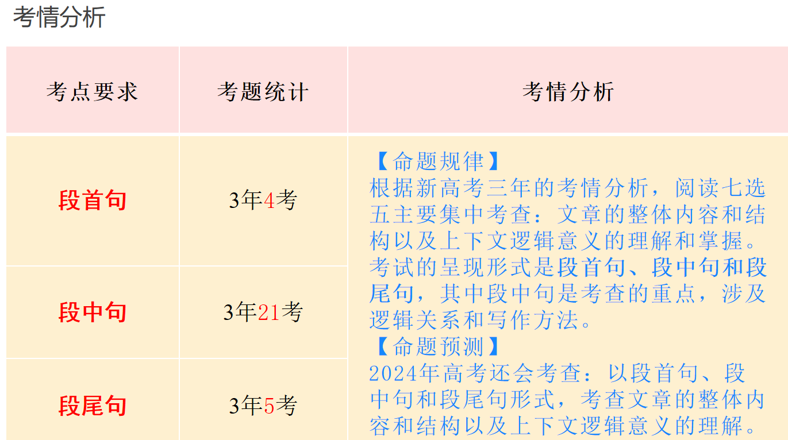
【设计意图】通过帮助学生了解新课标和高考考试说明中对阅读理解七选五考查目的，来提升学生在做题时的语篇意识。

Step 3 Guide students to discuss and conclude the “3-4-5”strategy

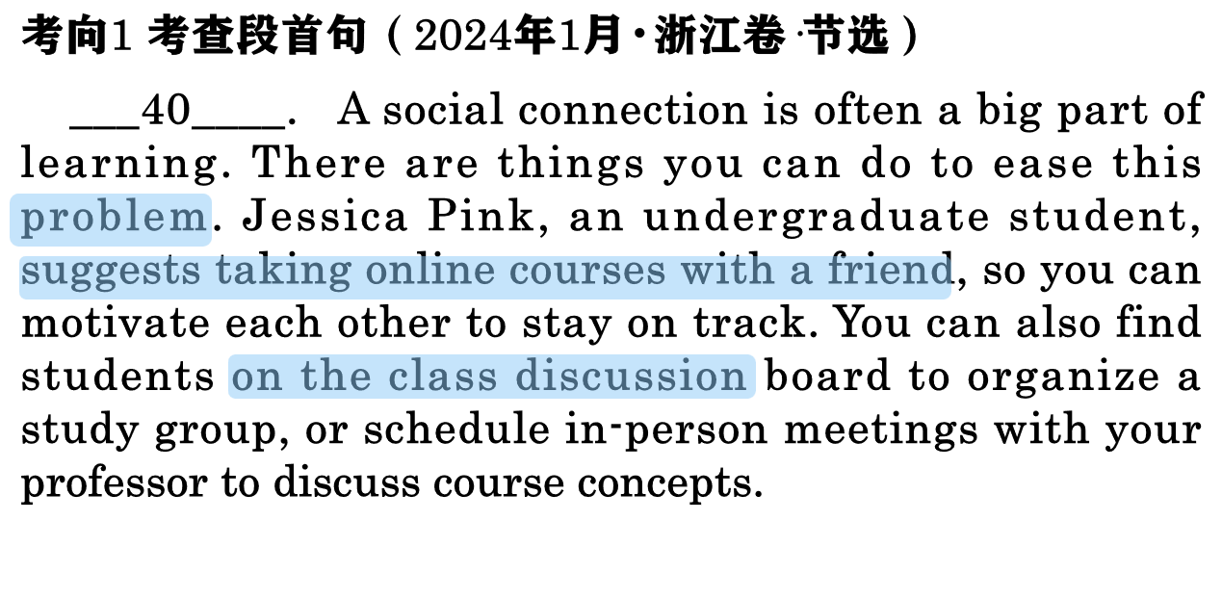
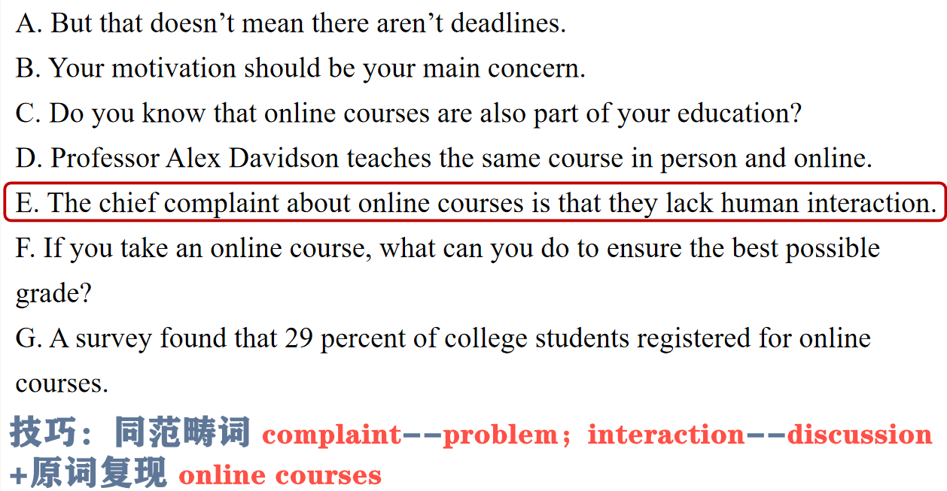

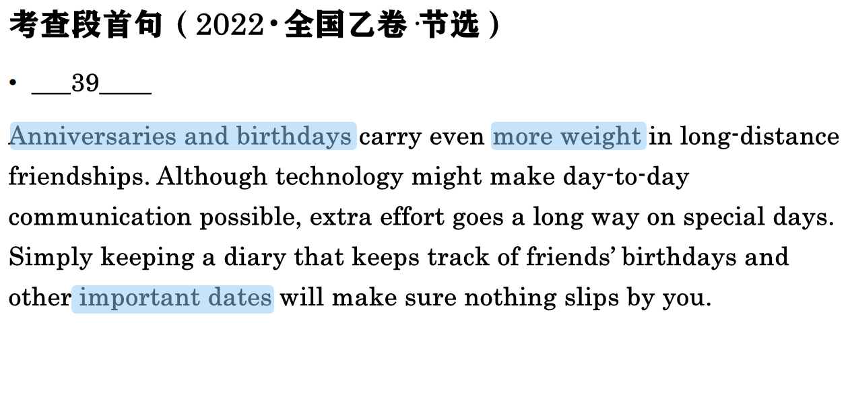
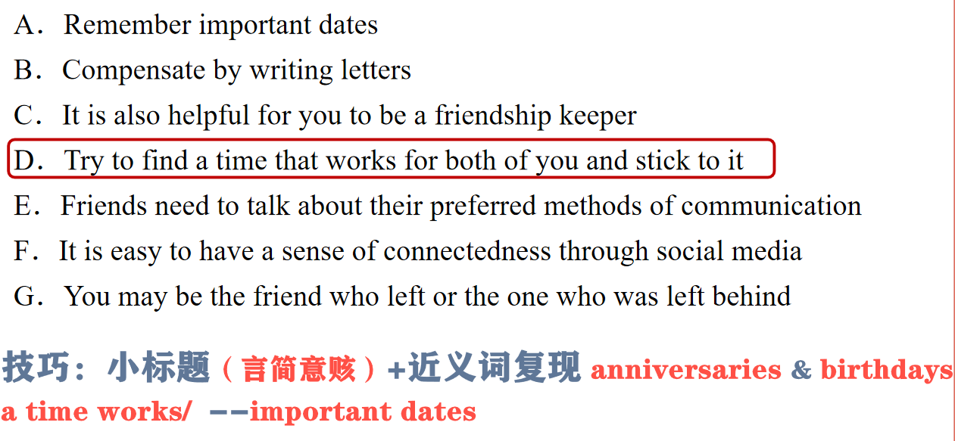

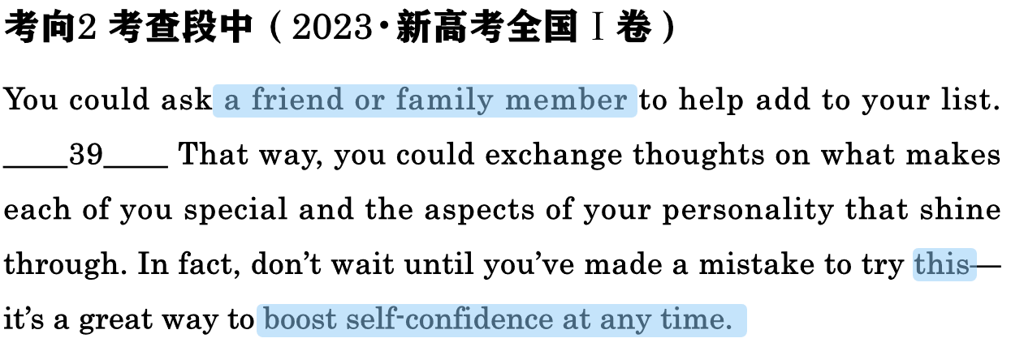

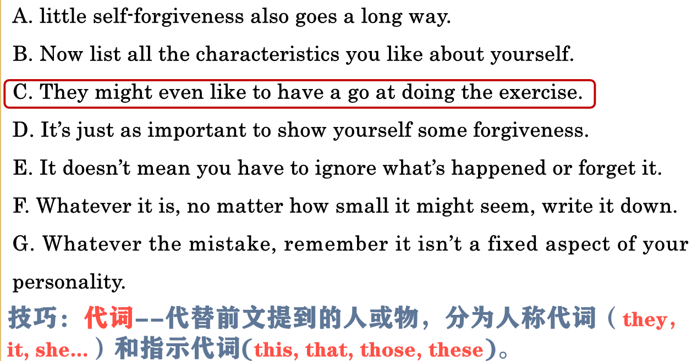

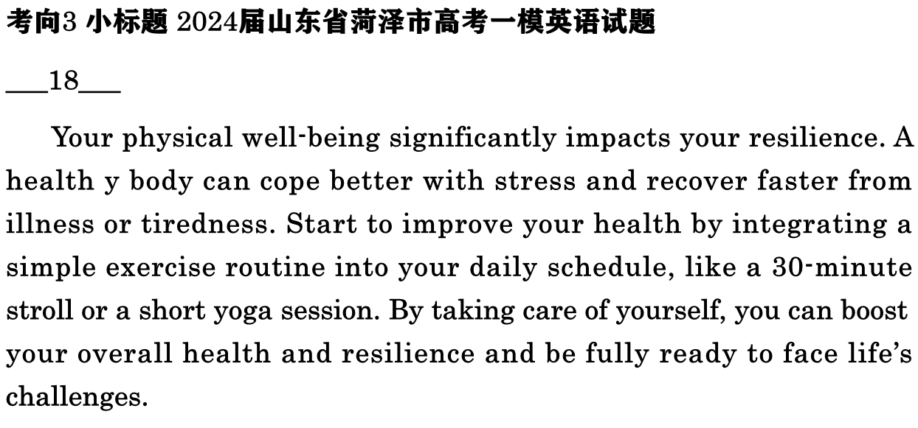
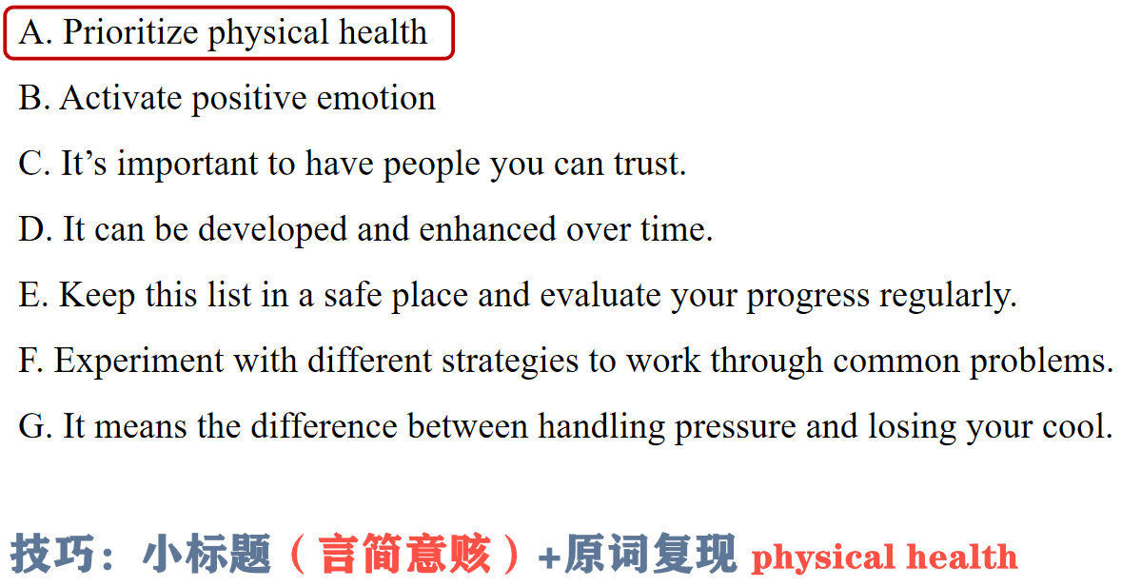

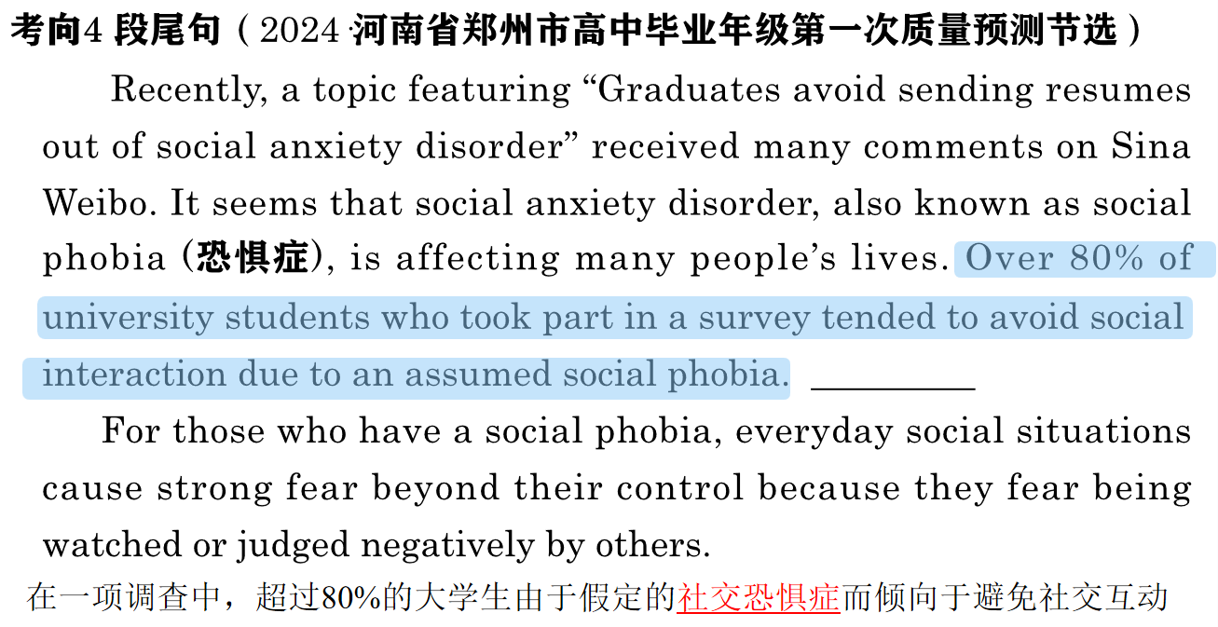
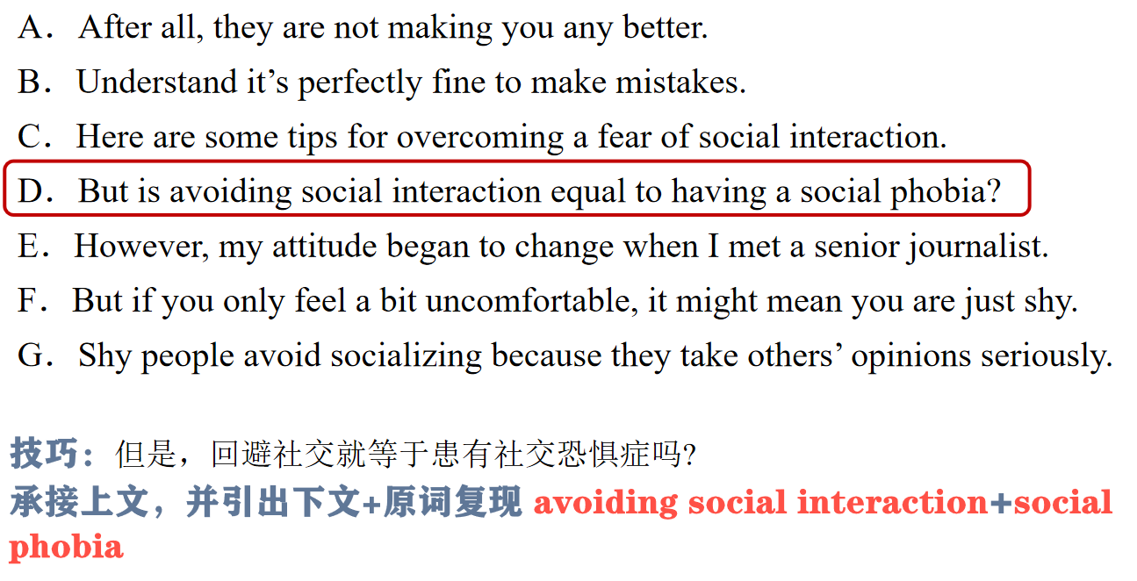

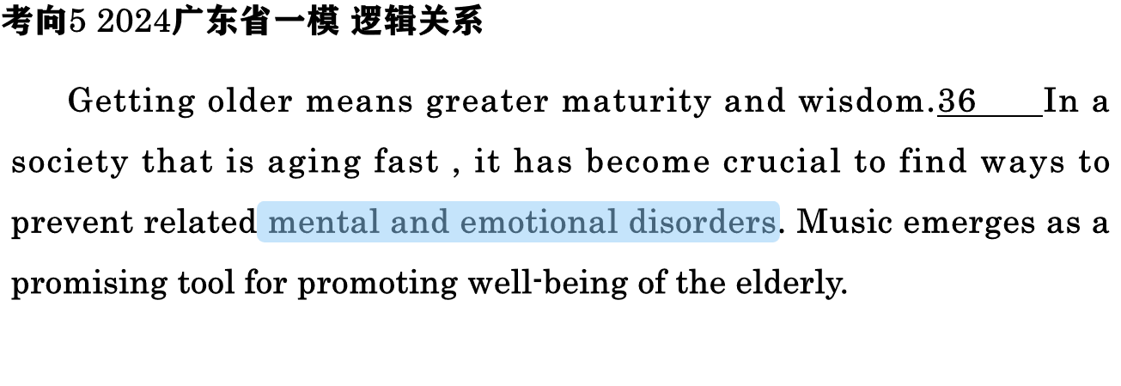

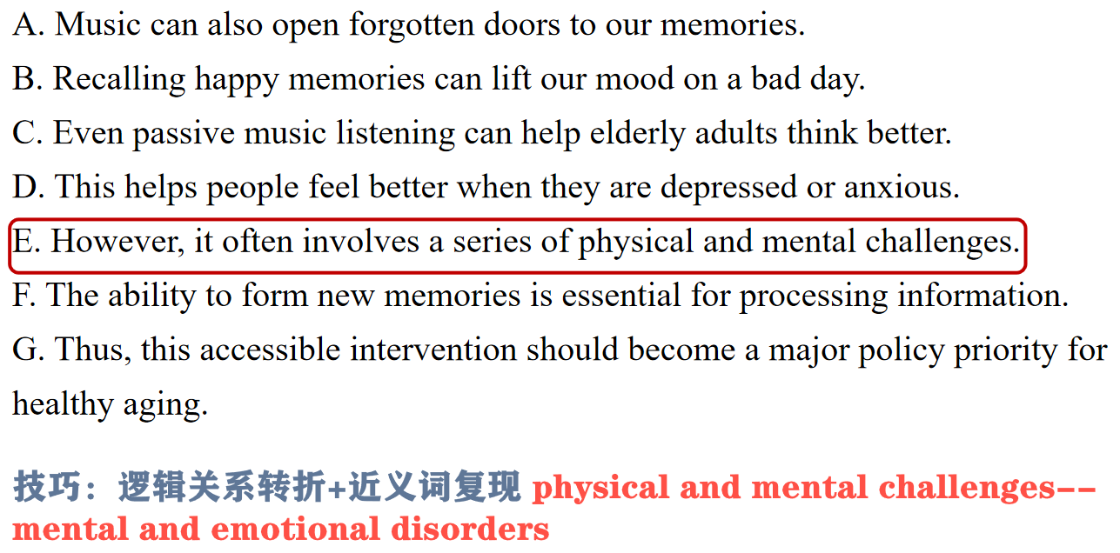

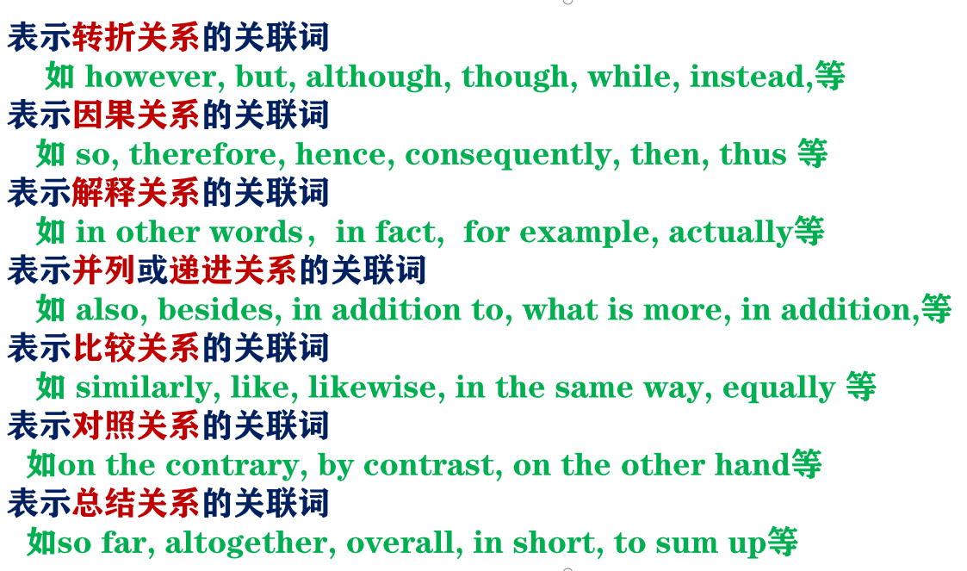

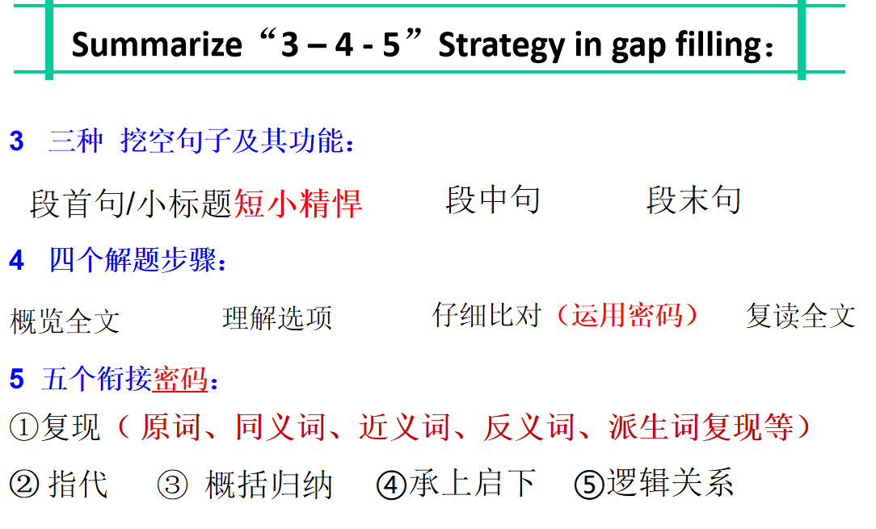
【设计意图】引导学生通过自主和合作讨论学习，从整体上把握文章的逻辑结构和内容上的联系，理解句子之间、段落之间的关系，归纳七选五解题技巧，从而培养学生分析问题并解决问题的能力。

Step 4 Expand and Migrate
考查段首句（2024·广东省高三上学期12月联考节选）
____Spending time with people pursuing knowledge as intentionally as you are can encourage you to push through challenges to achieve your learning goals. And engaging with people who have different opinions and experiences can help keep your worldview flexible. Then you can continue to find new fields of knowledge to explore.

A．Surround yourself with fellow learners.
B．Encourage yourself to brave challenges.
C．Every kid’s favorite question is “Why? ”
D．You’re surrounded by opportunities to learn.
E．There’s no better or worse hobby or information to acquire.
F．Of course, scheduling learning isn’t just limited to the ways mentioned.
G．Adding a learning session to your timetable prevents you forgetting about it.

（2024·高三第一次学业质量评价(T8联考)节选）
Have you ever caught a smell of something and been strongly reminded of a person or place? There seems to be a deep psychological link between smells and our memory. Some research even suggests that smells can influence our cognition(认知，感知). 36 Roja Dove, a perfumer, informed the BBC that when we are born, the olfactory bulb(嗅球), which is the area in our brain that processes smell, is empty, without pre-existing information or association.

A. Why do smells take us back?
B. So, don’t take your nose for granted.
C. How is the sense of smell connected to your brain?
D. Scents can revive memories that have been long forgotten.
E. We are not actively aware of them unless they are extremely strong.
F. This is especially true when it comes to the fragrance of essential oils.
G. Therefore, our responses to smells are learnt and highly individualized.

考查段中句（2024·广东省高三上学期12月联考节选）
Life’s rarely boring if you’re open to learning new things. No matter what you want to learn, the first step is noticing and seizing learning opportunities wherever you find them. Here are ways to develop the habit of learning.
Get curious and make friends with your inner child. ______This sense of curiosity is how you begin to learn, grow, and understand the world around you. As an adult, it’s important to stay curious to remain open to possibilities and opportunities by making a habit of asking questions.

- Surround yourself with fellow learners.
B．Encourage yourself to brave challenges.
C．Every kid’s favorite question is “Why? ”
D．You’re surrounded by opportunities to learn.
E．There’s no better or worse hobby or information to acquire.
F．Of course, scheduling learning isn’t just limited to the ways mentioned.
G．Adding a learning session to your timetable prevents you forgetting about it.

（2024·浙江省台州市高三上学期第一次教学质量评估节选）
Set actionable goals. It can be helpful to break down the feedback into specific, actionable goals. _____Set time to outline an action plan and timeline for each of these goals. With this, you can keep track of your progress and hold yourself accountable to your goals.
Though negative feedback may be disheartening, take the necessary steps to become an even better version of yourself.

A．Avoid reacting defensively.
B．Don’t take the feedback personally.
C．These can feel easier to work with and give you direction.
D．You don’t have to apply every piece of feedback you receive.
E．Negative feedback can sometimes make you feel like a failure.
F．It’s almost impossible to consistently do everything right all the time.
G．So instead of reacting negatively, thank those caring about you to give you honest feedback.

（2024·浙江省Z20名校联盟第二次联考节选）
Get eight hours of sleep. “When you’re not rested, everything that happens in your life is a lot more stressful,” says Dr. Arya Sharma, a professor of medicine at the University of Alberta. If we don’t have enough sleep, our bodies also have more difficulty controlling blood pressure, inflammation and glucose levels. 37

A．Avoid polluted air.
B．Engage in indoor activities.
C．These factors can all have an impact on cardiovascular health.
D．Read the following tips to make your life filled with happiness.
E．Doing good for others helps your self-esteem and relieves stress.
F．It reduces stress and depression, and it may also serve as a mini-workout.
G．Actually, a small change in your everyday routine can potentially have a big impact.

【设计意图】拓展迁移练习，培养学生迁移解决问题的能力。

Step 5 Homework
1. Draw a mind map about the strategies in completing gap-filling tests learned in this class.
2. Finish the gap-filling tests using these strategies.

2024届山东省日照市高考一模英语试题
阅读下面短文, 从短文后的选项中选出可以填入空白处的最佳选项, 选项中有两项为多余选项。
No matter how friendly your tone is or how honey sweet you are in a conversation, when you use one of these two words (or both) in your sentences, the message to your conversation companion is “You are wrong”. 16 They are “no” and “but”.
These words don’t say, “Let’s discuss this” or “I’d love to hear what you think about this” to people. They say, “You are wrong and I am right.” If your conversation companion is also eager to win at any cost, you will have a potential battle on your hands. The result? 17
Are you interested in a little test to see how competitive your co-workers are? Try this. For one week, keep a scorecard of how many times each person uses “no” or “but”. 18 And, if you explore a little deeper, you’ll see patterns emerge. For instance, some people use these words to gain power. You’ll see how much people hate it, consciously or not, and how it stifles(抑制)rather than opens up discussions.
19 Practically without even thinking, I keep count of their use of these two little words. It’s such an important indicator! If the numbers pile up in an initial meeting with a client, I’ll interrupt him or her and say, “We’ve been talking for almost an hour now, and do you realize that you have responded 17 times with either ‘no’ or ‘but’?” This is the moment when a serious talk about changing behavior begins.
If this is your interpersonal challenge, you can do this little test for yourself just as easily as you can to judge your co-workers. Stop trying to defend your position and start monitoring how many times you begin remarks with “no” or “but”. 20 For example That’s true, but...”. Another expression is “Yes, but...”.

A．I use this technique with my clients.
B．Why do people like to say these two words?
C．What are these conversation stopping words?
D．Nothing more can happen that will be productive.
E．It’s human nature to like being accepted and recognized.
F．You will be shocked at how frequently these words are used.
G．Pay close attention to when you use these words in sentences.

板书设计 |  | 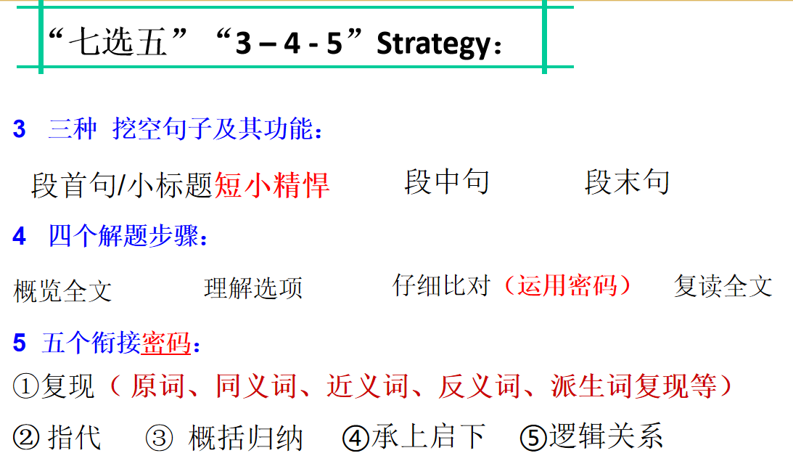
教
学
反
思

