2025届浙江名校体联盟—父亲的老房子
读后续写原文：
From my memory, my father was a man of few words and we were never close to each other. Before he joined the army, he built a house with his own hands. When he was tragically killed in one battle, the house became mine. As the house aged, it became a relic of the past, and we moved away, carrying with me the echoes of his silent presence.
One day, someone called, saying that he wanted to by that house. I said yes.
Before we reached a deal, I thought it a must to check out the old shack（小屋）first, just in case something of value had been left behind. My two young sons followed along, and we waded through the tall grass in the meadow where the old house sat. Time had taken its toll. The front porch had collapsed in on itself, most of the windows were gone, and the siding was falling off. We entered through an open window.
I felt as though I had chanced upon a time capsule（胶囊）. Here lay the things of my dad’s lives. A broken chair. Some old clothes. But the thing that drew my eye was a cardboard box stuffed with papers. I dug through its contents and was instantly transported back in time. There was a tax return from 1975. Greeting cards from old relatives and friends.
I spent most of a pleasant hour going through that box. All the while, I had to answer a stream of questions from my sons about the old house. They were amazed that nine people once occupied the tiny structure. And they shivered when I told them that in those days the cookstove was the only source of heat.
There's nothing of value had been left, I confirmed. So we came back. The house once again enjoyed the lonely solitude of our meadow.
Then the paying day came. For no reason, maybe some reason, I came to that old house to say goodbye to something.
注意：1. 续写词数应为150左右；
2. 请按如下格式在答题卡的相应位置作答。
Paragraph 1: As I stood in the house, my eye was drawn to a big yellowed envelope with two words "FROMARMY”on it.________________________________________________________
Paragraph 2: I pulled out my telephone and made a call to that buyer. _______________________

Words for reference:

a man of few words 寡言少语的人
age vi. 衰老；使显得苍老
a relic of the past 过去的遗迹；历史的遗留物
echo n.&vi. 回声；回音；响起回声
reach a deal 达成交易
check out sth. 查证；核实
leave sth. behind 丢下；落下
wade through sth. (在水中)艰难地行进
sit at/in 坐落于
take one’s toll 造成损失(伤亡、破坏)
porch 门廊
collapse in on itself 自己坍塌了
siding 壁板；墙板
chance upon 偶然发现；偶遇
a cardboard box 硬纸板盒
a tax return 纳税填报单
solitude n. 独处；独居
meadow 草地；牧场
envelope 信封

【设计理念】
初升高三的学生，基本上能完成读后续写的任务，即看懂原文并根据所给句完成续写任务。但是，在情节和语言上与原文的协同度较差，没有合理回扣所给句进行衔接，并且在解决故事中的矛盾和升华主旨上都有所欠缺。因此，本课采用问题解决式的框架，从学生的问题出发，从读大纲、读人物和读线索来解决续写中出现的问题。

【教学步骤】
- 辨问题
学生观察两篇典例，总结其中的写作问题：
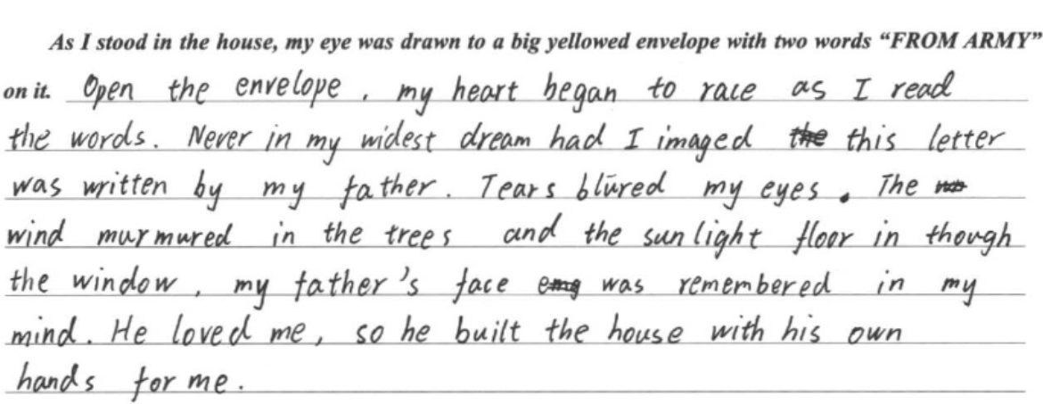
- 第一段续写过于跳跃性，并没有讲述原文中的矛盾冲突是如何解决的；
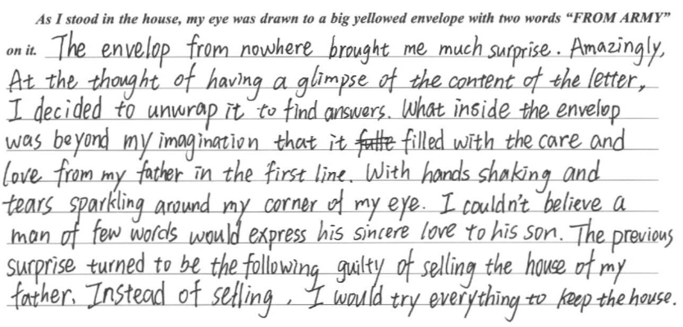
2. 第一段续写中指出了信封中的信件是解决矛盾冲突的关键，但是却没有对信件进行具体的描述。

二、找方法
基于所观察的问题，即如何解决原文中的矛盾冲突，以及为了化解矛盾冲突，信封中应该有什么物品，或者信件中应该写了什么，本堂课提出以下三个解决方向：
- 读原文，设大纲；
（1）读故事，用“故事山”分析原文：
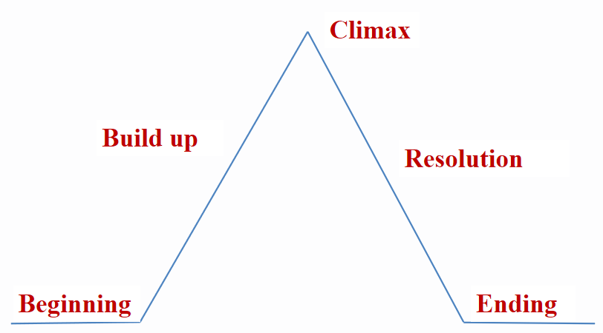（读前）
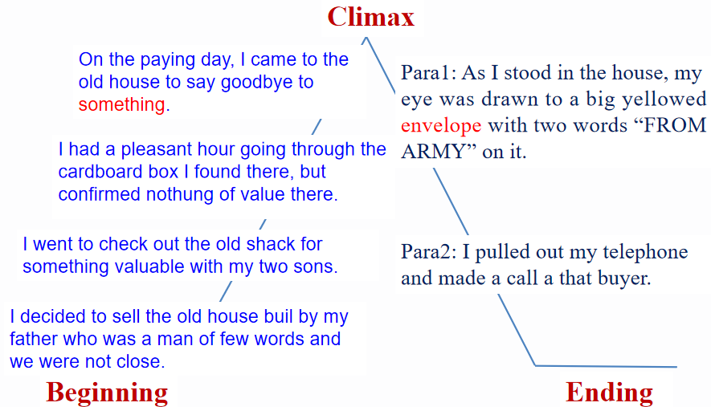（读后）
- 读所给句，用提问的方式写大纲：
Paragraph 1: As I stood in the house, my eye was drawn to a big yellowed envelope with two words “FROM ARMY” on it.
Q1: What was in the envelope?
Q2: How did I feel?
Q3: What did I decide to do?
Paragraph 2: I pulled out my telephone and made a call to that buyer.
Q1: What did I say to the buyer on the line?
Q2: What did I do later?
Q3: What is the ending?

- 读人物，明冲突；
（1）读原文中主要人物的言行、心理活动和面部表情等，判断主要人物之间的关系、以及各自的性格特征，以此在人与社会这样的文章中找到矛盾冲突。
My father was_________________  (reserved; loving; patriotic) | I was______________________  (resentful; loving)
my father was a man of few words | we moved away, carrying with me the echoes of his silent presence.
he joined the army | The house became mine.
he built a house with his own hands | One day, someone called, saying that he wanted to by that house. I said yes.
he was killed in one battle | I spent most of a pleasant hour going through that box.
 | I came to that old house to say goodbye to something.
A conflict: __________________________________________________________.
(I didn’t understand my father’s love.)
（2）基于所明确的矛盾，回到大纲中，判断本文的结局和主旨——love and inheritance
学生1：
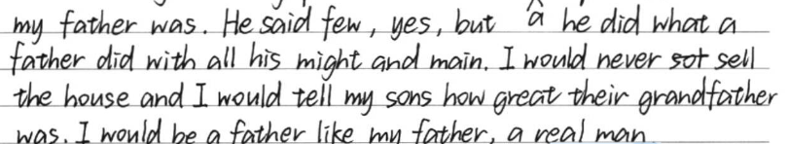
学生2：
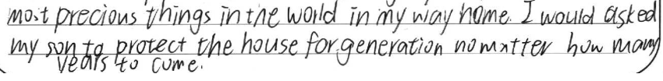

Possible version 1:
The vague(模糊的) silhouette /ˌsɪl.uˈet/（轮廓；剪影；逆光黑影） of my father, once a distant memory, was slowly sharpening(使清晰) into a distinct(可分辨的；清晰的) and vivid portrait. He was indeed a man of few words, yet it was also his silent love that filled the emptiness in my heart with a profound(强烈的；深沉的) and enduring(持久的；持续的) presence.
Possible version 2:
My beloved father didn’t just build the house with his own hands, but also with his heart, a heart carrying sincere hope that his kids could find solace(抚慰) and a sense of belonging within its walls. There, the echoes of his silent presence would continue to resonate, even after he was gone.
- 读线索，定细节。
（1）重读原文，获取以下的线索：
1. we were never close to each other.
2. he was tragically killed in one battle.
3. we moved away, carrying with me the echoes of his silent presence.
4. Here lay the things of my dad’s lives. A broken chair. ... a cardboard box ... a tax return ..Greeting cards from old relatives and friends.
5. nine people once occupied the tiny structure... in those days the cookstove was the only source of heat.
（2）仔细观察文中的线索，可以判断并解决出本次续写中最大的难点——信封里的什么东西让我最终理解了父亲对我的爱？
- A letter from my father which conveyed his love for me
- A letter from the officials in the army which spoke highly of father’s loyalty, bravery and concern for family
- A letter from my father chattering(唠叨；喋喋不休) endlessly, missing his hometown, and caring about everything about his family
- Photos of our family huddling together in this small but cozy house
- 信封描写的相关语料：
- It was a letter from my dad, written during his military service. The familiar handwriting revealed an image of my dad that was unfamiliar to me: chattering(唠叨；喋喋不休) endlessly, missing his hometown, and caring about everything about his family.
- The faded handwriting of my father's brought me back to the bitterly cold(极其寒冷的) mornings full of smoke, to his quiet longing for returning home and his never-faded hopes for me.
- What leapt at my eyes(跃入眼帘的是) was a folded sheets(一张纸) of official-looking correspondence(信件；信函) from the military, recounting(讲述；叙述) my father's service and sacrifice, his bravery, his leadership, and his unwavering(从不动摇的) dedication to our beloved motherland.
- 并根据上述判断，回答第一段大纲中的问题2 How was my feeling?
- I had once resented(感到愤恨；不满) his absence, unaware that during the time when I missed him, he was also missing me. I fell into deep contemplation(陷入沉思). When I looked up again, I felt that this little house was suffused with(弥漫；充满) a whole new significance(特殊意义).
- The breeze(微风) went through the windowless window, and I suddenly recalled my father's warm hand when he held mine.
- Tears blurred my vision(眼泪模糊了视线) as I finally began to learn about the man who I once hardly knew but now felt so connected to.
- 回答第二段大纲中问题2 What did I do later after the call?
- I would often bring my sons back here, I guess. In addition to sharing the family’s past stories, I would also tell them that their grandpa is never truly gone.
- For the following days, weeks and months, I, along with my two sons, weeded the tall grass in the meadow, fetched a carpenter to mend the wood shack, dusted off the rooms and collected my father’s belongings. My sons, young as they were, seemed to grasp something special about this house. Finally the shack was restored to its former familiarity.
- 此刻学生应该能更深刻地体验到本文的主旨：The house was once a relic of the past, but now a family bridge that transcended any barriers.
三、总结
In conclusion, what you have written should be in coordination with the _____________, __________ and _________ as well as ___________ in the story.
四、范文赏析
【Possible versions】
As I stood in the house, my eye was drawn to a big yellowed envelope with two words “FROM ARMY” on it. Yellowed with age, it seemed to blend in with(融入) the old house, which might explain why I didn't notice it last time. A subtle tremor through my heartstrings(我的心弦微微颤抖) sent(使做) me forward to pick up the envelope and delve into(深入探究) it. It was a letter from my dad, written during his military service. The familiar handwriting revealed an image of my dad that was unfamiliar to me: chattering(唠叨；喋喋不休) endlessly, missing his hometown, and caring about everything about his family. In a trance(昏睡状态；催眠状态), the handwriting in front of me overlapped with(与..交叠；与...有共同之处) the image of my dad in the past. I had once resented(感到愤恨；不满) his absence, unaware that during the time when I missed him, he was also missing me. I fell into deep contemplation(陷入沉思). When I looked up again, I felt that this little house was suffused with(弥漫；充满) a whole new significance(特殊意义). Silently, I made a resolution(下决心；下决定).
I pulled out my telephone and made a call to that buyer. With guilt, I expressed my sorry for not willing to sell the house anymore and made explanations. Fortunately, the buyer graciously(有礼貌地) showed his understanding, saying that he was originally drawn to the house’s historical charm and hoped we could relive the past(重温过去) in this house. After showering(某物如阵雨般落下) my gratitude, I hung up the phone and returned the yellow letter that seemed to have changed everything. The house was illuminated by/with(被...照亮) the sunlight, revealing the remnants of time’s passage and past memories(展现了时间流逝和过去回忆的遗迹). My dad’s voice and smiling face seemed to reappear in the warmth, slowly filling up(充满；填满) the emptiness in my heart. I’d often bring my sons back here, I guess. In addition to sharing the family’s past stories, I would also tell them that their grandpa is never truly gone.

As I stood in the house, my eye was drawn to a big yellowed envelope with two words "FROMARMY" on it. Its edges were frayed(布料、绳子磨损), and the faded(褪色的) ink told tales(讲故事) of time gone by. How could I have missed this? Unfolding one of the letter, I studied the familiar scrawl that belonged to my father. He wondered whether the house stood firm against the rains, whether the worry lines had deepened in my mother's eyes(因为忧心，母亲眼角的细纹加深了), and whether the children had grown to his shoulder. In each letter's closing, father repeated the same line: “I’ll be back soon and build a big new house for us, for our children. Love you all." The breeze(微风) went through the windowless window, and I suddenly recalled my father's warm hand when he held mine.
I pulled out my telephone and made a call to that buyer. When the phone was picked up, I found my voice faltered(声音颤抖了). Clearing my throat(清了清嗓子), I informed them of my change of heart and explained my reasons. Thankfully, they respected my decision. After hanging up, I looked around the aging house. The windows and siding spoke of hands that had built it, eyes that had fallen on it, and hearts that had felt it(房子里的窗户和壁板似乎在诉说着那双建造了它的手，曾经注视着它的一双双眼睛和感受到它的那一颗颗心). Yes, my dad didn't make it to witness us growing up in person, but he left part of his soul in the old house. My two sons approached, asking,“When can we get back home?” Lifting my eyes,“We are home," I whispered to the open meadow.

As I stood in the house, my eye was drawn to a big yellowed envelope with two words "FROMARMY" on it. My trembling hands tore open(撕开) the envelope, revealing an aged letter. It seemed the envelope, sealed and untouched by time, was waiting patiently for this very moment to unveil its secrets. I sat down to read the letter, trying to capture the remaining echoes from the long-lost past. The time capsule was re-opened. The faded handwriting of my father's brought me back to the bitterly cold(极其寒冷的) mornings full of smoke, to his quiet longing for returning home and his never-faded hopes for me. Tears dropped on the ground, I repeatedly murmured the words he left: “All is well here. Hope to see you soon." The old letter provided the reason I had been seeking—a part of my father that I had never truly known, yet now felt deeply connected to, which was never meant to be sold to anyone else.
Paragraph 2: I pulled out my telephone and made a call to that buyer. My voice faltered as I told the buyer about the unexpected discovery, mixed feelings of/a complicated mix of love, loss, and longing welling up within/surging inside/washing over/sweeping over me. I apologetically /əˌpɒl.əˈdʒet.ɪ.kəl.i/(表示歉意地) explained my sudden, overwhelming(难以抵挡的；抑制不住的) need to keep this piece of my dad, along with all the things of his life that remained here in the old shack. The line went quiet for a moment before I heard the empathetic reply. “I understand," the buyer said."Take your time. The house belongs to you." I hung up the phone and stood still in the house, surrounded by the worn(破旧的) walls, the sagging(下垂的) roof, and the creaking(嘎吱作响的) floors. Everything was ravaged/ˈræv.ɪdʒ/(严重破坏) by time, yet every single bit here held its value, preserving my dad’s silent love for the family.

As I stood in the house, my eye was drawn to a big yellowed envelope with two words "FROMARMY" on it. It lay half-buried under a pile of debris(碎片；残片) where the wall had crumbled(瓦解；成碎屑), weathered(受风雨侵蚀的) and fragile. I picked it up, dusting off(擦去灰尘) the years that had settled on its surface. What leapt at my eyes(跃入眼帘的是) was a folded sheets(一张纸) of official-looking correspondence(信件；信函) from the military, recounting(讲述；叙述) my father's service and sacrifice，his bravery, his leadership, and his unwavering(从不动摇的) dedication to our beloved motherland. Reading through the lines, I was again transported back to the bygone(过去的) era. Tears blurred my vision(眼泪模糊了视线) as I finally began to learn about the man who I once hardly knew but now felt so connected to.
I pulled out my telephone and made a call to that buyer. “I found something that's too important to me to part with(与...分别)," I managed to say, trying to hold back my emotions. “I think I need to hold onto the house a little longer. There are still a few things I need to sort out, a few goodbyes I need to say.” To my surprise, the buyer was understanding, allowing me to think twice. As I hung up, I knew that this old shack, though weathered and worn, had more secrets and stories to tell. This is more than just a relic; it's a living, breathing part of who I am, a link to a past I'd been too young to fully appreciate, which indeed deserved more than a hasty(仓促的) farewell. I decided then and there that I needed to take my time, to truly understand the life my father had lived before he became a name on apiece of paper.

