**2023年10月浙江省强基联盟高三读后续写教学设计**

**浙江省衢州第一中学 徐荣仙**

本课件聚焦于读后续写“爱”的诠释的写作指导。从八个维度对文本进行解读，帮助学生透彻解读文本，挖掘文本背后作者深含的寓意，进行爱的教育。本文的难点在于文本主旨的提炼、叙事节奏的把握和人物角色的刻画。通过板块式设计，使教学具有过程性、层次性和灵活性。

1. 主题语境分析：本文属于“人与自我、人与社会”，按照“话题－功能－结构－任务”相结合的模式，突出主题意义探究、锤炼语言、提升学生思维品质。
2. 写作重难点：本课例学生写作的困惑点是故事情节的建构，主旨的提炼，对话的有效建构和立意的升华。
3. 设计思路：本课例从八个维度对文本进行解读和剖析：文本词汇疑难链、理解原文问题链、理解首句问题链支架、“续”语篇中的思维与语言、学生习作中不合理的思维与情节、如何寻找“续写点”、如何预设和建构多维度结尾。最后展示考试范文并做点评。
4. 设计步骤:
5. 扫除语言障碍，为后续深度解读文本和挖掘做好铺垫。
6. 通过问题链，深度解读文本：文本词汇、基本信息、深度理解、预设情节、情感问题和反思问题。
7. 通过首句问题链，辅助合情合理的建构故事情节，提升立意。
8. 精读文本，“续”语篇中的思维与语言：①理清故事基本线索、故事冲突点、故事情节走向和文章主题立意 ②预测片段思维，推进情节发展。
9. 通过分析学生习作中不合理的思维与情节，帮助规避不合理的情节建构。
10. 创建地道合理的情节。为页面留白，创造视觉、听觉的画面感，增加吸引力

**导学案展示**

1. **读后续写文本**

第二节：读后续写（满分25分）

阅读下面短文，根据所给情节进行续写，使之构成一个完整的故事。

Sally's birthday was approaching, and the excitement that usually filled her heart was now replacedwith disappointment and stress. Turning eleven was a big deal, and she had always celebrated it with a grand party surrounded by her friends. However, this year was different. The burden of excessive homework and her parents' struggling business weighed heavily on her, forcing Sally to make the difficult decision of not having a birthday party, even though it was an event she enjoyed dearly every year.

　　One day, during break, her best friend, Jane, with a curious look in her eyes, approached.“Are yougoing to have a birthday party this year?”Jane asked, sensing Sally's sadness.

　　“No,”Sally sighed and replied sadly,“There's just too much going on and my parents are going throughfinancial difficulties.”

　　She smiled weakly, trying to conceal her immense disappointment and stress, but Jane saw through her pretence(假装) easily. Jane nodded thoughtfully and did not say anything. After the break, Sally saw her talking to one of their classmates, Sarah, secretively. Curious, Sally went over to them, but as soon as Jane saw her, she quickly walked away. Sally was startled by Jane's strange actions and turned towards Sarah.

“What did she say?”Sally asked.

However, Sarah simply shrugged and walked away with Jane, leaving Sally standing there, feeling leftout and anxious.

What is happening? Sally wondered anxiously. Are they keeping something from me?

　　As Sally’s birthday drew nearer, Jane was often found chatting softly with her other classmates.Whenever Sally went over to them, they would just walk away or tell her that they were talking about a secret which Sally was not allowed to know. Jane has never kept secrets from me before, Sally thought. Her heart fell. Even her friends were distancing themselves from her! She swung between confusion and sadness with each passing moment, desperately trying to figure out what was happening. Why were her friends distancing themselves from her? And what were they hiding?

On the day of Sally’s birthday, she went to school and found her classroom in total darkness.

Tears sprang from Sally’s eyes and her face broke into a radiant smile.

1. **过程展示**
2. **利用常态的生日晚会知识导入话题**

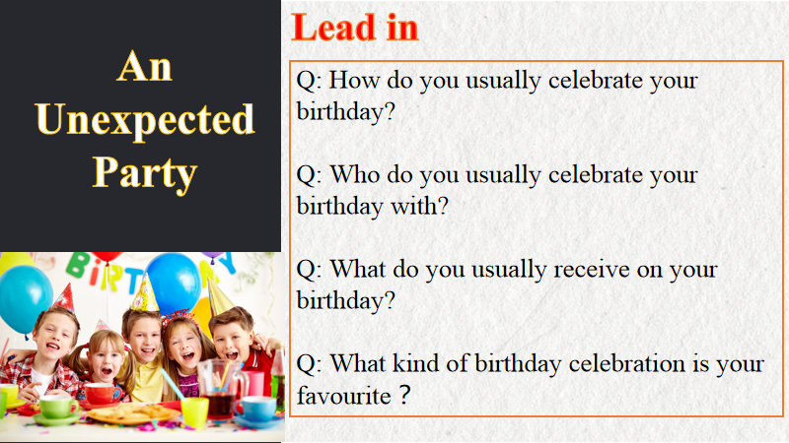

1. 细读、精读所给文本，获取有效词汇

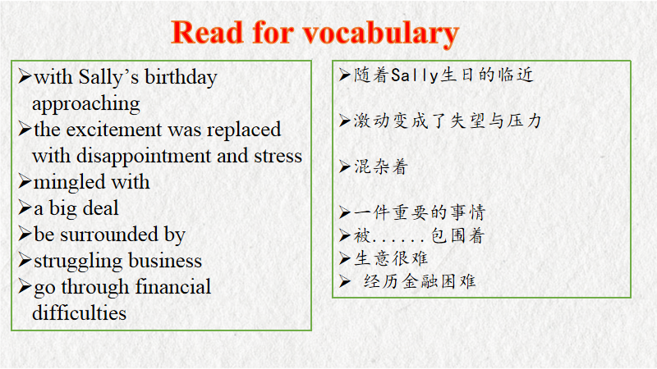

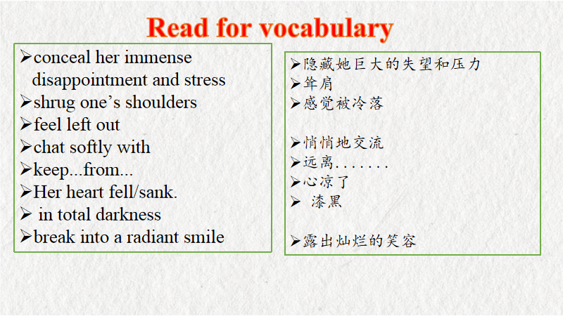

1. 解读文本的背景、冲突、高潮

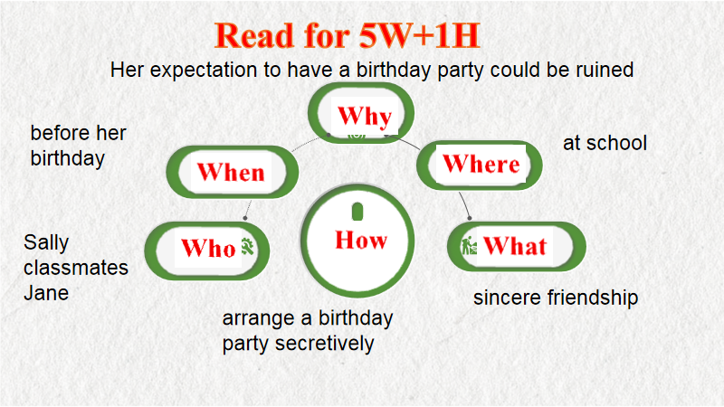

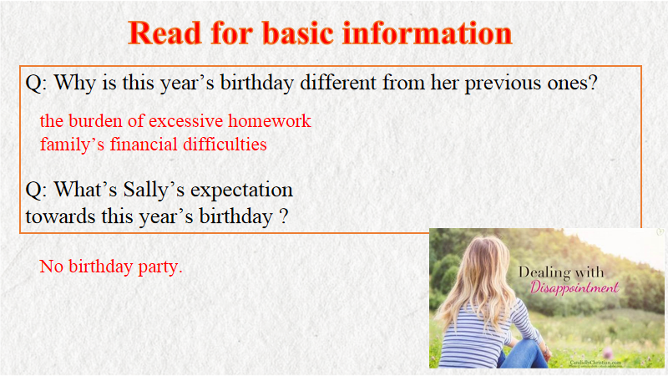

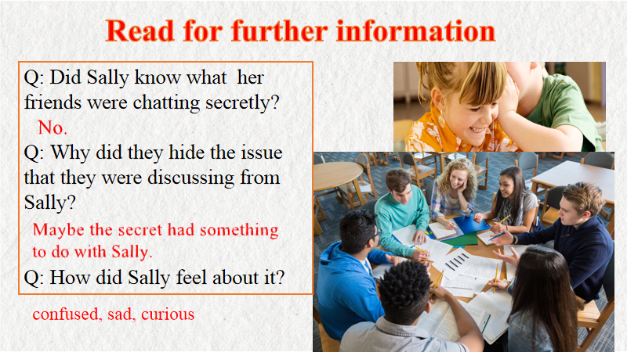

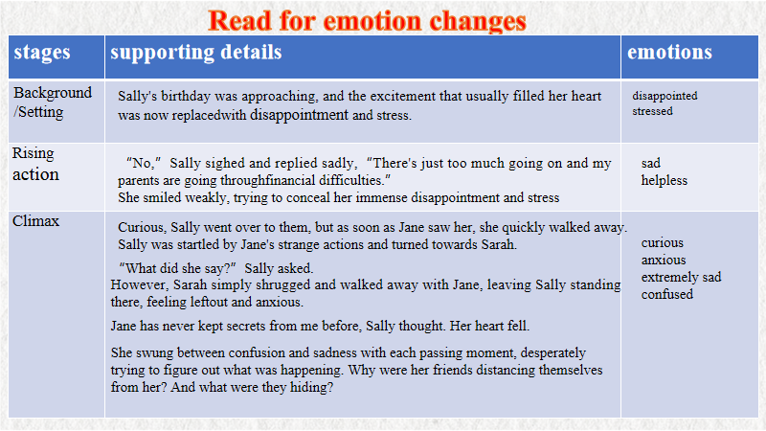

1. 根据所分析的文本，预设故事情节和多维结尾、挖掘主旨

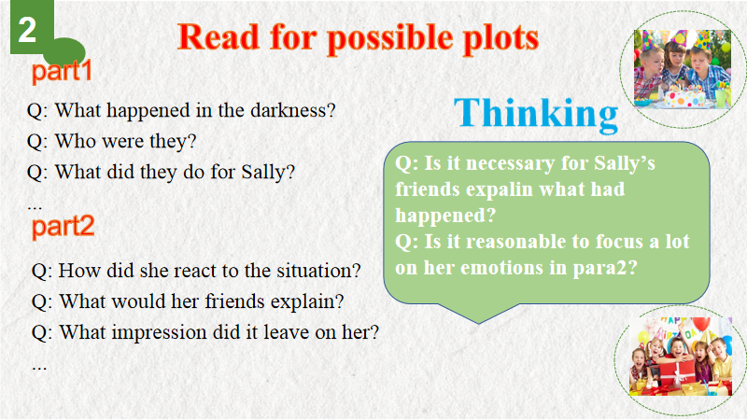

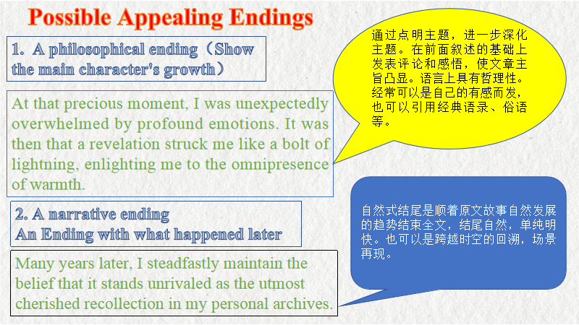

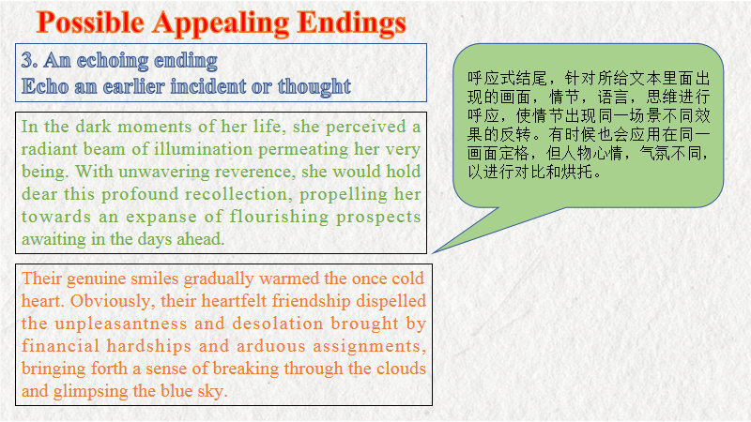

1. 范文展示

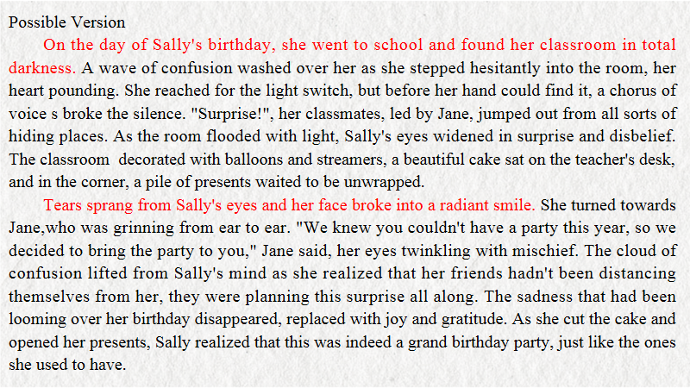

1. 范文点评

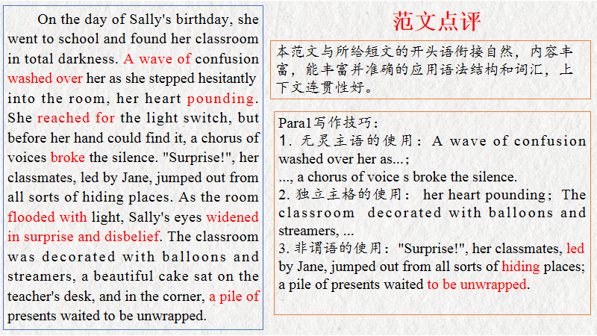

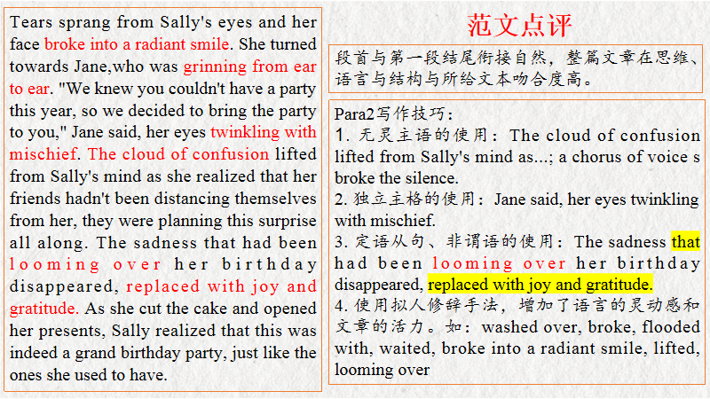

1. 同类话题训练

第二节：读后续写（满分25分）

阅读下面短文，根据所给情节进行续写，使之构成一个完整的故事。

I heard her sing when I opened the door.And I saw my crippled (跛腿的) grandmother was dancing. I was absolutely shocked. Her legs were crippled as long as I could remember. She once was the pet of the dancing world. And then she had her accident and it was all over. I read that in an old newspaper. She turned around and saw me. Grandmother sighed and turned towards the kitchen. I followed her and saw she was walking fine. So, out of curiosity, I asked her “what's going on?”

Oh Dear, let me share a little story of mine. “When your grandfather went to war, I was so afraid of losing him, the only way I could stay sane was to dance. And I became very good. Critics praised me, the public loved me, but all I could feel was the ache in my heart, not knowing whether the love of my life would ever return. Then I went home and reread his letters until I fell asleep. He always ended his letters with “You are my joy. I love you with my life” and after that he wrote his name.And then one day a letter came.There were only three sentences: “I have lost my leg. I give you back your freedom.It is best youforget about me..”

“I made my decision there and then. I bought myself a cane and start pretending to be crippled.I told a reporter I had a car accident,and couldn't dance again. Then I went to see your grandfather.” I told him “you're not the only one who lost a leg; I am not going to let you feel sorry for yourself. There is a whole life waiting for us out there! I don't intend to be sorry for myself, so you'd better snap out of it too.” Grandmother giggled and continued. “I limped toward him and showed him two engagement rings. ‘Nowshow me you are still a man,’I said, ‘I won't ask again.’He bent to take his cane from the ground and struggled out of that wheelchair. And so he managed it on his own and walked to me and never sat in a wheelchair again in his life.”

I looked at the drawing on the kitchen wall, sketched by my grandfather. “You are my Joy. I love you with my life.” I murmured quietly.

注意：所续写短文的词数应为150左右。

Paragraph1: Grandmother looked me in the eyes and asked me to make a promise._____________

_______________________________________________________________________________

Paragraph2: A few years went by. Six months after grandmother's funeral____________________

_______________________________________________________________________________

参考范文：

*Grandmother looked me in the eyes and asked me to make a promise.* “Could you make it a secret between us?” she continued, “at least before my death.” I looked up at Grandma in puzzle. “Why don’t you tell Grandpa the truth?” I asked in a low voice. “You will understand it when you meet the one who you want to marry,”explained Grandma. I nodded my head thoughtfully, as if I GOT the meaning behind. Grandma stroked my head softly. The wrinkles on her face were like a folded letter, silently expounding her love to Grandpa. Due to the secret, more opportinities to enjoy Grandmother’s dancing emerged in my life.

*A few years went by. Six months after grandmother's funeral,* I accidently found Grandpa sitting in Grandmother’s usual chair and wiping his secret tears. I walked up silently, wrapped him in my arms tightly and uttered, “Grandpa, I had to tell you a secret ! Actually,Grandma is not crippled.” On hearing it, I found his shoulders twitching violently and tears gushing out like a collapsed dam. “I had discovered it not long after your father was born! But no dancer is more beautiful than your grandmother, even though she is CRIPPLED!” “You are my Joy. Grandpa, I love you with my life.”I kneeled down and comforted him. I finally understood that true love meant that you care for another person’s happiness more than your own, no matter how painful the choices you face might be.