**The World**（**0601-0615**）材料分析和教学目标：

本次选用的材料：①、*National Geographic*的*Explorer of the Year: Fernando Trujillo*（国家地理年度探险家）②、*The Wall Street Journal*的*Mexico to Elect First Female President*（墨西哥将迎来首位女总统）③、*The Week*的*First rocks from far side of the moon*（人类首次月背取壤）④&⑤BBC的新闻报道。通过语法填空、阅读理解、分析长难句、翻译句子、听力填空和词汇拓展等方式，让学生从多角度提升学习兴趣，提高分析句子、运用词块和听力能力。外媒英语新闻可以让学生体验真实语境下的语言运用，拓展学生的国际视野，了解时事，逐步提升跨文化沟通能力，形成正确的世界观、人生观和价值观。

**教学思路：**

**Part 1: News Report 1 *National Geographic* (June 2024 P12)**

**Explorer of the Year: Fernando Trujillo 国家地理年度探险家**

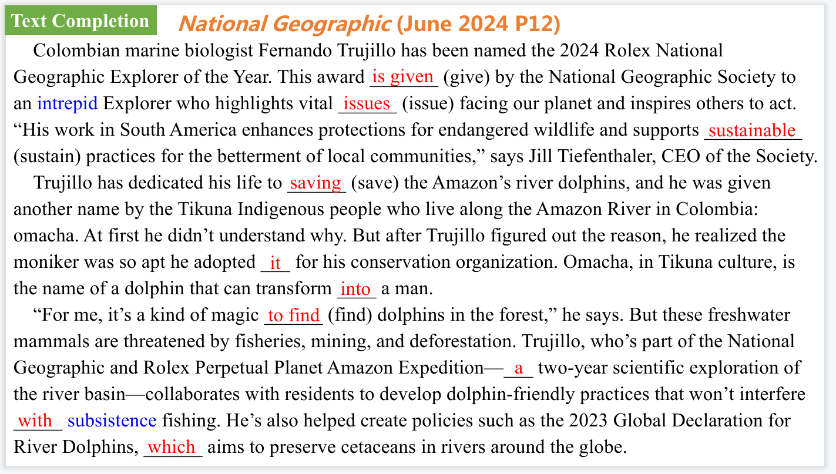

【设计意图】通过语篇填空的形式帮助学生理解新闻的主要内容，同时训练语言语法的运用能力：在语篇的视角下如何正确使用所给词汇，根据语法规则确定词汇的正确形式，使得文章通顺，激活学生的思维和语言。该新闻主题语境是关于“人与社会”中“社会热点问题”这一子主题，通过学习让学生了解国家地理年度探险家的事迹。



【设计意图】对文本中的词汇进行解读，并通过翻译句子对其进行巩固。

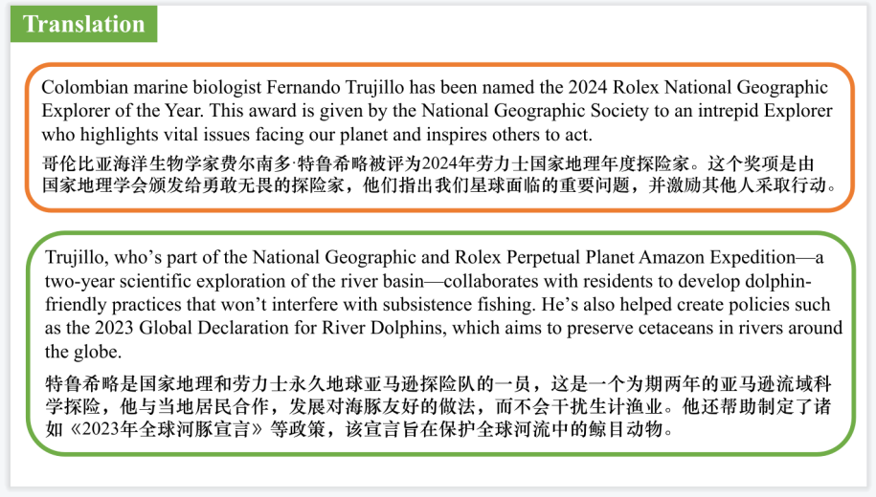

【设计意图】对文中的两个句子进行翻译练习，对其中单词、词组、句法进行巩固并关注句子结构。

**Part 2: News Report 2 *The Wall Street Journal* (June 3, 2024 A6)**

**Mexico to Elect First Female President 墨西哥将迎来首位女总统**

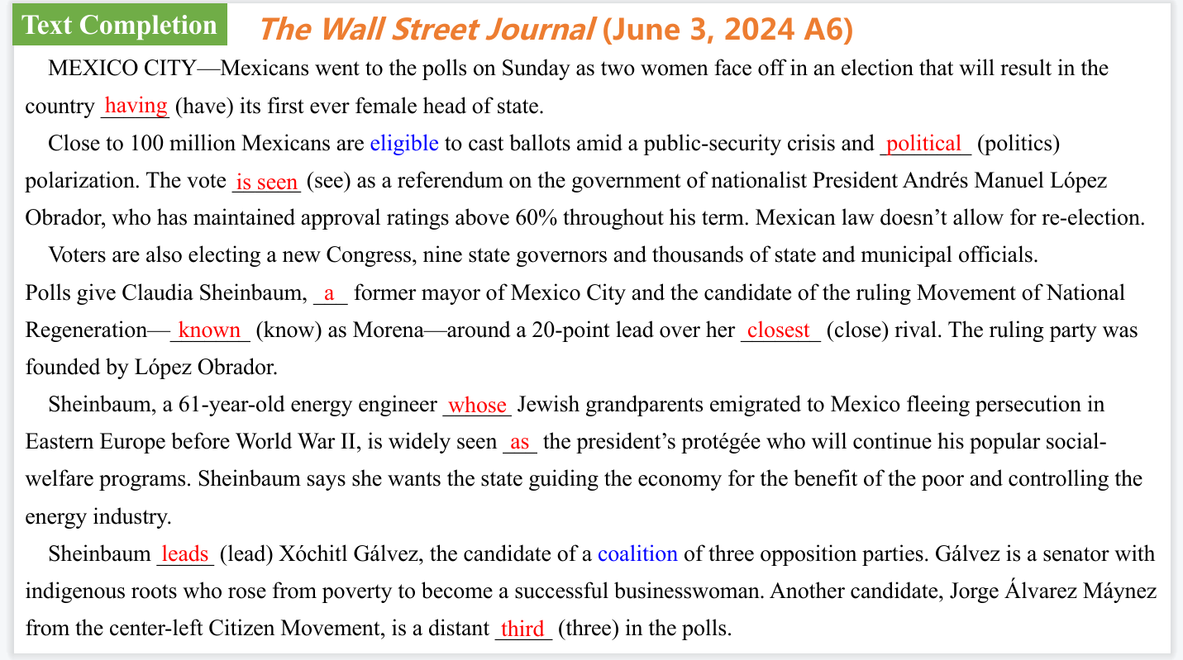

【设计意图】通过语篇填空的形式帮助学生理解新闻的主要内容，同时训练语言语法的运用能力：在语篇的视角下如何正确使用所给词汇，根据语法规则确定词汇的正确形式，使得文章通顺，激活学生的思维和语言。该新闻主题语境是关于“人与社会”中“社会热点问题”这一子主题，通过学习让学生了解墨西哥大选的新闻。



【设计意图】对文本中的词汇进行解读，并通过翻译句子对其进行巩固。



【设计意图】对文中的两个句子进行翻译练习，对其中单词、词组、句法进行巩固并关注句子结构。

**Part 3: News Report 3 *The Week* (June 21, 2024 P21)**

**First rocks from far side of the moon 人类首次月背取壤**

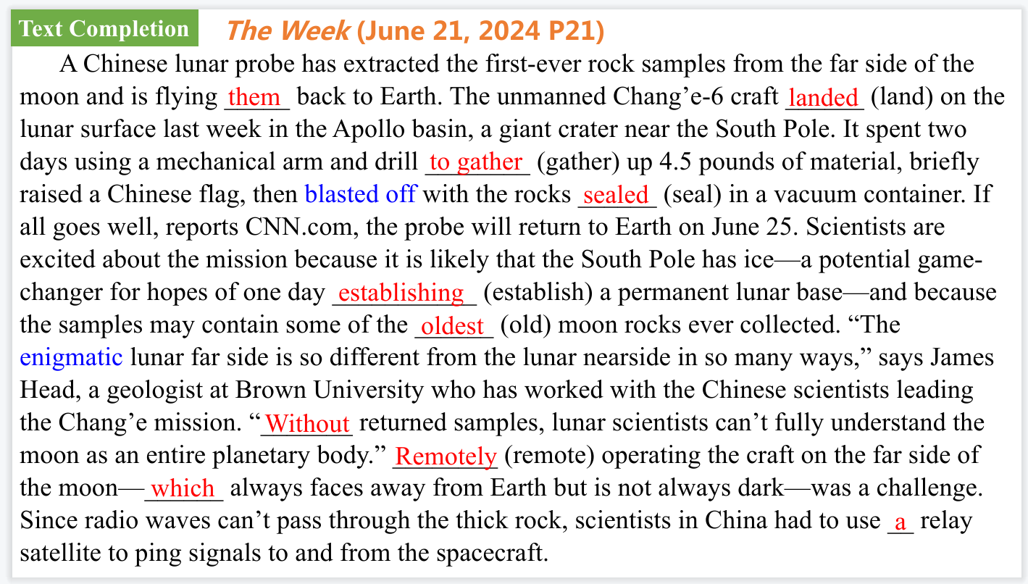

【设计意图】通过语篇填空的形式帮助学生理解新闻的主要内容，同时训练语言语法的运用能力：在语篇的视角下如何正确使用所给词汇，根据语法规则确定词汇的正确形式，使得文章通顺，激活学生的思维和语言。该新闻主题语境是关于“人与社会”中“社会热点问题”这一子主题，通过学习让学生了解关于人类首次月背取壤的新闻。



【设计意图】通过阅读理解的形式帮助学生理解新闻的主要内容。



【设计意图】对文本中的词汇进行解读，并通过翻译句子对其进行巩固。

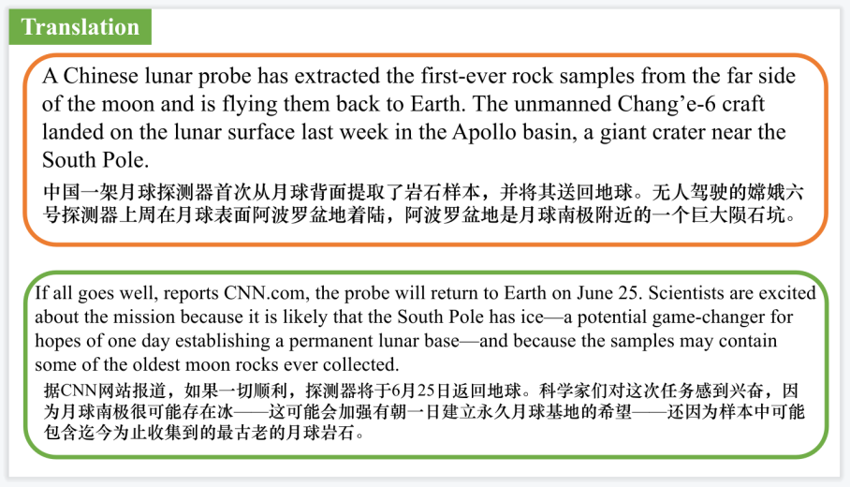

【设计意图】对文中的两个句子进行翻译练习，对其中单词、词组、句法进行巩固并关注句子结构。

**Part 4: BBC News 06/04/2024**

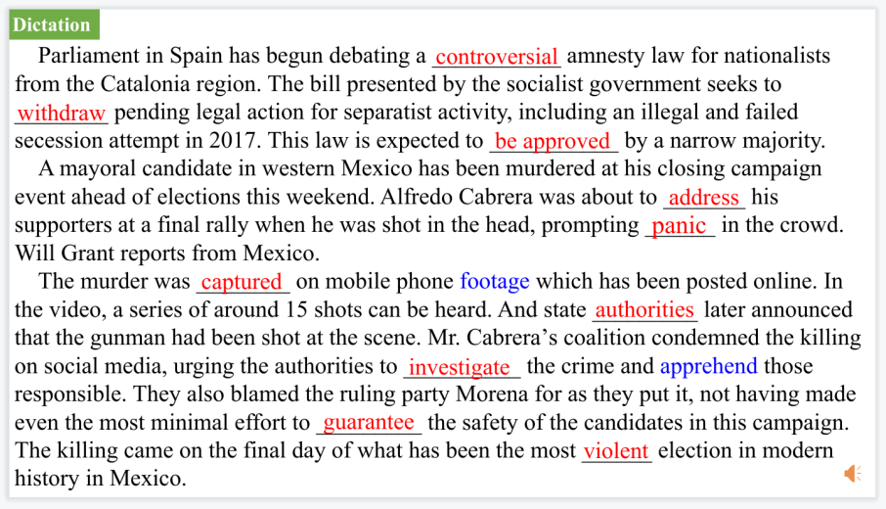

【设计意图】听一则材料，通过听力填空的方式理解文本，考察听力辨识词汇的能力。



【设计意图】对文本中的词汇进行解读，并通过翻译句子对其进行巩固。

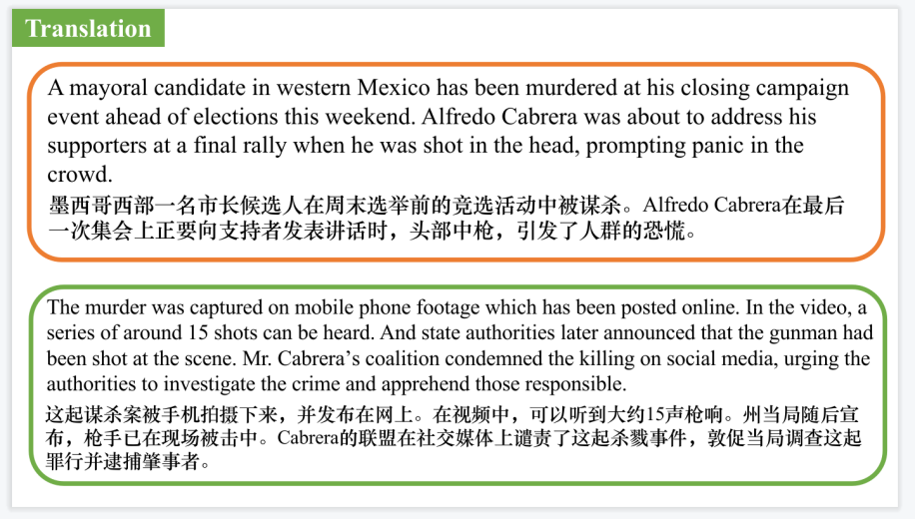

【设计意图】对文中的两个句子进行翻译练习，对其中单词、词组、句法进行巩固并关注句子结构。

**Part 5: BBC News 06/21/2024**



【设计意图】听一则材料，通过听力填空的方式理解文本，考察听力辨识词汇的能力。



【设计意图】对文本中的词汇进行解读，并通过翻译句子对其进行巩固。



【设计意图】对文中的两个句子进行翻译练习，对其中单词、词组、句法进行巩固并关注句子结构。

附：外刊原文

**Part 1: News Report 1 *National Geographic* (June 2024 P12)**

**Explorer of the Year: Fernando Trujillo 国家地理年度探险家**

Colombian marine biologist Fernando Trujillo has been named the 2024 Rolex National Geographic Explorer of the Year. This award is given by the National Geographic Society to an intrepid Explorer who highlights vital issues facing our planet and inspires others to act. “His work in South America enhances protections for endangered wildlife and supports sustainable practices for the betterment of local communities,” says Jill Tiefenthaler, CEO of the Society.

Trujillo has dedicated his life to saving the Amazon’s river dolphins, and he was given another name by the Tikuna Indigenous people who live along the Amazon River in Colombia: omacha. At first he didn’t understand why. But after Trujillo figured out the reason, he realized the moniker was so apt he adopted it for his conservation organization. Omacha, in Tikuna culture, is the name of a dolphin that can transform into a man.

“For me, it’s a kind of magic to find dolphins in the forest,” he says. But these freshwater mammals are threatened by fisheries, mining, and deforestation. Trujillo, who’s part of the National Geographic and Rolex Perpetual Planet Amazon Expedition—a two-year scientific exploration of the river basin—collaborates with residents to develop dolphin-friendly practices that won’t interfere with subsistence fishing. He’s also helped create policies such as the 2023 Global Declaration for River Dolphins, which aims to preserve cetaceans in rivers around the globe.

**Part 2: News Report 2 *The Wall Street Journal* (June 3, 2024 A6)**

**Mexico to Elect First Female President 墨西哥将迎来首位女总统**

MEXICO CITY—Mexicans went to the polls on Sunday as two women face off in an election that will result in the country having its first ever female head of state.

Close to 100 million Mexicans are eligible to cast ballots amid a public-security crisis and political polarization. The vote is seen as a referendum on the government of nationalist President Andrés Manuel López Obrador, who has maintained approval ratings above 60% throughout his term. Mexican law doesn’t allow for re-election.

Voters are also electing a new Congress, nine state governors and thousands of state and municipal officials.

Polls give Claudia Sheinbaum, a former mayor of Mexico City and the candidate of the ruling Movement of National Regeneration—known as Morena—around a 20-point lead over her closest rival. The ruling party was founded by López Obrador.

Sheinbaum, a 61-year-old energy engineer whose Jewish grandparents emigrated to Mexico fleeing persecution in Eastern Europe before World War II, is widely seen as the president’s protégée who will continue his popular social-welfare programs. Sheinbaum says she wants the state guiding the economy for the benefit of the poor and controlling the energy industry.

Sheinbaum leads Xóchitl Gálvez, the candidate of a coalition of three opposition parties. Gálvez is a senator with indigenous roots who rose from poverty to become a successful businesswoman. Another candidate, Jorge Álvarez Máynez from the center-left Citizen Movement, is a distant third in the polls.

**Part 3: News Report 3 *The Week* (June 21, 2024 P21)**

**First rocks from far side of the moon 人类首次月背取壤**

A Chinese lunar probe has extracted the first-ever rock samples from the far side of the moon and is flying them back to Earth. The unmanned Chang’e-6 craft landed on the lunar surface last week in the Apollo basin, a giant crater near the South Pole. It spent two days using a mechanical arm and drill to gather up 4.5 pounds of material, briefly raised a Chinese flag, then blasted off with the rocks sealed in a vacuum container. If all goes well, reports CNN.com, the probe will return to Earth on June 25. Scientists are excited about the mission because it is likely that the South Pole has ice—a potential game-changer for hopes of one day establishing a permanent lunar base—and because the samples may contain some of the oldest moon rocks ever collected. “The enigmatic lunar far side is so different from the lunar nearside in so many ways,” says James Head, a geologist at Brown University who has worked with the Chinese scientists leading the Chang’e mission. “Without returned samples, lunar scientists can’t fully understand the moon as an entire planetary body.” Remotely operating the craft on the far side of the moon—which always faces away from Earth but is not always dark—was a challenge. Since radio waves can’t pass through the thick rock, scientists in China had to use a relay satellite to ping signals to and from the spacecraft.

**Part 4: BBC News 06/04/2024**

Parliament in Spain has begun debating a controversial amnesty law for nationalists from the Catalonia region. The bill presented by the socialist government seeks to withdraw pending legal action for separatist activity, including an illegal and failed secession attempt in 2017. This law is expected to be approved by a narrow majority.

A mayoral candidate in western Mexico has been murdered at his closing campaign event ahead of elections this weekend. Alfredo Cabrera was about to address his supporters at a final rally when he was shot in the head, prompting panic in the crowd. Will Grant reports from Mexico.

The murder was captured on mobile phone footage which has been posted online. In the video, a series of around 15 shots can be heard. And state authorities later announced that the gunman had been shot at the scene. Mr. Cabrera's coalition condemned the killing on social media, urging the authorities to investigate the crime and apprehend those responsible. They also blamed the ruling party Morena for as they put it, not having made even the most minimal effort to guarantee the safety of the candidates in this campaign. The killing came on the final day of what has been the most violent election in modern history in Mexico.

Politicians, health experts and celebrities have urged the American pharmaceutical firm Gilead to allow cheap generic versions of a promising new HIV drug to be produced, so it can reach people in developing countries. In an open letter, they said the drug Lenacapavir could be a real game changer in the fight against HIV. It's been approved for use in the US and Europe.

The home village of the British pop star Harry Styles has launched an official tour of his childhood horns to cater for the thousands of fans who flock there each year. The tours of Holmes Chapel in northern England will visit sites, including the bakery where Styles worked as a teenager and a viaduct where he had his first kiss.

**Part 5: BBC News 06/21/2024**

The US Secretary of State Antony Blinken says the government is continuing to withhold consignment of bombs from Israel over concerns about their possible use in urban areas of Gaza. He said the issue remained under review. An hour before he spoke, the Israeli Prime Minister Benjamin Netanyahu claimed Mr. Blinken had privately assured him that Washington was working to remove what he called 'bottlenecks' in arms deliveries.

A mysterious, reflective monolith has appeared in a remote mountain range in the Nevada desert in the United States, sparking speculation about how it got there. The Las Vegas police department said they spotted the three-metre tall rectangular structure over the weekend. They heartbeat on such a rescue mission near Gass Peak, a popular hiking area in the desert about an hour north of Las Vegas. Their pictures on social media showed the object in rugged terrain, standing tall against a bright blue sky. The shining prism is similar to other metal installations that appeared around the world in 2020. All of the structures disappeared as quickly as they popped up.

One of baseball's greatest ever players, Willie Mays has died. He was 93. Over 22 seasons, Mays became a huge star thanks to his batting power, lightning, speed, and athleticism in the field. He made a spectacular catch in the 1954 World Series that remains one of the sport's best known plays. Mays was among the first generation of African Americans who were allowed to compete in Major League Baseball.

And that's the latest BBC news.