Book1 Unit 2 listening and talking-make reservations

Teaching aims: instruct students to get main fact and details by listening and motivate them to talk about the topic of making reservations.

Teaching difficulties: encourage students to speak out and be aware of the main parts of the dialogue.

Teaching process:

**Step1 lead in**

1. What reservations do we need to make before or when we travel?
2. In what ways do people make reservations?

**Step 2 listening**

1. Listening to the phone call and answer the questions.
2. What are the two speakers talking about?
3. What is the relationship between the two speakers?

♣ before listening, let students read the questions and predict what is going to hear.

1. Listening again and complete the table with the words you hear.

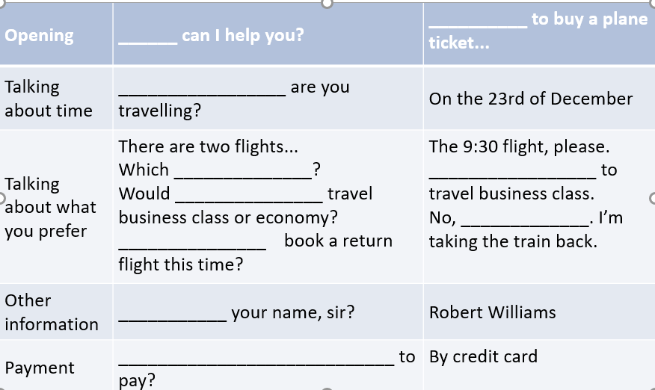

♣ Insist students listen for exact words and play the audio as many times as possible until they are able to distinguish the individual words. Then check their answers and make the students clear of 2 points: the 4 main parts of the dialogue and the expressions to show **politeness**.

1. Collect the expressions for the necessary part of the dialogue.

**Step 3 Talking**

Imagine you are making plans for the holiday. Choose one of the situations and role-play a phone call with a partner.

♣ Before role play, help students get more information and expressions of different situation-booking air tickets, booking a hotel room and booking a table for dinner.

♣After each the role-play of each situation, a sample dialogue and a short video are followed to make students better show themselves next time.