**Unit1 Science and Scientists-Build Up Your Vocabulary**

**-by Lily**

1. **Teaching Analysis:**

The topic of this unit is about “ science and scientists ”. And the words of this unit are difficult for ss to remember since some words are technical words and long words. For ss, they have known some ways to form words but they lack strategies to grasp the meaning of words and build up a network of words according to their meanings and topics. Thus, the teaching objectives are designed as follow:

1. **Teaching Objectives:**
2. To summarize the meanings of affixes and grasp the meaning of the words based on the affixes and roots.
3. To understand the meaning of words within the collocations and identify the core meanings of certain prepositions.
4. To grasp the meanings of words in the topic-related contexts.
5. To learn to build up a network of words by classifying words into different semantic fields.
6. **Teaching Procedures:**

**Step 1: Lead-in**

Look at the longest words and try to guess the meaning of it according to the meanings of affixes.

【Aims: to elicit the topic and stir up ss interests in affix learning.】

**Step 2: summarize the meaning of affix**

1. Finish the form and summarize the meaning of affix.

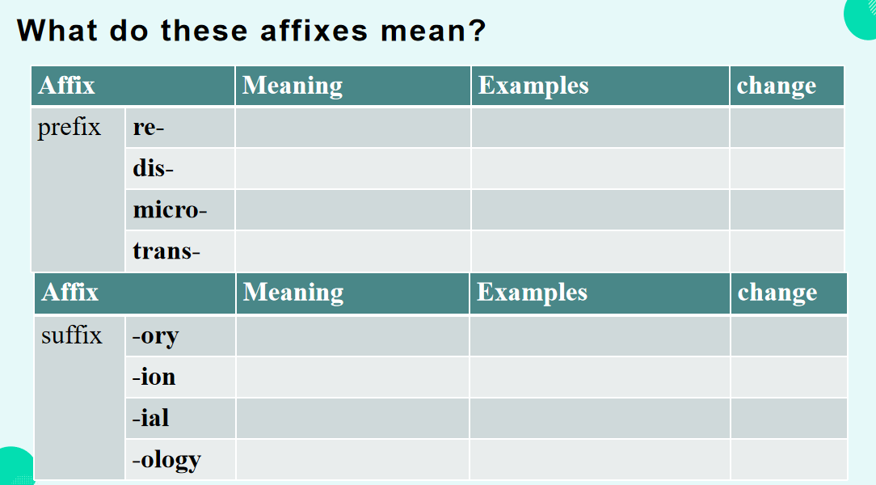

【Aims: to enable ss to learn how to summarize the meaning of affix and practise the strategy.】

**Step3: Grasp the words in collocations**

1. Look at the wordcloud and try to find as many collocations as possible

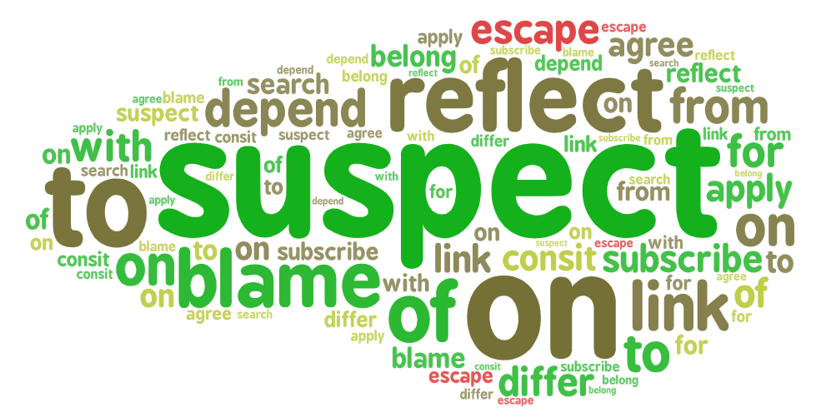

1. Practise

【Aims: to enable ss to learn the strategy to grasp words in collocations and train the strategy.】

**Step 4: Grasp words with synonyms**

Ask ss to paraphrase the underlined words.

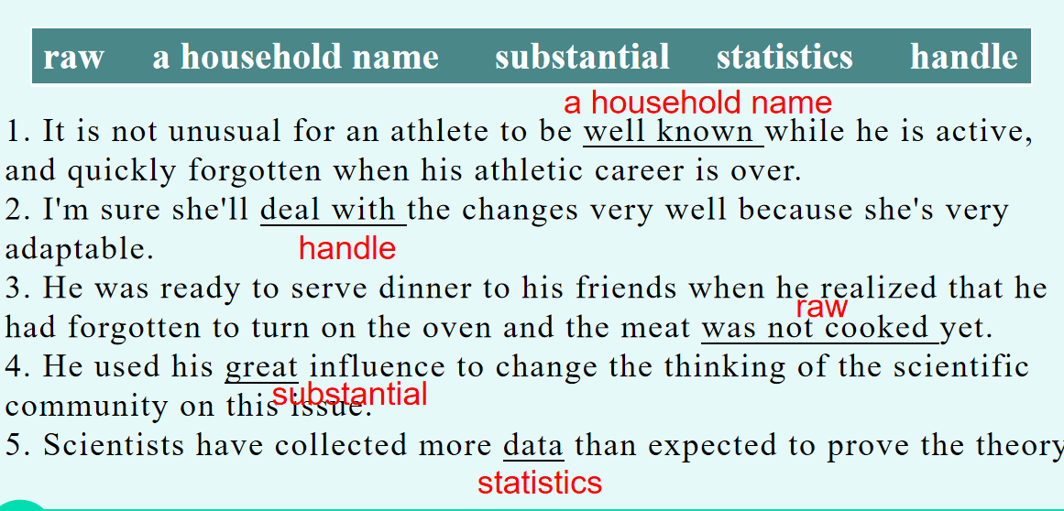

【Aims: to enable ss to learn the strategy to grasp words with synonyms and train the strategy.】

**Step 5: Grasp words in topic-related contexts.**

1. To complete the text with proper words and try to read for the details.

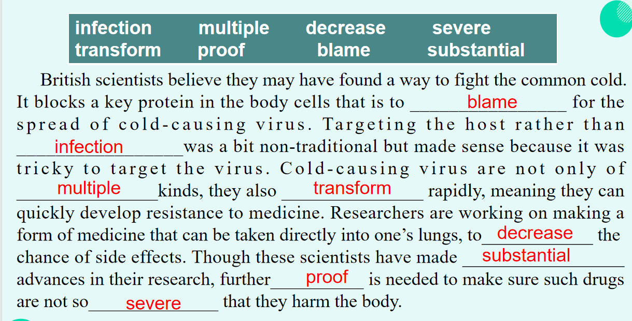

1. Group Work: raise questions about the content and answer them in group.

【Aims: to enable ss to learn the strategy to grasp words in contexts and train the strategy.】

**Step 6: Homework**

Make a mindmap of words in this unit.

【Aims: To learn to build up a network of words by classifying words into different semantic fields】