**24年2月高二浙江省名校协作体应用文**

**讲评学案**

**【题目回顾】**

假定你是高中生李华，将在假期和你校的英国交换生Jack共同完成一项研究性学习任务。请给Jack写一封邮件，提议研究偶像对高中生成长的影响。内容包括：

1. 选题理由；

2. 实施方案；

3. 征询意见；

参考词汇：偶像idol

Dear Jack,

**______________________________________________________________________________________________________________________________________________________________**

Yours,

Li Hua

**【审题】**

|  |  |
| --- | --- |
| 写作对象 |  |
| 体裁 |  |
| 时态&人称 |  |
| 主要点 |  |
| 次要点 |  |

**【框架搭建】**

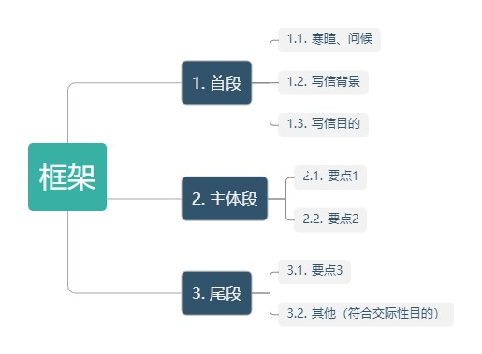

**【难点突破】**

1. 要点1选题理由可以从哪些方便考虑？

**______________________________________________________________________________________________________________________________________________________________**

1. 实施研究性学习有哪几个步骤？

**______________________________________________________________________________________________________________________________________________________________**

1. 尾段语言

你对这个话题的看法：

**______________________________________________________________________________________________________________________________________________________________**

是否有其他更好的提议：

**______________________________________________________________________________________________________________________________________________________________**

期待回信：

**______________________________________________________________________________________________________________________________________________________________**

**【参考范文】**

Dear Jack,

I hope this email finds you well. I am excited that we are to work together on a research project during the upcoming holidays.

After giving it some thought, I would like to propose a project that explores the influence of idols on the growth of high school students. That’s because idols, ranging from celebrities to common people who inspire them, often serve as role models and can have a profound impact on teenagers’ values and behaviors. Our approach would involve surveying peers, analyzing data, and perhaps interviewing educators to gain deeper insights.

Would this be something you’re interested in? Please let me know your thoughts at your earliest convenience, as I am eager to embark on this research journey with you.

Yours,

Li Hua

Dear Jack,

How’s everything going? I have an intriguing topic in mind for our research project in the upcoming holidays that I believe might interest you — The Influence of Idols on High School Students’ Growth.

My inspiration stems from observing how idols can significantly shape young people’s values, self-identity, and behaviors. The project will involve conducting surveys and interviews with a diverse group of high school students to gather data on their perspectives regarding idols and write a comprehensive report detailing our conclusions and insights.

What do you think of it? I’m really keen to get your perspective on this.

Yours,

Li Hua