选择性必修3
Unit1 Art Using Language (2)
Write an art exhibition announcement教学设计
年 级 | Senior Grade 2 | 授 课  教 师 | 郭文昇 | 学 科 | English | 授 课  日 期
课 题 | Unit1 Art Using Language (2)  Ancient Chinese Art on Show |  |  | 课时  安排 | 2 | 课 型 | 新授课
Ⅰ. Teaching analysis:
The text type is practical writing about a short introduction to the ancient Chinese art exhibition. The text is usually shown on the website of art galleries or museums. The content of this passage can be divided into four parts. An introduction of the exhibition is presented in Part 1(para 1); Part 2 (para 2-4) is about three highlights of the exhibition; Part 3 (para5) summarizes the exhibition briefly; Part 4 (para6-9) provides some details about the exhibition.
Ⅱ. Instructional objectives:
At the end of this class, students will be able to:
1. know the writing type of the passage
2. write an art exhibition announcement.
3. deepen the reading skills of skimming and scanning.
4. cultivate students’ awareness of spreading Chinese culture.
Ⅲ. Key points:
Guide and assist students to master the text structure and language features of practical writing.
Ⅳ. Difficult points
Help students write an announcement.
Ⅴ. Teaching procedures:
Step1 Lead-in
Activity 1. Brainstorming
Enjoy some pictures of Chinese artworks and identify them. Then, students will be encouraged to think of more related Chinese artworks and prepare for reading and writing.
Justification: arouse students’ interest, and enable them to engage in the class activities actively.
Q1. What Chinese art have you ever seen in the museum?
Justification: to elicit the topic
Step2 Pre-writing
Activity 2. Prediction
Students skim the title and pictures to identify the text type.
Q1. What do you expect to read from the text?
Q2. Where can you read the text?
Q3. What is the text type of the passage?
Justification: prepare for reading
Activity 3. Skimming
After prediction, they are asked to skim the text quickly to see whether they are right or not. Then, the teacher leads students to identify the text type of the passage. Finally, students conclude the main idea and figure out the structure of this passage.
Justification: study the structure of practical writing so that students can produce one of their own.
Activity 4. Detailed reading
Students read the passage carefully to find the basic information. Then, they fill in the blanks to know how to write an art exhibition announcement.
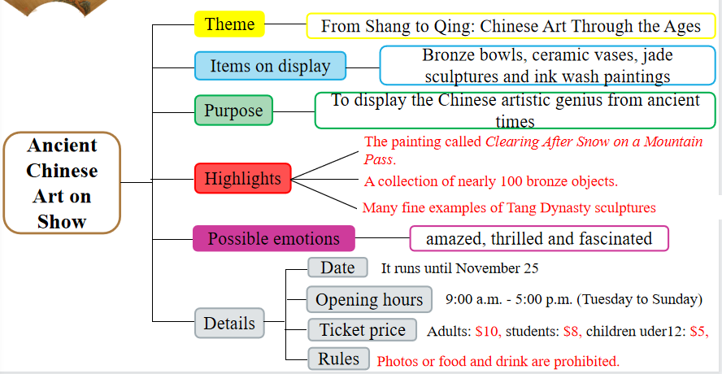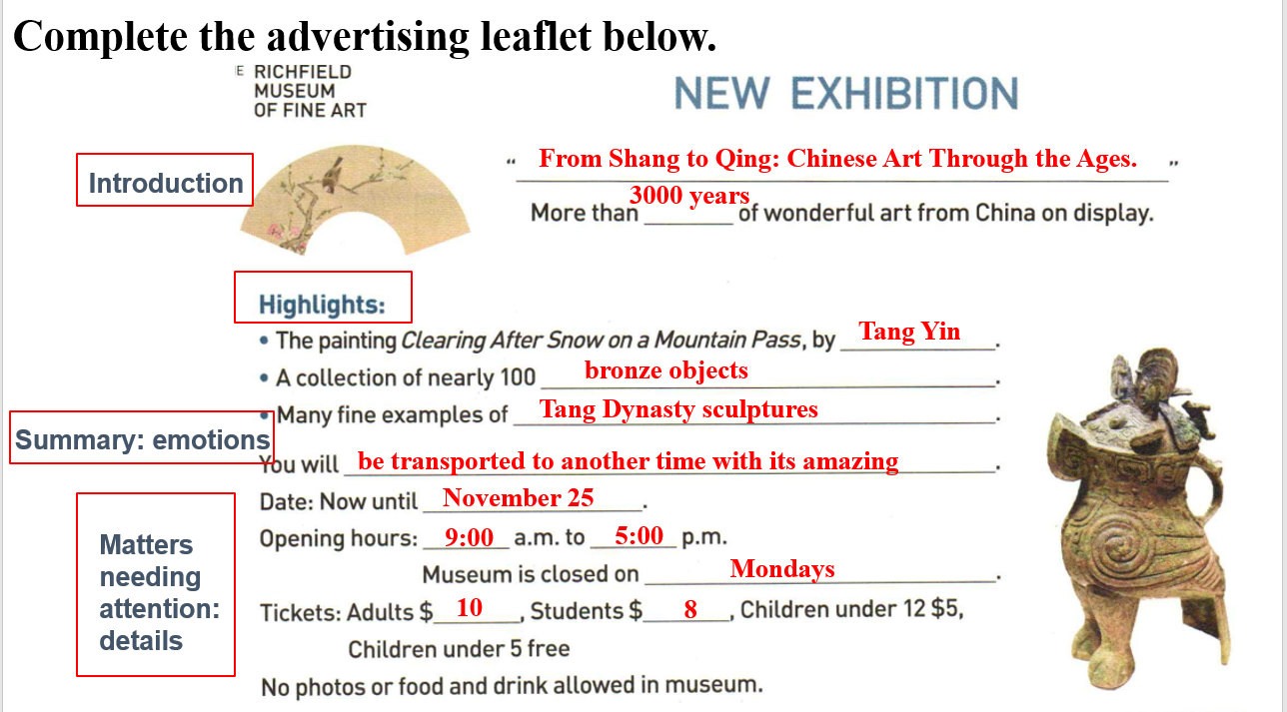
Justification: Practice reading a passage for details and language features. Help students to fully understand the text to support Step 4.
Activity 5. Critical thinking
Students discuss with their partners, brainstorm the details, structure and language features about the exhibition and take notes.
Q1. Who are the target readers?
Q2. What’s the author’s purpose of writing this passage?
Q3. How to spread the Chinese traditional culture to the world?
Justification: cultivate students’ critical thinking.
Activity 6. Read for the language features
Students discuss and summarize the language features as well as the arrangement of an announcement.
Step3 While-writing
Activity 7. Writing an announcement
After discussion, students try to write an announcement for art club members about a trip to see an exhibition, then share or read it out.
Justification: provide students with a chance to practice what they have learned about an art exhibition announcement.
Step4 Post-writing
Activity 8. Showtime
Show some samples of students.
Justification: Help students learn from each other and get advice for improving their work. Getting another person’s opinion and help in checking your works is an important aspect of writing.
Step5 Homework
Try to write an announcement named Beyond the Bounds of History: A Collaborative Exhibition Between the Palace Museum and Dunhuang.
