读后续写：偶遇漂流瓶教学设计

杭州二中树兰高级中学 郭合英

**Topic**：Man and self

**Teaching objectives:**

1. Get a general idea of the story.
2. To infer the story with backstepping method (逆推情节).
3. To cultivate the students’ divergent thinking (发散性思维).

**Teaching focus:**

1. To infer the story with backstepping method
2. To cultivate the students’ divergent thinking;

**Teaching difficulties**:

1. How to polish the students’ composition, especially its richness and diversity of language.
2. How to cultivate the students’ divergent thinking.

**Teaching process:**

**Showing the story.**

第二节读后续写(满分25分)

阅读下面短文，根据所给情节进行续写,使之构成一个完整的故事。

It was on September 5th, my birthday, that we left Cambridge and moved away. We went to the seaside, to our holiday house, which was now to be our permanent home.

I remember the day was cold and grey, with a light rain falling slowly but constantly. My father drove in silence. No one spoke and all we could hear was the sound of the tyres on the wet road.

When we got to the small house near the sea, my mother quietly started to unpack the few things we had brought with us. Carol, Julie and I went down to the beach. We said we were going to look for crabs in the rockpools but actually , we just wanted to get away from our father and his silence.

We climbed along the rocks by the side of the beach. Julie and Carol became interested in some shells they found in one of the pools. I wandered away, lost in my private thoughts. It was my birthday, but no one had said " Happy Birthday" to me. I had not received any cards or presents.

I walked down to the seashore, where the waves were breaking lazily against the muddy sand. Suddenly, I saw something green sticking out of the water. I looked at it more carefully. The green thing moved closer and closer to the shore, and when it was almost near enough for me to touch, I realized what it was.

It was a bottle. I went over and picked it up, all the time looking at it. It seemed old, and had no label on it. Then 1 realized there was something inside. Slowly, I pulled out the wet cork from the top of the bottle. Inside was a piece of paper. With great care, I took out the folded paper and opened it.

Written on it were these words:

“To whomsoever finds this bottle, I promise you a new friend.

Paragraph 1

I stared at the paper and then looked around. ________________________________

Paragraph 2

As I opened my eyes, I found my father standing right beside me. _______________

**Step 1. （1）Text interpretation: Filling the blanks with grammatical knowledge**

On my birthday, that’s was September 5th, we family left Cambridge 1 our holiday house near the seaside, 2 was now to be our permanent home. With a light rain falling slowly but 3 (constant), my father drove in silence, none 4 (speak). When we got there, with the aim of avoiding the father and his cold silence, Carol, Julie and I went down to the beach. They were immersed in some shells 5 (find) in one of the pools while I wandered away, 6 (lose) in my private thoughts with the feeling of a little lose due to no birthday blessings or gifts. In a sudden, I saw something green 7 (stick) out of the water. Not until it was near enough for me to touch 8 I know it was a bottle. 9

(realize) there was something inside, I pulled out the wet cork from the top of the bottle with care. Inside 10 (be) a piece of paper, reading

“To whomsoever finds this bottle, I promise you a new friend”. I stared at the paper, looking around┄┄

（2）Reading comprehension：Choose the right answer.

1. In the fourth paragraph, “I wandered away, lost in my private thoughts.” , here private

thoughts means _____ .

A. Julie and Carol didn’t play with me together.

B. I wanted to pick a bottle.

C. Not receiving any cards and birthday gifts, I was a little unhappy.

D. I wanted to make a new friend.

2. Which of the following is true?

A. The mother was wrapped up in making a cake in the house.

B. I saw the bottle the moment I reached the seashore.

C. We talked and laughed when my father drove due to our holiday.

D. To keep away from father’s silence, Julie and Carol went to the seaside, searching for crabs.

3. After I picked up the bottle, ______ .

A. I pulled out the wet cork quickly. B. I just found it was very new.

C. I found there was label on the bottle. D. I found there was something in the bottle.

4. According to the article, what was the father like?

A. kind B. serious C. out-going D. humorous

**Step 2. Clarify the context of the article**

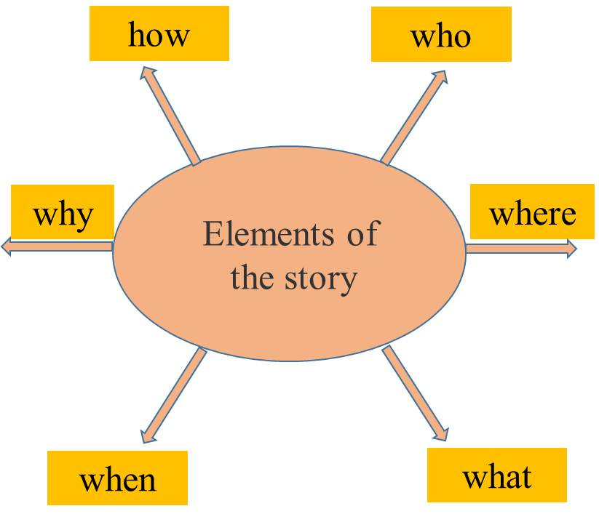

**Step 3 Personality analysis**

We can learn about the traits of each character according to what he/she says and does, using some adjectives to describe.

The development of the story should be in line with the persona, which can pave the way for the subsequent development of the story. Therefore，it is important for you to analyze the traits of each person.

|  |  |
| --- | --- |
| persons | **traits** |
| Dad |  |
| Mom |  |
| I |  |
| Carol, Julie |  |

**Step 4. Sentiment analysis**

Written on it were these words:

“To whomsoever finds this bottle, I promise you a new friend.

It was a bottle. I went over and picked it up, all the time looking at it.

I wandered away, lost in my private thoughts.

My mother quietly started to unpack the few things we had brought with us.

My father drove in silence.

It was on September 5th, my birthday.

**Step6 To infer the story with backstepping method**

**Can this drifting bottle make the promise come true?**

①根据原文已知情节和第二段开头的给出句，找出里面的关键词（关键信息），合理推出第一段发生的故事情节；

② 利用第一段的给出句，找出里面的关键词（关键信息），提出问题和假设，使故事情节合理发展。

Paragraph 1

I stared at the paper and then looked around.

Paragraph 2

As I opened my eyes, I found my father standing right beside me.

**Step7 vocabulary accumulation**

**开心**

1. gratify v. 使高兴；使满意

翻译：收到他们的祝福我非常高兴。

2. beam 笑容满面，眉开眼笑

翻译：他笑容满面，他的灿烂的微笑点亮了房间。

3. 他欢呼雀跃。（用动作描写高兴）

4. 开心的无灵表达

5. 开心的俚语表达

(1）have a whale of a time

(2）be tickled pink

**激动**

1. sweep off one’s feet: 美国习惯用语：使兴奋；使某人大为激动；使某人倾心。

翻译：听说我收到了他们的贝壳项链，他们非常激动。

2. be on cloud nine  异常兴奋；

翻译：得知爸爸给我买了生日礼物，我兴奋极了。

3. be buzzing for: excited for something that’s going to happen 对┄激动不已

翻译：听说我们要去海边度假我激动不已。

4. mingle v. 与┄结合；使混合。mingled adj.混合的

悲喜交加：mingled feelings of happiness and sorrow

翻译：看到爸爸手上拿着的蛋糕，我悲喜交加。

**心累**

1. be in a bad mood 心情不好

翻译：别在我心情很差的时候跟我讲话。

2. be down in the dumps 心情很难受

翻译：没有收到礼物，我心里很难受。

3. get a face like a wet weekend 表示某人很难过，而且情绪全写在脸上。

翻译：我没有找到新朋友心里很难过。

4. a lump in one’s throat 哽咽，如鲠在喉

翻译：当看到生日蛋糕的时候我哽咽地说不出话来。

5.feel blue 情绪低落

翻译：我突然觉得情绪很低落，可是我不知道为什么会这样。

**Step8 Student’s composition 1**

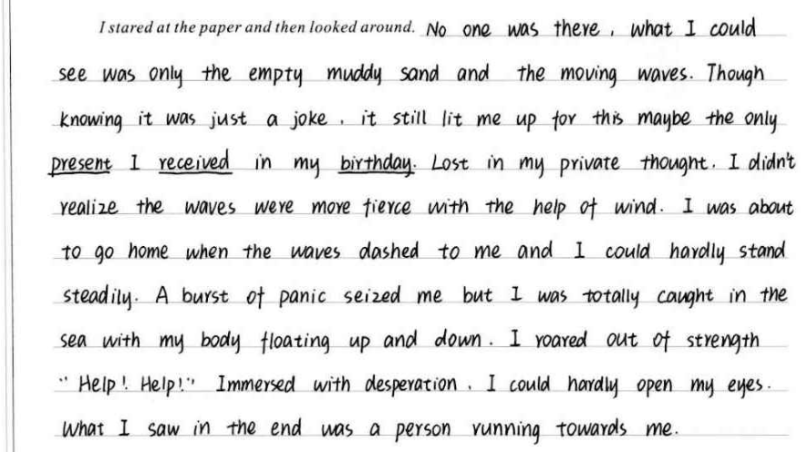

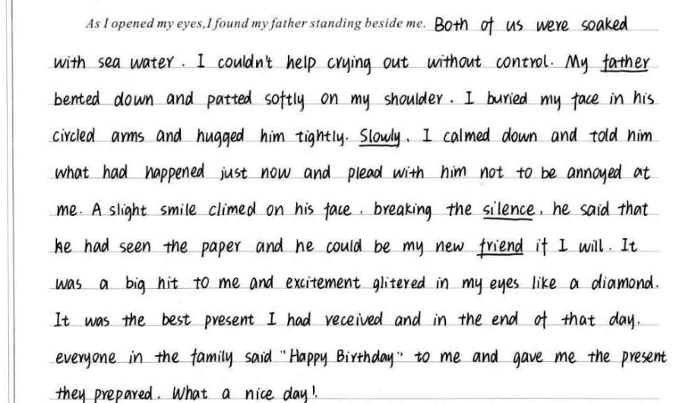

**Step 8 Student’s composition 2**

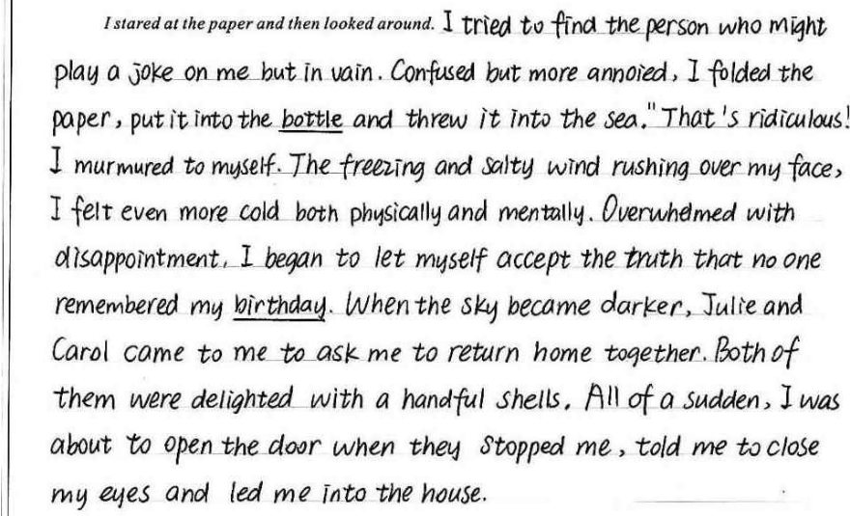

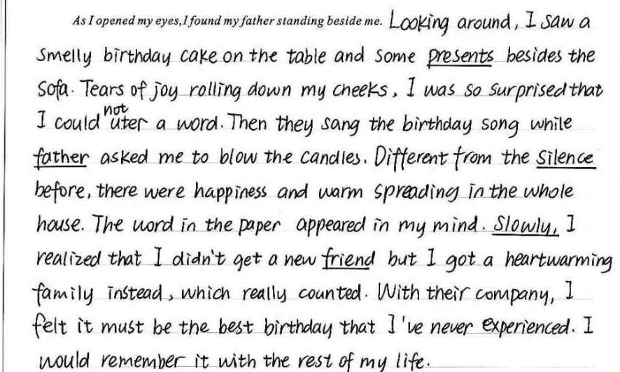

**Step9 A possible version**

I stared at the paper and then looked around. However, no one standing here, a wave of disappointment took possession of me deeply. I wandered around with my head drooping and tear blurring my eyes. Suddenly, something strange, shining under the sun, came into my sight. Approaching it with curiosity, I found it was a necklace made by shells, attached to a piece of paper, reading“Happy Birthday!” I grasped it swiftly like a rabbit running away. A flush of exhilaration overwhelmed me, my eyes twinkling like a glittering diamond. Gripped by an unexpected burst of happiness, I closed my eyes expectantly with my hands crossed before my chest, praying a new friend would suddenly turn up.

As I opened my eyes, I found my father standing right beside me. Instead of cold silence, he grinned, saying “Happy Birthday!” with a cake in his hands, which enabled me to have mingled feelings of startle and excitement. At this time, Carol, Julie and mom also moved here mysteriously, Carol and Julie shouting loudly, “ Is the shell necklace beautiful?” Everything they prepared looked as if a ray of sunshine shone my heart. I was swept off my foot with tear blurring my eyes. I reckoned it was the best present I received, which make me be on cloud nine. We embraced one another tightly, singing and dancing. What an unforgettable birthday! I’m firmly convinced all the unhappiness would disappear and a brand new chapter of life would unfold before us.

**收获与感受**